EV MARKET PERFORMANCE
& INSIGHTS
Final Project Report
Prepared by: Husain Patrawala
Tableau Public | Individual Project
1 November 2026

1. INTRODUCTION

1.1 Project Overview
EV Market Performance & Insights is a Tableau Public analytics project exploring an electric-vehicle dataset through KPI summaries, charts, an interactive dashboard, and a six-point Tableau Story. The analysis covers manufacturers, vehicle categories, recorded annual sales, customer ratings, battery technologies, battery capacity, driving range, and manufacturing countries.
Important: the supplied dataset is synthetic. Values describe records in this dataset and are not verified real-world market totals, market shares, or forecasts.

1.2 Purpose
- Summarize the dataset using high-level KPIs.
- Compare EV records across categories and manufacturers.
- Explore recorded annual sales by model year.
- Compare average customer ratings across categories.
- Examine battery technology and manufacturing-country distributions.
- Explore average battery capacity against average driving range.

2. IDEATION PHASE

2.1 Problem Statement
The dataset contains many vehicle-level records and dimensions. Reading raw rows makes it difficult to identify patterns quickly. This project organizes selected fields into visual summaries and a guided Story.

2.2 Empathy Map Canvas
Perspective | Project assumption
User | Student, analyst, or reader exploring the supplied EV dataset.
Needs | Quick overview, understandable comparisons, and filtering.
Questions | Which categories and manufacturers have the most records? Which battery types appear most often?
Pain points | Large row-level datasets are difficult to scan manually.
Desired outcome | A clear visual summary and guided exploration.

This is a design assumption, not the result of interviews with real customers.

2.3 Brainstorming
- KPI cards for dataset-level measures.
- Bar charts for categories, manufacturers, ratings, and battery technologies.
- Line chart for annual sales by model year.
- Map for manufacturing-country distribution.
- Scatter plot for battery capacity versus driving range.
- Heatmap for category versus battery type.
- Tableau Story to present the views in sequence.

3. REQUIREMENT ANALYSIS

3.1 Customer Journey Map
Step | Viewer action | Information
Open | Open the Tableau Story | Project overview
Orient | Review overview | KPI and category composition
Compare | Open manufacturer and sales views | Record counts and annual sales trend
Explore | Review rating and battery views | Average ratings and battery counts
Locate | Open country map and filter | Geographic distribution of dataset records

3.2 Solution Requirements
- Connect the supplied training CSV to Tableau Public Desktop.
- Create aggregations and visualizations for the project questions.
- Assemble worksheets into a dashboard and Story.
- Provide relevant filters and navigation.
- The Tableau workbook and six-point Story are available through the Tableau Public project link listed in this report.

3.3 Data Flow Diagram
Training CSV → Tableau data connection → worksheets and aggregations → dashboard → six-point Tableau Story → optional Tableau Public publishing.
This is a descriptive visualization workflow; no predictive model or live data pipeline is claimed.

3.4 Technology Stack
Technology | Use
CSV dataset | Input data source
Tableau Public Desktop | Data exploration, worksheets, dashboard, Story
Tableau Public | Publish and share interactive project
GitHub | Store packaged workbook, dataset archive, and README

4. PROJECT DESIGN

4.1 Problem-Solution Fit
A Tableau dashboard and Story convert selected dataset fields into visual summaries and let viewers move between related questions without manually scanning the CSV. This is suitable for descriptive exploration.

4.2 Proposed Solution
- Six KPI summaries: manufacturers, EV models/records, annual sales, average range, average rating, and average battery capacity.
- EV category distribution and top 10 manufacturers by EV record count.
- Annual EV sales trend by model year.
- Average customer rating by category.
- Battery technology distribution and country map.
- Battery capacity versus driving range scatter plot.
- Category versus battery type heatmap.

4.3 Solution Architecture
The training CSV is connected to Tableau Public Desktop. Worksheets aggregate selected fields and are assembled into a dashboard and six-point Story. The packaged workbook and compressed training dataset are organised as supporting project deliverables.

5. PROJECT PLANNING & SCHEDULING

5.1 Project Planning
Phase | Work completed
Data preparation | Connected the training CSV as the Tableau source.
Visualization | Created KPI cards and category, manufacturer, sales, rating, battery, map, scatter, and heatmap views.
Dashboard | Assembled views into EV Market Performance Dashboard.
Story | Created six story points: overview, manufacturers, sales trend, ratings, battery technology, and country distribution.
Publishing | Created the six-point Tableau Story.
Repository | Prepared the workbook, zipped training data, and README as project repository deliverables.

6. FUNCTIONAL AND PERFORMANCE TESTING

6.1 Performance Testing
The workbook and Story were reviewed in Tableau Public Desktop. Formal load-time, stress, security, and cross-device tests were not measured.
Check | Observed result | Status
Publishing | Tableau Public Story link is listed in this report | Link included
Public access | Google Drive demonstration video playback tested by project owner | Demo video playback tested by project owner
Story navigation | Six story points created in Tableau Story | Created
GitHub workbook upload | Workbook and supporting files prepared for repository | Prepared as repository deliverables
Dataset upload | Compressed training CSV prepared for repository | Prepared as repository deliverables
Formal load/security testing | Not performed | Not tested

7. RESULTS

7.1 Output Screenshots and Key Observations
Dashboard KPI values:
KPI | Value
Total manufacturers | 200
Total EV models / records as labelled | 17,980
Total annual EV sales (sum of recorded values) | 1,550,703,961
Average driving range | 324.5 km
Average customer rating | 4.09
Average battery capacity | 78.24 kWh

Category chart: Two-Wheeler Scooter has 19,652 records, Hatchback 17,142, Sedan 17,234, and Compact SUV 17,137. These are dataset record counts, not verified sales.
Top manufacturers chart ranks by EV record count, not sales. AmpereGroup leads with 1,080 records, followed by VoltWorks (1,073) and AxleWheels (1,069).
Annual sales trend covers model years 2018–2026. Displayed endpoints are 172,072,584 (2018) and 170,776,243 (2026); the plotted values vary within a relatively narrow band.
Battery technology counts: NMC 67,672; LFP 64,036; NCA 34,099; Sodium-Ion 20,089; Solid-State 14,103. NMC and LFP are most represented.
Average customer ratings are tightly grouped, approximately 4.08–4.10, so category differences are small. The map, scatter plot, and heatmap support geographic, relationship, and composition exploration but do not establish causation.
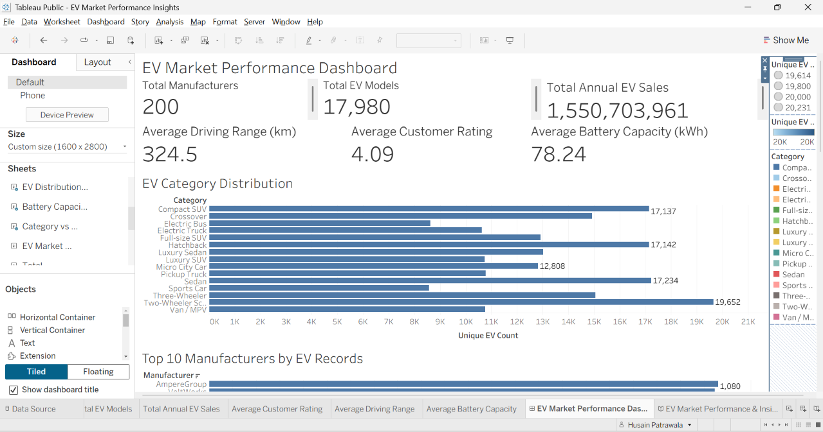
Figure 1. Dashboard overview with KPI cards and category distribution.
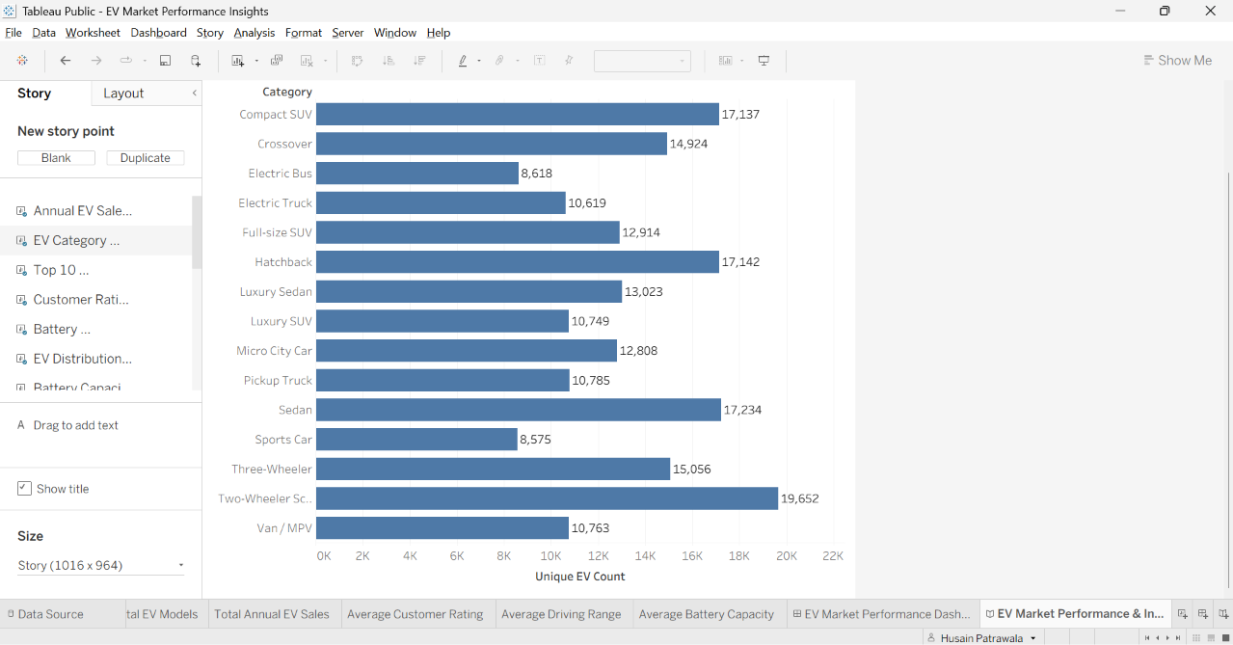
Figure 2. Dashboard views: battery technology, map, scatter plot, and heatmap.
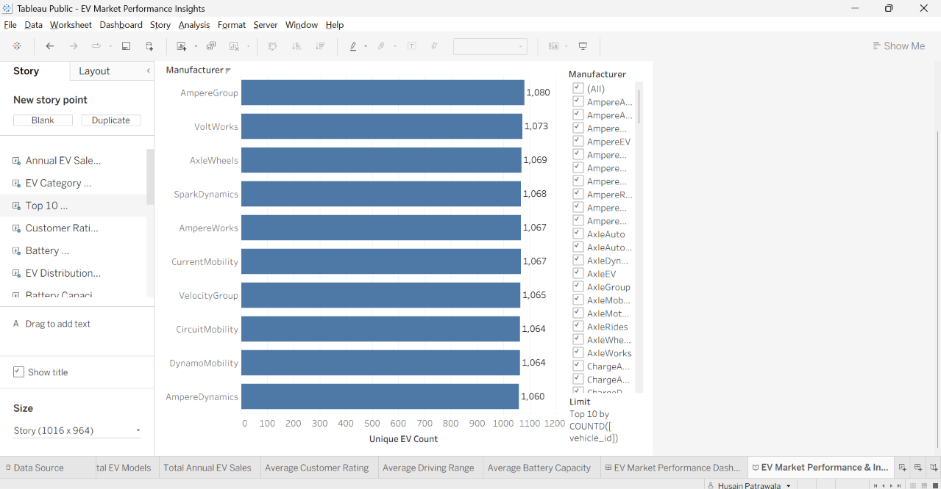
Figure 3. Tableau Story annual sales trend.

8. ADVANTAGES & DISADVANTAGES

Advantages
- Combines multiple views in one dashboard.
- Provides a guided Story.
- Uses filters and visual encodings for exploration.
- Designed for sharing through Tableau Public.

Disadvantages and limitations
- The dataset is synthetic, not verified market intelligence.
- The project is descriptive and does not forecast sales.
- Average ratings are very close across categories.
- Manufacturer ranking is based on record count, not sales volume.
- The tall dashboard requires scrolling.
- No formal load, security, or usability study was conducted.

9. CONCLUSION
The project transforms the supplied synthetic EV dataset into a Tableau dashboard and six-point Story. It summarizes dataset scale, category and manufacturer representation, recorded annual sales, ratings, battery technologies, country distribution, and battery/range relationships. Findings must be interpreted only as patterns in the supplied dataset.

10. FUTURE SCOPE
- Use verified, sourced EV registration and sales data.
- Add a clearly defined sales-based manufacturer ranking.
- Improve dashboard layout for laptop, tablet, and mobile viewing.
- Add metric definitions, tooltips, and data-quality notes.
- Perform formal usability and performance testing.
- Consider forecasting only after validating a suitable real-world time series.

11. APPENDIX
Submission status note: A demo video has been recorded and a Google Drive link has been supplied. The link is included below; its playback and sharing permissions should be checked by opening it in a signed-out/private browser before final assessment.

Project links
Tableau Story: https://public.tableau.com/app/profile/husain.patrawala/viz/EVMarketPerformanceInsights_17934819389030/EVMarketPerformanceInsightsStory
GitHub: https://github.com/Husain-Patrawala/EV-Market-Performance-Insights
Repository files: EV_Market_Performance_Insights.twbx; ev_market_train.zip; README.md.
Demo video link: https://drive.google.com/file/d/1opWF_J5xJjJ4qRY1Gv2nDzHRJ2lkqKqk/view?usp=sharing
Dataset note: The supplied Electric Vehicle Market Classification Dataset is synthetic. The training CSV contains 200,000 rows and 37 columns. Findings describe this dataset only; they are not verified real-world market totals or forecasts.

Phase 7 – Final Documentation Check
- The Tableau Public Story contains six points covering the main analysis sections.
- The project deliverables include the packaged Tableau workbook, training dataset archive, README, and completed phase documents for repository submission.
- The project includes Tableau Public, GitHub repository, and Google Drive demonstration links.
- The demonstration video has been recorded, uploaded to Google Drive, and its playback has been tested by the project owner.
- The GitHub repository link and demonstration video link are provided for the project submission.
The project demonstration video is available at the Google Drive link below. Its playback has been tested by the project owner.

