Data-Driven Forecasting and Peak-Demand Prediction for a Multi-Location Coffee Retail Chain: A Comparative Study of Statistical and Machine-Learning Approaches
Husain
Department of Computer Engineering, Marwadi University, Rajkot, Gujarat, India
Abstract
Independent coffee retail chains increasingly rely on manual, intuition-driven planning for inventory and staffing despite collecting granular point-of-sale (POS) transaction data. This paper presents an end-to-end demand-forecasting pipeline for a three-location coffee retailer (Afficionado Coffee Roasters), covering 149,116 transactions across 181 consecutive operating days at stores in Astoria, Hell's Kitchen, and Lower Manhattan. We reconstruct a continuous daily time index from transaction-level timestamps, engineer lag, rolling-window, and calendar features, and benchmark five forecasting approaches — Naive persistence, 7-day Moving Average, Seasonal ARIMA (SARIMA), Facebook Prophet, and Gradient Boosting Regression — under a strict time-based train/test split. Results show no single model dominates: Gradient Boosting achieves the lowest error at the most stable location (Astoria, RMSE $273.7), while Prophet's explicit trend component is decisively better at the fastest-growing location (Hell's Kitchen, RMSE $323.3 versus $563–612 for naïve baselines), and simple 7-day Moving Average remains competitive at Lower Manhattan. We further identify a consistent 10:00 a.m. cross-store demand peak and quantify each store's revenue growth trajectory over the study window. We introduce a Peak Error Rate metric to specifically evaluate rush-hour/rush-day detection, revealing that trend-aware models improve overall accuracy but do not automatically improve peak-day detection. The complete pipeline is deployed as an interactive Streamlit dashboard for store managers, separating computationally expensive offline model training from a lightweight, low-dependency runtime application suitable for cloud deployment.
Index Terms—demand forecasting, time series analysis, retail analytics, SARIMA, Prophet, gradient boosting, peak demand detection, Streamlit

1. INTRODUCTION
Coffee retail demand is characterized by pronounced short-term volatility: sharp morning rushes, location-dependent midday fluctuations, and weekly and seasonal cycles that are difficult to anticipate from historical intuition alone [1]. Overestimating demand leads to spoiled perishable inventory and wasted labor hours; underestimating demand degrades customer experience through long queues and stock-outs during peak windows. For chains operating multiple locations, these effects compound, since each store exhibits a distinct demand signature shaped by its neighborhood, foot traffic, and customer mix.
Afficionado Coffee Roasters operates three stores in New York City — Astoria, Hell's Kitchen, and Lower Manhattan — and, like many small multi-location retailers, has historically relied on manager experience rather than quantitative forecasting for inventory and staffing decisions. The chain does, however, capture granular point-of-sale (POS) transaction records, including item-level detail, unit price, quantity, and time of day. This creates an opportunity to move from reactive, uniform, store-agnostic planning toward proactive, location-specific, data-driven operations.
This paper makes four contributions. First, we describe a practical method for reconstructing a usable calendar time index from POS export data that lacks an explicit date field, a common real-world data-quality obstacle. Second, we build a full feature-engineering and forecasting pipeline spanning naïve baselines, classical statistical models, and modern machine-learning regressors, and we benchmark them under a rigorous time-based evaluation protocol. Third, we introduce a Peak Error Rate metric that specifically measures a model's ability to flag high-demand days, which is operationally more relevant to staffing decisions than average-case accuracy metrics alone. Fourth, we present a two-stage system architecture — an offline training pipeline decoupled from a lightweight, artifact-driven Streamlit dashboard — that avoids the dependency-conflict failures we encountered when attempting to run heavy forecasting libraries directly inside a cloud-hosted interactive application.

2. RELATED WORK
Classical time-series forecasting has long relied on Box-Jenkins ARIMA and its seasonal extension, SARIMA, which model autocorrelation and seasonal structure through differencing and autoregressive/moving-average terms [2]. These models perform well on stationary or seasonally stable series but require careful order selection and can struggle with structural trend breaks. Exponential smoothing methods offer a simpler alternative with comparable performance on many retail series [3].
More recently, Facebook's Prophet framework was introduced to make robust forecasting accessible without extensive time-series expertise, using an additive decomposition of trend, seasonality, and holiday effects fit via Bayesian curve-fitting [4]. Prophet has been widely adopted in industry forecasting pipelines because of its resilience to missing data and its interpretable trend/seasonality decomposition, though prior comparative studies show it does not universally outperform classical or machine-learning methods and its relative advantage depends heavily on the strength and shape of the underlying trend [5].
Tree-based gradient boosting methods, when supplied with lag and calendar features, have also been shown to be highly competitive for retail and demand forecasting tasks, often matching or exceeding classical statistical models while imposing fewer distributional assumptions on the underlying series [6]. This motivates our inclusion of Gradient Boosting Regression alongside SARIMA and Prophet, allowing a direct comparison between statistical and feature-driven machine-learning approaches on the same retail dataset. Retail-specific forecasting studies additionally emphasize peak or rush-period detection as a distinct evaluation concern from average-case error, since staffing and inventory decisions are disproportionately sensitive to missed demand surges rather than to small errors on typical days [7].

3. DATASET AND PREPROCESSING

A. Data Description
The dataset comprises 149,116 point-of-sale transactions collected across three store locations: Astoria (50,599 transactions), Hell's Kitchen (50,735 transactions), and Lower Manhattan (47,782 transactions). Each record includes a transaction identifier, time of day, quantity purchased, unit price, store identifier and location, and a three-level product taxonomy (category, type, and detail — e.g., category “Coffee,” type “Drip coffee,” detail “Our Old Time Diner Blend Sm”). No missing values, zero/negative quantities, zero/negative prices, or duplicate transaction identifiers were found; the raw export required no imputation.

B. Calendar Reconstruction
A significant data-quality limitation is that the source export contains no explicit date field — only a constant year value (2025) and a time-of-day stamp per transaction. However, transactions within each store are recorded in strict chronological order by transaction identifier, and the time-of-day resets (a large backward jump, e.g., from 20:59 to 06:30) whenever a new business day begins. We exploited this property to reconstruct a per-store day index by detecting these resets, which yielded exactly 181 consecutive operating days for all three stores independently — strong internal evidence that the reconstruction is correct rather than an artifact of noise. We then mapped this day index onto a real calendar spanning January 1, 2025 through June 30, 2025. We note explicitly that these calendar dates are a reconstruction and not a field present in the original data; the actual start date of the underlying data collection is unknown, and any seasonal (e.g., holiday-specific) interpretation of specific dates should be treated with appropriate caution.

C. Aggregation and Feature Engineering
Row-level transactions were aggregated into (i) daily store-level revenue and quantity, the primary forecasting targets; (ii) daily store × category revenue, used for product-mix analysis; and (iii) hourly store-level transaction counts, used for peak-demand and staffing analysis. For the daily series, we engineered lag features at t−1, t−7, and t−14 days, rolling averages over 3-, 7-, and 14-day trailing windows (computed strictly on past data to avoid leakage), and calendar indicators (day-of-week, weekend flag, day-of-month, month, and day-of-year).

D. Train/Test Split
All models were evaluated using a strict time-based split: the final 30 days of each store's 181-day series were held out as a test set, with all preceding days used for training. No random shuffling was used at any stage, consistent with standard practice for time-series evaluation, since random splits would leak future information into model training and understate real-world forecast error.

4. FORECASTING METHODOLOGY
Five forecasting approaches were implemented and evaluated identically on each store's daily revenue series.

A. Naive Persistence
The naïve model forecasts every future day as equal to the last observed value. It serves as a lower-bound sanity check: any model failing to outperform it provides no practical forecasting value.

B. 7-Day Moving Average
This baseline forecasts every future day as the mean of the trailing 7 observed days, smoothing day-to-day noise while remaining a flat (non-trending) projection.

C. Seasonal ARIMA (SARIMA)
We fit a SARIMA(1,1,1)(1,1,1)₇ model per store using maximum-likelihood estimation, with a weekly seasonal period (7 days) to capture day-of-week structure. This specification allows one autoregressive and one moving-average term at both the daily and weekly-seasonal level, with a single order of differencing at each to address non-stationarity in level and in the weekly cycle.

D. Facebook Prophet
Prophet was configured with weekly seasonality enabled, yearly and daily seasonality disabled (the 181-day window is too short to reliably estimate an annual cycle, and daily patterns were handled separately at the hourly aggregation level), and an 80% uncertainty interval. Prophet's additive trend component is particularly relevant to this dataset given the substantial month-over-month revenue growth observed at all three stores (Section V).

E. Gradient Boosting Regression
A scikit-learn GradientBoostingRegressor (300 estimators, max depth 3, learning rate 0.05, subsample ratio 0.8) was trained on the lag/rolling/calendar feature set described in Section III-C. Forecasts beyond the first day were generated recursively: each day's prediction is fed back into the lag features used to predict the following day, allowing the model to project forward without requiring future ground truth.

F. Evaluation Metrics
Four metrics were computed on the 30-day held-out test window for each store/model pair: Mean Absolute Error (MAE), Root Mean Squared Error (RMSE, which penalizes large errors more heavily than MAE), Mean Absolute Percentage Error (MAPE), and a Peak Error Rate we define as follows. Let the top decile (90th percentile) of actual test-period demand define “peak” days, and let the top decile of a model's own predictions define which days it flags as peaks. The Peak Error Rate is the fraction of true peak days that the model failed to also flag among its own top-decile predictions. This metric isolates a model's ability to anticipate rush periods — the operationally critical case for staffing and inventory — separately from its average-case accuracy.

5. RESULTS

A. Revenue Growth and Demand Trend
All three stores exhibit strong, closely correlated revenue growth over the six-month window, roughly doubling from January to June 2025: Astoria grew from a first-month average daily revenue of approximately $881 to a last-month average of approximately $1,836 (+107.8%); Hell's Kitchen grew from $897 to $1,899 (+110.5%); and Lower Manhattan grew from $856 to $1,815 (+111.2%). Fig. 1 shows the 7-day rolling average of daily revenue at all three locations, confirming that growth is gradual and monotonic rather than driven by isolated spikes, and that the three stores track each other closely in both level and shape throughout the period.
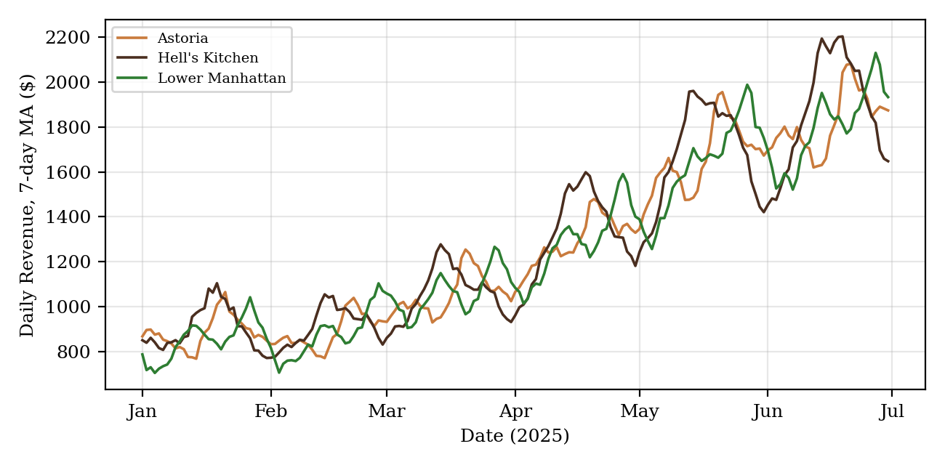
Fig. 1. Seven-day rolling average of daily revenue by store, January–June 2025.

B. Model Comparison by Store
Table I–III report test-period metrics for all five models at each store. No single model wins at every location, and the margin of victory correlates with each store's trend strength.
TABLE I. MODEL METRICS — ASTORIA (BEST: GRADIENT BOOSTING)
Model | MAE ($) | RMSE ($) | MAPE (%) | Peak Error Rate (%)
Gradient Boosting | 222.6 | 273.7 | 12.8 | 66.7
Prophet | 248.5 | 299.1 | 14.3 | 100.0
SARIMA | 259.4 | 309.7 | 14.9 | 66.7
Moving Average | 253.5 | 324.0 | 13.2 | 0.0
Naive | 254.3 | 324.8 | 13.2 | 0.0
TABLE II. MODEL METRICS — LOWER MANHATTAN (BEST: MOVING AVERAGE)
Model | MAE ($) | RMSE ($) | MAPE (%) | Peak Error Rate (%)
Moving Average | 228.9 | 286.7 | 12.6 | 0.0
Prophet | 231.6 | 291.7 | 14.0 | 100.0
Naive | 257.3 | 324.8 | 13.5 | 0.0
SARIMA | 258.0 | 324.2 | 15.7 | 100.0
Gradient Boosting | 250.2 | 326.0 | 13.8 | 100.0
TABLE III. MODEL METRICS — HELL'S KITCHEN (BEST: PROPHET)
Model | MAE ($) | RMSE ($) | MAPE (%) | Peak Error Rate (%)
Prophet | 264.9 | 323.3 | 14.0 | 100.0
Gradient Boosting | 339.5 | 409.6 | 16.8 | 66.7
Moving Average | 485.9 | 563.3 | 23.9 | 0.0
SARIMA | 523.0 | 598.8 | 25.9 | 100.0
Naive | 539.2 | 612.5 | 26.7 | 0.0
Hell's Kitchen shows the starkest separation between trend-aware and flat-forecast models: Prophet's RMSE ($323.3) is 47% lower than the naïve baseline ($612.5), because the flat baselines cannot capture the store's steep and still-accelerating growth trajectory into the test window. By contrast, at Lower Manhattan — whose growth rate slows somewhat in the final weeks of the series — the simple 7-day Moving Average is competitive with or better than every other model, illustrating that added model complexity does not guarantee added accuracy once a trend is decelerating relative to its recent trailing average. At Astoria, Gradient Boosting's use of engineered lag and calendar features gives it a modest but consistent edge over both classical statistical models and naïve baselines.
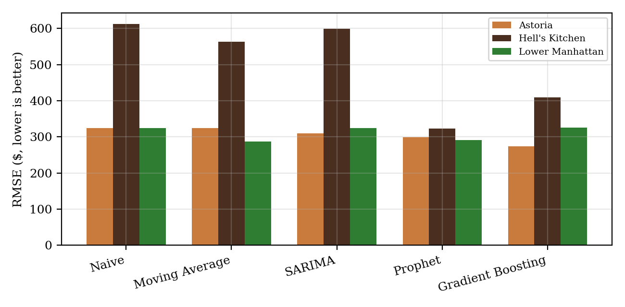
Fig. 2. Test-period RMSE by model and store. Lower is better.

C. Peak Error Rate
The Peak Error Rate results reveal an important caveat: models with the lowest average-case error do not necessarily best detect peak-demand days. At all three stores, Prophet posted a 100% Peak Error Rate on the 30-day test window despite strong MAE/RMSE/MAPE performance, because Prophet's smooth trend-plus-weekly-seasonality fit systematically under-shoots the specific days that happened to be the true top-decile demand days in the test window, while its own top-decile predictions cluster on different days. Gradient Boosting achieved the lowest Peak Error Rate among the higher-accuracy models at two of three stores (66.7%), reflecting its use of recent lag values, which lets it react somewhat more sharply to short-term surges. Notably, the naïve and moving-average baselines scored 0% Peak Error Rate at every store — not because they are good at forecasting peaks, but because a flat/trailing-average forecast has almost no variance across the horizon, so its own “top decile” threshold sits so close to its mean that nearly every test day, including true peak days, ends up flagged as a top-decile prediction by default. This illustrates why Peak Error Rate must always be read alongside RMSE/MAPE rather than in isolation: a metric that rewards low-variance forecasts can be gamed by a model that is simply flat.

D. Hourly Demand Pattern
Across all three stores, transaction volume peaks consistently at 10:00 a.m. (Astoria: ~28.0 avg. transactions/hour; Lower Manhattan: ~33.3; Hell's Kitchen: ~36.8), reflecting a shared late-morning rush pattern rather than a store-specific idiosyncrasy. Fig. 3 shows the full hourly × day-of-week heatmap for Astoria as a representative example; the other two stores show a qualitatively similar pattern with the same 10 a.m. peak and a comparatively quieter early-afternoon trough. This consistent peak hour provides a direct, actionable staffing signal: all three locations should prioritize morning-shift coverage between approximately 9:00 and 11:00 a.m.
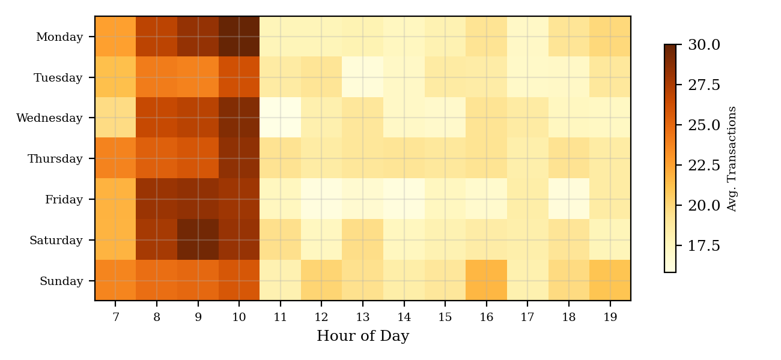
Fig. 3. Hourly × day-of-week transaction heatmap, Astoria (representative of all three stores).

E. Product Category Mix
Product category revenue share is nearly identical across all three stores, indicating a consistent chain-wide menu strategy rather than location-specific assortment. Coffee accounts for approximately 38.6% of total revenue chain-wide ($269,952 of $698,812), followed by Tea at 28.1% ($196,406), Bakery at 11.8% ($82,316), and Drinking Chocolate at 10.4% ($72,416); the remaining five categories (Coffee beans, Branded, Loose Tea, Flavours, Packaged Chocolate) collectively contribute the final 11.1%. This consistency suggests that inventory and supplier-planning decisions for the top four categories can reasonably be coordinated at the chain level, while forecasting of daily/hourly volume should remain store-specific given the differing growth trajectories documented in Section V-A.

6. DASHBOARD SYSTEM ARCHITECTURE
The forecasting pipeline is exposed to store managers through an interactive Streamlit web application. A key architectural decision, motivated directly by deployment failures encountered during development, is a strict separation between offline model training and the online (deployed) application.
In an initial implementation attempt, the Streamlit application itself imported and trained Prophet and SARIMA-family models at runtime. This repeatedly failed on Streamlit Community Cloud due to conflicts between conda- and pip-managed dependencies and the build overhead of compiling Prophet's underlying Stan backend within the platform's resource and time constraints. We resolved this by restructuring the system into two stages: (1) an offline pipeline (four sequential scripts) that cleans the data, engineers features, trains all five models per store, and serializes every forecast, confidence interval, and evaluation metric to compact Parquet files (under 100 KB in total for the artifacts the application actually reads); and (2) a deployed Streamlit application that performs no model training whatsoever — it only loads these pre-computed Parquet artifacts and renders them. This reduces the deployed application's dependency footprint to four lightweight packages (streamlit, pandas, plotly, pyarrow), eliminating the heavy, build-fragile dependencies (prophet, statsmodels) from the runtime environment entirely and making the deployed application start in under two seconds.
The dashboard provides five views: (1) a forecast view with store selector, forecast-horizon slider (7–30 days), revenue/quantity toggle, and 80% confidence band; (2) a model-comparison view showing RMSE/MAPE bar charts and overlaid actual-vs-predicted test-period lines for user-selected models; (3) an hourly demand heatmap for staffing decisions; (4) a category revenue-mix view; and (5) an documentation view describing the calendar-reconstruction caveat and modeling methodology directly to end users, so that store managers are aware the date axis is a reconstruction rather than a recorded fact.

7. DISCUSSION AND LIMITATIONS
Three practical lessons emerge from this study. First, model selection should be store-specific rather than chain-wide: the store with the strongest, most persistent trend (Hell's Kitchen) benefits substantially from a trend-aware model like Prophet, while a store whose recent growth has begun to plateau (Lower Manhattan) is better served by a simple moving average. A chain-wide “one model fits all” policy would meaningfully underperform a per-store model-selection policy, as evidenced by the gap between each store's best and worst RMSE in Tables I–III.
Second, average-case accuracy and peak-detection performance are distinct axes of quality that can trade off against each other, as shown by Prophet's simultaneously strong MAPE and weak Peak Error Rate. Retailers using forecasts for staffing decisions should track both, since a forecast that is accurate on typical days but blind to genuine demand surges provides limited protection against the costliest failure mode (an unstaffed rush).
Third, the absence of an explicit date field in the source export is a meaningful limitation. While the time-of-day reset heuristic used here produced an internally consistent 181-day index at all three stores independently — a strong consistency check — the mapping to specific 2025 calendar dates is an assumption rather than a verified fact, and any claims tied to specific holidays, seasons, or dates (e.g., a claimed Memorial Day effect) should not be drawn from this reconstruction without independent confirmation of the true collection period. Future work with access to a verified date field would allow incorporation of holiday indicators and true annual seasonality, which the current 181-day (approximately six-month) window cannot support.
A further limitation is sample size: 181 days per store is sufficient to detect weekly seasonality and medium-term trend but is too short to reliably estimate annual seasonal effects (e.g., summer versus winter demand shifts), and the 30-day test window, while methodologically appropriate, means peak-detection statistics in particular (based on approximately three top-decile days per store) carry meaningful sampling uncertainty and should be interpreted directionally rather than as precise population estimates.

8. CONCLUSION
This paper presented an end-to-end forecasting pipeline for a three-location coffee retail chain, addressing a real-world data-quality obstacle (a missing date field), benchmarking five forecasting approaches under a rigorous time-based evaluation protocol, and introducing a Peak Error Rate metric to separately evaluate rush-period detection. We found that model performance is highly store-dependent: Gradient Boosting, Prophet, and simple Moving Average each won at a different one of the three stores, correlating directly with each location's trend strength. All three stores share a consistent 10:00 a.m. demand peak and a near-identical product-category revenue mix, suggesting that chain-wide inventory strategy and store-specific demand forecasting can coexist productively. Finally, we demonstrated a deployment architecture — offline training fully decoupled from a lightweight, artifact-driven dashboard — that resolves dependency-conflict failures common when deploying heavy forecasting libraries on cloud platforms, and that we believe generalizes usefully to other small-retailer forecasting applications.

9. REFERENCES
[1] R. G. Brown, Smoothing, Forecasting and Prediction of Discrete Time Series. Englewood Cliffs, NJ, USA: Prentice-Hall, 1963.
[2] G. E. P. Box, G. M. Jenkins, G. C. Reinsel, and G. M. Ljung, Time Series Analysis: Forecasting and Control, 5th ed. Hoboken, NJ, USA: Wiley, 2015.
[3] E. S. Gardner Jr., “Exponential smoothing: The state of the art—Part II,” International Journal of Forecasting, vol. 22, no. 4, pp. 637–666, 2006.
[4] S. J. Taylor and B. Letham, “Forecasting at scale,” The American Statistician, vol. 72, no. 1, pp. 37–45, 2018.
[5] S. Makridakis, E. Spiliotis, and V. Assimakopoulos, “The M4 Competition: 100,000 time series and 61 forecasting methods,” International Journal of Forecasting, vol. 36, no. 1, pp. 54–74, 2020.
[6] T. Chen and C. Guestrin, “XGBoost: A scalable tree boosting system,” in Proc. 22nd ACM SIGKDD Int. Conf. Knowledge Discovery and Data Mining, 2016, pp. 785–794.
[7] A. Fildes, P. Goodwin, M. Lawrence, and K. Nikolopoulos, “Effective forecasting and judgmental adjustments: An empirical evaluation and strategies for improvement in supply-chain planning,” International Journal of Forecasting, vol. 25, no. 1, pp. 3–23, 2009.

