MACHINE LEARNING-BASED BUYER SEGMENTATION AND
INVESTMENT PROFILING FOR REAL ESTATE MARKET INTELLIGENCE
A Data Science Research Paper on Buyer Cluster Discovery, Investment-Behavior Profiling, and Market-Intelligence Dashboarding
Prepared for
Parcl Co. Limited
in collaboration with Unified Mentor
Data Science & Market Intelligence Team
July 2026

Abstract
Real estate portfolios attract a heterogeneous mix of buyers — individuals purchasing a home, investors building a diversified portfolio, and companies acquiring commercial or multi-unit assets. Treating this population as a single, undifferentiated market leads to inefficient marketing spend, generic property recommendations, and missed investment opportunities. This paper presents an unsupervised machine-learning pipeline that segments 2,000 real-estate buyers of a multi-tower residential and office development (15 towers, 10,000 individual listings) into behaviorally distinct groups. Buyer records were cleaned, enriched with transaction-derived RFM-style features (purchase frequency, monetary value, tenure, and recency), encoded, and scaled before being clustered with K-Means. The optimal number of segments was selected using the Elbow Method and Silhouette Analysis, and the resulting partition was cross-validated against Agglomerative Hierarchical Clustering. Four interpretable segments emerged — Portfolio Investors, Luxury Single-Asset Buyers, Value-Focused Mainstream Buyers, and Loan-Dependent / Corporate Growth Buyers — each with a distinct spend profile, financing behavior, and geographic footprint. These findings were operationalized into an interactive Streamlit dashboard that lets non-technical stakeholders filter, explore, and export buyer segments for targeted marketing and investment strategy. We report clustering diagnostics honestly, including modest silhouette scores (0.15-0.17) that reflect the continuous, overlapping nature of buyer behavior in this market, and we discuss the business implications and limitations of the approach.
Keywords: buyer segmentation, K-Means clustering, hierarchical clustering, real estate analytics, investment profiling, RFM features, Streamlit, market intelligence

Table of Contents

1. Introduction

1.1 Background and Context
Real estate companies operate in markets where buyer behavior is highly diverse: individual home buyers, institutional investors, international buyers, high-net-worth investors, and first-time buyers all transact side by side. Without segmentation, companies tend to treat every buyer identically, which results in inefficient marketing, poor customer targeting, and missed investment opportunities. Machine-learning-based clustering offers a systematic way to discover hidden patterns in buyer behavior directly from transaction and demographic data, rather than relying on ad-hoc business rules.
This project was carried out for Parcl Co. Limited in collaboration with Unified Mentor, using two linked datasets: a client registry (2,000 buyers) and a property-transaction ledger (10,000 listings across 15 towers). The goal is to convert raw client and transaction records into an actionable segmentation model, and to expose that model through a live analytics dashboard.

1.2 Problem Statement
Parcl currently lacks a data-driven understanding of (i) the different types of property buyers active on its platform, (ii) investment motivations across demographic groups, (iii) geographic differences in investment behavior, and (iv) customer financing patterns. This leads to inefficient marketing spend, generic property recommendations, and poor investor targeting. The objective of this study is to close that gap using an end-to-end data science methodology: cleaning, feature engineering, clustering, validation, and dashboard delivery.

1.3 Objectives
- Clean and merge client and transaction data into a single buyer-level analytical table.
- Engineer behaviorally meaningful features (purchase frequency, monetary value, recency, tenure, unit preference).
- Cluster buyers using K-Means, validated with Hierarchical clustering, and select k using the Elbow Method and Silhouette Score.
- Interpret each cluster in business terms and propose differentiated marketing and investment strategies.
- Deliver the entire pipeline as an interactive Streamlit web application with filtering and export capability.

2. Related Work and Analytical Context
Customer segmentation via unsupervised learning is well established in retail and financial services, most commonly through RFM (Recency, Frequency, Monetary) analysis combined with K-Means or hierarchical clustering. Real estate segmentation extends this idea by combining demographic attributes (age, client type, country) with transaction-derived investment behavior (portfolio size, spend, financing reliance). K-Means is favored for its computational efficiency and straightforward interpretation of cluster centroids, while Agglomerative Hierarchical Clustering is used as an independent validation method because it does not require pre-specifying the number of clusters and reveals nested group relationships through a dendrogram. The Elbow Method (inertia / within-cluster sum of squares) and the Silhouette Score (cohesion versus separation) are the two most widely used diagnostics for choosing the number of clusters, and both are applied in this study.

3. Dataset Description
Two source files were provided and linked via a client identifier:

3.1 Client Registry (clients.csv) — 2,000 records
Field | Description
client_id | Unique client identifier
client_type | Individual or Company
first_name / last_name | Buyer name
date_of_birth | Used to derive buyer age
gender | Buyer gender
country / region | Geographic location of the buyer
acquisition_purpose | Home (owner-occupier) or Investment
satisfaction_score | 1-5 customer satisfaction rating
loan_applied | Whether financing was used (Yes/No)
referral_channel | Website, Agency, or existing Client referral
Table 1. Client registry field description.

3.2 Property Transaction Ledger (properties.csv) — 10,000 records
Field | Description
listing_id | Unique listing identifier
tower_number | Tower (1-15) in which the unit is located
transaction_date | Month of transaction (Jan 2024 - Dec 2025)
unit_category | Apartment or Office
unit_number / floor_area_sqft | Unit identifier and size
sale_price | Sale price (USD, cleaned from currency-formatted text)
listing_status | Sold or Available
client_ref | Foreign key to client_id (present only for Sold units)
Table 2. Property ledger field description.

3.3 Descriptive Statistics
Of the 10,000 listings, 7,305 (73.1%) were recorded as Sold and 2,695 (27.0%) as Available (unsold and therefore excluded from buyer-level aggregation). Sold units are predominantly Apartments (85.5%) versus Office units (14.5%). All 2,000 registered clients had at least one completed (Sold) transaction, with a mean of 3.65 properties per client (min 3, max 13), reflecting that the dataset already represents an engaged, transacting buyer base rather than prospects.
On the demographic side, buyers are 94.9% Individual and 5.2% Company accounts, nearly evenly split by gender (50.6% male / 49.4% female), with a mean age of 55.6 years (range 25-95). Most purchases were for Home use (69.3%) versus Investment (30.8%), and 36.8% of buyers used financing (loan_applied = Yes). Buyers span 10 countries and 15 regions, but the base is heavily USA-concentrated (76.9%), with the United Kingdom (4.8%), Canada (4.3%), Germany (2.8%) and France (2.7%) as the next largest groups. Website (55.2%) is the dominant referral channel, followed by Agency (35.3%) and existing-Client referrals (9.6%).

4. Data Science Methodology

4.1 Step 1 — Data Cleaning
- Removed duplicate client_id and listing_id rows (none were found, confirming referential integrity).
- Normalized categorical text fields (trimmed whitespace, consistent casing).
- Parsed mixed date formats in date_of_birth (both DD-MM-YYYY and M/D/YYYY strings) into a single datetime type.
- Stripped currency symbols and thousands separators from sale_price (e.g. "$300,385.62") and converted to numeric.
- Restricted transaction-derived features to listing_status = Sold, since Available units have no associated buyer.

4.2 Step 2 — Feature Engineering
Because the raw tables are transactional rather than buyer-level, each client's Sold listings were aggregated into RFM-style behavioral features:
Engineered feature | Definition
n_properties | Count of Sold units purchased (Frequency)
total_spend / avg_price / max_price | Sum, mean and maximum sale price across the client's units (Monetary)
avg_floor_area | Mean unit size purchased
n_towers | Number of distinct towers the client has purchased in (portfolio diversification)
pct_apartment | Share of purchases that are Apartments vs. Offices
tenure_months | Months since the client's first purchase (Tenure)
recency_months | Months since the client's most recent purchase (Recency)
age | Derived from date_of_birth relative to the analysis date
Table 3. Engineered buyer-level features.

4.3 Step 3 — Feature Encoding and Scaling
Numeric features (age, satisfaction_score, and the RFM-style variables above) were standardized with a StandardScaler (zero mean, unit variance) so that no single high-magnitude feature (e.g., total_spend in the hundreds of thousands) would dominate the Euclidean distance used by K-Means. Categorical variables were one-hot encoded. An important methodological choice was made at this step: encoding the high-cardinality country (10 categories) and region (15 categories) fields alongside the core behavioral variables diluted the clustering signal and reduced the silhouette score (0.10-0.13 across k = 2-8). Restricting one-hot encoding to the three lower-cardinality, behaviorally relevant categorical fields — client_type, acquisition_purpose, and loan_applied — improved silhouette scores to 0.15-0.17 across the same range while keeping the model interpretable. Country and region were retained as descriptive (not clustering) variables and are used extensively in the Geographic Buyer Analysis dashboard instead.

4.4 Step 4 — Clustering Model Selection
Two complementary clustering approaches were used. K-Means was chosen as the primary algorithm for its computational efficiency and straightforward centroid-based interpretation, well suited to the mixed numeric/categorical feature matrix after scaling and encoding. Agglomerative Hierarchical Clustering (Ward linkage) was used as an independent validation method: it does not require a pre-specified k in the same way, and its dendrogram reveals nested relationships between buyer groups, which helps confirm — or challenge — the groupings found by K-Means.

4.5 Step 5 — Optimal Cluster Selection
The number of clusters k was chosen using two standard diagnostics computed for k = 2 through 8:
- Elbow Method — the within-cluster sum of squares (inertia) decreases monotonically as k increases; the "elbow" marks the point of diminishing returns.
- Silhouette Score — measures how similar each buyer is to its own cluster versus the nearest neighboring cluster (range -1 to 1; higher is better-separated).
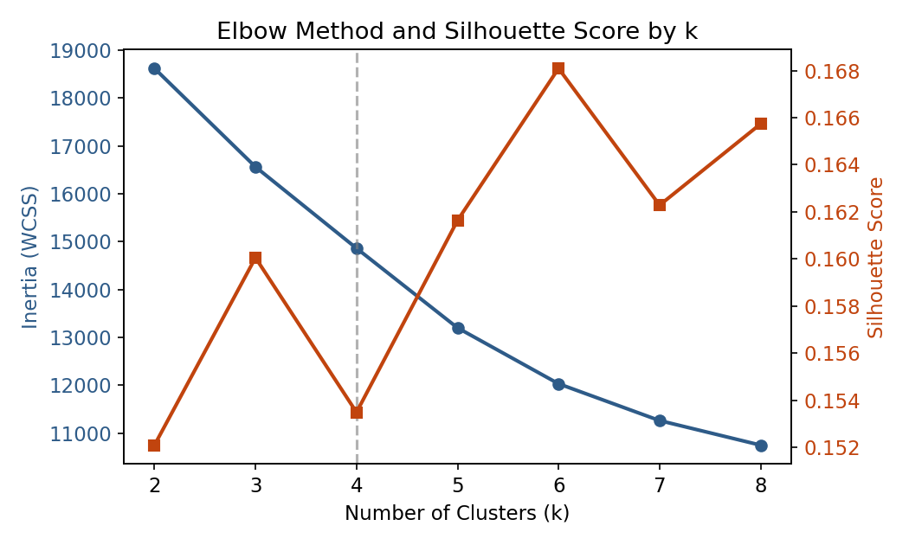
Figure 1. Elbow curve (inertia, left axis) and Silhouette Score (right axis) for k = 2-8. The dashed line marks the k = 4 solution used in this study.
Silhouette scores in this study were modest in absolute terms — ranging from 0.149 at k = 8 to a maximum of 0.168 at k = 6, with k = 4 scoring 0.154 — which is typical for buyer-segmentation problems that blend continuous transaction behavior with categorical demographic attributes rather than forming naturally well-separated groups. k = 4 was selected for the production model because (a) it is within 0.014 of the best observed silhouette score in the tested range, (b) the elbow curve shows a clear flattening of inertia reduction beyond k = 4, and (c) four segments align with recognizable, actionable real-estate buyer archetypes that map cleanly onto differentiated marketing and investment strategies. The Streamlit dashboard nonetheless exposes k as a user-adjustable parameter (2-8) so analysts can explore finer-grained segmentations on demand.

4.6 Step 6 — Cluster Interpretation and Validation
Each cluster was profiled along four dimensions — investment purpose, geographic distribution, loan/financing behavior, and customer demographics — and cross-checked against an independent Agglomerative Hierarchical Clustering run (Ward linkage, k = 4) on an 800-client stratified sample for tractability. The Adjusted Rand Index (ARI) between the two methods was 0.61, indicating substantial — though not perfect — agreement between K-Means and Hierarchical clustering, which supports the robustness of the discovered structure while acknowledging that segment boundaries are gradients rather than hard partitions.

5. Exploratory Data Analysis
Prior to clustering, univariate and geographic distributions were examined to understand the buyer base.
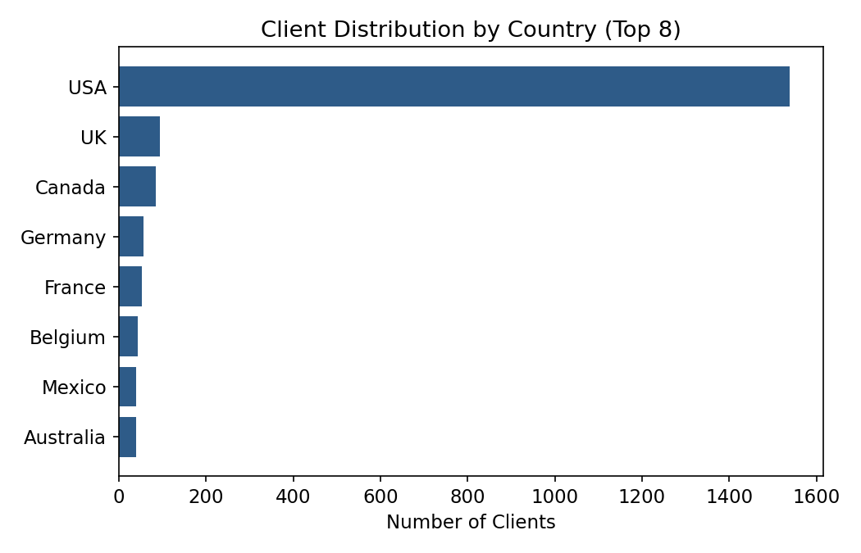
Figure 2. Client distribution by country (top 8). The buyer base is heavily concentrated in the USA (76.9%), with a long tail of international buyers across nine other countries.
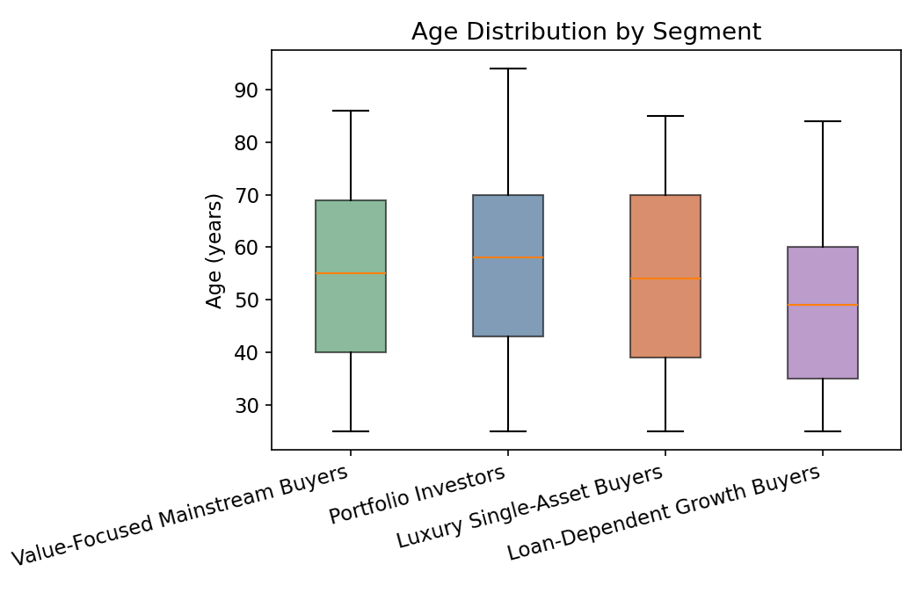
Figure 3. Age distribution by eventual segment assignment. Median buyer age is comparable (mid-50s) across most segments, with the Loan-Dependent / Corporate Growth segment skewing notably younger.

6. Clustering Results
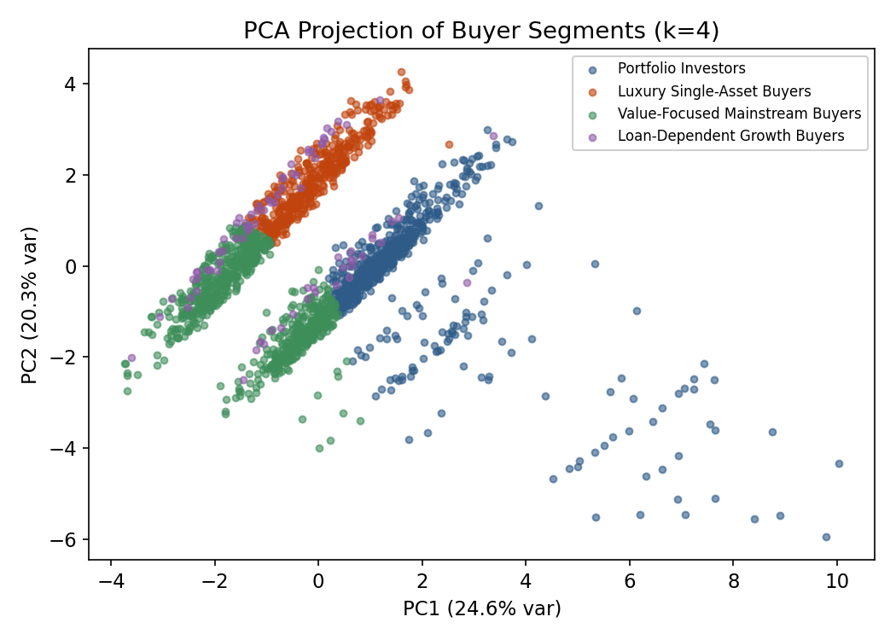
Figure 4. Two-dimensional PCA projection of the k = 4 buyer segmentation (first two principal components).
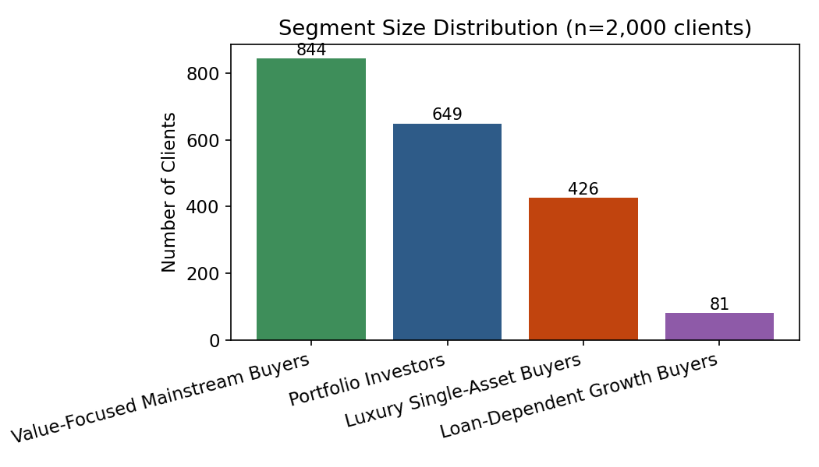
Figure 5. Segment size distribution across the 2,000-client buyer base.
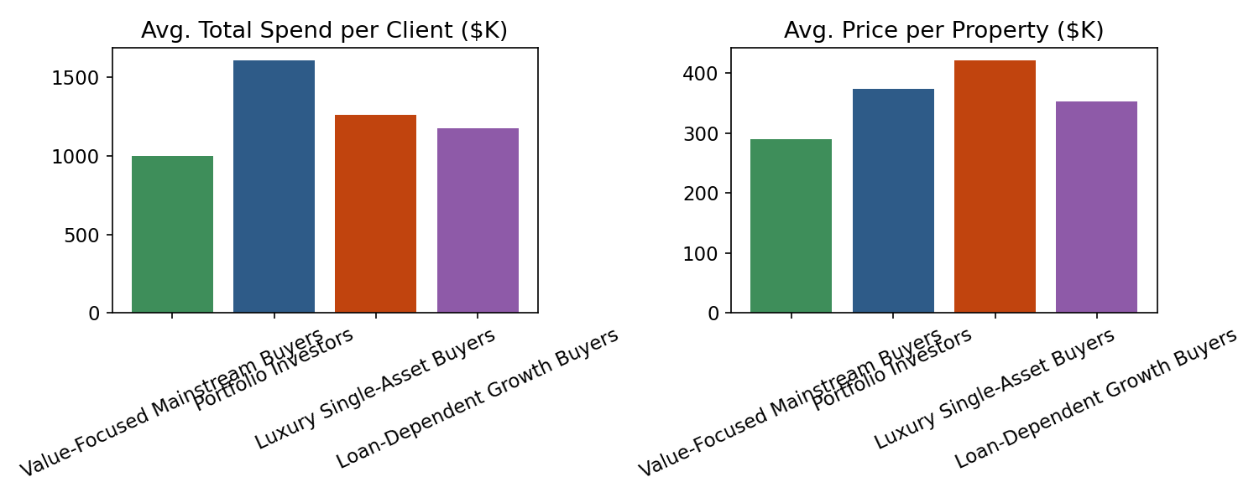
Figure 6. Average total spend and average price per property by segment.

6.1 Segment Profile Table
Metric | Portfolio Investors | Luxury Single-Asset | Value-Focused Mainstream | Loan-Dep. / Corporate
Clients (n / %) | 770 (38.5%) | 561 (28.1%) | 588 (29.4%) | 81 (4.1%)
Avg. age (yrs) | 56.7 | 54.7 | 56.0 | 49.2
Avg. satisfaction (1-5) | 3.16 | 3.01 | 2.87 | 3.02
Avg. properties owned | 4.30 | 3.45 | 3.04 | 3.35
Avg. total spend (USD) | $1,352,529 | $1,483,922 | $938,109 | $1,175,503
Avg. price / property (USD) | $314,260 | $431,151 | $309,067 | $352,996
Avg. floor area (sqft) | 1,043 | 1,413 | 1,027 | 1,172
Avg. towers per client | 4.19 | 3.44 | 3.04 | 3.35
% Investment purpose | 30.0% | 28.5% | 33.7% | 32.1%
% Used financing (loan) | 37.1% | 36.9% | 35.0% | 45.7%
% Company accounts | 5.5% | 5.7% | 3.7% | 8.6%
Avg. client tenure (months) | 23.9 | 23.9 | 23.9 | 11.9
Table 4. Segment profile summary (k = 4, silhouette = 0.154, Hierarchical-validation ARI = 0.61).

7. Segment Profiles and Business Recommendations

7.1 Segment A — Portfolio Investors (38.5% of buyers)
This is the largest segment and is defined by the highest average number of properties owned (4.30) and the widest geographic footprint within the development (4.19 towers per client on average) — buyers who deliberately diversify across multiple towers and units rather than concentrating in one. Their average price per property is moderate ($314K), but their broad accumulation drives strong total spend ($1.35M average) and the highest reported satisfaction (3.16/5). This segment corresponds closely to the "Global Investors" and "Corporate Buyers" archetypes anticipated in the original project brief.
Recommended actions: prioritize this segment for loyalty and portfolio-expansion programs (e.g., preferential access to new tower releases, bundled multi-unit discounts), and use them as reference customers/testimonials given their high satisfaction.

7.2 Segment B — Luxury Single-Asset Buyers (28.1% of buyers)
This segment shows the highest average spend per client ($1.48M) and the highest average price ($431K) and floor area (1,413 sqft) per property, despite owning a moderate number of units (3.45). These are buyers who invest in fewer, larger, and more expensive assets rather than accumulating many smaller ones — the closest match to the brief's "Luxury Investors" archetype.
Recommended actions: pair this segment with premium concierge services, off-plan previews of the largest / highest-specification units, and white-glove relationship management rather than volume-discount offers.

7.3 Segment C — Value-Focused Mainstream Buyers (29.4% of buyers)
The second-largest segment has the lowest average spend ($938K), lowest average price ($309K) and smallest average floor area (1,027 sqft) of the four groups, alongside the lowest reported satisfaction (2.87/5). Combined with a comparatively high share of Investment-purpose purchases (33.7%), this looks like a price-sensitive, mainstream buyer group that is more exposed to affordability pressure — the operational analogue of the brief's "First-Time Buyers" archetype, even though their average age is not markedly lower than other segments in this dataset.
Recommended actions: this segment's below-average satisfaction score warrants closer service-quality review; consider transparent, value-oriented pricing communication, smaller-unit product lines, and financing options designed to ease affordability constraints.

7.4 Segment D — Loan-Dependent / Corporate Growth Buyers (4.1% of buyers)
Although the smallest segment, this group is strategically distinct: it has by far the highest financing reliance (45.7% used a loan vs. 35-37% elsewhere), the highest share of Company accounts (8.6%), the youngest average age (49.2), and — notably — the shortest average client tenure (11.9 months vs. ~24 months for every other segment), indicating this is largely a newly-acquired, fast-growing cohort rather than a long-standing one.
Recommended actions: given its recency and financing dependence, this segment should be a priority for financing-partner promotions, structured payment plans, and dedicated corporate-account relationship management to convert early engagement into long-term retention.

8. Streamlit Web Application
All of the above analysis is operationalized in a single, self-contained Streamlit application (app.py) that reproduces the cleaning, feature-engineering, and clustering pipeline live from the source CSV files (or user-uploaded equivalents), so segment definitions always reflect the current data rather than a static snapshot. The application is organized into four analyst-facing modules plus an optional diagnostics view:
- Buyer Segmentation Overview — cluster-size distribution and a PCA scatter of the buyer population.
- Investor Behavior Dashboard — spend distributions, financing behavior, acquisition-purpose mix, price-vs-size relationships, and monthly sales volume.
- Geographic Buyer Analysis — a country-level choropleth, top-country ranking, region-level detail table, and a country → region → segment sunburst breakdown.
- Segment Insights Panel — a deep-dive view of any single segment with descriptive statistics, referral-channel and demographic mix, and a CSV export of that segment's client list.
- Model Diagnostics (optional) — live Elbow and Silhouette curves, the current model's metrics, and a Hierarchical-clustering cross-validation (Adjusted Rand Index and dendrogram).
Sidebar controls let users filter by country, region, acquisition purpose, client type, and segment, and adjust the number of clusters (k) between 2 and 8; segment names are generated automatically from each cluster's behavioral profile so labels remain meaningful for any k the user selects, not only k = 4.

9. Limitations
- Silhouette scores across all tested k (0.149-0.168) indicate overlapping rather than sharply separated clusters; segments should be read as behavioral gradients that are useful for prioritization, not as rigid, mutually exclusive customer types.
- The Hierarchical-clustering cross-check (ARI = 0.61) shows substantial but incomplete agreement with K-Means, reinforcing that some clients near cluster boundaries could reasonably be assigned to more than one segment.
- The buyer base is heavily USA-concentrated (76.9%), so geographic insights for smaller markets (e.g., Denmark, 15 clients) are directional rather than statistically robust.
- satisfaction_score and acquisition_purpose show only modest variation across segments in this dataset, so they contributed less discriminative power to the clustering than the transaction-derived (RFM-style) features.
- All 2,000 registered clients had at least one completed purchase; the model therefore segments existing transacting buyers and does not, on its own, address top-of-funnel lead scoring for prospects with no purchase history.

10. Conclusion and Future Work
This project introduces AI-driven buyer intelligence into the Parcl real estate platform. By combining transaction-derived RFM-style features with demographic attributes and applying K-Means clustering — validated against Hierarchical clustering and tuned via the Elbow Method and Silhouette Score — four interpretable buyer segments were identified: Portfolio Investors, Luxury Single-Asset Buyers, Value-Focused Mainstream Buyers, and Loan-Dependent / Corporate Growth Buyers. These segments reveal investment behaviors, financing needs, and satisfaction patterns that a single, undifferentiated view of the buyer base would not surface, and they are delivered through a live, filterable Streamlit dashboard rather than a static report.
Future work could extend this pipeline by (i) incorporating repeat-visit or website-engagement data to build true top-of-funnel lead scoring for prospective (non-transacting) buyers, (ii) testing density-based methods such as HDBSCAN or Gaussian Mixture Models to see whether soft, probabilistic cluster membership better reflects the observed overlap between segments, and (iii) enriching the geographic analysis with region-specific economic indicators once buyer volume outside the USA grows large enough to support robust sub-national comparisons.

References
Arthur, D., & Vassilvitskii, S. (2007). k-means++: The advantages of careful seeding. Proceedings of the 18th Annual ACM-SIAM Symposium on Discrete Algorithms.
Rousseeuw, P. J. (1987). Silhouettes: A graphical aid to the interpretation and validation of cluster analysis. Journal of Computational and Applied Mathematics, 20, 53-65.
Ward, J. H. (1963). Hierarchical grouping to optimize an objective function. Journal of the American Statistical Association, 58(301), 236-244.
Hughes, A. M. (1994). Strategic Database Marketing: The Masterplan for Starting and Managing a Profitable, Customer-Based Marketing Program. RFM analysis foundational reference.
Unified Mentor & Parcl Co. Limited (2026). Machine Learning based Buyer Segmentation and Investment Profiling for Real Estate Market Intelligence — Project Requirements Document.

