UNITED STATES INTERNATIONAL UNIVERSITY - AFRICA
SCHOOL OF SCIENCE AND TECHNOLOGY
APT3065: MID-TERM PROJECT
REPAIRTRACK
Complete System Design Document
Secure Mobile-Friendly Device Repair Tracking System for Small ICT Repair Businesses
Prepared by: Husain Zohair Kaka
Student ID: [Insert Student ID]
Submission Date: [Insert Date]
Semester: Summer 2026
Prepared as the design blueprint for the Week 1-13 RepairTrack project, with explicit coverage of UML interaction modelling, 3NF database design, architecture selection, GitFlow, Kanban planning and prioritized sprint user stories.

Document Control
Version | Date | Author | Description
1.0 | [Insert Date] | Husain Zohair Kaka | Recreated complete design document aligned to APT3065 Lesson 5 requirements.
1.1 | [Optional] | Project Supervisor / Reviewer | Feedback updates and final corrections before submission.

Table of Contents
1. Project Overview and Design Purpose
2. Lesson 5 Compliance Matrix
3. Requirement-to-Design Mapping
4. Architectural Design and Pattern Justification
5. UML Interaction Design
6. Database Design, Normalization and ERD
7. User Interface Design
8. Development Methodology, GitFlow and Kanban Planning
9. Security, Privacy and Quality Design
10. Testing and Acceptance Design
11. Week 1-13 Project Timeline
12. Submission Checklist and References

1. Project Overview and Design Purpose
RepairTrack is a secure, lightweight, mobile-friendly web-based device repair tracking system for small ICT repair businesses. The system addresses the operational gap between large enterprise helpdesk platforms and the practical day-to-day needs of small repair shops that receive phones, laptops and accessories for diagnosis, upgrade and repair. Instead of relying on handwritten records, scattered WhatsApp messages or unstructured spreadsheets, RepairTrack centralizes repair intake, technician assignment, repair status updates, customer status lookup, service history and audit trails.
The purpose of this design document is to translate the approved business requirements into technical blueprints that can guide implementation. It defines the system architecture, user interactions, database structure, user interface, security controls, development workflow and sprint plan for the full Week 1-13 project. The document is designed for academic submission and for practical use by a small ICT repair business such as Husaini Tech Solutions in Nairobi.

1.1 Design Objectives
- Model the interactions between administrators, technicians and customers using UML use case and sequence diagrams.
- Design a robust relational database normalized to Third Normal Form (3NF) to reduce redundancy and improve data integrity.
- Select and justify an appropriate software architecture pattern for a small-business web system.
- Define a practical development methodology using Git/GitHub, GitFlow, a Kanban board and sprint-based user stories.
- Provide a complete implementation blueprint covering Weeks 1-13, from requirements analysis to final submission.

2. Lesson 5 Compliance Matrix
The table below maps the design document to the Lesson 5 systems-analysis and software-development requirements.
Lesson 5 instruction / requirement | How it is addressed in this document | Evidence section
Translate business requirements into tangible technical blueprints. | The document maps RepairTrack requirements into architecture, UML, data design, UI design, security and test design. | Sections 3-10
Create UML diagrams, specifically Use Case and Sequence diagrams. | A full system use case diagram, authentication use case diagram, login sequence diagram and ticket workflow model are included. | Section 5
Normalize a dataset to Third Normal Form (3NF) and produce an ERD. | The raw repair-ticket dataset is normalized through 1NF, 2NF and 3NF, followed by a complete ERD and data dictionary. | Section 6
Select and justify an architectural pattern such as MVC or microservices. | MVC is selected and justified against microservices for a small, maintainable web application. | Section 4
Initialize Git/GitHub using a standard branching strategy such as GitFlow. | A GitFlow branch strategy, branch names, commit rules and repository structure are documented. | Section 8.2
Set up a digital Kanban board with prioritized user stories and sprint allocations. | A Kanban board structure, product backlog and first two sprint allocations with story points are provided. | Sections 8.3-8.5

3. Requirement-to-Design Mapping

3.1 Stakeholders and User Roles
Role | Main responsibility | Access level
Administrator | Registers customer devices, assigns technicians, reviews audit trails, manages users and generates reports. | Full access to tickets, users, reports and configuration.
Technician | Views assigned tickets, updates repair status and records diagnostic/repair notes. | Limited to assigned tickets and service history needed for repair work.
Customer | Checks repair progress using a QR code or ticket reference. | Public read-only access to limited ticket status information only.

3.2 Core Functional Requirements
ID | Requirement | Design response | Priority
FR1 | The system shall authenticate staff users with email and password. | AuthController validates credentials, User model checks password hash, SessionService starts role-based session. | Must
FR2 | The system shall allow administrators to register device intake records. | Device Intake View stores customer, device and issue details and generates a unique ticket reference. | Must
FR3 | The system shall allow administrators to assign tickets to technicians. | TicketController updates assigned_to and logs the assignment in audit_logs. | Must
FR4 | The system shall allow technicians to update repair status and notes. | Technician Ticket View creates status_history and repair_notes entries. | Must
FR5 | The system shall allow customers to check limited status using QR/reference. | Public Lookup Controller displays sanitized status, not private staff notes or customer data. | Must
FR6 | The system shall retrieve service history by customer, device or ticket reference. | Search functions query 3NF ticket/device/customer tables. | Should
FR7 | The system shall generate basic reports. | Reports module summarizes open tickets, completed jobs and technician workload. | Should

3.3 Non-Functional Requirements
ID | Category | Measurable requirement | Design response
NFR1 | Performance | Common pages shall load within 3 seconds on a normal 4G connection during pilot use. | Lightweight MVC pages, indexed ticket_ref, customer_id, assigned_to and status columns.
NFR2 | Security | Passwords shall never be stored in plaintext. | Password hashes stored with a one-way password hashing function; sessions regenerated after login.
NFR3 | Authorization | Technicians shall only access tickets assigned to them unless administrator role is present. | Role-based access control in controllers and middleware.
NFR4 | Usability | A staff user shall register a device intake record in under 3 minutes after orientation. | Single-page mobile-friendly intake form with required fields and inline validation.
NFR5 | Reliability | Audit records shall be created for ticket assignment and status changes. | AuditLog model writes user, action, entity, entity_id and timestamp for key events.
NFR6 | Maintainability | The system shall separate presentation, controller and data-access logic. | MVC architecture with clear folders for controllers, models and views.

4. Architectural Design and Pattern Justification

4.1 Selected Pattern: Model-View-Controller (MVC)
RepairTrack will use the Model-View-Controller (MVC) architecture. MVC separates the user interface, request-handling logic and data-access logic into distinct components. This pattern is appropriate because RepairTrack is a small-business web application with several forms, role-based dashboards and database operations. It supports maintainability, reusable code and parallel development without introducing the operational complexity of distributed microservices.
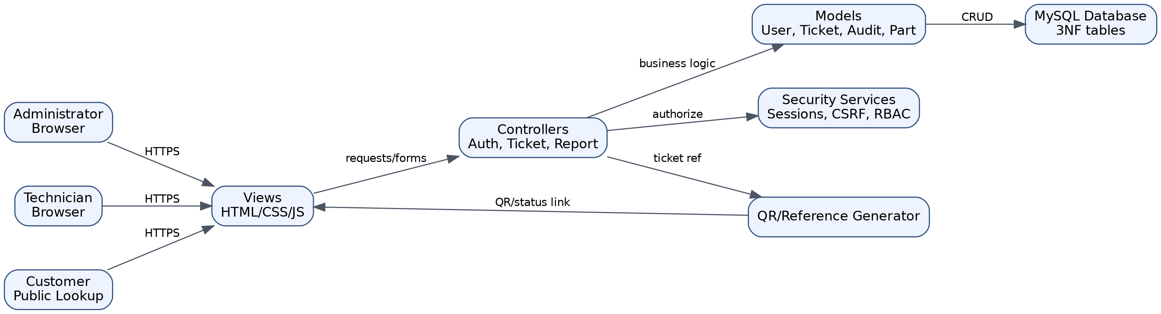
Figure 1. RepairTrack MVC architecture and component interaction.

4.2 MVC Compared with Microservices
Criterion | MVC Monolith | Microservices | Decision for RepairTrack
Project size | Fits a small-to-medium web system. | Better for large systems with many independent teams. | MVC selected.
Deployment | Single deployment package; simple hosting. | Multiple services require service discovery, APIs and monitoring. | MVC reduces schedule risk.
Maintainability | Clear separation of models, views and controllers. | High flexibility but more infrastructure overhead. | MVC provides enough structure.
Scalability | Can scale vertically and later split modules if needed. | Scales independently by service. | Future migration possible after prototype validation.

4.3 Proposed Technology Stack
Layer | Technology | Justification
Frontend | HTML5, CSS3, JavaScript, responsive layout | Simple, mobile-friendly and easy to deploy.
Backend | PHP or Python Flask MVC-style application | Suitable for CRUD workflows, authentication and fast student prototyping.
Database | MySQL / MariaDB | Relational database supports normalized tables, constraints and indexing.
Version control | Git and GitHub | Required for collaboration, branching and change history.
Project tracking | GitHub Projects / Trello Kanban board | Supports To Do, In Progress, Review and Done columns.

5. UML Interaction Design
This section documents system interaction using UML-style diagrams. Use case diagrams focus on what the actors can do, while sequence diagrams focus on how objects interact over time during a specific scenario.

5.1 Full System Use Case Diagram
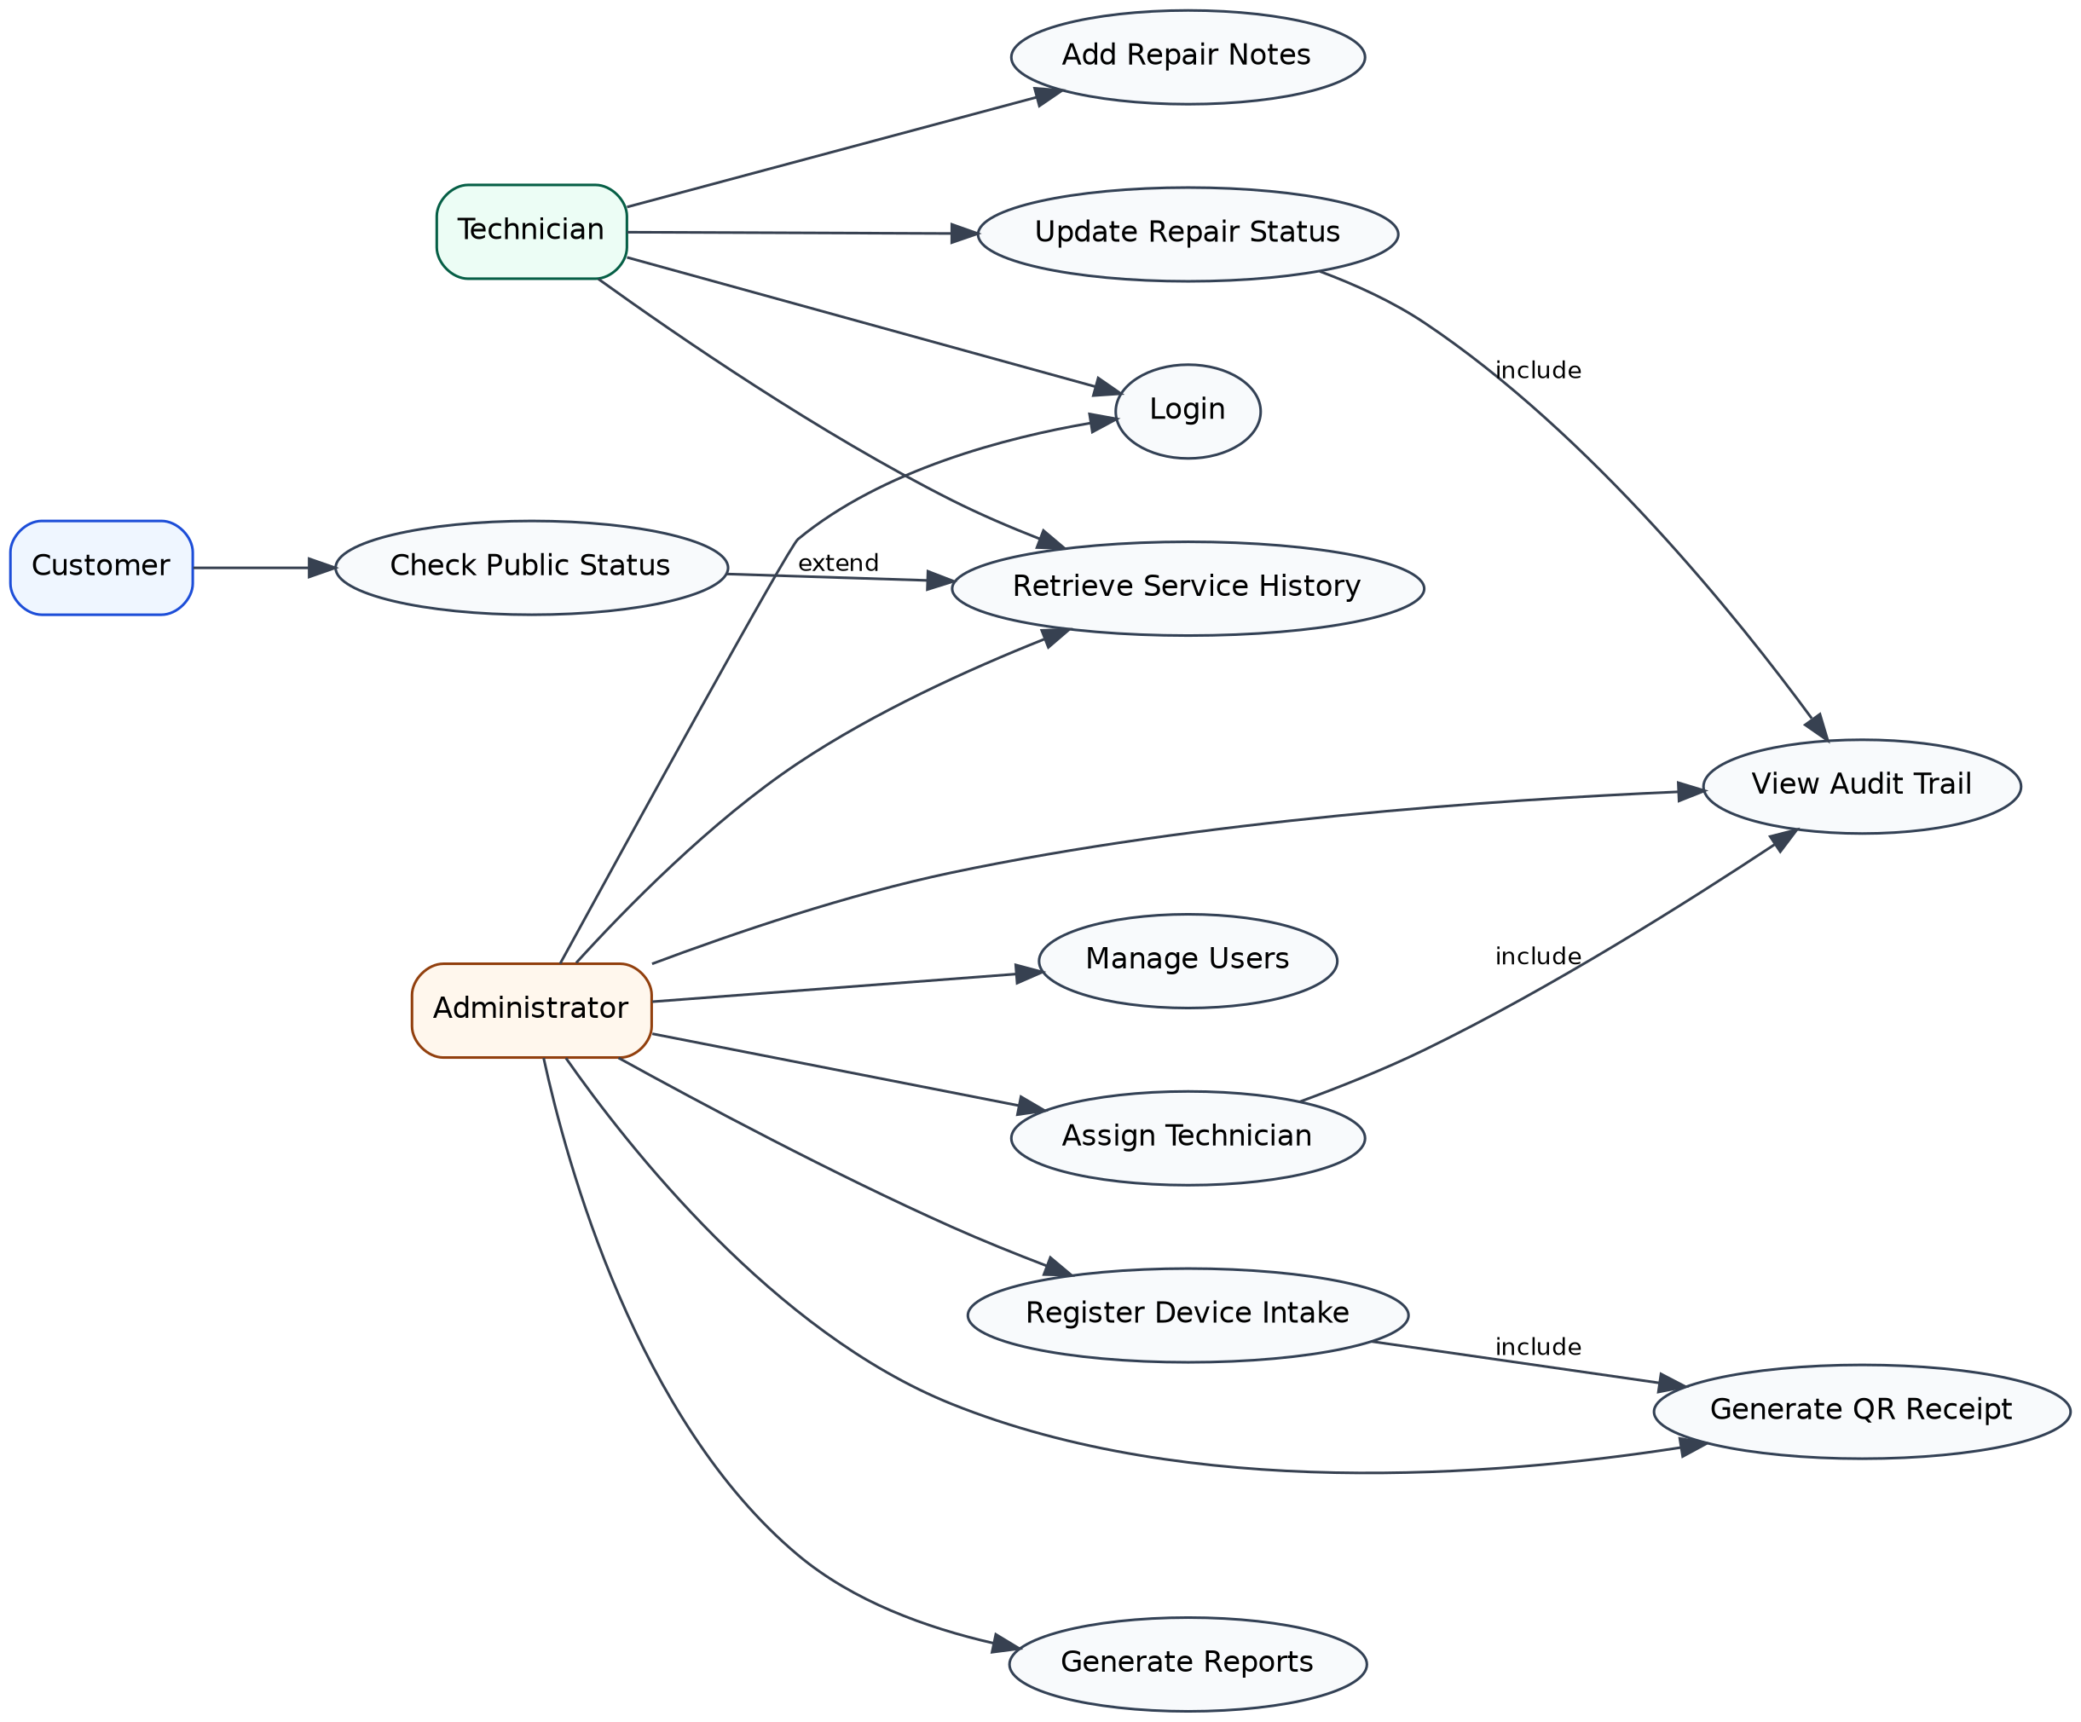
Figure 2. Full RepairTrack use case diagram showing administrator, technician and customer interactions.

5.2 Primary Authentication Use Case Diagram
The authentication flow is the primary security entry point for staff users. It includes credential submission, credential validation, session creation, role-based routing, error handling and logout.
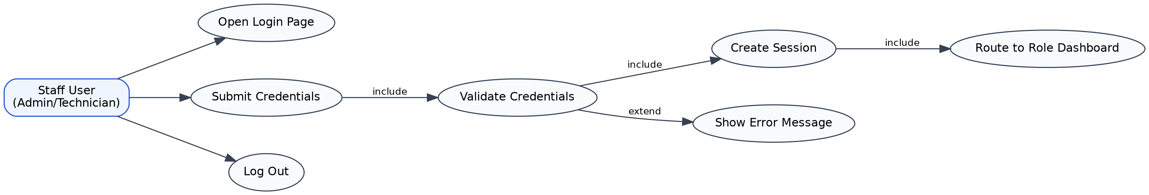
Figure 3. High-fidelity authentication use case diagram for staff login.

5.3 Login Sequence Diagram
The sequence diagram below shows how a staff user interacts with the login view, controller, user model and database. It also includes session regeneration after successful login to reduce session fixation risk.
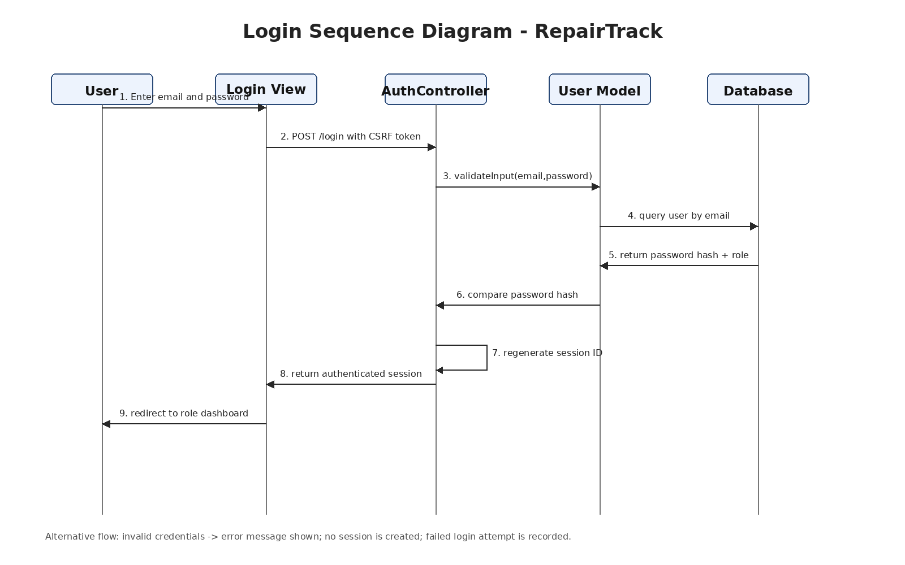
Figure 4. Sequence diagram for the RepairTrack login scenario.

5.4 Core Ticket Workflow
RepairTrack uses a controlled ticket workflow to maintain transparency and accountability. Each status change is written to the status_history table and key actions are also recorded in the audit trail.
Figure 5. Repair ticket workflow from intake to closure.

6. Database Design, Normalization and ERD

6.1 Raw Dataset Before Normalization
A common manual record in a small repair shop may store customer details, device details, technician information, repair notes, status changes and payment details in one spreadsheet row. This creates repeating groups and redundancy because the same customer, technician and device details are repeatedly written across multiple jobs. It also makes it difficult to maintain an accurate audit trail.
Raw field group | Example attributes
Customer | Customer name, phone, email
Device | Device type, brand, model, serial number, accessories
Repair ticket | Ticket reference, issue, current status, estimated ready date
Technician | Assigned technician name and phone
Repeating history | Multiple status changes, multiple notes, multiple parts used, multiple payment records

6.2 Normalization to 3NF
Normal form | Problem solved | RepairTrack design decision
1NF | Eliminates repeating groups and ensures each cell stores a single value. | Status changes, repair notes, parts and payments are separated from the main ticket record.
2NF | Removes partial dependencies in tables with composite logic. | Ticket part details are stored in ticket_parts; part names and base costs are stored in parts.
3NF | Removes transitive dependencies so non-key attributes depend only on the primary key. | Customer details are stored in customers, device details in devices, role names in roles and audit actions in audit_logs.

6.3 Final 3NF Entity-Relationship Diagram
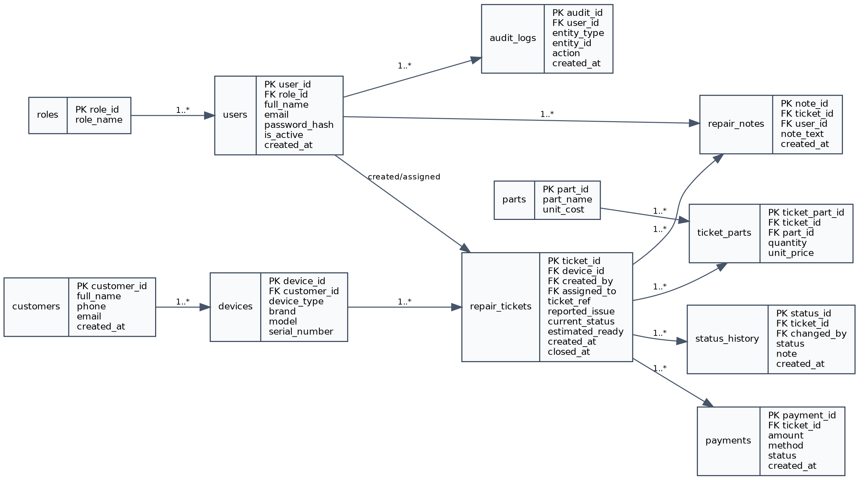
Figure 6. RepairTrack ERD after normalization to Third Normal Form (3NF).

6.4 Data Dictionary
Table | Primary key | Important foreign keys | Purpose
roles | role_id | None | Defines Administrator and Technician roles.
users | user_id | role_id | Stores staff accounts, password hashes and active status.
customers | customer_id | None | Stores customer identity and contact details.
devices | device_id | customer_id | Stores device category, brand, model and serial number.
repair_tickets | ticket_id | device_id, created_by, assigned_to | Stores ticket reference, issue, current status and dates.
status_history | status_id | ticket_id, changed_by | Stores timestamped status changes.
repair_notes | note_id | ticket_id, user_id | Stores technician and administrator repair notes.
parts | part_id | None | Stores reusable parts catalog.
ticket_parts | ticket_part_id | ticket_id, part_id | Associates used parts with repair tickets.
audit_logs | audit_id | user_id | Stores accountability trail for critical actions.
payments | payment_id | ticket_id | Stores payment records for repair jobs.

7. User Interface Design
The interface is designed as a mobile-friendly web application because small repair shops may use laptops, tablets or mobile phones at the service desk. The design prioritizes quick intake, simple ticket search, clear status updates and limited public access for customers.
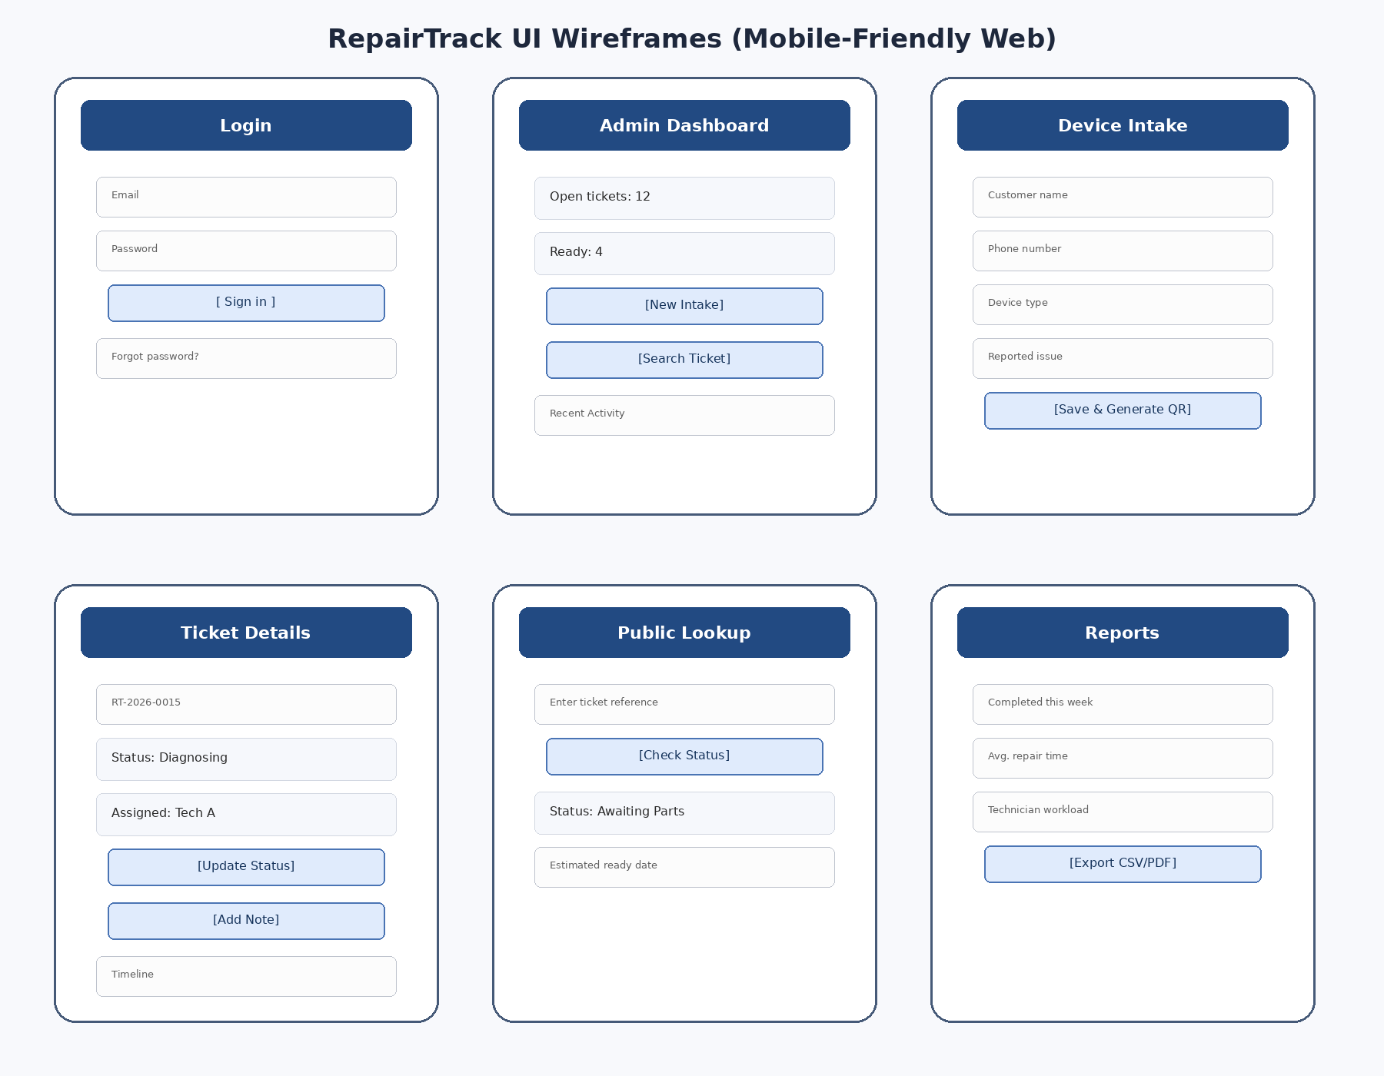
Figure 7. UI wireframes for key RepairTrack screens.

7.1 Interface Rules
- Every staff page requires authentication and role-based authorization.
- The device intake form must show required fields clearly and prevent empty ticket references.
- Customer public lookup must show only limited ticket status, not internal repair notes or staff names unless approved.
- Ticket pages must show a visible timeline of status history and repair notes.
- All forms must include server-side validation even if browser validation is present.

8. Development Methodology, GitFlow and Kanban Planning

8.1 Methodology Comparison and Selection
Methodology | Strength | Limitation | Suitability for RepairTrack
Waterfall | Clear phases and documentation. | Less flexible when requirements change after pilot feedback. | Useful for initial planning but not ideal as the only method.
Agile/Scrum-lite | Supports iterative development, sprint reviews and user feedback. | Requires disciplined backlog control. | Selected as main development method.
DevOps | Strong for automated deployment and continuous delivery. | May be too infrastructure-heavy for a student prototype. | Adopt selected practices such as Git and repeatable deployment steps.
RepairTrack will use Agile/Scrum-lite with two-week development sprints, a GitHub repository, GitFlow branching and a Kanban board. This approach is flexible enough for user feedback while still providing structured milestones for the 13-week academic timeline.

8.2 Git/GitHub Setup and GitFlow Branching Strategy
The project repository should be named repairtrack. The final GitHub URL should be inserted here after repository creation: https://github.com/[username]/repairtrack
Branch | Purpose | Rules
main | Stable submission/demo branch. | Only merge tested release code.
develop | Integration branch for completed features. | Sprint features merge here after review.
feature/auth-login | Login and role-based access feature. | Created from develop; merged through pull request.
feature/device-intake | Device registration and ticket reference feature. | Created from develop; tested before merge.
feature/ticket-workflow | Assignment, status updates, notes and audit trail. | Created from develop; merges after unit and functional tests.
release/week13-final | Final polishing and submission branch. | Bug fixes only; merged to main and tagged v1.0.
hotfix/* | Urgent fixes after release. | Created from main and merged back to main and develop.

8.3 Repository Structure
repairtrack/
app/{controllers, models, views, middleware}
public/{css, js, images}
database/{schema.sql, seed.sql}
tests/
docs/{diagrams, screenshots}
README.md
.gitignore

8.4 Kanban Board Setup
Backlog | To Do | In Progress | Review / Test | Done
All user stories not yet selected for a sprint. | Stories committed for the current sprint. | Tasks currently being implemented. | Completed code awaiting test, review or documentation update. | Accepted stories meeting Definition of Done.

8.5 Prioritized Product Backlog and First Two Sprints
ID | User story | Priority | Sprint | Story points | Acceptance criteria
US1 | As staff, I want secure login. | High | Sprint 1 | 5 | Role dashboard opens.
US2 | As admin, I want role control. | High | Sprint 1 | 3 | Admin/technician rules work.
US3 | As admin, I want device intake with RT reference. | High | Sprint 1 | 8 | Ticket and QR/reference are created.
US4 | As admin, I want an open-jobs dashboard. | Medium | Sprint 1 | 5 | Counts display correctly.
US5 | As admin, I want technician assignment. | High | Sprint 2 | 5 | Assigned tech sees ticket.
US6 | As technician, I want status updates. | High | Sprint 2 | 8 | History records are created.
US7 | As technician, I want repair notes. | High | Sprint 2 | 5 | Notes are timestamped.
US8 | As admin, I want an audit trail. | High | Sprint 2 | 5 | Actions appear in audit_logs.

8.6 Definition of Done
- Code for the user story is committed to a feature branch and merged through develop after testing.
- The story has at least one functional test or documented manual test case.
- UI screens render correctly on laptop and mobile-sized browser windows.
- Security controls are applied for authentication, authorization and input validation.
- The README and design documentation are updated when the feature affects setup, database or workflow.

9. Security, Privacy and Quality Design
Risk / quality concern | Control design | Verification method
Unauthorized access | Staff authentication, role-based access control, protected routes. | Attempt technician access to admin-only pages.
Weak password storage | Use one-way password hashing and never display stored hashes. | Inspect database and confirm no plaintext password exists.
Session fixation | Regenerate session identifier after successful login. | Login test and session behavior review.
Cross-site request forgery | Use CSRF tokens on state-changing forms. | Submit form without token and confirm rejection.
Excessive customer data exposure | Public lookup displays only ticket status and safe fields. | Review public lookup output for data minimization.
Poor accountability | Audit logs for assignment, status updates, user management and report exports. | Check audit log after each critical action.

9.1 Data Protection and Privacy
RepairTrack handles limited personal data such as customer name, phone number, email address, device information and ticket history. The privacy design therefore follows data minimization: the system stores only what is necessary to manage the repair process. Public lookup is intentionally limited and does not expose technician notes, internal audit logs, full customer contact records or payment details.

10. Testing and Acceptance Design
Test area | Test case | Expected result | Acceptance target
Authentication | Valid staff login. | User is redirected to correct role dashboard. | Pass for admin and technician accounts.
Authentication | Invalid credentials. | Error shown; no session created. | 100% rejection of invalid password attempts.
Device intake | Register new ticket. | Ticket reference and QR/status link are generated. | Device intake completed in under 3 minutes.
Assignment | Admin assigns technician. | Assigned technician sees ticket in dashboard. | Assignment saved and audited.
Workflow | Technician updates status. | status_history row is created and current_status changes. | All status changes recorded.
Public lookup | Customer checks ticket reference. | Limited status is displayed. | No internal notes exposed.
Reporting | Admin views weekly report. | Open, completed and technician workload counts appear. | Report loads in under 3 seconds in pilot environment.

10.1 Success Criteria
- At least 90% of core functional test cases pass by Week 10.
- A staff user can complete device intake in under 3 minutes after orientation.
- A customer can retrieve public repair status using a ticket reference in under 60 seconds.
- Every ticket assignment and status update creates an audit record with user and timestamp.
- The database schema enforces foreign keys for users, customers, devices, tickets and history records.

11. Week 1-13 Project Timeline
The timeline below extends the approved work plan into a full 13-week design and implementation schedule. It includes requirements gathering, design, repository setup, sprint development, testing, documentation and final submission.
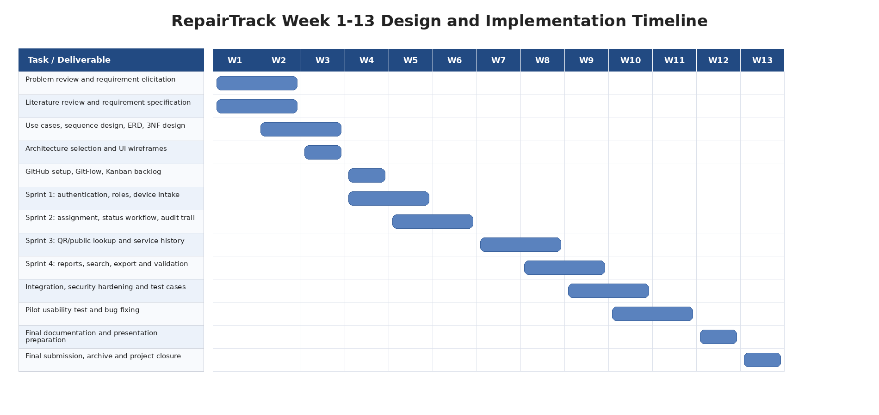
Figure 8. Week 1-13 Gantt chart for RepairTrack.

12. Ready-to-Submit Checklist
Item | Requirement met? | Location
Business requirements translated into technical blueprint | Yes | Sections 3-11
Use Case diagram included | Yes | Figures 2 and 3
Sequence diagram for login included | Yes | Figure 4
3NF normalization explained | Yes | Section 6.2
ERD included | Yes | Figure 6
Architecture pattern selected and justified | Yes | Section 4
GitFlow branching strategy documented | Yes | Section 8.2
Kanban board documented | Yes | Section 8.4
First two sprints mapped with user stories and story points | Yes | Section 8.5
Week 1-13 timeline included | Yes | Figure 8

References
Booch, G., Rumbaugh, J., & Jacobson, I. (2005). The unified modeling language user guide (2nd ed.). Addison-Wesley.
Chacon, S., & Straub, B. (2014). Pro Git (2nd ed.). Apress.
Elmasri, R., & Navathe, S. B. (2016). Fundamentals of database systems (7th ed.). Pearson.
Fowler, M. (2002). Patterns of enterprise application architecture. Addison-Wesley.
Object Management Group. (2017). OMG Unified Modeling Language (OMG UML), Version 2.5.1. https://www.omg.org/spec/UML/2.5.1/
OWASP Foundation. (n.d.). Authentication cheat sheet. https://cheatsheetseries.owasp.org/cheatsheets/Authentication_Cheat_Sheet.html
Sommerville, I. (2016). Software engineering (10th ed.). Pearson.

Appendix A: Mermaid-Compatible Sequence Source
The following text can be pasted into Mermaid.js to recreate the login sequence diagram if a source diagram is required.
sequenceDiagram
actor User
participant View as Login View
participant Controller as AuthController
participant Model as User Model
participant DB as Database
User->>View: Enter email and password
View->>Controller: POST /login with CSRF token
Controller->>Model: validateInput(email, password)
Model->>DB: query user by email
DB-->>Model: return password hash and role
Model-->>Controller: password valid / invalid
alt Valid credentials
Controller->>Controller: regenerate session ID
Controller-->>View: authenticated session
View-->>User: redirect to role dashboard
else Invalid credentials
Controller-->>View: error message
View-->>User: retry login
end

