

GUJARAT TECHNOLOGY UNIVERSITY
Chandkheda, Ahmedabad affiliated

A Project On
PBL Activity 3: Complex Problem Solving (CPS)

Smart Study Planner:

An SDG-Oriented Personal Academic Planning Web Application

UNDER THE SUBJECT OF

Web Application Development

(BE05000281)

BE 3rd YEAR, SEM 5
(Computer Engineering)
Submitted by :
Husain Bardanwala
240410107008
Nikunj Dhobi
240410107033

Guided by Faculty Mentor:
Prof. Nidhi Shah

Sardar Vallabhbhai Patel Institute of Technology, Vasad Academic Year (2026-2027)

TABLE OF CONTENTS
Sr no. | Topic | Page no.
1 | Title Page | 3
2 | Introduction | 3
3 | Project Definition & Problem Statement / Objectives | 4
4 | Proposed System / System Design | 5
5 | Screenshots of Results | 9
6 | Conclusion and Future Scope | 11
7 | References | 11

SMART STUDY PLANNER: AN SDG-ORIENTED PERSONAL ACADEMIC PLANNING WEB APPLICATION
A full-stack (React + Node.js + MongoDB) web application that helps students plan tasks, track study hours with a Pomodoro timer, and visualize progress to reduce missed deadlines.
Item | Details
Project title | Smart Study Planner: An SDG-Oriented Personal Academic Planning Web Application
Activity | PBL Activity 3 – Complex Problem Solving (CPS)
SDGs addressed | SDG 4 (Quality Education)
Subject | Web Application Development (BE05000281)
Technology stack | MongoDB, Express.js, React.js, Node.js (MERN)
Submitted by | Husain Bardanwala (240410107008), Nikunj Dhobi (240410107033)
Class | BE 3rd Year, Semester 5, Computer Engineering
Faculty guide | Prof. Nidhi Shah
Institute | Sardar Vallabhbhai Patel Institute of Technology, Vasad

2. Introduction
A web application is software that runs on a web server and is used through a web browser. Unlike a static website that only shows fixed pages, a web application accepts input from users, stores data in a database and shows each user information that matches their role. Modern web applications are usually split into a frontend, a backend, and a database.
The United Nations Sustainable Development Goals (SDGs) are 17 global goals for 2030. SDG 4 – Quality Education aims to ensure inclusive and equitable quality education and promote lifelong learning opportunities for all. Students who lack structured study habits often miss deadlines, cannot estimate time per subject, and rarely review progress.
Before this project, task information was scattered across WhatsApp messages, personal notebooks, and calendar apps that do not understand the academic workload. There was no single place to view subjects, tasks, deadlines, study hours, and progress together.
In this project, a web application named Smart Study Planner is designed and developed using the MERN stack. A student registers, logs in, creates subjects and tasks with due dates and priorities, marks tasks complete, and uses a configurable Pomodoro timer to focus. The dashboard shows total, completed, pending tasks, subject count, and an overall progress bar.
Need of the project: centralize all academic tasks in one place, never miss a deadline again, visualize progress, and build consistent study habits with the Pomodoro timer.
Web technologies used in this project:
- HTML5 and CSS3 – semantic structure, Flexbox/Grid layouts and media queries for responsive design.
- JavaScript (ES6+) – arrow functions, destructuring, Promises and async/await for API calls.
- React.js – component-based SPA with hooks, routing and conditional rendering.
- Node.js and Express.js – REST API server with middleware for logging, authentication and error handling.
- MongoDB with Mongoose – NoSQL document database with schemas and validation.
- HTTP, JSON and REST – communication between browser and server, tested with Postman and curl.

3. Project Definition & Problem Statement / Objectives

3.1 Project Definition
Item | Details
PBL activity | Activity 3 – Complex Problem Solving (CPS)
Domain | Education / productivity (SDG-oriented web application)
Project title | Smart Study Planner – Academic Task & Time Manager
Users (roles) | Student
Frontend | React 19, Vite, React Router, CSS3
Backend | Node.js, Express.js, JSON Web Token (JWT), bcryptjs
Database | MongoDB with Mongoose ODM
Tools | VS Code, MongoDB Compass, Postman, npm, Git

3.2 Problem Statement
Students today juggle assignments, exams, projects, and revision across multiple platforms. They do not have a single place to see what is due, what is done, which subjects need more time, and how much progress they have made. Missing due dates leads to last-minute panic and lower scores. This project delivers a single-page dashboard that centralizes subjects and tasks, highlights overdue items, and encourages focused study with a Pomodoro timer.

3.3 Objectives
- 1. To design and develop a full-stack web application using React, Node.js, Express.js and MongoDB.
- 2. To provide secure registration and login with hashed passwords and JWT-based authentication.
- 3. To let students create, edit, complete and delete tasks with priorities and due dates.
- 4. To build REST APIs that perform all CRUD operations on tasks and subjects.
- 5. To show live dashboard stats and a progress bar based on completion.
- 6. To implement a configurable Pomodoro timer for focused study.
- 7. To make the interface responsive and usable on mobile phones and desktops.

3.4 Scope of the Project
The project covers user management, subject creation, task CRUD, filtering by subject/priority, deadline sorting, overdue highlighting, a progress bar, and a Pomodoro timer. Future enhancements include study-hour analytics, shared group lists, notifications, and calendar sync.
Live URLs: Frontend https://smart-study-planner-pi-gules.vercel.app | API https://smartstudyplanner-api.onrender.com

4. Proposed System / System Design

4.1 System Architecture
Smart Study Planner follows a three-tier client–server architecture. The React application runs in the browser and sends HTTP requests in JSON format. The Express server verifies the JWT token, runs business logic, and reads/writes data in MongoDB through Mongoose. The database stores users, tasks, and subjects.
Figure 1: System architecture of Smart Study Planner

4.2 Technologies Used
Layer | Technology | Purpose in project
Frontend | React 19 + Vite | Component-based SPA, fast dev server
Routing | React Router 6 | Pages without full reload; protected routes
HTTP client | fetch API | API calls; Authorization header with JWT
Styling | CSS3 (Flexbox, Grid, media queries) | Responsive layout for mobile and desktop
Backend | Node.js + Express.js | REST API, routing and middleware
Security | bcryptjs, jsonwebtoken | Password hashing and token-based login
Database | MongoDB + Mongoose | Document storage, schema validation
Testing | Postman, curl, Playwright | API tests and UI smoke tests
Deployment | Render, Vercel, Atlas | Cloud hosting

4.3 Modules of the System
- Authentication module – register, log in, persist token in localStorage, log out.
- Dashboard module – stats cards, progress bar, quick actions.
- Task module – create, edit, toggle complete, delete, filter by subject/priority, sort by deadline, overdue badge.
- Subject module – add subjects and use them as task categories.
- Pomodoro timer module – configurable duration, start/pause/reset.

4.4 Database Design
Collection | Fields | Rules
users | name, email, password, createdAt, updatedAt | email unique, password bcrypt-hashed
tasks | name, subject, due, priority, completed, user, createdAt, updatedAt | name/ subject required, priority enum, user ref
subjects | name, user, createdAt, updatedAt | name required, user ref

4.5 REST API Design
Method | Endpoint | Access | Purpose
POST | /api/auth/register | Public | Register student
POST | /api/auth/login | Public | Login, receive JWT
GET | /api/auth/me | Logged in | Current user profile
GET | /api/tasks | Logged in | List my tasks
POST | /api/tasks | Logged in | Create task
PUT | /api/tasks/:id | Logged in | Update task (whitelisted fields)
DELETE | /api/tasks/:id | Logged in | Delete task
GET | /api/subjects | Logged in | List my subjects
POST | /api/subjects | Logged in | Add subject
DELETE | /api/subjects/:id | Logged in | Delete subject

4.6 Working of the System
1. The student registers/logs in. The server checks the password with bcrypt and returns a signed JWT, which React saves in localStorage.
2. The dashboard fetches tasks/subjects using the token in the Authorization header.
3. The student creates a task; React sends POST /api/tasks. Mongoose validates the data and saves it.
4. The student can mark a task complete, edit its details, delete it, or filter by subject/priority.
5. The Pomodoro timer runs in the browser and helps the student focus in configurable intervals.

4.7 Security Features
- Passwords hashed with bcrypt (10 salt rounds).
- JWT authentication: protected routes return 401 without a valid token.
- User ID is taken from the token, not the request body.
- Whitelisted update fields on tasks/subjects.
- Secrets in .env, excluded from Git.
- CORS origin-configurable; input trimming and length validation.

4.8 Implementation Steps
- Install Node.js, MongoDB Community Server, create React+Vite client.
- Build backend: npm init, express, mongoose, cors, dotenv, bcryptjs, jsonwebtoken.
- Create Mongoose models, middleware, routes in MVC-style structure.
- Build React pages: Home, Login, Register, Dashboard; components: Navbar, TaskCard, TaskForm, Timer, ProgressBar.
- Test APIs with Postman/curl; add seed + demo data.
- Deploy: Atlas for DB, Render for API, Vercel for frontend.

5. Screenshots of Results
The application was run with demo data. All functional tests produced the expected result.
Test | Action | Expected result | Result
1 | Open home page | Hero + features shown, no login required | Pass
2 | Register new user | JWT returned, redirected to dashboard | Pass
3 | Login as student | Token issued, dashboard opens | Pass
4 | Add task | 201 Created, appears in list | Pass
5 | Mark complete | Status flips, progress bar updates | Pass
6 | Edit task | Fields prefilled, PUT updates list | Pass
7 | Filter by subject/priority | Only matching tasks shown | Pass
8 | Start Pomodoro | Countdown runs, pause/reset works | Pass

Screenshot 1: Landing page with features
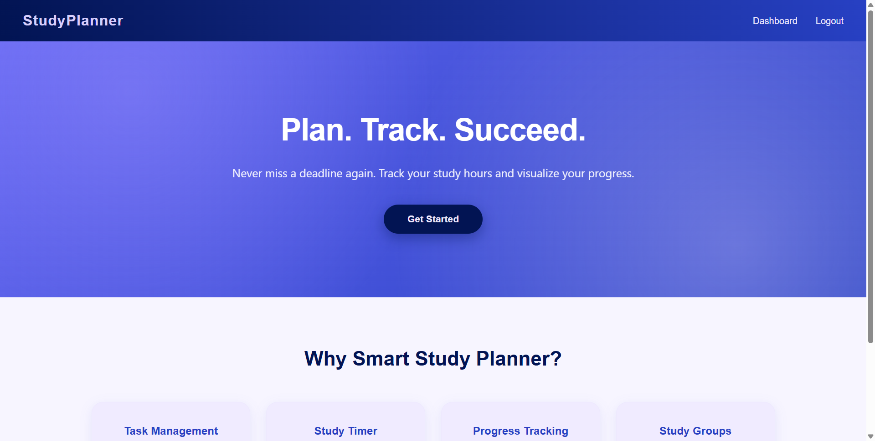
Screenshot 2: Login page
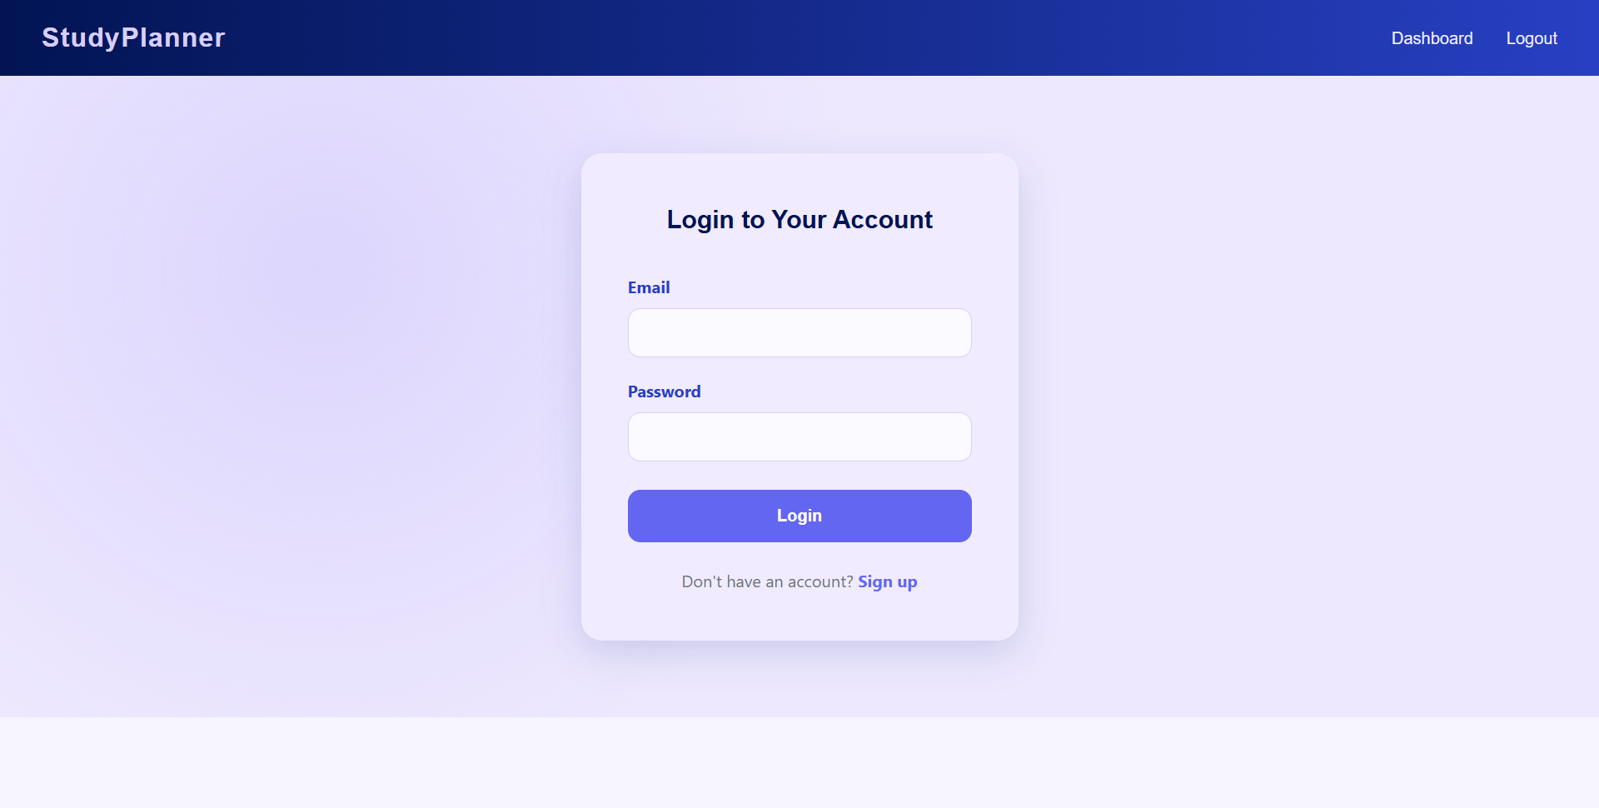
Screenshot 3: Dashboard with demo data and overdue task
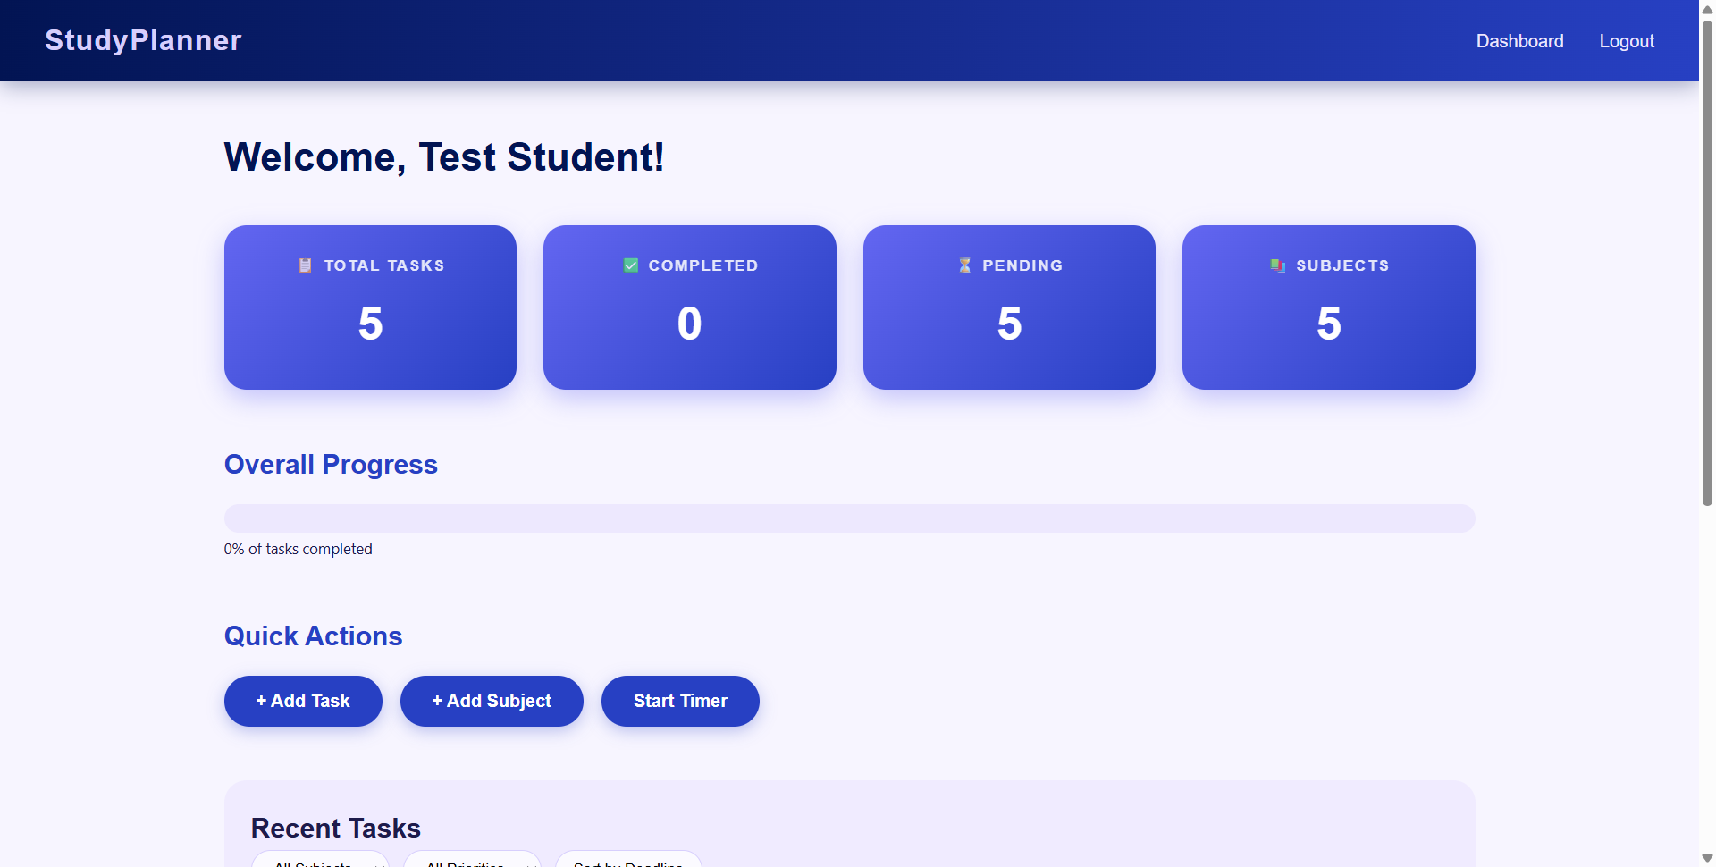
Screenshot 4: Add task form
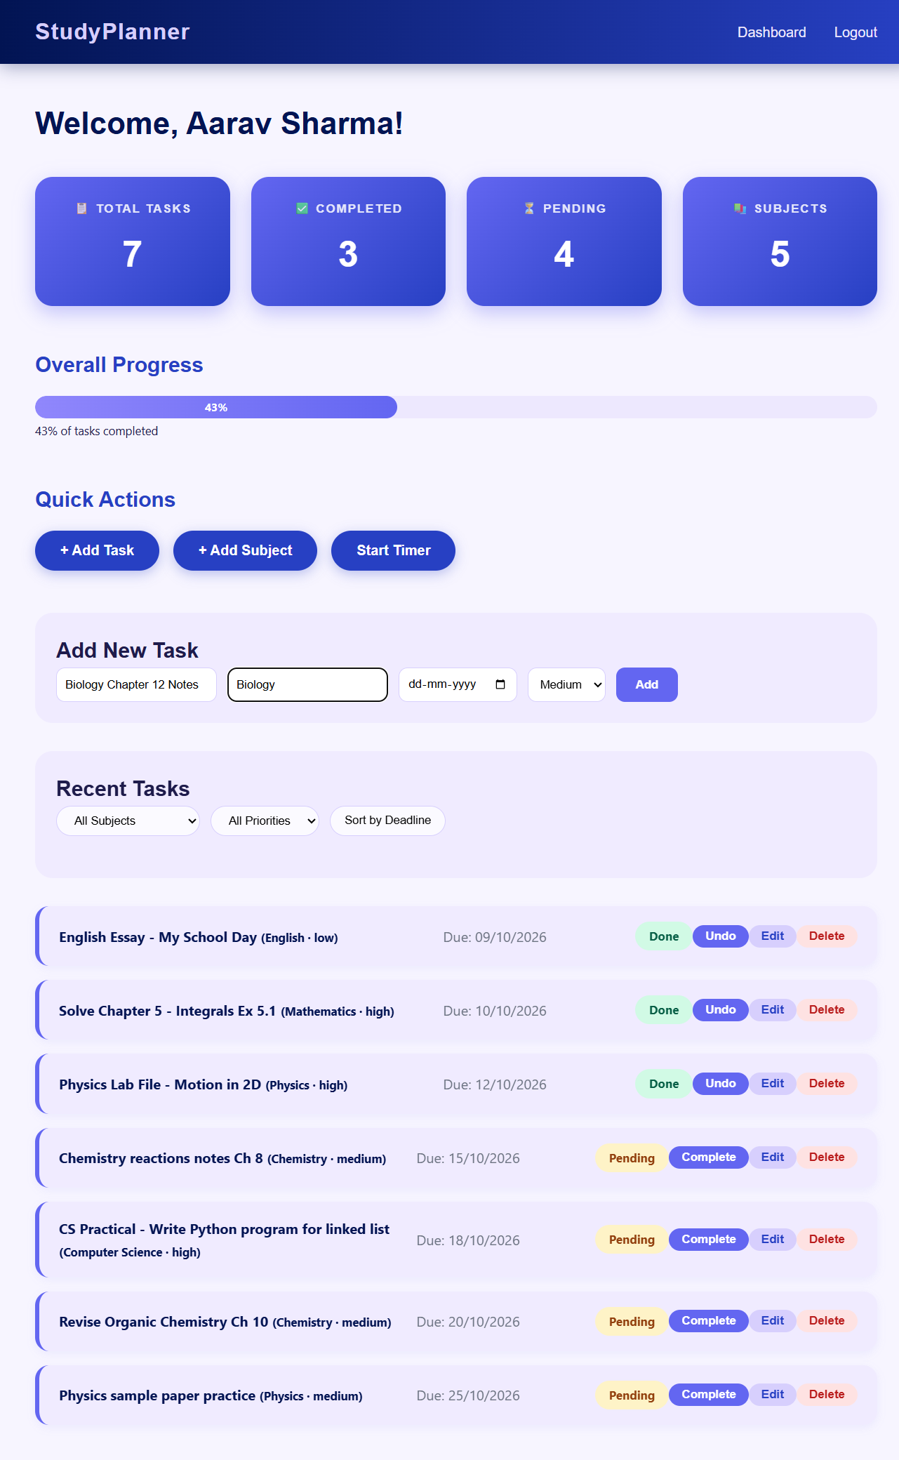
Screenshot 5: Pomodoro timer with presets
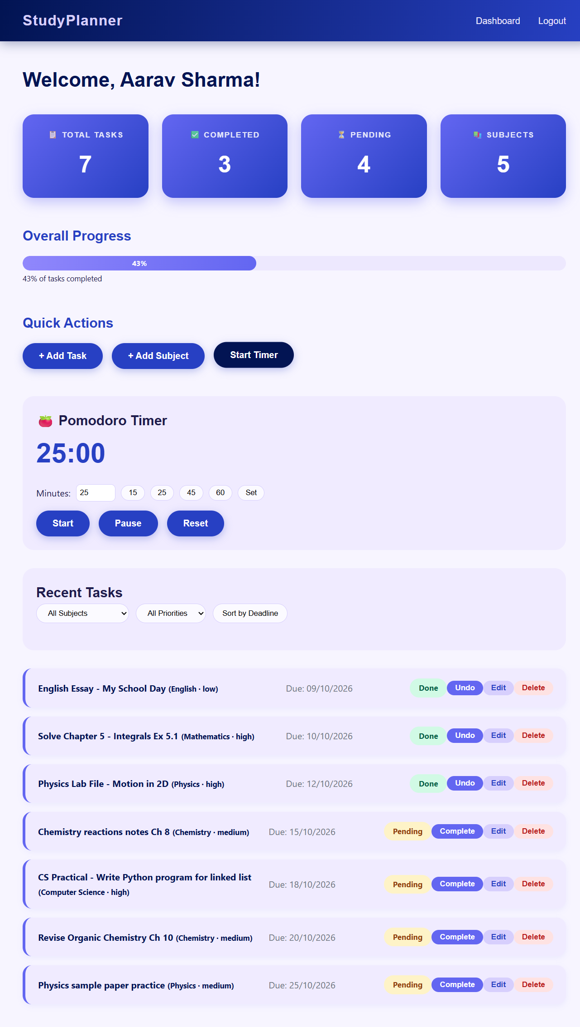

6. Conclusion and Future Scope
Smart Study Planner solves a real academic productivity problem. Students can centralize subjects and tasks, mark them done, see their progress, and focus better with a Pomodoro timer. It demonstrates the full web application stack: HTML/CSS, JavaScript, React, Node.js/Express, MongoDB, JWT security, and cloud deployment.
Future scope:
- Study-hour analytics and weekly charts.
- Notifications before deadlines.
- Group tasks for study teams.
- Calendar view and Google Calendar sync.
- Mobile app (PWA) support.

7. References
- United Nations, "Sustainable Development Goals – Goal 4", sdgs.un.org.
- React documentation, react.dev.
- Express.js documentation, expressjs.com.
- MongoDB and Mongoose documentation, mongodb.com/docs and mongoosejs.com.
- MDN Web Docs – HTML, CSS, JavaScript and HTTP, developer.mozilla.org.

