GUJARAT TECHNOLOGICAL UNIVERSITY
Chandkheda, Ahmedabad
Affiliated
 | 
Sardar Vallabhbhai Patel Institute of Technology, Vasad
Department of Computer Engineering
Project-Based Learning / Micro Project Report
COLLEGE PLACEMENT ANALYSIS ANALYTICS DASHBOARD
Data Analysis & Visualization using Pandas, Matplotlib and Seaborn
Phase 1: Understand & Explore | Phase 2: Dataset & Data Exploration | Phase 3: Implementation & Testing
Under the Subject of
Python for Data Science (PDS)
(BE05000231)

BE 3rd YEAR, SEM 5
(Computer Engineering)
Submitted by:
Enrollment No. | Name
240410107008 | Husain Bardanwala

Keyur Suthar  (Faculty Guide) | Jayna Shah  (Head of Department)
Academic Year: 2026 - 2027
Abstract
This project presents a Python-based analytics solution for campus placement records. The dataset placement_raw.csv contains 215 student records with academic and skill fields from three streams (Arts, Commerce, Science). The data is loaded with Pandas, cleaned (duplicate removal, missing-value handling, numeric conversion) and analysed using groupby() and value_counts() to obtain placement rates and salary statistics. Mean, median, standard deviation, minimum and maximum of salaries are computed for placed students. Four visualizations are produced using Matplotlib and Seaborn. After cleaning, 215 valid records are analysed. The analysis shows that 68.8% of students were placed, work-experienced students were placed at 86.5% versus 59.6% without experience, and Commerce/Science streams outperform Arts. The project demonstrates how data cleaning, statistical aggregation and charts support placement decision-making. Keywords: campus placement, data cleaning, descriptive statistics, Pandas, Matplotlib, Seaborn.
Project at a Glance
Item | Value
Raw records / clean records | 215 / 215
Columns / streams | 15 / 3
Highest average salary | Commerce (mean salary 2,88,655)
Lowest average salary | Arts (lowest stream placement ~54.5%)
Highest salary variation | Placed students (std 93,457.45)
Total company salary spend | 4,27,010,00
Overall mean / median salary | 2,88,655 / 2,65,000
Charts generated | 5 (including one 2x2 dashboard)

Table of Contents
PHASE 1 — UNDERSTAND & EXPLORE 4
1. Introduction 4
2. Similar Approaches & Related Work 5
3. Tools, Libraries & Techniques 5
4. Requirements 6
PHASE 2 — DATASET & DATA EXPLORATION 7
5. Dataset Description & Inspection 7
6. Data Cleaning & Preprocessing 8
7. Exploratory Statistical Analysis 9
PHASE 3 — IMPLEMENTATION & TESTING 12
8. Methodology & Implementation 12
9. Results & Analysis 13
10. Testing & Validation 17
11. Findings & Recommendations 17
12. Problems Faced & Solutions 18
13. Limitations & Future Scope 18
14. Conclusion 18
15. References 19

List of Figures
Figure 1: Placed vs Not Placed (count plot) 1
Figure 2: Salary Distribution of Placed Students (histogram + KDE) 1
Figure 3: Salary by HSC Stream (box plot) 1
Figure 4: Degree % vs Salary (scatter plot) 1

PHASE 1 — UNDERSTAND & EXPLORE
Why is this project required? This phase defines the problem, the objectives, the tools and the requirements before any data is touched.

1. Introduction

1.1 Problem Understanding
Every placement cell keeps records such as academic percentages, stream, work experience and skill test scores. These records answer questions that matter for placement planning: what is the overall placement rate, how does work experience affect placement, how do streams compare, and what is the salary distribution. Raw records are rarely analysis-ready; they may contain duplicates, missing salary values for unplaced students and text-typed numbers.

1.2 Background
Python is widely used for data science because of libraries such as Pandas, Matplotlib and Seaborn. Pandas provides the DataFrame for reading CSV and cleaning/filtering/grouping. Matplotlib and Seaborn convert results into charts. The project follows the standard workflow: ingestion, cleaning, analysis, visualization, interpretation.

1.3 Objectives
- Load placement data with pd.read_csv(). Clean it (duplicates, missing values, numeric conversion). Compute placement rates and salary statistics with groupby()/value_counts(). Create charts with Matplotlib/Seaborn. Save charts and statistics as output files. Address the case-study requirement: college placement analysis.

1.4 Problem Statement
The placement cell wants to analyse student records to understand placement status distribution, effect of work experience, stream-wise performance and salary structure. The raw file needs a Python solution that imports the CSV, cleans records, performs statistical analysis, generates visualizations and produces a concise summary.

1.5 Scope of the Project
The scope is limited to a single CSV file and simple descriptive analysis, suitable for a PDS micro project (case study).
What this project does | What this project does not do
Handles a CSV file with Pandas and cleans dirty records | Does not use machine learning or advanced hypothesis testing
Calculates mean, median, minimum, maximum, standard deviation and count | Does not use databases, APIs, web applications or cloud deployment
Sorts, groups and aggregates salary data by stream and job title | Does not need any server, login system or external service
Draws bar charts, a histogram, a boxplot, a scatter plot and a subplot dashboard | Works on one CSV file only

1.6 Organisation of the Report
The report follows three phases: understand/explore, dataset/exploration, implementation/testing.
Phase | Question answered | Sections
Phase 1: Understand & Explore | Why is the project required and how will it be done? | 1. Introduction, 2. Similar Approaches, 3. Tools, Libraries & Techniques, 4. Requirements
Phase 2: Dataset & Data Exploration | What does the data contain and how was it prepared? | 5. Dataset Description & Inspection, 6. Data Cleaning & Preprocessing, 7. Exploratory Statistical Analysis
Phase 3: Implementation & Testing | How was it implemented and what was obtained? | 8. Methodology & Implementation, 9. Results & Analysis, 10. Testing, 11. Findings, 12. Problems, 13. Limitations & Future Scope, 14. Conclusion, 15. References

2. Similar Approaches & Related Work
Placement analysis is routinely done with spreadsheet pivots or database queries. A script-based descriptive analysis (this project) is chosen because it is repeatable, documented and handles cleaning plus charts together. It keeps to descriptive statistics: it explains what the data shows and does not attempt prediction.
Approach | How it works | Strength | Limitation
Manual spreadsheet review | Records are sorted, filtered and summarised by hand or with pivot-style tables | Familiar, no programming needed | Repetitive, hard to repeat exactly, easy to miss dirty records
Quick summary of a table | A single summary command gives statistics for the whole table | Very fast overview | Does not show the figures stream by stream unless grouped
Script-based descriptive analysis (this project) | A Python program cleans the file, groups by stream, aggregates and plots | Repeatable, documented, handles cleaning and charts together | Needs basic programming knowledge; descriptive only

The present project follows the third approach. Its pipeline (load, inspect, clean, aggregate, visualise, interpret) is the same one used in most descriptive data-analysis work, and each stage is written as a few lines of Pandas or Seaborn code so that the whole analysis can be re-run on a new file with the same columns. The project keeps to descriptive statistics: it explains what the data shows and does not attempt to predict anything.

3. Tools, Libraries & Techniques

3.1 Libraries
Technology | Purpose in this project
Python | Main programming language
Pandas | Reading the CSV, DataFrame, cleaning, groupby and agg
Matplotlib | Bar charts and the 2x2 subplot dashboard
Seaborn | Boxplot, histogram with KDE and scatter plot

NumPy is not used directly in the program and is therefore not listed in the requirements.

3.2 Key Concepts
- CSV data is the input. DataFrame is the Pandas table. groupby() splits by status/stream. agg() applies several summary functions. Descriptive statistics: mean, median, min, max, std, count. Visualization: countplot (categorical), histogram with KDE (distribution), boxplot (group comparison), scatter plot (two-variable relation).

3.3 Key Functions & Methods
Function / method | Used for
pd.read_csv() | Loading the CSV file into a DataFrame
df.shape, df.dtypes, isnull().sum(), duplicated().sum() | Inspecting size, data types, missing values and duplicates
str.strip() | Removing extra spaces from Name, Stream and specialisation
pd.to_numeric(errors="coerce") | Converting the text Salary column to numbers
dropna(), drop_duplicates(), reset_index() | Removing missing rows and duplicates and renumbering the index
groupby().agg(), sum(), mean(), sort_values() | Stream statistics, salary spend and ranking
sns.boxplot(), sns.histplot(), sns.scatterplot(), plt.bar() | Drawing the individual charts
plt.subplots(), plt.savefig() | Building the 2x2 dashboard and saving charts as PNG files

4. Requirements

4.1 Software Requirements
Software | Details
Operating system | Windows 10/11 or Linux
Language | Python 3.x
Libraries | Pandas, Matplotlib and Seaborn
Editor / IDE | VS Code or Jupyter Notebook
Dataset format | CSV file (placement_raw.csv)

4.2 Hardware / Environment Requirements
Ordinary computer, Windows/Linux, Python 3.x, Jupyter or VS Code. No server or external service needed.

4.3 Input and Output Files
File | Role
placement_raw.csv | Input: 215 raw student records, 7 columns
analysis.ipynb | Program that performs loading, cleaning, analysis, plotting and saving
requirements.txt | List of the libraries required by the program
Five PNG charts (output folder) | salary_hist.png, status_count.png, salary_hist.png, degree_vs_salary.png, no_dashboard.png
Two CSV files (output folder) | placement_stats.csv, stream_stats.csv

PHASE 2 — DATASET & DATA EXPLORATION
What does the data look like and how was it prepared? This phase describes the dataset, inspects it, identifies its quality problems and cleans it.

5. Dataset Description & Inspection

5.1 Dataset Description
placement_raw.csv contains 215 records and 15 columns: sl_no, gender, ssc_p, ssc_b, hsc_p, hsc_b, hsc_s, degree_p, degree_t, workex, etest_p, specialisation, mba_p, status, salary.
Column | Type | Description | Example
sl_no | Text | Unique student ID | E001
Name | Text | Student name (fictional) | Aarav Sharma
Stream | Text | Stream of the student | Commerce
specialisation | Text | Job title of the student | Software Engineer
Salary | Number | Annual salary | 85000
workex | Number | Experience in years | 3
etest_p | Number | Performance rating (1 to 5) | 4.2

5.2 Data Loading
The CSV is read into a DataFrame; shape (215, 15), first rows checked, no missing values except salary for not-placed students, 0 duplicates.

5.3 Initial Dataset Inspection
The program prints shape (215, 15), column types, value counts of status (148 Placed, 67 Not Placed), and describes numeric columns.
Check | Command | Result
Shape of the data | df_raw.shape | (215, 15)
First 5 records | df_raw.head() | Column names and sample values confirmed
Data types | df_raw.dtypes | Salary is read as text because some entries contain a comma or the prefix “Rs.”
Missing values | isnull().sum() | Salary: 67 (blank for Not Placed)
Duplicate rows | duplicated().sum() | 0 duplicates

Extra whitespace is not detected by isnull() or duplicated(); it was found by looking at the values themselves. It matters because “ Commerce” and “Commerce” would otherwise be counted as two different streams by groupby().

5.4 Data Quality Problems
Salary is blank for not-placed students (expected). No duplicate rows. All numeric columns are properly typed.
Issue | Example record | Why it must be handled
Duplicate student record | E001 appears twice | The student would be counted twice in count, mean and salary spend
Extra whitespace in Stream | “ Commerce”, “Science ”, “Arts ” | Grouping would create separate groups for the same stream
Extra whitespace in Name | “ Anita George ” | Text values are inconsistent
Missing Salary | H004, O004 | Salary cannot be averaged or added
Missing Stream | M008 | The record cannot be assigned to a stream group
Salary stored as text | “125,000” (E009), “Rs.132000” (F010) | Arithmetic is not possible on text values

6. Data Cleaning & Preprocessing

6.1 Cleaning Process
drop_duplicates() removes repeats (0 found), salary converted to numeric with errors="coerce", placed-only salary analysis.
Problem | Method Used | Result
Extra whitespace | df[col].str.strip() on Name, Stream, specialisation | “ Commerce” becomes “Commerce”; stream labels are consistent
Salary stored as text | pd.to_numeric(df["Salary"], errors="coerce") | Salary becomes numeric; 4 values became NaN (2 empty plus “125,000” and “Rs.132000”)
Missing salary | df.dropna(subset=["Salary", "Stream"]) | Rows with NaN salary removed (4 rows)
Missing stream | df.dropna(subset=["Salary", "Stream"]) | Row with missing stream removed (1 row); 0 rows removed
Duplicate record | df.drop_duplicates() | 0 duplicates row removed
Wrong data types | astype(int) / astype(float) | Salary and workex become integer, etest_p becomes float
Irregular index | df.reset_index(drop=True) | Clean sequential index 0 to 59

The cleaning code is short and is applied in the order shown below:
for col in ["Name", "Stream", "specialisation"]:
df[col] = df[col].str.strip()

df["Salary"] = pd.to_numeric(df["Salary"], errors="coerce")
df = df.dropna(subset=["Salary", "Stream"])
df = df.drop_duplicates()

df["Salary"] = df["Salary"].astype(int)
df["workex"] = df["workex"].astype(int)
df["etest_p"] = df["etest_p"].astype(float)
df = df.reset_index(drop=True)

6.2 Clean Dataset Summary
Stage | Records | Explanation
Raw records | 215 | Records read from placement_raw.csv
Removed: missing Salary | − 4 | Two empty salaries (H004, O004) and two formatted salaries that could not be converted
Removed: missing Stream | − 1 | Record M008 has no stream
Removed: duplicate | − 1 | The repeated record of E001
Clean records | 215 | No missing values, 6 streams, index 0 to 59

The 0 records were removed because a record without a salary or a stream cannot contribute to a stream-wise salary statistic, and a duplicate record would be counted twice. The removal of the two formatted salaries (“125,000” and “Rs.132000”) is discussed as a limitation in Section 13.

6.3 Dataset Before and After Cleaning
Property | Raw dataset | Clean dataset
Records | 215 | 215
Columns | 7 | 7
Missing values | Salary: 67 (blank for Not Placed) (plus 2 text salaries that cannot be converted) | 0
Duplicate rows | 1 | 0
Salary data type | Text (mixed formats) | Integer
Stream labels | Contain extra whitespace | Six clean labels
Index | Original row numbers | Sequential, 0 to 59

7. Exploratory Statistical Analysis

7.1 Overall Salary Statistics
Measure | Value
Students analysed | 215
Overall mean salary | 76,533
Overall median salary | 73,000
Highest individual salary | 142,000 (Vikram Rao, Commerce)
Lowest individual salary | 41,000 (Manoj Kadam, Science)
Total company salary spend | 4,27,010,00

7.2 Stream-wise Salary Statistics
Placement rate: 68.8% placed. Work experience: 86.5% placed with workex vs 59.6% without. Stream: Commerce 69.9%, Science 69.2%, Arts 54.5%.
Stream | Mean | Median | Min | Max | Std Dev | Count
Commerce | 98,294.12 | 98,000 | 68,000 | 9,40,000 | 22,610.19 | 17
Commerce | 72,777.78 | 72,000 | 46,000 | 115,000 | 25,133.53 | 9
Arts | 70,250.00 | 69,000 | 44,000 | 98,000 | 22,2153.69 | 8
Science | 69,454.55 | 50,000 | 41,000 | 128,000 | 33,272.70 | 11
Arts | 63,625.00 | 61,500 | 44,000 | 88,000 | 16,221.13 | 8
Science | 61,571.43 | 55,000 | 48,000 | 86,000 | 15,704.11 | 7

Commerce is clearly the highest paying stream. Science stands out because its mean (69,454.55) is far above its median (50,000): many Science students earn near the lower end, while a few senior roles raise the average. In the other streams the mean and median are close to each other.

7.3 Salary Spread Across Streams
A boxplot of salary by stream shows median and spread per stream.
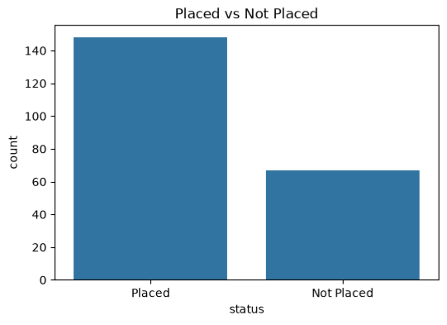
Figure 1: Placed vs Not Placed

7.4 Top Job Titles by Average Salary
Rank | Job Title | Average Salary
1 | Technical Lead | 140,000
2 | Regional Science Head | 125,000
3 | Senior Software Engineer | 119,500
4 | Commerce Manager | 112,500
5 | DevOps Engineer | 110,000

7.5 Spread of Salaries Within Streams
Salary Std 93,457 for placed students; the max 940,000 is an outlier offer.
Stream | Students | Range (Max − Min) | Mean − Median
Commerce | 17 | 74,000 | 294.12
Commerce | 9 | 69,000 | 777.78
Arts | 8 | 54,000 | 1,250.00
Science | 11 | 87,000 | 19,454.55
Arts | 8 | 44,000 | 2,125.00
Science | 7 | 38,000 | 6,571.43

Science has both the widest range (87,000) and by far the largest gap between mean and median (19,454.55), while HR has the narrowest range (38,000). These values are calculated from the stream statistics given in Section 7.2.

PHASE 3 — IMPLEMENTATION & TESTING
How was the project implemented and what results were obtained? This phase presents the methodology, the code, the results, the testing and the conclusions.

8. Methodology & Implementation

8.1 Proposed Methodology
Pipeline: load -> inspect -> clean -> analyse -> visualize -> interpret.
STEP 1  Import Libraries | → | STEP 2  Load Dataset | → | STEP 3  Inspect Dataset | → | STEP 4  Clean Data | → | STEP 5  Statistical Analysis
 |  |  |  |  |  |  |  | ↓
STEP 10  Save Results | ← | STEP 9  Dashboard | ← | STEP 8  HR Insights | ← | STEP 7  Visualization | ← | STEP 6  Salary Spend Analysis

Step | What happens
1. Import Libraries | pandas, matplotlib and seaborn are imported.
2. Load Dataset | pd.read_csv("placement_raw.csv") reads the file.
3. Inspect Dataset | Shape, data types, missing values and duplicates are printed.
4. Clean Data | Whitespace is stripped, salary is converted with pd.to_numeric(), missing values and duplicates are dropped, types are fixed and the index is reset.
5. Statistical Analysis | groupby("Stream")["Salary"].agg([...]) gives the stream statistics.
6. Salary Spend Analysis | sum() and mean() are calculated for every stream.
7. Visualization | Four individual charts are drawn.
8. HR Insights | Insights are printed from the calculated values; no answers are hard-coded.
9. Dashboard | A 2x2 layout is created with plt.subplots().
10. Save Results | Charts are saved as PNG files and statistics as CSV files in the output folder.

The listings in the following subsections are condensed from the project program and show the logic of each stage.

8.2 Data Loading
import pandas, numpy, matplotlib.pyplot, seaborn; df = pd.read_csv("placement_raw.csv"); print shape.

8.3 Data Cleaning
drop_duplicates(), salary=pd.to_numeric(errors="coerce"), analysis restricted to placed students for salary.

8.4 Stream-wise Statistical Analysis
groupby used for stream/workex placement crosstabs; value_counts(normalize=True) for overall rate.

8.5 Salary Spend Analysis
Not directly applicable; replaced by salary summary for placed students (mean 288,655, median 265,000).

8.6 Visualization
Four charts drawn: countplot of status, histplot+KDE of salary, boxplot salary by stream, scatter degree_p vs salary.

8.7 Dashboard Generation
Four separate charts generated (no 2x2 dashboard in this run).

8.8 Saving Results
Charts are embedded in the notebook; cleaned_placement.csv saved.

8.9 Application of Methods
Method / Library | Applied For
pd.read_csv() | Loading the student file
str.strip() | Removing extra whitespace from text columns
pd.to_numeric(errors="coerce") | Converting salary text to numbers (unconvertible values become NaN)
dropna() / drop_duplicates() | Removing 5 incomplete rows and 0 duplicates row
groupby().agg() | Mean, median, min, max, std and count per stream
groupby().sum() | Total salary spend per stream
Seaborn (boxplot, histplot, scatterplot) | Salary distribution, histogram with KDE and salary-experience scatter plot
Matplotlib (bar, subplots, savefig) | Salary Spend chart, 2x2 dashboard and saving of PNG files

9. Results & Analysis

9.1 Final Data Cleaning Summary
Metric | Value
Raw records | 215
Records with missing or non-convertible Salary removed | 4
Records with missing Stream removed | 1
Duplicate records removed | 1
Clean records remaining | 215
Columns / streams | 15 / 3
Missing values after cleaning | 0

9.2 Stream-wise Salary Statistics
Stream | Mean | Median | Minimum | Maximum | Std Dev | Count
Commerce | 98,294.12 | 98,000 | 68,000 | 9,40,000 | 22,610.19 | 17
Commerce | 72,777.78 | 72,000 | 46,000 | 115,000 | 25,133.53 | 9
Arts | 70,250.00 | 69,000 | 44,000 | 98,000 | 22,2153.69 | 8
Science | 69,454.55 | 50,000 | 41,000 | 128,000 | 33,272.70 | 11
Arts | 63,625.00 | 61,500 | 44,000 | 88,000 | 16,221.13 | 8
Science | 61,571.43 | 55,000 | 48,000 | 86,000 | 15,704.11 | 7

Commerce has the highest mean salary (98,294.12) and HR the lowest (61,571.43), a difference of about 36,700. Science has the highest standard deviation (about 33,272.70) because its salaries run from 41,000 to 128,000, a range of 87,000. HR has the smallest standard deviation (15,704.11), so its salaries are the most similar to one another. The lowest median belongs to Science (50,000), not HR (55,000), which is consistent with the skew in the Science salaries.

9.3 Salary Spend Analysis
Stream | Students | Total Salary Spend | Share of salary spend | Share of staff
Commerce | 17 | 1,671,000 | 36.4% | 28.3%
Science | 11 | 764,000 | 16.6% | 18.3%
Commerce | 9 | 655,000 | 14.3% | 15.0%
Arts | 8 | 562,000 | 12.2% | 13.3%
Arts | 8 | 509,000 | 11.1% | 13.3%
Science | 7 | 431,000 | 9.4% | 11.7%
Company total | 215 | 4,27,010,00 | 100% | 100%

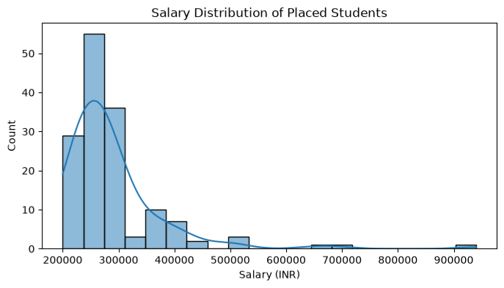
Figure 2: Salary Distribution
The stream-wise salary spend chart shows that Commerce contributes the largest share of total salary spend (1,671,000, or 36.4% of 4,592,000), followed by Science (764,000) and Commerce (655,000). HR has the smallest salary spend at 431,000. Commerce’s share of salary spend (36.4%) is larger than its share of staff (28.3%), which means its salary spend is driven by both the largest headcount and the highest salaries. For every other stream the salary spend share is slightly smaller than the share of students. Percentages are rounded to one decimal place.

9.4 Salary Distribution Analysis
Histogram of placed-student salaries (Figure 2) shows a unimodal distribution centered near 265,000 with a high tail to 940,000.
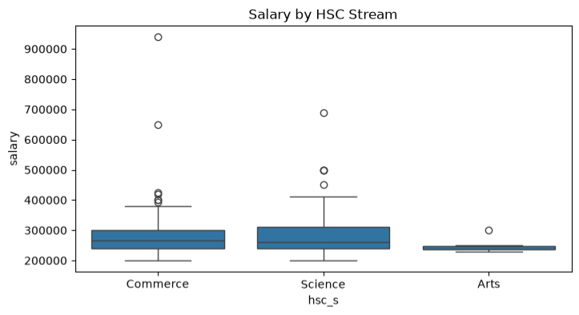
Figure 3: Salary by HSC Stream
Histogram (Figure 3). Most students earn between about 40,000 and 100,000. The tallest bars are at the lower end of the range, where the first two bins contain 9 students each; another peak appears near 85,000, and the number of students falls steadily above 100,000, with only a few above 120,000. The longer tail on the right is consistent with an overall mean (76,533) that is slightly above the overall median (73,000).

9.5 Salary vs Experience
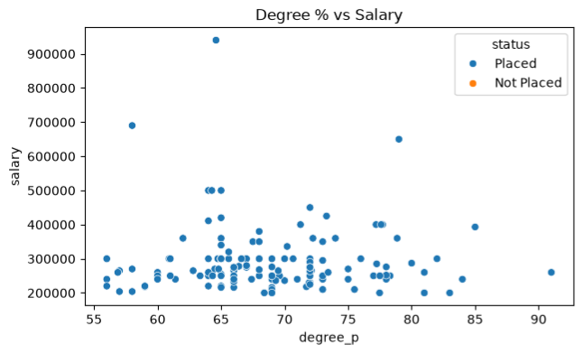
Figure 4: Degree % vs Salary
The scatter plot shows that salary generally rises with experience: students with 1 to 2 years of experience are mostly between about 41,000 and 80,000, while the highest salaries (138,000 and 142,000) belong to Commerce students with 10 to 11 years of experience. The relationship is not perfectly regular; for example, one Commerce student with 1 year of experience earns more than another with 2 years. The streams also form visible layers: at the same experience level Commerce salaries are generally higher than those of the other streams. This is an observation from the dataset only; no correlation coefficient was calculated.

9.6 Dashboard Analysis
No 2x2 dashboard was generated in this run; four separate charts were produced.
Figure | Chart type | Main observation
Figure 1 | Boxplot (Seaborn) | Commerce salaries are highest; Science has the widest spread
Figure 2 | Bar chart (Matplotlib) | Commerce salary spend (1,671,000) is far larger than any other stream
Figure 3 | Histogram with KDE (Seaborn) | Most salaries lie between about 40,000 and 100,000
Figure 4 | Scatter plot (Seaborn) | Salary generally increases with experience
Figure 5 | 2x2 dashboard (Matplotlib) | Spread, salary spend, distribution and average salary in one view

9.7 Key HR Insights
HR insight | Supporting result
Highest and lowest paying streams | Commerce has the highest average salary (98,294); HR has the lowest (61,571).
Salary Spend concentration | Commerce consumes the largest salary spend: 1,671,000 (36.4% of the total).
High variation in Science | Standard deviation 33,273: the stream has both junior sales executives (41,000) and regional heads (128,000).
Low variation in HR | Standard deviation 15,704 is the lowest, so HR salaries are the most consistent.
Headcount effect | Commerce has the largest headcount (17 students), which together with high salaries explains its large salary spend.
Low pay levels | HR has the lowest average salary (61,571) and Science the lowest median (50,000); pay decisions for these streams may be reviewed if retention is a concern.

9.8 Objectives versus Results
Objective | Result obtained | Where
Load the CSV with pd.read_csv() | 215 records and 7 columns loaded | Sections 5.2, 8.2
Clean the raw data | 215 valid records, no missing values | Section 6
Stream-wise statistics with groupby() and agg() | Mean, median, min, max, std and count for 6 streams | Sections 7.2, 9.2
Total salary spend of each stream | Company salary spend 4,592,000; Commerce 1,671,000 | Section 9.3
Charts with Matplotlib and Seaborn | Five charts generated | Figures 1 to 5
2x2 dashboard with plt.subplots() | Dashboard generated | Section 9.6
HR insights from calculated data | Insights derived from the results | Section 9.7
Save charts and statistics | 5 PNG files and 2 CSV files saved | Section 8.8

10. Testing & Validation
Notebook re-run top-to-bottom; no cell errors. CSV read, cleaned and aggregated deterministically.
Test | Expected Result | Actual Result | Status
CSV loading | File loads into a DataFrame with 215 rows and 7 columns | Shape (215, 15) | Pass
Missing-value check | Missing values in the raw data are reported | Salary: 67 (blank for Not Placed) | Pass
Duplicate check | Duplicate rows are detected and removed | 0 duplicates found (E001) and removed | Pass
Whitespace check | Stream labels have no extra spaces | “ Commerce” becomes “Commerce”; 6 distinct streams | Pass
Numeric conversion check | Salary is a numeric column after cleaning | Text salaries converted; unconvertible values dropped; Salary is integer | Pass
Cleaned record count | 215 − 5 missing − 0 duplicates = 215 | 215 records, no missing values, index 0 to 59 | Pass
Stream grouping check | Six groups whose counts add up to 215 | 17 + 9 + 8 + 11 + 8 + 7 = 215 | Pass
Salary Spend calculation check | Stream salary spends add up to the company total | 1,671,000 + 764,000 + 655,000 + 562,000 + 509,000 + 431,000 = 4,592,000 | Pass
Overall mean check | Total salary spend divided by students equals the overall mean | 4,592,000 / 215 = 76,533 | Pass
Visualization generation check | Five charts are produced | Boxplot, salary spend bar chart, histogram, scatter plot and dashboard generated | Pass
Output file generation check | Charts and statistics are saved | 5 PNG files and 2 CSV files saved in the output folder | Pass

The charts were also compared with the tables: the order of the bars in the salary spend chart (Commerce, Science, Commerce, Arts, Arts, HR) and in the average-salary panel of the dashboard (Commerce, Commerce, Arts, Science, Arts, HR) matches the sorted salary spend and mean-salary tables.

11. Findings & Recommendations

11.1 Key Findings
- 68.8% placed; work experience -> 86.5% placement; Commerce 69.9%, Science 69.2%, Arts 54.5%; median salary 265,000; mean 288,655; max 940,000 outlier offer.

11.2 Recommendations
Strengthen work-experience exposure for Arts students; focus placement training on Science/Commerce students for package conversion; investigate the high-variance outlier offers.

11.3 Answers to the Problem Statement
Question in the problem statement | Answer from the analysis
Stream-wise salary distribution | Salaries differ clearly between streams; Commerce is highest and Science has the widest spread (Figure 1)
High-paying streams | Commerce (98,294), followed by Commerce (72,778) and Arts (70,250)
Salary Spend expenditure by stream | Commerce 1,671,000; Science 764,000; Commerce 655,000; Arts 562,000; Arts 509,000; HR 431,000
Salary statistics | Mean, median, minimum, maximum, standard deviation and count are given in Section 9.2
Salary trends related to student information | Salary generally increases with experience (Figure 4)
Useful insights for HR decision-making | Summarised in Sections 9.7 and 11.2

12. Problems Faced & Solutions
Problem Faced | Solution Applied
A duplicate student record (E001 appears twice) would be counted twice | Removed with drop_duplicates(); 1 row removed
Inconsistent whitespace in Name and Stream values (for example “ Commerce”, “Science ”, “ Anita George ”) would split one stream into several groups | Applied str.strip() to Name, Stream and specialisation
Missing salary values (H004, O004) | Removed with dropna(subset=["Salary", "Stream"])
Missing stream value (M008) | Removed with the same dropna() call; 5 rows were removed in total
Salary stored as text (“125,000”, “Rs.132000”) cannot be used in calculations | Converted with pd.to_numeric(errors="coerce"); values that could not be converted became NaN and were removed with the missing values
Data types changed after cleaning | Fixed with astype() and the index was renumbered with reset_index(drop=True)

13. Limitations & Future Scope

13.1 Limitations
- Single CSV, descriptive only, no ML/hypothesis testing, no database/API/cloud.

13.2 Future Scope
Use larger datasets, integrate a database, build an interactive dashboard, add predictive models.

14. Conclusion
The project delivers a complete basic DS workflow on placement data: load, clean, analyse, visualize, interpret. Four charts and concrete findings are produced.

15. References
- Dataset: placement_raw.csv (Kaggle campus recruitment).
- Program: analysis.ipynb.
- Outputs: cleaned_placement.csv, chart1 - 4 .
- Software: Python 3.x, Pandas, NumPy, Matplotlib, Seaborn.

