Classification: (y values are discrete values. Spam/not, malignant /benign)
Can't apply linear regression for classification problems as hypothesis value can be anything (>1 or <0).

Logistic Regression: 0<= h_{θ}(x) <=1
hypothesis h_{θ}(x)=g(θ^{T}x) , g(z) = 1/(1+e^{-z})
so, h_{θ}(x)=1/(1+e^{-θ'x} )

g(z):Sigmoid function/logistic function
value goes from 0 to 1, both being the assymptotes, 0 at -inf and 1 at + inf. Crosses vertical axis at 0.5

h_{θ}(x) gives the probability that y=1 on input x.

Predict, y=1 when h_{θ}(x)>=0.5 => θ^{T}x >=0
y=0 when h_{θ}(x) < 0.5 => θ^{T}x < 0

Decision boundary separates region with y=1 and y=0. It is the property of the hypothesis including θ_{0,}θ_{1,}θ₂,... and not of the data set.
........................................................................................................................
Logistic Regression Model:(To fit parameters theta for logistic regression)
m examples
x=[x₀, x₁, ......, x_{n}]^{T} y={0,1}
h_{θ}(x)=1/(1+e^{-θ'x} )
J(θ)=(1/m)* Σ Cost(h_{θ}(x),y)
where,
Cost(h_{θ}(x),y) = -log(h_{θ}(x)) , if y=1
= -log(1-h_{θ}(x)) , if y=0
Cost(h_{θ}(x),y) = -ylog(h_{θ}(x)) -(1-y)log(1-h_{θ}(x))
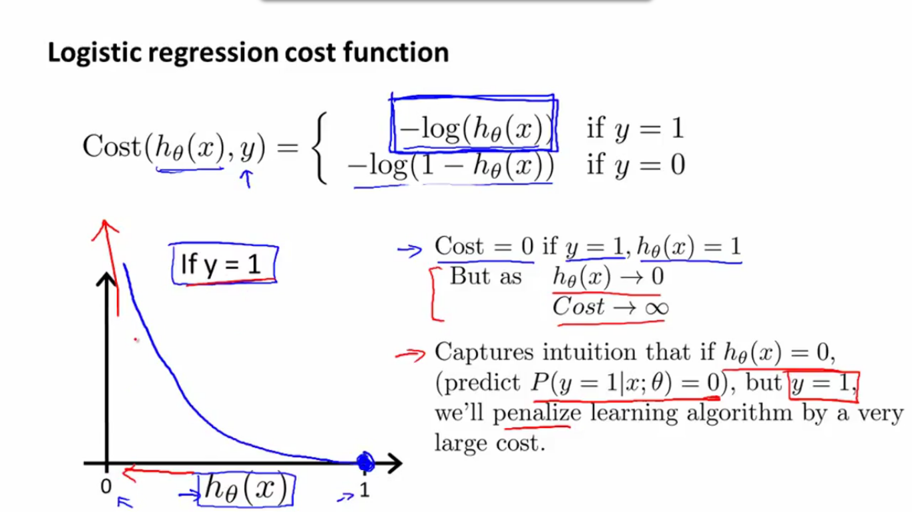
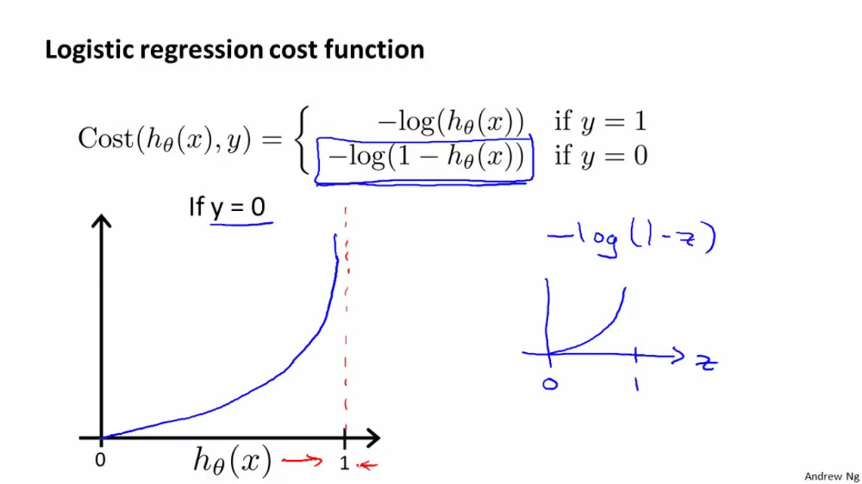

_{m}
J(θ) = -(1/m) [Σ y^{(i)} log(h_{θ}(x^{(i)})) + (1-y^{(i)})log(1-h_{θ}(x^{(i)})) ]
^{i=1}
.........................................................................................................................................................................................

Gradient descent: (θ_{j} := θ_{j} – α * partial der. of J wrt θ_{j})
_{m}
θ_{j} := θ_{j} - α* Σ (h_{θ}(x^{(i)}) – y^{(i)}) x_{j}^{(i)} (Simultaneous update all θ_{j})
^{i=1}

Optimizations:
optimization algorithms:
*Gradient descent
*Conjugate gradient.................> No need to manually pick α
*BFGS.....................................> Often faster than gradient descent
*L-BFGS.................................> But more complex

In case of large data set, in octave, use:

function [jval, grad] = func_name(theta)
jval = code to calculate J(θ)
grad = zeros(no of dimension+1,1)
grad(1) = code to calculate partial der of J wrt θ₀
grad(2) = code to calculate partial der of J wrt θ₁, etc.

Now call from Octave,
options= optimset('GradObj','on', 'MaxIter','100')
thetain=zeros(dimension+1,1)
[thetaf,funcval,exitflag]=fminunc(@func_name, thetain, options)

%@ is a pointer to the function
...........................................................................................................

Multiclass classification: One vs All:
In this case we treat all but 1 class as same, and divide the 2 classes obtained by a line and find the probablity of it being in the class comprising of 1 type. Reapeat the same with other class. The set from which highest probability is obtained corresponds to the required desired class.

