Neuron Model:
inputs mapped to output ( sigmoid activation function, g(z)
g(z)=1\(1+e^{-z}) ) by some computation analogous to neurons.

weights of the model are the parameters, 'thetas', of the model.
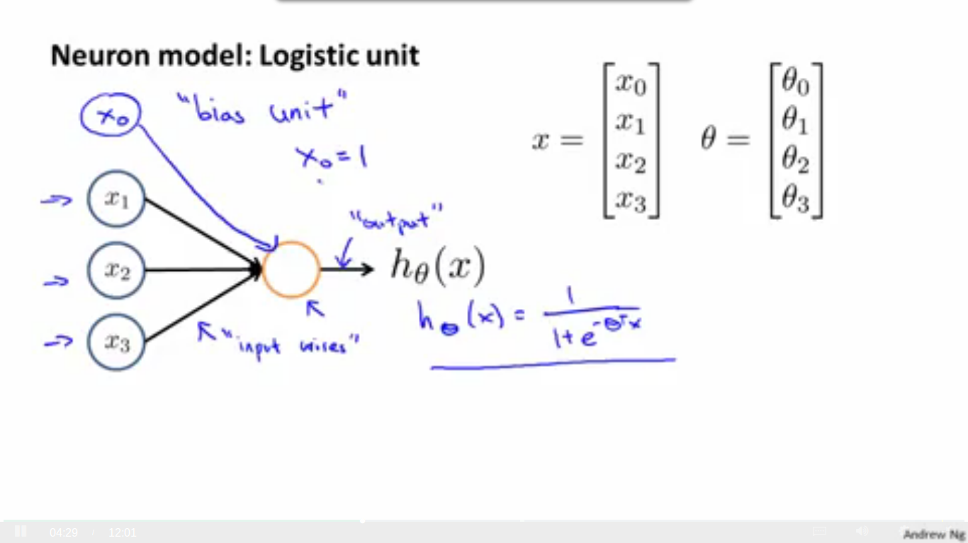

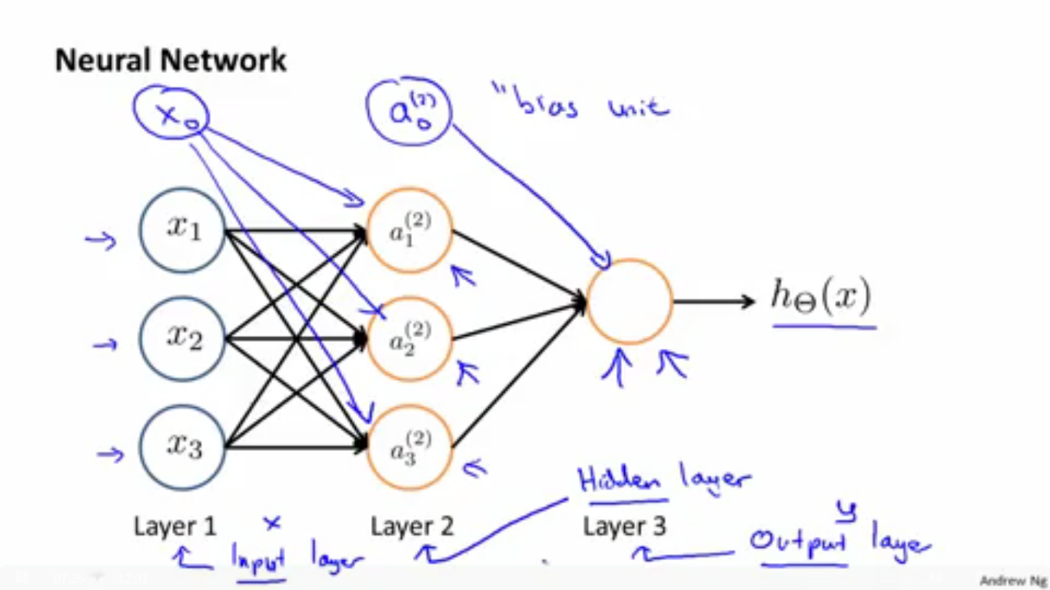

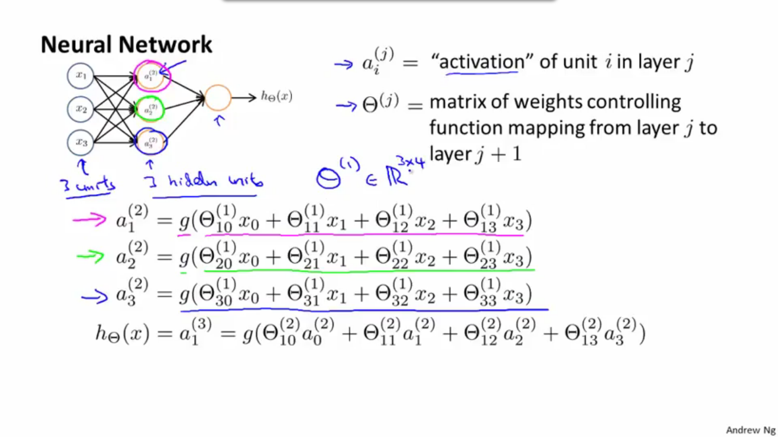
The total network outputs a value hich is then computed by the sigmoid function.

If the network has s_{j} units in layer j, and s_{j+1} units in layer j+1,
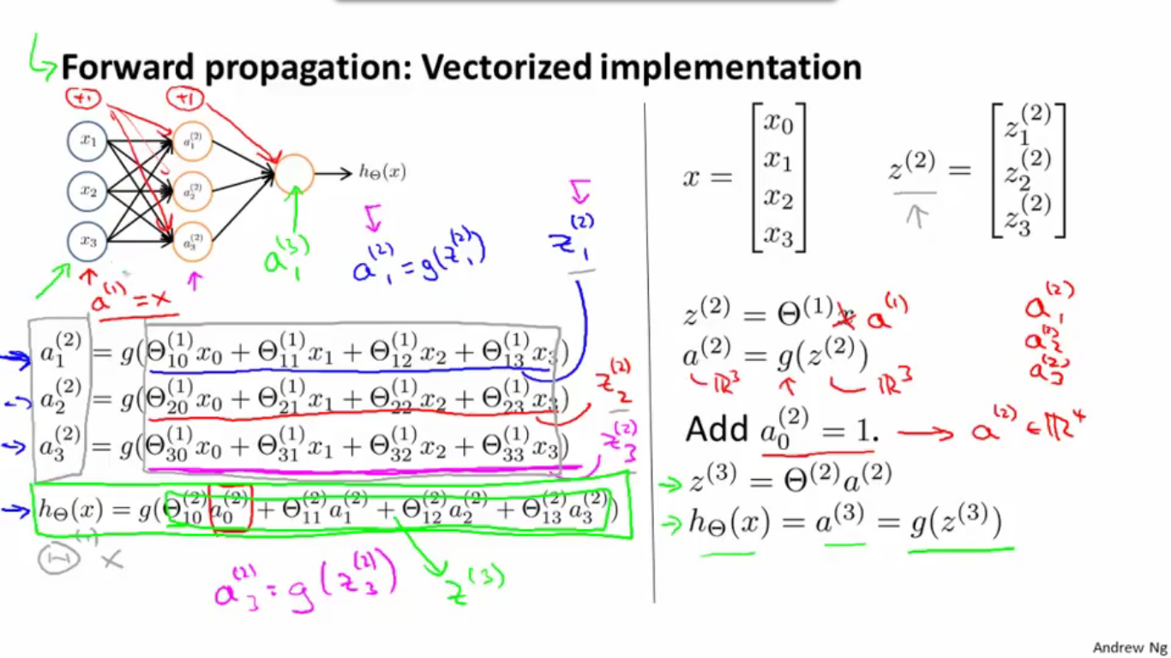
then theta^{(j)} will be dimension s_{j+1} x (s_{j} + 1)

