
The Hashemite University
Faculty of Engineering
Department of Computer Engineering
Data Science (2104081410)
Project Phase 1
Data Preprocessing of a Customer Dataset
Team Name: ____________________________
Prepared by:
# | Student Name | Student ID

Submitted to:
Dr. Mohammad Al-Hammouri
Fall Semester 2026/2027
November 2026

Abstract
This report describes the preprocessing of a customer dataset of 20,330 records and 23 attributes, as required in Phase 1 of the Data Science course project. The raw data contained missing values in 11 columns, inconsistent text formats, four different date formats, placeholder values, duplicate records and outliers. Using Python (Pandas, NumPy, Matplotlib, Seaborn and scikit-learn) in VS Code, we cleaned and transformed the data into two outputs: a cleaned, human-readable dataset of 20,000 unique customers with no missing values, and a model-ready, encoded and scaled dataset of 31 features split into training and testing sets.

1. Introduction
Real-world data is rarely ready for analysis. Before any machine learning model can be trained, the data must be inspected, cleaned and transformed so that it is accurate, consistent and in a numeric form that algorithms can use. The objective of this phase is to perform all required preprocessing steps on the customer dataset provided by the instructor, following the data preparation topics of the course: data loading, data cleaning and preparation, data visualization and correlation.
All work was implemented in a Jupyter notebook (Project_Phase1_Preprocessing.ipynb) using VS Code. A plain Python script version (project_phase1_preprocessing.py) is also included. Both produce the same results and figures.

2. Dataset Description
The dataset (Project_dataset.csv) contains 20,330 rows and 23 columns describing customers of a retail company in Jordan and the region (Jordan, Egypt, UAE, Saudi Arabia and Lebanon).
Table 1: Dataset attributes
Attribute | Type | Description
client_ref | ID | Customer identifier (CUSTxxxxxx)
client_name | Text | Customer full name
sex | Categorical | Male / Female
location, country_iso | Categorical | City (10 cities) and country code
yearly_salary, monthly_salary | Numeric | Customer income
salary_bracket | Ordinal | Low / Mid / High / Very High
spend_per_order | Numeric (stored as text) | Average amount per order
order_count | Numeric | Number of orders
credit_rating_score | Numeric | Credit score
tenure_years | Numeric | Years as customer (0–20)
education | Ordinal | High School / Bachelors / Masters / PhD
satisfaction_level, satisfaction_points | Ordinal / Numeric | Customer satisfaction as a label and a 0–100 score
item_category | Categorical | Main product category (6 values)
registration_date, birth_date | Date | Registration and birth dates
account_status, previous_churn_flag, premium_customer | Binary | Yes / No flags
web_session_ref, record_status | ID / Constant | Session ID and record status

3. Data Quality Assessment
Before changing any value, we explored the data using info(), describe(), value_counts() and visualizations. Figure 1 shows the number of missing values per column, and Table 2 summarizes all the problems we found.
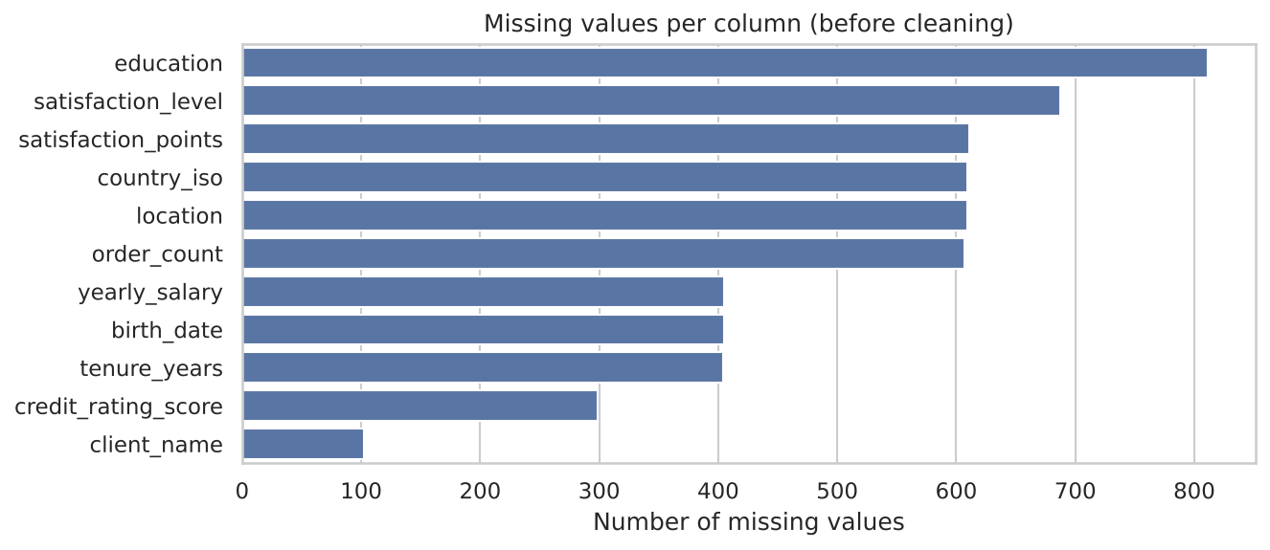
Figure 1: Missing values per column before cleaning
Table 2: Data quality problems found
Problem | Details / Examples
Missing values | 5,549 missing cells in 11 columns (e.g. education 811, satisfaction_level 687, order_count 607, location 609)
Inconsistent text | Different capitalisation and extra spaces: 'Male', 'male', 'MALE', ' Male ' (sex, location, education, item_category)
Inconsistent booleans | Yes/No written in 10 ways: Yes, yes, Y, 1, TRUE, No, no, N, 0, FALSE
Wrong data type | spend_per_order stored as text with '$' signs and thousands separators ('$1,005.17')
Mixed date formats | m/d/Y, d/m/Y (e.g. 23/06/2023), dd-Mon-yy (28-Aug-24) and Y-m-d
Placeholder values | '?' and 'unknown' in satisfaction_level; 'Unknown' in salary_bracket; -999, -100, 0, 999 in credit_rating_score
Invalid values | Birth dates in the future (up to 2031) or customers under 18; order_count values of 60–980 (normal range 1–49)
Duplicates | 104 exact duplicate rows; 330 repeated client_ref IDs (same customer with different text format or web session)
Outliers / skew | yearly_salary up to 1.33 million (skewness 12.3)
Useless columns | record_status has one value; IDs and names carry no predictive information

4. Preprocessing Steps

4.1 Fixing Data Types and Standardizing Text
- Removed leading and trailing spaces from all text columns and converted empty strings to missing values.
- Unified capitalisation: names and cities in Title Case, education mapped to four fixed labels, country codes in upper case.
- Mapped the ten Yes/No forms in account_status, previous_churn_flag and premium_customer to 1 and 0.
- Removed '$', commas and spaces from spend_per_order and converted it to float.
- Replaced the placeholders '?', 'unknown' and 'Unknown' with missing values so they are treated correctly in the next steps.

4.2 Parsing Dates
A custom function detects the format of each date string. The main format is month/day/year. When the first number is greater than 12, the value can only be day/month/year, so it is parsed that way. The formats dd-Mon-yy and Y-m-d are also handled. All 20,330 registration dates were parsed successfully (range 2015-01-01 to 2024-12-30).

4.3 Removing Duplicates
After standardizing the text, records that had looked different (e.g. 'Thomas Sabbagh' and 'THOMAS SABBAGH') became identical. We removed 300 exact duplicate rows, and then 30 more records that repeated the same client_ref with only a different web session, keeping the first record. The final dataset has 20,000 rows and every client_ref is unique.

4.4 Handling Invalid Values
- Credit score: valid credit scores range from 300 to 850. The 258 values of -999, -100, 0 and 999 are placeholders, so they were set to missing.
- Birth date: 1,166 dates gave an age below 18, above 100, or in the future (relative to 31-Dec-2024, the last registration date) and were set to missing.
- Order count: 77 values were between 60 and 980, while normal values are 1–49. All of them are multiples of 20, which indicates a data-entry error, so they were set to missing.

4.5 Handling Missing Values
We chose the filling method for each column based on its meaning and its relationship with other columns, instead of deleting rows:
Table 3: Missing value treatment
Column | Method | Reason
yearly_salary | monthly_salary × 12 | monthly_salary has no missing values and the correlation between them is 0.99999
salary_bracket | Recomputed from salary | Bracket limits in the data: <25k, 25–50k, 50–100k, >100k
satisfaction_level | Derived from satisfaction_points | Each level matches a range of points (e.g. Medium ≈ 39–60)
satisfaction_points | Median of its level | Keeps the value consistent with the label
credit_rating_score, tenure_years, order_count | Median | The median is robust to outliers
birth_date | Median date | Keeps the age distribution unchanged
education | Mode (Bachelors) | Most frequent category
location, country_iso | 'Unknown' category | Always missing together (600 rows); a guess could be wrong

After this step the dataset has no missing values.

4.6 Handling Outliers
We used box plots and the IQR rule to find outliers (Figure 2). Salaries and spend per order are strongly right-skewed. These are real high-income customers rather than errors (yearly salary still equals 12 × monthly salary), so instead of deleting them we capped (winsorized) the values at the 1st and 99th percentiles. A log-transformed salary feature was also added to reduce skewness. Figure 3 shows the result.
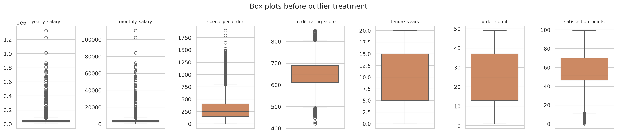
Figure 2: Box plots before outlier treatment
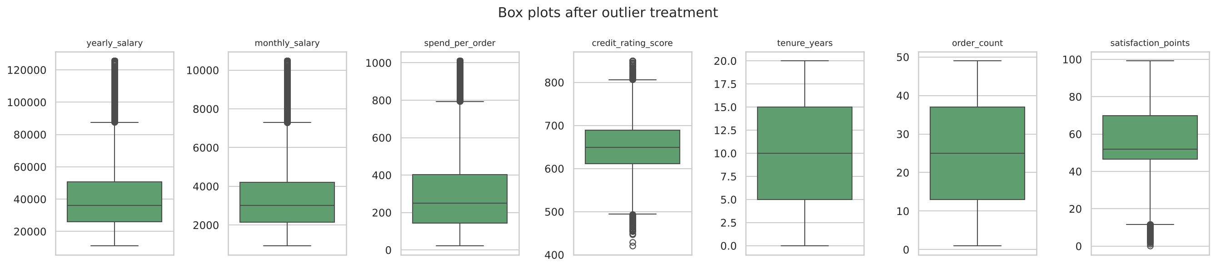
Figure 3: Box plots after outlier treatment

4.7 Feature Engineering
- age: customer age on 31-Dec-2024, computed from birth_date.
- days_since_registration and registration_year: computed from registration_date.
- total_spend: spend_per_order × order_count.
- log_yearly_salary: log(1 + yearly_salary), to reduce skewness.
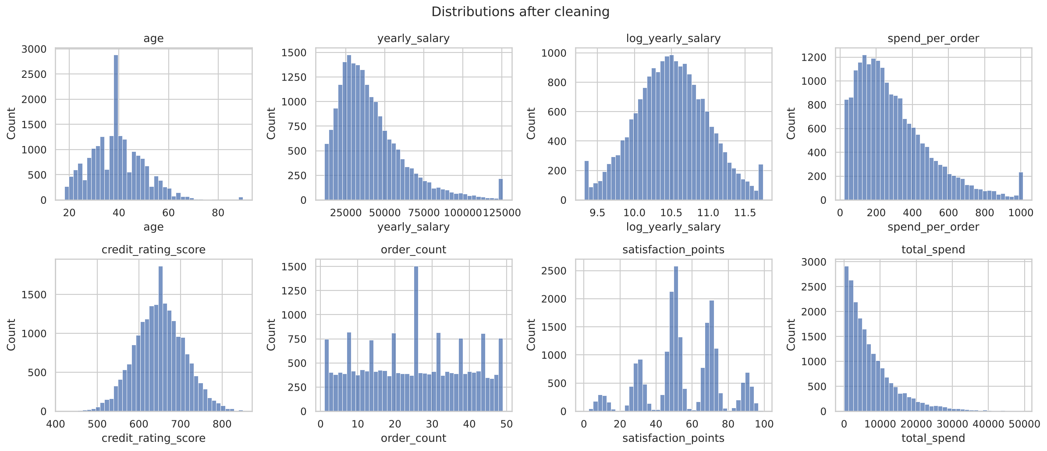
Figure 4: Distributions of numeric features after cleaning
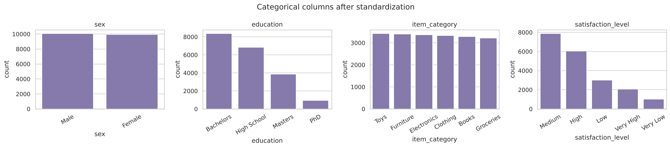
Figure 5: Categorical columns after standardization

4.8 Encoding Categorical Variables
- Ordinal encoding for columns with a natural order: education (0–3), satisfaction_level (0–4), salary_bracket (0–3).
- Binary encoding for sex (Male = 1, Female = 0) and the three Yes/No flags.
- One-hot encoding for nominal columns without order: location (11 columns including Unknown) and item_category (6 columns).

4.9 Correlation Analysis and Feature Selection
Figure 6 shows the correlation matrix. Several pairs carry the same information: yearly and monthly salary (r = 1.00), days since registration and registration year (r = −0.99), and satisfaction points and level (r = 0.99). To avoid redundancy we kept one feature from each pair. We also dropped ID columns, the constant column record_status, and country_iso, which depends fully on location. The model-ready dataset has 31 columns.
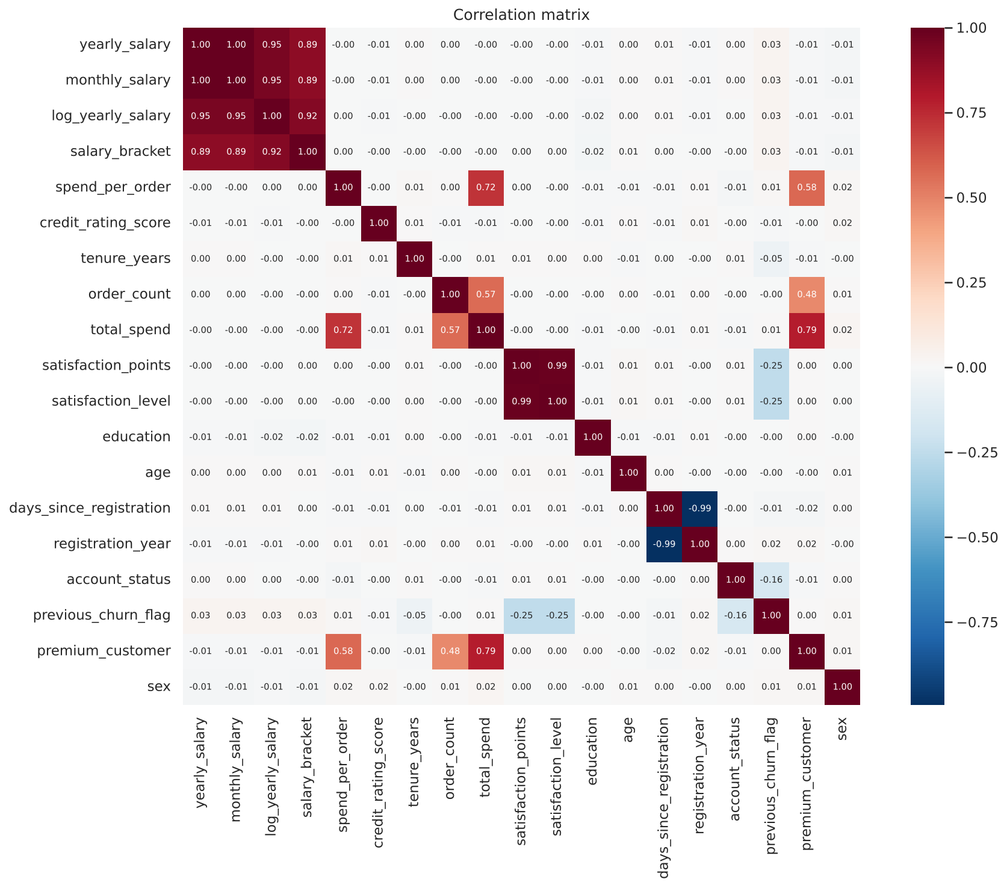
Figure 6: Correlation matrix of the main features
Interesting relationships: premium_customer is strongly related to total_spend (r = 0.79), and previous_churn_flag is negatively related to satisfaction (r = −0.25) and account_status (r = −0.16). These relationships will be useful in the modelling phase.

4.10 Train/Test Split and Feature Scaling
The data was split into 80% training (16,000 rows) and 20% testing (4,000 rows) with stratification. previous_churn_flag was used as an example target. The continuous features were standardized with StandardScaler (mean 0, standard deviation 1). The scaler was fitted on the training set only and then applied to the test set, to avoid data leakage.

5. Results
Table 4: Dataset before and after preprocessing
Measure | Before | After
Rows | 20,330 | 20,000
Missing values | 5,549 | 0
Exact duplicate rows | 104 | 0
Duplicate client IDs | 330 | 0
Distinct values in 'sex' | 8 | 2
Distinct values in 'education' | 16 | 4
Date formats | 4 | 1 (datetime)
Features for modelling | 23 raw columns | 31 encoded, scaled columns

Output files (in the outputs folder):
- customers_cleaned.csv – cleaned dataset with readable values (20,000 × 28).
- customers_model_ready.csv – encoded dataset after feature selection (20,000 × 31).
- train_scaled.csv, test_scaled.csv – scaled training and testing sets.
- figures/ – all figures used in this report.

6. Conclusion
The customer dataset contained many quality problems that would have led to wrong results if used directly. By standardizing text, unifying formats, parsing dates, removing duplicates, replacing invalid values, filling missing values using the relationships between columns, treating outliers, creating new features, encoding categories, removing redundant features and scaling, we produced a clean and consistent dataset of 20,000 unique customers. The data is now ready for the next phase of the project: building and evaluating machine learning models.

References
[1] W. McKinney, Python for Data Analysis, O'Reilly Media, 2012.
[2] A. Géron, Hands-on Machine Learning with Scikit-Learn, Keras, and TensorFlow, O'Reilly Media, 2019.
[3] P. Deitel and H. Deitel, Intro to Python for Computer Science and Data Science, Pearson, 2020.
[4] Pandas documentation, https://pandas.pydata.org/docs/
[5] scikit-learn documentation, https://scikit-learn.org/stable/

