Function Estimation From Given Inputs And Simulation Of The Estimated Function

Hüsamettin Eken  
*Electric-Electronic Engineering   
Ankara University*Ankara, Turkey  
husamettineee@gmail.com

***Abstract*—In this study, a function is estimated and simulated the estimated function. This study has two part and the first part is function estimation from given input and output values. Polynomial regression is used to estimate function because the problem says the function is polynomial. The second part is the simulation of the estimated function in the first part. There are three graphs in the simulation. There are balls in the first graph and they move with time. There is a location-time graph for the ball in the second graph and the velocity-time graph for the ball in the third graph.**

***Keywords—free-fall, estimation, function, polynomial, regression, polynomial regression, simulation, estimation, gravity acceleration, coefficients, MATLAB***

# Introduction

In this study, there is regression analysis which is the start point of artificial intelligence and the polynomial type of regression analysis is used. Regression analysis is a method that finds a relationship between the given data. This work has input data x values, output data y values and function of this problem is a polynomial function. We will use this data and find an estimated function. After the estimate a function from data, we will simulate it.

# Algorıtms and codes

## *S*earching About Problems

First, I tried to find important keywords. Problem one was estimating function from given input and output data. So there are no coefficients in this function and my first important keyword is coefficients. After that, this function is polynomial and the degree of function is two so my function is a parabola. Parabola is my second keyword. I was doing an estimation so estimation was the third keyword. When I searched these keywords on the internet, I found parabola formulas and regression analysis at first. I didn’t look regression analysis first because I was looking for a formula to find coefficients easily but when I realized there is no formula about finding coefficients, I looked regression analysis page and it was what I wanted. The method was to find the coefficients at function. After to find how to estimate coefficients, I start to learn regression analysis. I found some web sites and I understood basic logic. When I was looking for regression analysis I found a Youtube video[4] and I understood that how I will use it in Matlab. I did this search for the first part. For the second part, I searched for motion formulas. I found some web pages that give all motion formulas.

## Applications of Research

In the first part, we will apply the mathematical steps of regression analysis. Steps happen from at like below:

$A*x=B$

A=Input matrix(X Values)

x=Coefficients(Values what we wanted)

B=Output matrix(Y Values)

Step 1 : $A^{T}*A*x =A^{T}*B {}^{}$

Step 2: ${{(A}^{T}*A)}^{-1}{*(A}^{T}*A)*x={{(A}^{T}*A)}^{-1}*{(A}^{T}*B)$

Step 3 : $x ={{(A}^{T}*A)}^{-1}*{(A}^{T}*B)$

At the end of the steps, I found coefficients like in figure 1. Figure 1 also shows the results of polyfit function of Matlab. Polyfit is a ready function to determine coefficients of functions. The results are so close. In the second part, I started with calculating gravity acceleration value. I calculated it from these equations::

$h =V_{0}*t-1/2*g*t^{2}+h_{0}$

$V=V_{0}-g*t$, At time symmetry point of parabola V=0

$r=-b/2a$,Parabola symmetry point

Firstly, I used the third equation and find special time value. After that, I used the second equation and find a relationship between V0 and g. Consequently, I used the first equation and found the gravity acceleration value. After the found gravity acceleration value, I calculated V0. You can see in figure 2. When I finished the mathematical partitions, I start simulations. Firstly, I started with the mathematical model that I estimated in the first part to simulate. After that, I continued with location- time graph and velocity-time graph. All of the graphics were dependent on time. I used subplot function to draw all graphs in one figure. Consequently, I simulated inaccurate values. They seem only when time is increased being an integer value. You can see simulation screenshots in figure 4-9.

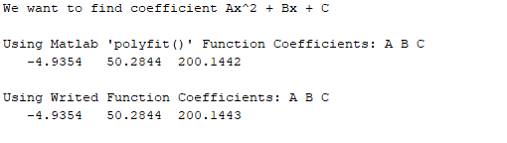

**FIGURE 1. Matlab console window for first part results with polyfit function and written function.**

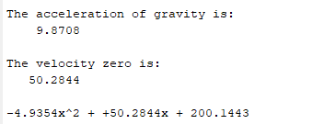

**FIGURE 2. Matlab console window for second part results(gravity, start velocity, mathematical model)**

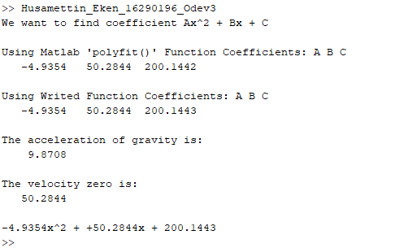

**FIGURE 3. Matlab console window for the full study**

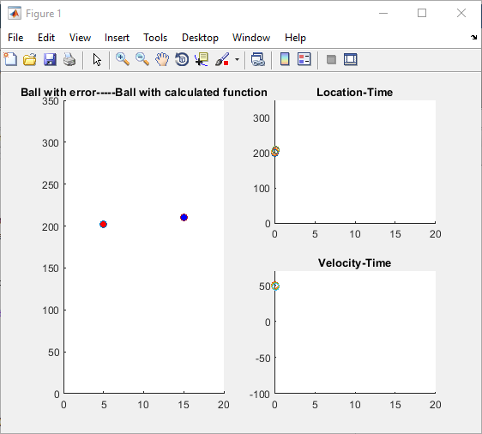

**FIGURE 4. Second part simulation window. The starting point for balls and graphs. The blue ball for estimated values and red ball for inaccurate values.**

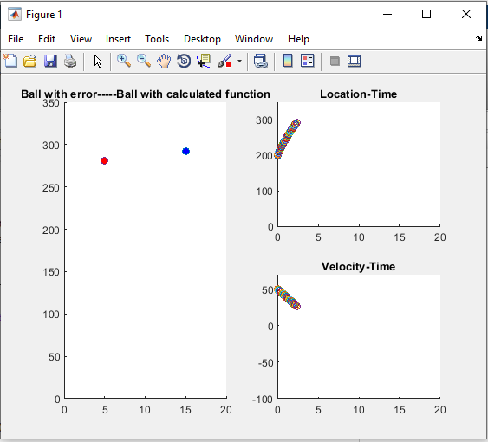

**FIGURE 5. Second part simulation window. The ball's location values are increasing. The blue ball for estimated values and red ball for inaccurate values.**

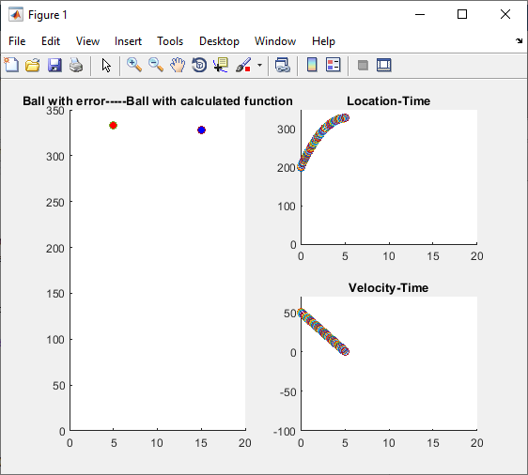

**FIGURE 6. Second part simulation window. The ball's location values are at top values. The blue ball for estimated values and red ball for inaccurate values.**

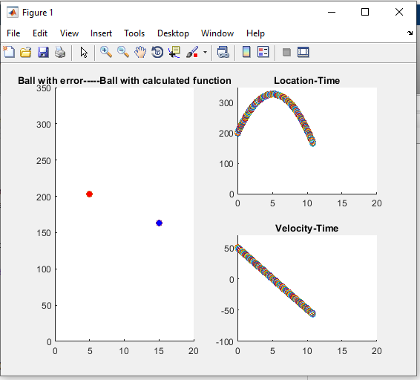

**FIGURE 7. Second part simulation window. The ball's location values are decreasing. The blue ball for estimated values and red ball for inaccurate values.**

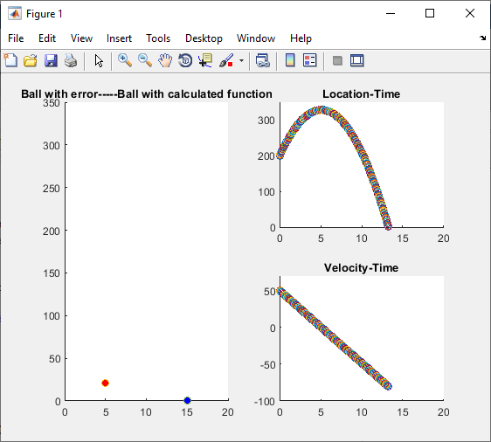

**FIGURE 8. Second part simulation window. The ball's location values are at the lowest values. The blue ball for estimated values and red ball for inaccurate values.**

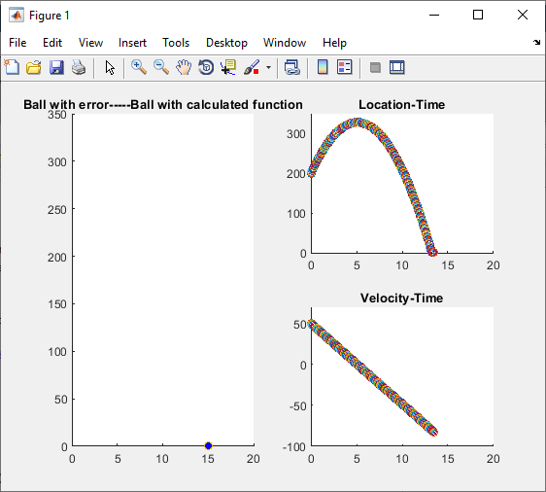

**FIGURE 9. Second part simulation window. The blue ball is on the floor and the red ball doesn’t appear because its time is finished. The blue ball for estimated values and red ball for inaccurate values.**

# Consequently

Last of all I learned what is regression and what is the logic of regression. I learned how I will apply it to the given data. How many types of regression there are? I used linear algebra in this study and i remembered it again.

References

1. <http://www.istatistik.gen.tr/?p=83>
2. <https://docplayer.biz.tr/21800933-Regresyon-ve-interpolasyon-ridvan-yakut.html>
3. <http://matlabogren.blogspot.com/2015/06/egri-uydurma-matlab-kodu.html>
4. <https://youtu.be/CXk30OZwK-Y>
5. <https://saniye21.wordpress.com/atis-formulleri/>
6. <https://eodev.com/gorev/657558>