LAB-MST
Q1: DROP TABLE department CASCADE;
CREATE TABLE department (
dept_id INT PRIMARY KEY,
dept_name VARCHAR(30)
);
DROP TABLE employee CASCADE;
CREATE TABLE employee (
emp_id INT PRIMARY KEY,
emp_name VARCHAR(50),
salary NUMERIC(10,2),
dept_id INT REFERENCES department(dept_id)
);
INSERT INTO department VALUES
(1, 'IT'),
(2, 'Sales'),
(3, 'HR');
INSERT INTO employee VALUES
(101, 'Aman', 90000, 1),
(102, 'Neha', 70000, 1),
(103, 'Raj', 50000, 1),
(104, 'Priya', 80000, 2),
(105, 'Karan', 60000, 2),
(106, 'Riya', 40000, 2),
(107, 'Mohit', 75000, 3),
(108, 'Simran', 55000, 3);
SELECT
d.dept_name AS "department",
e.emp_name AS "employee",
e.salary AS "salary"
FROM employee e
JOIN department d
ON e.dept_id = d.dept_id
WHERE e.dept_id IN (
SELECT dept_id
FROM employee
GROUP BY dept_id
HAVING COUNT(*) >= 3
)
AND e.salary > (
SELECT AVG(e2.salary)
FROM employee e2
WHERE e2.dept_id = e.dept_id
);

OUTPUT:
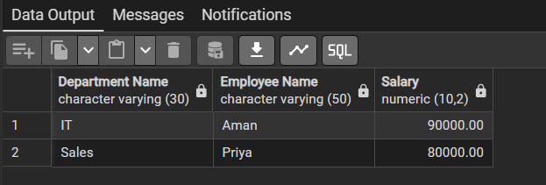

Q2: CREATE TABLE bank_customer (
customer_id INT PRIMARY KEY,
customer_name VARCHAR(50),
balance NUMERIC(10,2)
);
CREATE TABLE customer_audit (
audit_id SERIAL PRIMARY KEY,
customer_id INT,
customer_name VARCHAR(50),
action VARCHAR(20),
action_time TIMESTAMP
);
INSERT INTO bank_customer VALUES
(1, 'Rahul', 50000),
(2, 'Neha', 75000);
CREATE OR REPLACE FUNCTION log_customer_action()
returns trigger as $$
begin
IF TG_OP = 'INSERT' THEN
INSERT INTO customer_audit
(customer_id, customer_name, action, action_time)
VALUES
(NEW.customer_id, NEW.customer_name, 'ADDED', CURRENT_TIMESTAMP);
RETURN NEW;
ELSIF TG_OP = 'DELETE' THEN
INSERT INTO customer_audit
(customer_id, customer_name, action, action_time)
VALUES
(OLD.customer_id, OLD.customer_name, 'REMOVED', CURRENT_TIMESTAMP);
RETURN OLD;
END IF;
END;
$$ LANGUAGE plpgsql;
CREATE TRIGGER trg_customer_audit
AFTER INSERT OR DELETE
ON bank_customer
FOR EACH ROW
EXECUTE FUNCTION log_customer_action();
INSERT INTO bank_customer
VALUES (3, 'Aman', 60000);
DELETE FROM bank_customer
WHERE customer_id = 1;
select * from customer_audit;

OUTPUT:
