LAB-MST
Q1: Static Routing: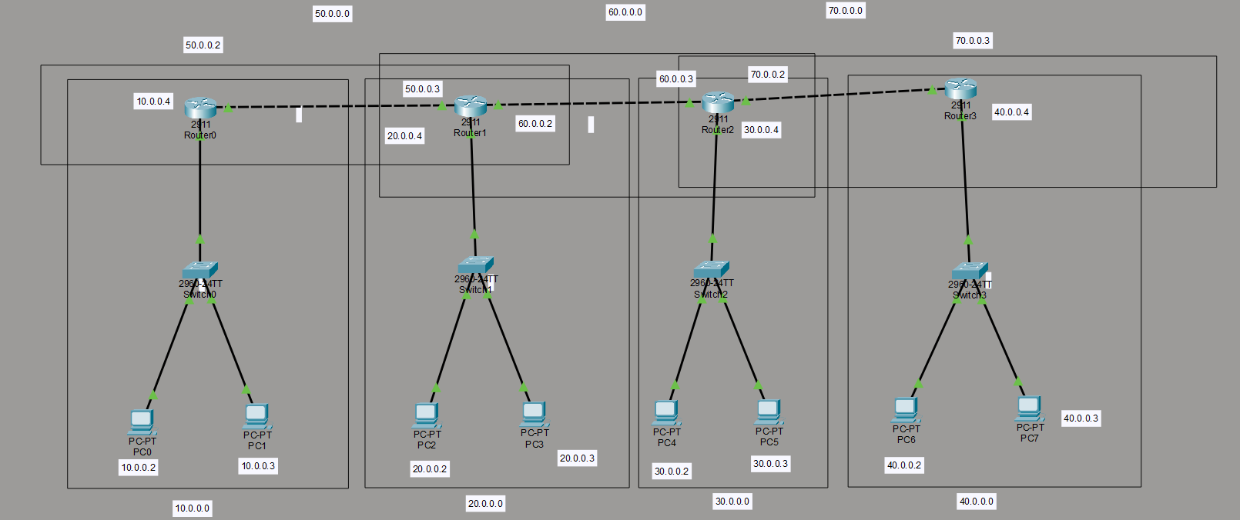
Steps of implementation:
1. Assign the IP addresses to all the end devices and networking devices:
Device | Interface/Network | IP
R0 LAN | 10.0.0.0/24 | R0 = 10.0.0.4
PC0 | 10.0.0.0/24 | 10.0.0.2
PC1 | 10.0.0.0/24 | 10.0.0.3
R0–R1 | 50.0.0.0/24 | R0 = 50.0.0.2, R1 = 50.0.0.3
R1 LAN | 20.0.0.0/24 | R1 = 20.0.0.4
PC2 | 20.0.0.0/24 | 20.0.0.2
PC3 | 20.0.0.0/24 | 20.0.0.3
R1–R2 | 60.0.0.0/24 | R1 = 60.0.0.2, R2 = 60.0.0.3
R2 LAN | 30.0.0.0/24 | R2 = 30.0.0.4
PC4 | 30.0.0.0/24 | 30.0.0.2
PC5 | 30.0.0.0/24 | 30.0.0.3
R2–R3 | 70.0.0.0/24 | R2 = 70.0.0.2, R3 = 70.0.0.3
R3 LAN | 40.0.0.0/24 | R3 = 40.0.0.4
PC6 | 40.0.0.0/24 | 40.0.0.2
PC7 | 40.0.0.0/24 | 40.0.0.3

2. Configure all the PC’s:
PC-0: IP Address: 10.0.0.2
Subnet Mask: 255.255.255.0
Default Gateway: 10.0.0.4
PC-1: IP Address: 10.0.0.3
Subnet Mask: 255.255.255.0
Default Gateway: 10.0.0.4
PC-2: IP Address: 20.0.0.2
Subnet Mask: 255.255.255.0
Default Gateway: 20.0.0.4
PC-3: IP Address: 20.0.0.3
Subnet Mask: 255.255.255.0
Default Gateway: 20.0.0.4
PC-4: IP Address: 30.0.0.2
Subnet Mask: 255.255.255.0
Default Gateway: 30.0.0.4
PC-5: IP Address: 30.0.0.3
Subnet Mask: 255.255.255.0
Default Gateway: 30.0.0.4
PC-6: IP Address: 40.0.0.2
Subnet Mask: 255.255.255.0
Default Gateway: 40.0.0.4
PC-7: IP Address: 40.0.0.3
Subnet Mask: 255.255.255.0
Default Gateway: 40.0.0.4

3. Configure the routers:
Router0: gig0/0: 10.0.0.2
Gig0/1: 50.0.0.2
And for routing:
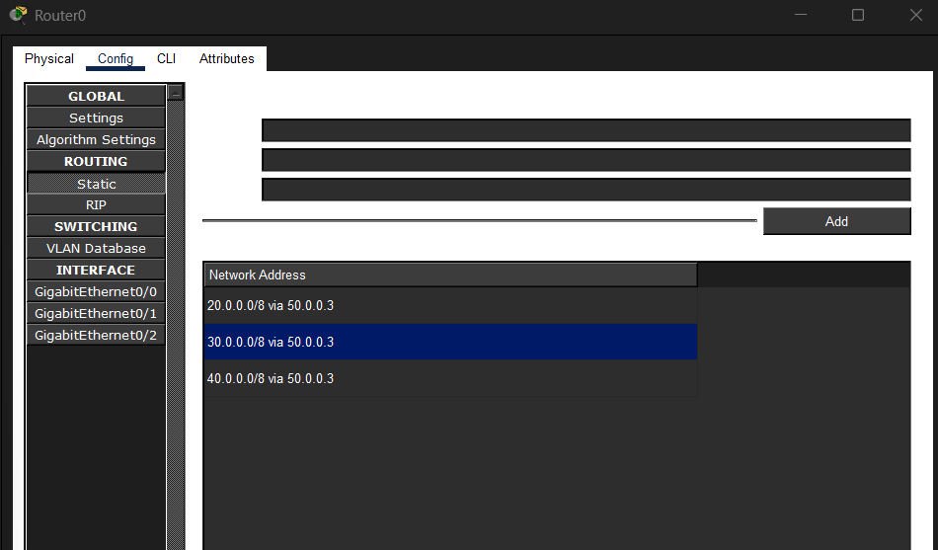

Router1: gig0/0: 20.0.0.4
Gig0/1: 50.0.0.3
Gig0/2: 60.0.0.2
And for routing:
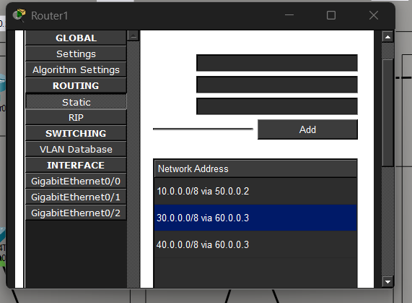

Router2: gig0/0: 30.0.0.4
Gig0/1: 60.0.0.3
Gig0/2: 70.0.0.2
And for routing:
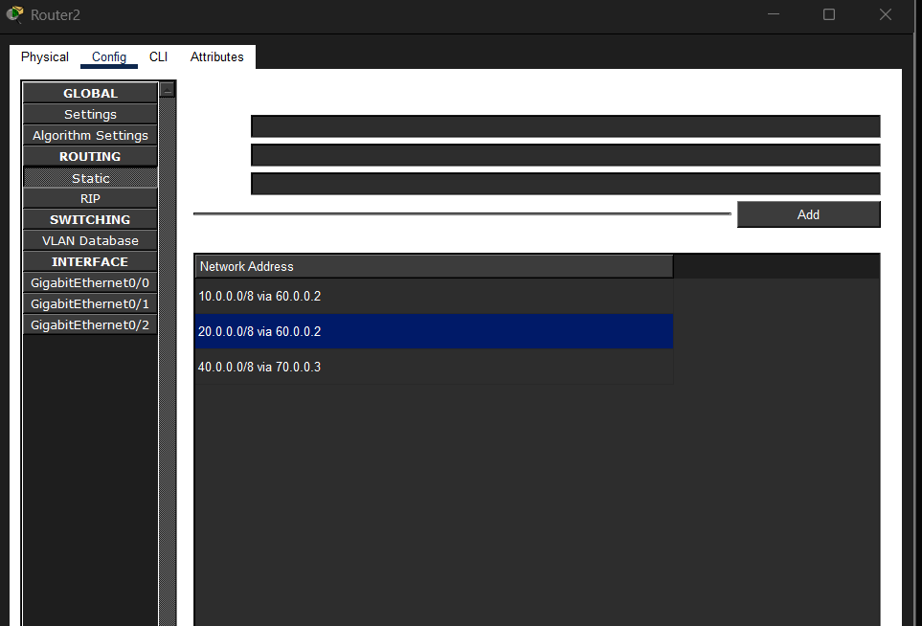
Router3: gig0/0: 40.0.0.4
Gig0/1: 70.0.0.3
And for routing:
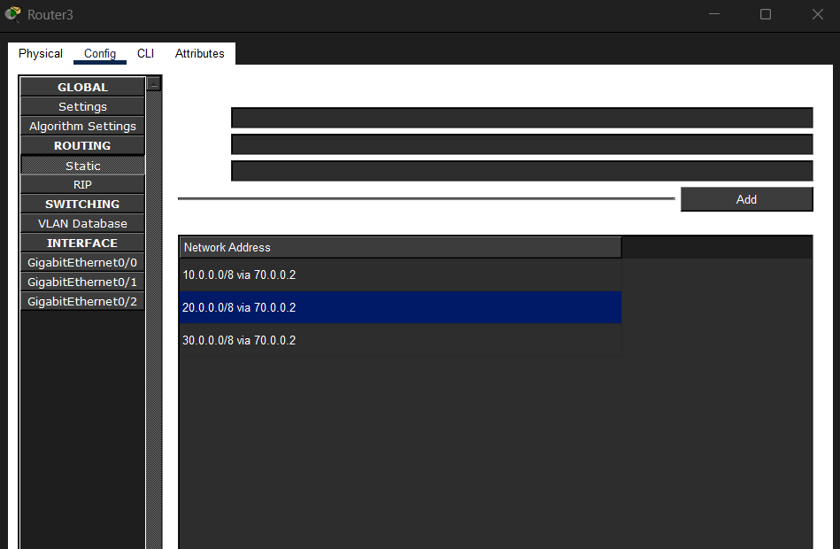
Connections between the networks:
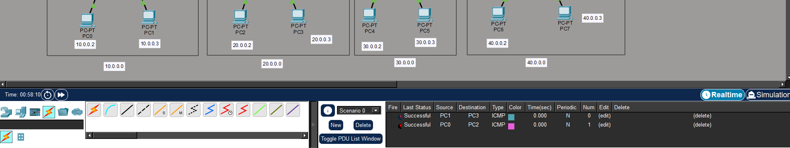

Q2: VLAN Creation:
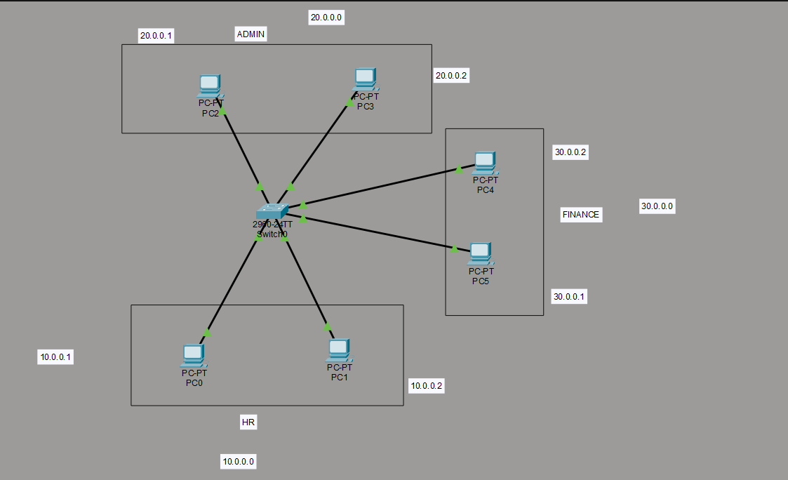
1. Connections between the devices:
PC | Department | IP | VLAN | Switch Port
PC0 | HR | 10.0.0.1 | 10 | Fa0/1
PC1 | HR | 10.0.0.2 | 10 | Fa0/2
PC2 | ADMIN | 20.0.0.1 | 20 | Fa0/3
PC3 | ADMIN | 20.0.0.2 | 20 | Fa0/4
PC4 | FINANCE | 30.0.0.1 | 30 | Fa0/5
PC5 | FINANCE | 30.0.0.2 | 30 | Fa0/6

2. Assign IP addresses to PC’s:
PC-0: IP Address: 10.0.0.1
Subnet Mask: 255.0.0.0
PC-1: IP Address: 10.0.0.2
Subnet Mask: 255.0.0.0
PC-2: IP Address: 20.0.0.1
Subnet Mask: 255.0.0.0
PC-3: IP Address: 20.0.0.2
Subnet Mask: 255.0.0.0
PC-4: IP Address: 30.0.0.1
Subnet Mask: 255.0.0.0
PC-5: IP Address: 30.0.0.2
Subnet Mask: 255.0.0.0

3. Configure the devices:
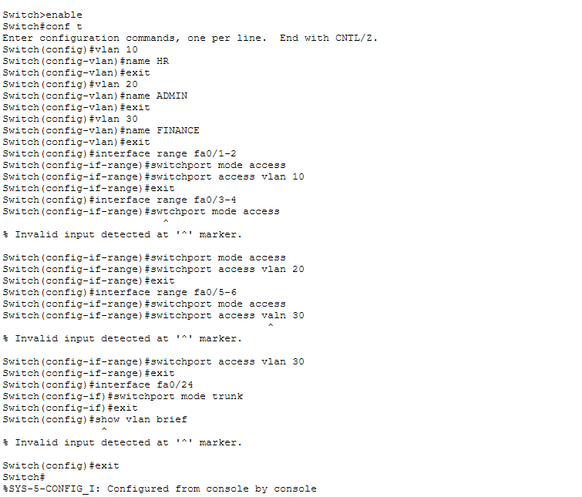
4. Checking the interfaces: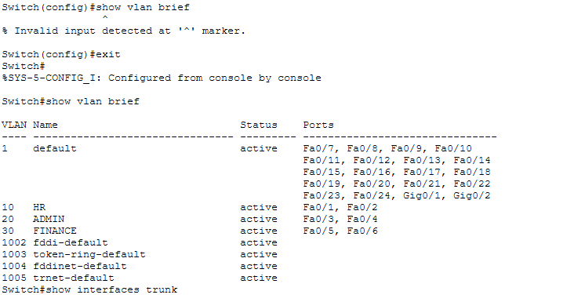
5. Check the connectivity between the networks:
