Student Name: Husanpreet Kaur UID: 24BCY70138
Branch: AIT-CSE (Cyber Security) Section/Group: 24AIT_KRG2
Semester: 4 Date of Performance: 27/02/2026
Subject Name: Database Management System Subject Code: 24CSH-298

WORKSHEET 7
AIM: To design and implement a materialized view and to compare and analyze execution time and performance differences between simple views, complex views, and materialized views.

S/W Requirement: • Database Management System: PostgreSQL / Oracle Database Express Edition
• Database Administration Tool: pgAdmin

OBJECTIVES:
- Create simple views
- Create complex views
- Create materialized views
- Compare execution time and performance of each

PROBLEM STATEMENT:
In large-scale enterprise systems, frequent execution of complex queries can significantly affect performance. Optimized mechanisms are required to improve query response time without compromising data consistency.

TABLE STRUCTURE:

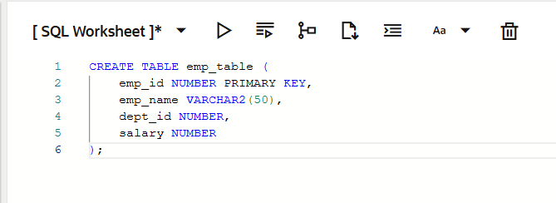

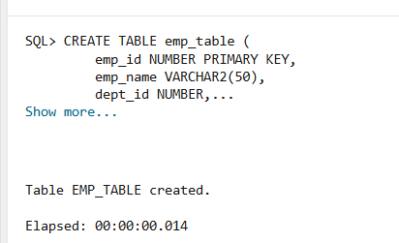
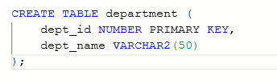
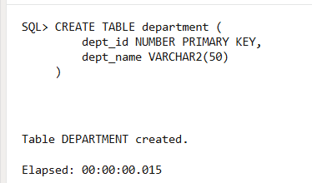
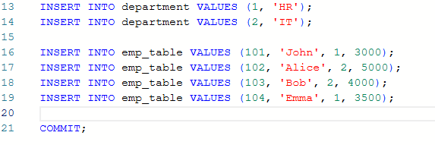
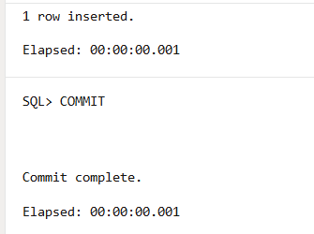

1. PROBLEM STATEMENT – Simple View

Create a simple view based on a single table.
PROGRAM:
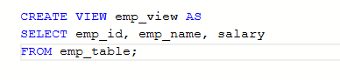
OUTPUT:
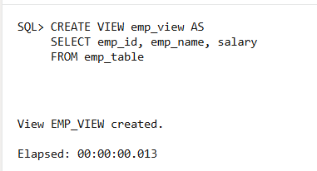

2. PROBLEM STATEMENT –Complex View
Create a complex view using join and aggregation.
PROGRAM:
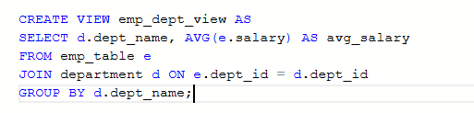
OUTPUT:
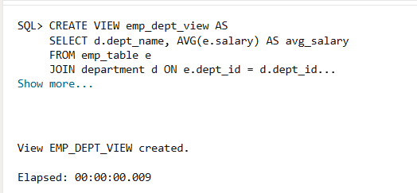

3. PROBLEM STATEMENT – Materialized View

Create a materialized view to store precomputed results.
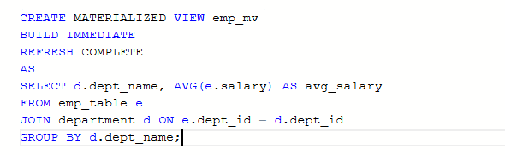
OUTPUT:
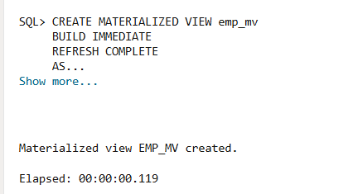
REFRESH MATERIALIZED VIEW:

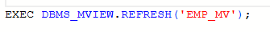
OUTPUT:
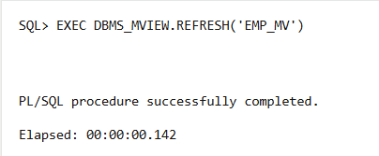

PERFORMANCE ANALYSIS:

QUERY ON SIMPLE VIEW:

OUTPUT:

QUERY ON COMPLEX VIEW:

OUTPUT:

QUERY ON MATERIALIZED VIEW:

OUTPUT:


LEARNING OUTCOMES:
11. Understood the concept of simple, complex, and materialized views
2. Learned how to create and use materialized views in Oracle
3. Compared performance between different types of views
4. Learned how materialized views improve query performance
5. Applied concepts useful in real-world applications

CONCLUSION:
This experiment demonstrated the differences between simple views, complex views, and materialized views. Materialized views improve performance by storing precomputed results, making them highly useful for data-intensive applications.

