Student Name: Husanpreet Kaur UID: 24BCY70138
Branch: AIT-CSE (Cyber Security) Section/Group: 24AIT_KRG2
Semester: 4 Date of Performance: 28/01/2026
Subject Name: Database Management System Subject Code: 24CSH-298

WORKSHEET 3
AIM: To design and implement a simple PL/SQL program that demonstrates the basic structure of a PL/SQL block using employee details. The program includes a declaration section for defining variables and an execution section for displaying employee information using output statements

S/W Requirement: Oracle Database Express Edition, SQL*Plus / Oracle SQL Developer
OBJECTIVES:
- To understand the basic structure of a PL/SQL block
- To declare and initialize variables in the DECLARE section
- To execute procedural statements in the BEGIN–END block
- To display output using DBMS_OUTPUT.PUT_LINE

Problem Description:
An organization wants to display basic employee details such as Employee ID, Employee Name, and Employee Salary using a PL/SQL program. The program should demonstrate the use of variable declaration and execution blocks and should print the stored values using appropriate output statements.

Program Design:
Variables Used
- emp_id – Stores Employee ID
- emp_name – Stores Employee Name
- emp_salary – Stores Employee Salary

- Database Design
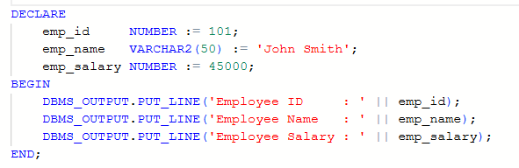
OUTPUT:
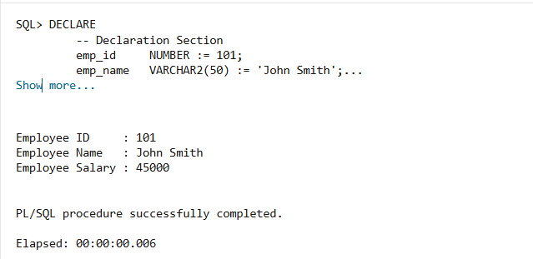
Learning Outcomes:
- Understood the structure of a basic PL/SQL block.
- Learned how to declare and initialize variables in PL/SQL.
- Gained practical experience in using DBMS_OUTPUT.PUT_LINE to display output.
- Improved understanding of procedural programming concepts in Oracle databases.

Conclusion:
This experiment successfully demonstrated the working of a basic PL/SQL program using employee details. By separating the declaration and execution sections, the program clearly illustrated how PL/SQL processes data and produces output. This experiment forms a foundation for learning advanced PL/SQL concepts such as conditional statements, loops, procedures, and functions.

