Student Name: Husanpreet Kaur UID: 24BCY70138
Branch: AIT-CSE (Cyber Security) Section/Group: 24AIT_KRG2
Semester: 4 Date of Performance: 18/04/2026
Subject Name: Database Management System Subject Code: 24CSH-298

WORKSHEET 9
AIM: To design and implement a package-like structure using schema in PostgreSQL that contains procedures/functions and shared cursors to retrieve employee details, demonstrating modular and reusable database programming.

S/W Requirement: Database Management System:
- Oracle Database Express Edition (Oracle XE)
- PostgreSQL Database
Database Administration Tool / Client Tool:
- Oracle SQL Developer (for Oracle XE)
- pgAdmin (for PostgreSQL)

OBJECTIVES:
To implement modular database programming using schema (as package equivalent), functions, and shared cursors in PostgreSQL.

PROBLEM STATEMENT:
In enterprise systems, related database operations must be grouped together for better maintainability, reusability, and performance. While Oracle provides packages, PostgreSQL achieves similar functionality using schemas and functions.

PRACTICAL/EXPERIMENT STEPS:
Design a package-like structure that:
- Contains procedures/functions to fetch employee details
- Uses a shared cursor to retrieve employee records
- Demonstrates execution of functions

TABLE STRUCTURE:
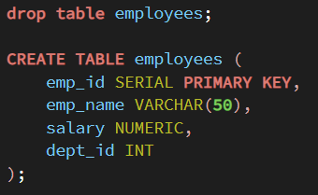
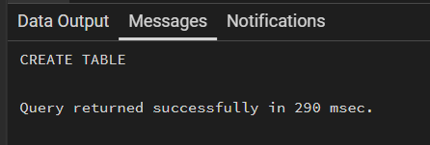
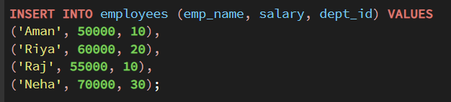

1. IMPLEMENTATION

Package Creation (Schema in PostgreSQL)
PROGRAM:
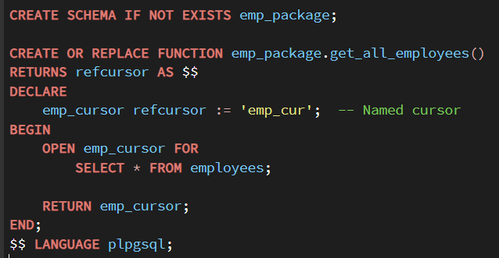
OUTPUT:
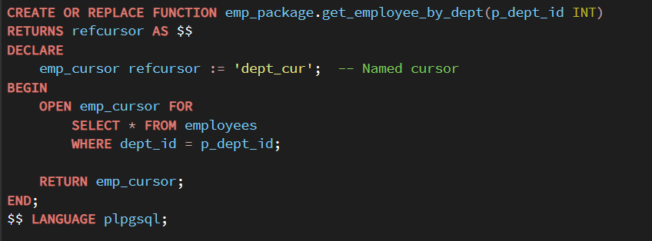
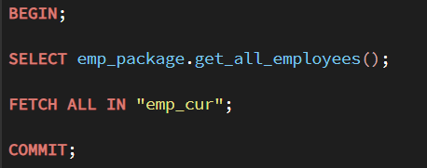
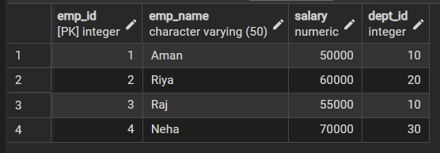
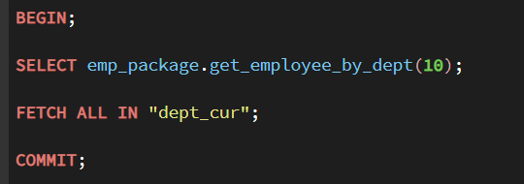
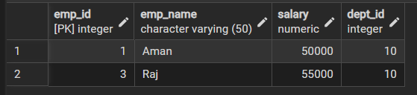

LEARNING OUTCOMES:
- Understand the concept of packages and their equivalent in PostgreSQL
- Differentiate between schema and package
- Implement functions with shared cursors

- Execute cursor-based data retrieval using FETCH
- Develop modular and reusable database logic used in organizations like Oracle Corporation and SAP

CONCLUSION:
The experiment successfully demonstrated the implementation of a package-like structure in PostgreSQL using schema and functions. By using shared cursors and modular logic, efficient and reusable database operations were achieved. This approach aligns with real-world enterprise practices, improving maintainability and scalability of database systems.

