Student Name: Husanpreet Kaur UID: 24BCY70138
Branch: AIT-CSE (Cyber Security) Section/Group: 24AIT_KRG2
Semester: 4 Date of Performance: 01/04/2026
Subject Name: Database Management System Subject Code: 24CSH-298

WORKSHEET 8
AIM: To design and implement a stored procedure that accepts gender as an input parameter and returns the total number of employees based on the given gender, thereby demonstrating procedural programming and parameterized logic in PL/SQL.

S/W Requirement: Database Management System:
- Oracle Database Express Edition (Oracle XE)
- PostgreSQL Database
Database Administration Tool / Client Tool:
- Oracle SQL Developer (for Oracle XE)
- pgAdmin (for PostgreSQL)

OBJECTIVES:
To write and execute a PL/SQL stored procedure that dynamically accepts gender as an argument and computes the employee count corresponding to the given gender.
- Create tables and insert data
- Implement stored procedures
- Use IN, OUT, and INOUT parameters

PROBLEM STATEMENT:
Organizations often require flexible reporting mechanisms to analyze workforce distribution based on gender for compliance, diversity tracking, and internal analytics.

PRACTICAL/EXPERIMENT STEPS:
Design a stored procedure that:
- Accepts gender as an input parameter

- Counts the total number of employees matching the given gender
- Returns the count as an output parameter

TABLE STRUCTURE:
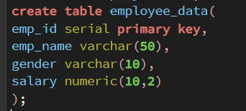
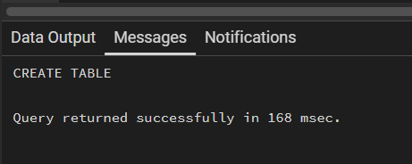
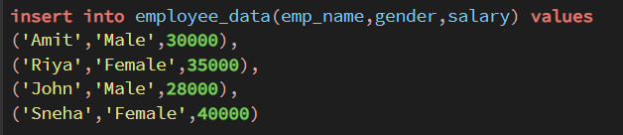
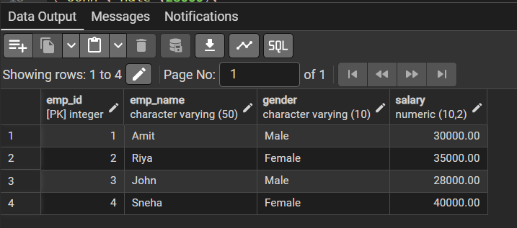
1. PROBLEM STATEMENT – Procedure Implementation

Create a procedure to count employees based on gender.
PROGRAM:
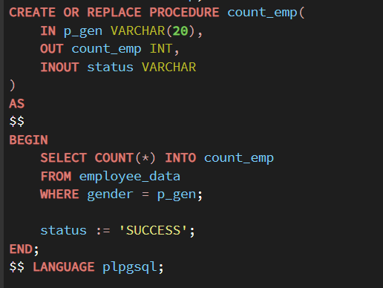
OUTPUT:
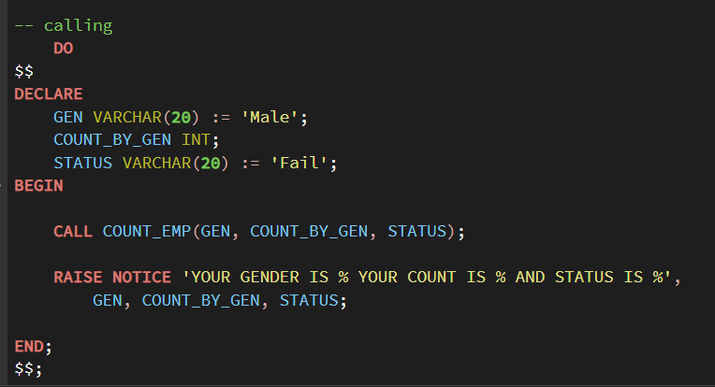
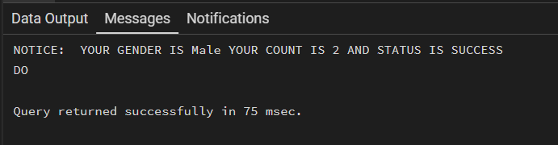

LEARNING OUTCOMES:
1. Understand the structure and components of a stored procedure
2. Implement IN and OUT parameters in PL/SQL procedures
3. Pass dynamic input values to stored procedures
4. Apply aggregate functions (like COUNT) within procedures

5. Develop reusable database logic for real-world business scenarios used in companies like CData and Toddle

CONCLUSION:
The experiment successfully demonstrated the design and implementation of a parameterized PL/SQL stored procedure to calculate employee count based on gender. By using IN and OUT parameters along with aggregate functions, dynamic and reusable database logic was achieved. This method improves efficiency in data retrieval and supports real-world organizational requirements such as workforce analysis and reporting.

