Student Name: Husanpreet Kaur UID: 24BCY70138
Branch: AIT-CSE (Cyber Security) Section/Group: 24AIT_KRG2
Semester: 4 Date of Performance: 27/02/2026
Subject Name: Database Management System Subject Code: 24CSH-298

WORKSHEET 6
AIM: To understand the concept and working of cursors in PL/SQL for row-by-row data processing, and to analyze how implicit cursors, explicit cursors, and cursor attributes are used to implement business logic on multiple rows in a database table.

S/W Requirement: • Database Management System: PostgreSQL / Oracle Database Express Edition
• Database Administration Tool: pgAdmin

OBJECTIVES:
To implement and analyze the use of:
- Implicit cursors
- Explicit cursors
- Cursor attributes
for processing multiple rows from a database table and applying business logic effectively.

PROBLEM STATEMENT:
In real-world enterprise applications, database queries often return multiple rows that need to be processed individually to apply specific business rules.
PRACTICAL/EXPERIMENT STEPS:
Design and execute PL/SQL programs that demonstrate:
- The use of implicit cursors for single-row DML operations
- The use of explicit cursors to fetch and process multiple records
- The application of cursor attributes to control program execution.

- PROBLEM STATEMENT – Implicit Cursor

Write a PL/SQL program to update salary and display the number of rows affected using an implicit cursor.
PROGRAM:
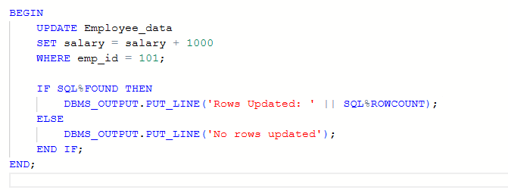
OUTPUT:
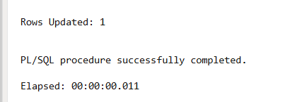

- PROBLEM STATEMENT – Explicit Cursor

Fetch and display employee records using an explicit cursor.
PROGRAM:
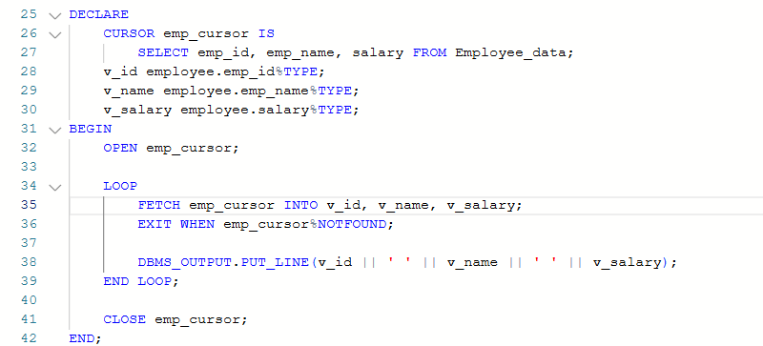

OUTPUT:

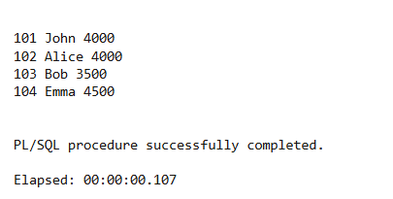

- PROBLEM STATEMENT –Cursor Attributes
Demonstrate the use of cursor attributes such as %FOUND, %NOTFOUND, and %ROWCOUNT.
PROGRAM:
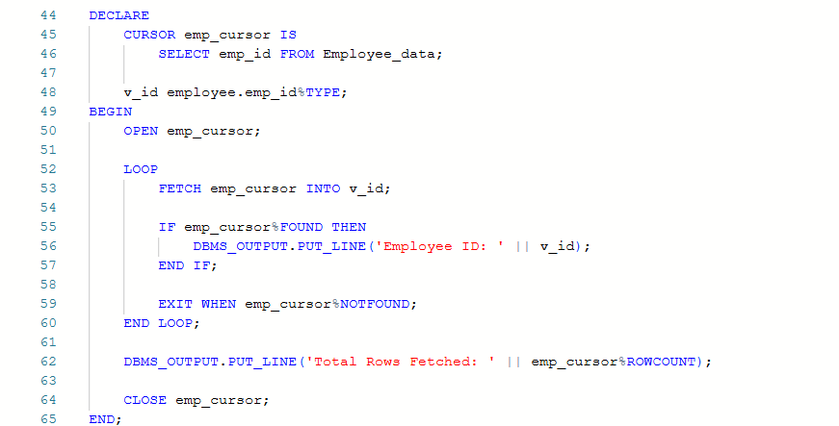
OUTPUT:
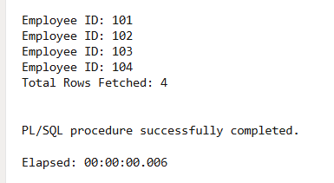

LEARNING OUTCOMES:
1. Understood the role of cursors in PL/SQL for handling multi-row query results
2. Learned the difference between implicit and explicit cursors
3. Used cursor attributes such as %FOUND, %NOTFOUND, %ROWCOUNT, and %ISOPEN
4. Developed PL/SQL programs to process records row by row
5. Applied cursor-based logic in practical database scenarios.

CONCLUSION:
This experiment demonstrated the use of implicit and explicit cursors in Oracle PL/SQL.

