

**Computer Science Department**

**COMP133 ( Spring 2022)**

**Project Phase One *Due Date: Monday 16/05/2022 by 10:00 pm ( on Ritaj )***

Each student will have to build a ***student management system*** for adding, deleting, or searching for students in the department. Each student in the department will have a name (*string*), student id number (*four digit integer*), and an average (*double*). When the program starts, it will load existing student information from a text file and when the program exits, it will save all changes made while running the program to that same file.

After the student information is loaded from the file ***( In this phase all you need to do is just print a message that the student information is loaded, but you don’t really open any files or load anything)*** , the program will display the following main menu to the user:

***Please Select an Operation (1-4):***

***1- Add a Student***

***2- Remove a Student***

***3- Search for a Student***

***4- Exit System***

This menu will keep showing after each time a user selects an operation and that operation is performed. When the user selects operation 4 (exit system), the program will load all changes (updates) to the file ***( In this phase all you need to do is just print a message that the student information is updated, but you don’t really open any files or update anything)*** and will then exit.

Your program should at least contain the following functions:

void displayMainMenu(); // displays the main menu shown above

void addStudent(); // adds information for a new student

void removeStudent(); // removes information of old student

void searchForStudent(); // searches for a student in the dept.

void uploadDataFile(); // uploads student data from file

void updateDataFile(); // saves student data updates to file

**For this phase those functions are just void functions that will mostly contain *printf* statements just to print what they are supposed to do. In later phases, the function prototypes will change and the functions will do more.**

**For example:**

***The addSudent() function will be as follows and so forth:***

***void addStudent()***

***{***

***printf("Student info has been added\n");***

***}***

**Items that should be turned in by each student:**

1. ***A copy of your main.c file***
2. ***An image of a complete run similar to the output shown on page 3.***

Make sure your program works **very similar** to the following sample run:

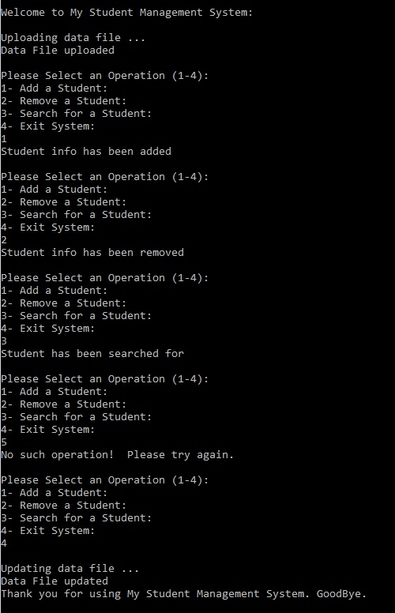

***Late project phases will not be accepted for any reason***.