**NVR Systems – Basics, Components, and Benefits**

NVR is a network-attached computer system that includes a software program for recording video in a digital format to storage devices such as a disk drive, USB flash drive, SD memory card, and many more. Popularly known as POE security camera systems, it is more flexible than DVR systems. The following components are required to set up an NVR system.

* IP Cameras:

NVR system uses IP cameras, which act as standalone image capturing devices. These cameras are capable of processing video data before sending it to the recorder. IP cameras are robust, and capable of recording and transmitting audio in addition to the image. Advanced hardware on these cameras improves intelligent video analytics such as license plate and facial recognition.

* Ethernet Cables:

The NVR system makes use of standard Ethernet cables such as Cat5e and Cat6 to connect the camera to the recorder. They are easier to set up owing to their thin size and shape and cost-effectiveness and easy availability compared to coaxial cables.

* Recorder:

The NVR recorder is only responsible for storing and viewing the footage. The system doesn’t process video data.

**DVR Systems – Basics, Components, and Benefits**

The DVR system is designed for recording video in a digital format. These security systems are priced lower than NVR systems, and this is one of the advantages of DVR systems, especially for small or domestic applications which do not encompass long-distance data transfer or remote viewing.

* Analog Cameras:

As discussed before, the DVR system uses analog cameras. The camera is responsible for streaming an analog single to the recorder, which then processes the video data. Unlike NVRs, most DVR cameras are less expensive.

* Coaxial Cables:

The [coaxial cables](https://www.versitron.com/blog/optical-coaxial-and-hdmi-cables-what-is-good-for-your-audio-connection) connect the analog camera to the DVR system. The use of coaxial cable may not seem significant due to their limitations; however, ultimately data is transferred over this cable type. Coaxial cable does not support power supplying devices on the same line. Thus, another cable is needed to carry electrical signals, while the other cable carries data signals for video transmission. These cables are stiffer and wider than Ethernet cables, making installation a challenge. Also, audio is a limitation as the standard coaxial cable may not support audio transmission.

* AD Encoder:

DVR recorders heavily rely on AD encoders, which is responsible for processing the raw data streaming from the camera into viewable footage. Thus, every [security camera system](https://www.versitron.com/blog/factors-to-consider-when-buying-security-cameras) needs to be connected to both the recorder and a separate power source.

|  |  |  |
| --- | --- | --- |
| 01. | DVR stands for Digital Video Recorder. | NVR stands for Network Video Recorder. |
| 02. | It is mainly used for recording data from analog cameras or coaxial based cameras. | It is mainly used for recording data from IP cameras wirelessly over a network. |
| 03. | DVR is paired with analog coax based cameras with resolution  2MP maximum. | NVR is paired with IP cameras with resolution ranging from 2MP to 12MP or higher. |
| 04. | DVR uses Coax cables as transmission cable. | NVR uses Ethernet cables as transmission cable. |
| 05. | It has lower recording quality than Network Video Recorder. | It has higher recording quality than Digital Video Recorder. |
| 06. | DVR system setup is tougher as compared to NVR. | NVR system setup is easier as compared to DVR. |
| 07. | DVR camera cost is lower. | NVR camera cost is higher. |
| 08. | Signal stability is independent upon the internet working. | Signal stability depends upon the internet working. |
| 09. | DVR needs lower operating cost than NVR. | NVR needs higher operating cost than DVR. |
| 10. | In DVR system both power cable and audio/video cable needed. | In NVR system wireless or single Ethernet cable is used for power & data. |
| 11. | It can not be placed anywhere as it is limited by the coax cable. | It can be placed anywhere with a network access. |

**DVR NVR**

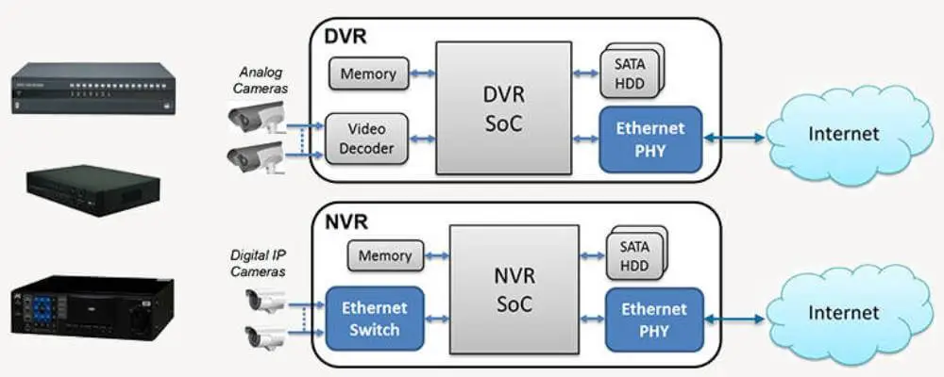

#### **Types of DVRs**

Currently, there are three types of DVRs in use. These include the following:’

**1.** PC-based DVRs: These come integrated with your personal computer and contain the following:

* Memory drive
* Network card
* Motherboard
* DVR capture
* Network board

2. **Embedded DVRs**

The way that this system works is basic. It takes input from an analog CCTV camera, converts it into digital before compressing and saving it to its local HDD.

**3.Hybrid DVRs**

This takes video inputs from IP as well as CCTV cameras and works well if you’re transitioning from an analog system to an IP one. This means that you can have the best of both worlds at your home:

High-resolution IP cameras: In high-risk areas

Low-resolution CCTV cameras: In low-risk, less vulnerable spots

#### **Types of NVRs**

There are three types of NVR systems available to choose from.

**1.4.Channel NVR Security System**

The entry-level NVR has applications for your home, a small office or a retail store. It works well with IP cameras and doesn’t come with additional hardware or software requirements.

**2.**  **8-Channel NVR Security System**

This works like a 4-Channel NVR system but is compatible with up to 8 IP cameras. The procedure of connecting to the cameras remains the same, the NVR automatically searches for and connects to the cameras.

**3. 16-Channel NVR Security System**

This is ideal for a large house, warehouse, departmental store, etc. where multiple cameras become necessary. This works like the 4-channel and 8-channel systems do, but, can connect to up to 16 IP cameras at a time.  
  
However, you need to have a big enough HDD to store data from 16 cameras.  

