CS-484 Homework 1 Question 2

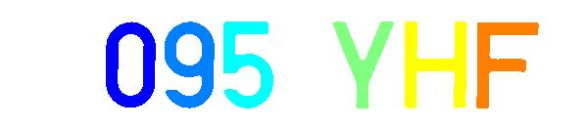



Figure 1: Above are example plate images, first thresholded, then applied erosion and dilation opearations and after used connected component labeling. All results are given in the last page.

Firstly I extracted all color channels, then I thresholded using

thresholded_img = blue_channel < 65 & red_channel < 70 & green_channel < 70;

After thresholding, I had some extra unwanted pieces in the image such as dots, lines, hyphens seperating the parts of the plate etc. These generally were smaller than the digits and letters so I used erosion to delete them. I used erosion 2 times first with 7x7 and then 3x3 square structuring element. For generating the structuring elements I used strel function [1] As below:

% Use Erosion to get rid of small things

se = strel("square",7);

eroded_img = erosion(thresholded_img,se);

se = strel("square",3);

eroded_img = erosion(eroded_img,se);

After that, I wanted to recover the letters and digits, I used conditional dilation with 5x5 diamond structuring element. I iterated 25 times with the conditional dilation. With the code below:

se = strel("diamond",5);

dilated_img = dilate(eroded_img,se);

for j = 1:25

temp = dilated_img & thresholded_img;

dilated_img = dilate(temp,se);

end

dilated_img = dilated_img & thresholded_img;

With these morphological operations, I got the center image in Figure 1 above. Then I used Matlab’s bwconncomp [2] function to do connected component analysis on the dilated images, after connected component analysis, I got the right image in Figure 1.

This example is of course cherry picked among the results. In some of the plate images, the lines covering the edges of the plate had a similar width with the letters and digits. Because of this, I couldn’t erase edge lines without losing the digits or letters. Since I could not erase them, connected component analysis labeled them as another block. Therefore, I couldn’t erase them. Also, there were some smaller letters on the plates. These were lost because the structuring elements that would erase unwanted details also erased them too. I could get a better result if I would work specially with one image, but changes in morphological operations produced good results with one example but worsened others. So I tried to optimize operations for all of the dataset.

Also, my function takes another argument i which is index number of the license plate, which is only used naming the result image file.

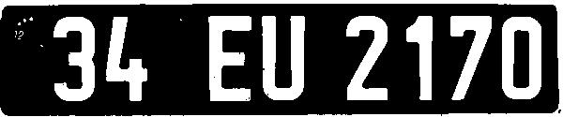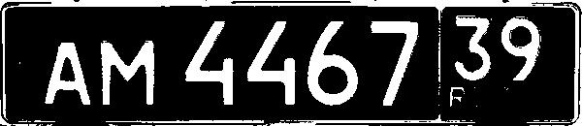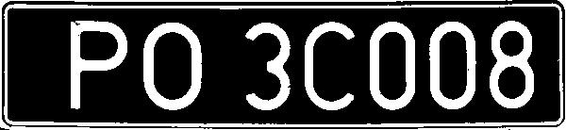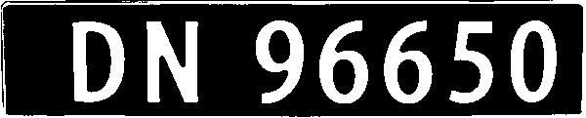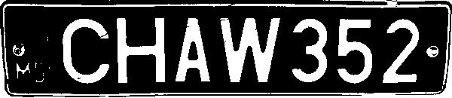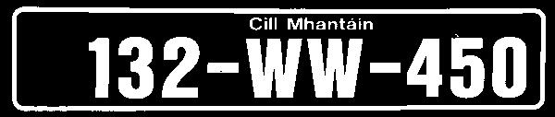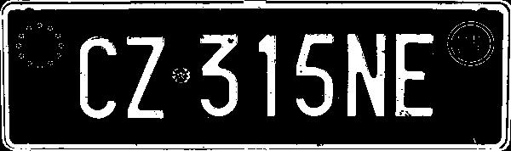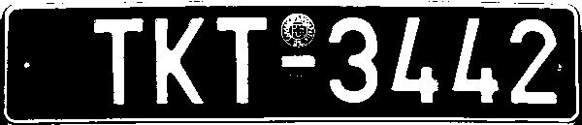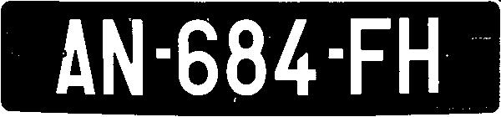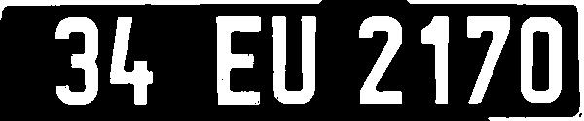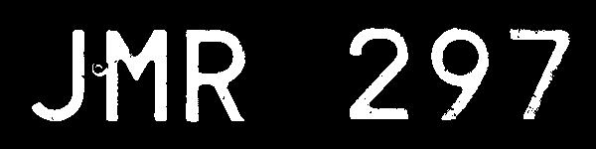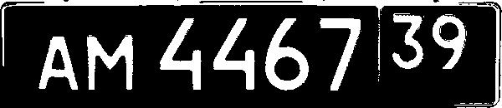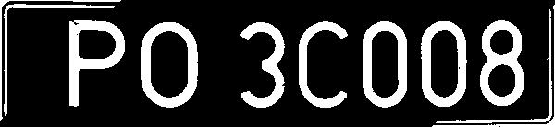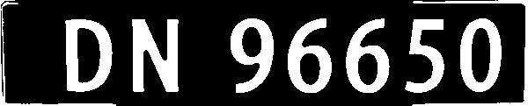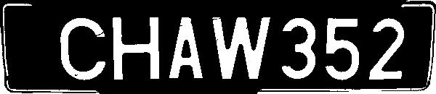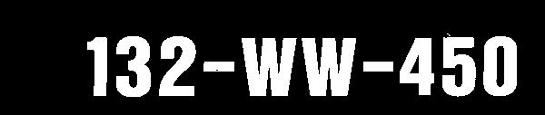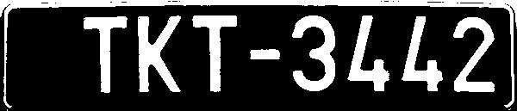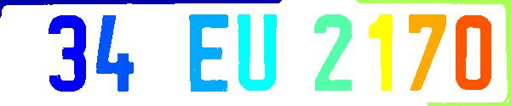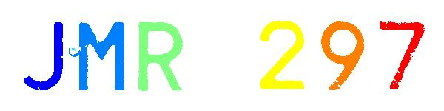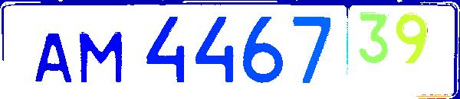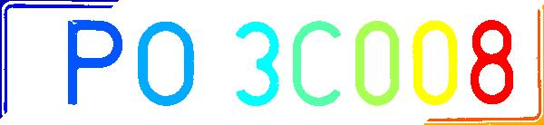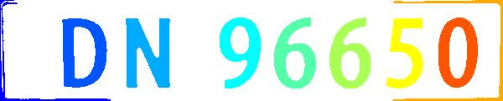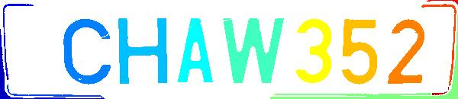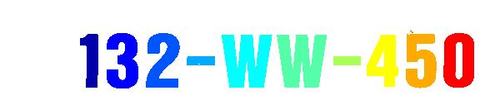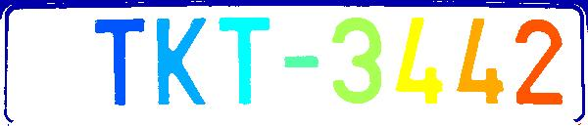

(The first 12 pictures are results of thresholding, second 12 are results of morphological operations and the last 12 are from connected component analysis)

# Works Cited

|  |  |
| --- | --- |
| [1] | [Online]. Available: https://www.mathworks.com/help/images/ref/strel.html. |
| [2] | [Online]. Available: https://www.mathworks.com/help/images/ref/bwlabel.html. |