Crypto Lab – One-Way Hash Function and MAC

Copyright *§*c 2006 - 2014 Wenliang Du, Syracuse University.

The development of this document is/was funded by three grants from the US National Science Foundation: Awards No. 0231122 and 0618680 from TUES/CCLI and Award No. 1017771 from Trustworthy Com- puting. This lab was imported into the Labtainer framework by the Naval Postgraduate School, Center for Cybersecurity and Cyber Operations under National Science Foundation Award No. 1438893. Permission is granted to copy, distribute and/or modify this document under the terms of the GNU Free Documentation License, Version 1.2 or any later version published by the Free Software Foundation. A copy of the license can be found at [http://www.gnu.org/licenses/fdl.html.](http://www.gnu.org/licenses/fdl.html)

# Overview

The learning objective of this lab is for students to get familiar with one-way hash functions and Message Authentication Code (MAC). After finishing the lab, in addition to gaining a deeper unders

tanding of the concepts, students should be able to use tools and write programs to generate one-way hash value and MAC for a given message.

# Lab Environment

The lab is started from the Labtainer working directory on your Docker-enabled host, e.g., a Linux VM. From there, issue the command:

labtainer onewayhash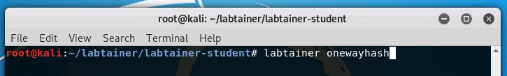

The resulting virtual terminals will include a display of a bash shell. The openssl package and other software described below are pre-installed on the system.

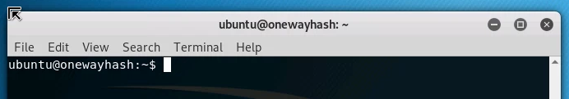

# Lab Tasks

## Task 1: Generating Message Digest and MAC

In this task, we will play with various one-way hash algorithms. You can use the following openssl dgst command to generate the hash value for a file. To see the manpages, you can type man openssl and man dgst.

% openssl dgst dgsttype filename

Please replace the dgsttype with a specific one-way hash algorithm, such as -md5, -sha1, -sha256, etc. And replace filename with filetodigest.txt, which is in your home directory. In this task, you should try at least 3 different algorithms, and describe your observations. You can find the supported one-way hash algorithms by typing "openssl dgst -h" NOTE: the list of algorithms included in the manpages is not correct.

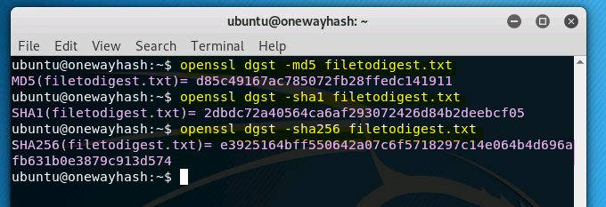

## Task 2: Keyed Hash and HMAC

In this task, we would like to generate a keyed hash (i.e. MAC) for a file. We can use the -hmac option (this option is currently undocumented, but it is supported by openssl). The following example generates a keyed hash for a file using the HMAC-MD5 algorithm. The string following the -hmac option is the key.

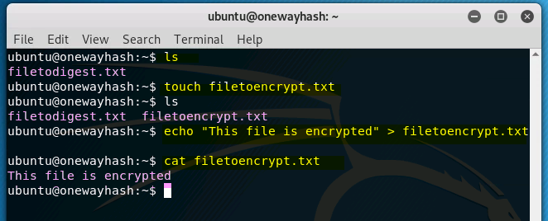

% openssl dgst -md5 -hmac "abcdefg" filename

Please generate a keyed hash using HMAC-MD5, HMAC-SHA256, and HMAC-SHA1 for any file that you choose. Please try several keys with different length. Do we have to use a key with a fixed size in HMAC? If so, what is the key size? If not, why?

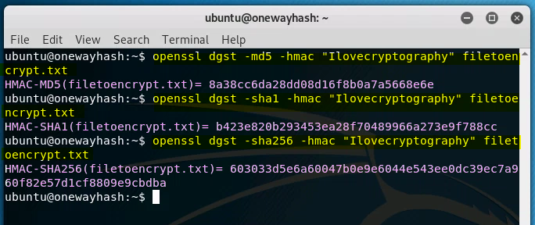

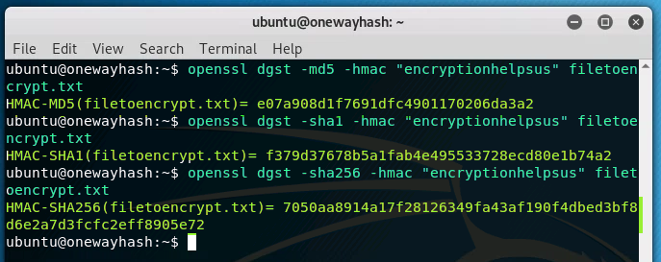

## Task 3: The Randomness of One-way Hash

To understand the properties of one-way hash functions, we would like to do the following exercise for MD5 and SHA256:

* + 1. Create a text file named ”edit-this-file.txt” of any length. 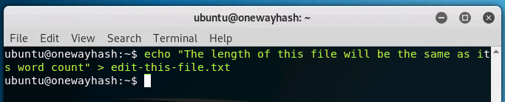
    2. Generate the hash value *H*1 for this file using a specific hash algorithm.

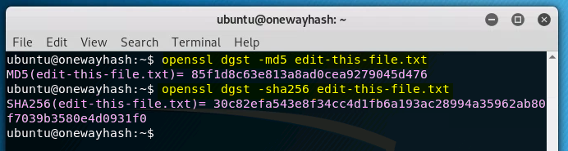

* + 1. Flip one bit of the input file. You can achieve this modification using hexedit. 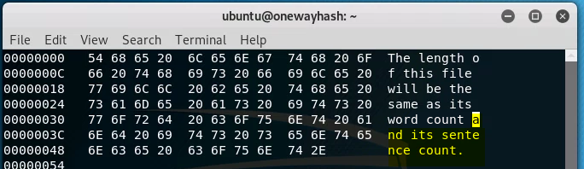

4.Generate the hash value *H*2 for the modified file.

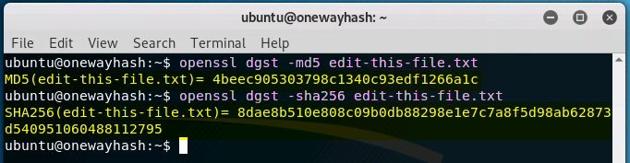

5.Please observe whether *H*1 and *H*2 are similar or not. Please describe your observations in the lab report. You can write a short program to count how many bits are the same between *H*1 and *H*2.

## Task 4: One-Way Property versus Collision-Free Property

In this task, we will investigate the difference between hash function’s two perperties: one-way property versus collision-free property. We will use the brute-force method to see how long it takes to break each of these properties. Instead of using openssl’s command-line tools, you are required to write our own C programs to invoke the message digest functions in openssl’s crypto library. A sample code can be found from [http://www.openssl.org/docs/crypto/EVP_DigestInit.html.](http://www.openssl.org/docs/crypto/EVP_DigestInit.html) Please get familiar with this sample code.

Since most of the hash functions are quite strong against the brute-force attack on those two properties, it will take us years to break them using the brute-force method. To make the task feasible, we reduce the length of the hash value to 24 bits. We can use any one-way hash function, but we only use the first 24 bits of the hash value in this task. Namely, we are using a modified one-way hash function. Please design an experiment to find out the following:

* + 1. How many trials it will take you to break the one-way property using the brute-force method? You should repeat your experiment for multiple times, and report your average number of trials.
    2. How many trials it will take you to break the collision-free property using the brute-force method?

Similarly, you should report the average.

* + 1. Based on your observation, which property is easier to break using the brute-force method?
    2. (10 Bonus Points) Can you explain the difference in your observation mathematically?

# Submission

When the lab is completed, or you’d like to stop working for a while, run

stoplab onewayhash

from the host Labtainer working directory. You can always restart the Labtainer to continue your work. When the Labtainer is stopped, a zip file is created and copied to a location displayed by the stoplab com- mand. When the lab is completed, send that zip file to the instructor.

You need to submit a detailed lab report to describe what you have done and what you have observed; you also need to provide explanation to the observations that are interesting or surprising. In your report, you need to answer all the questions listed in this lab.