Title: VPN Lab Exercise (host-to-host VPN)

1. Background

This Labtainer exercise illustrates a simple host-to-host vpn implemented with openvpn, and a static shared key.

The example network includes a client and a server with a router between them. The server offers a simple HTTP service, and the student will use wget on the client to retrieve html files from the server.

The openvpn application is pre-installed on the client and the server, and the corresponding openvpn configurtion files already exist. To create an encrypted tunnel, the student only has to execute openvpn on the client and the server.

The student will observe both unencrypted and encrypted network traffic using tcpdump on the router.

2. Performing the lab

The lab is started from the Labtainer working directory on your Docker-enabled host, e.g., a Linux VM. From there, issue the command:

labtainer vpnlab

The resulting virtual terminals include a display of these instructions, a terminal connected to a client, and a terminal connected to a server.

To navigate this instruction, the arrow keys along with the Space/Home/End/Page-Up/Page-Down keys are usable.

To exit navigation of this instruction, type 'q'.

3. Tasks

3.1 Use tcpdump on the router to display network traffic:

sudo tcpdump -n -XX -i eth0

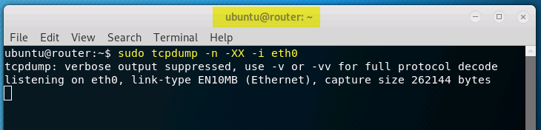

3.2 Use wget on the client to fetch the index.html file

wget <http://<IPADDr>/index.html>

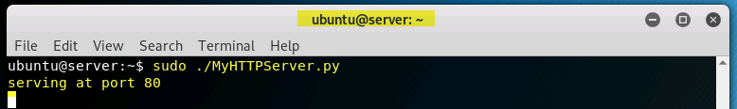

Use “Ctrl + Z” to continue.

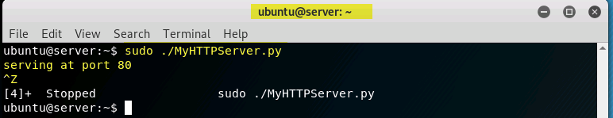

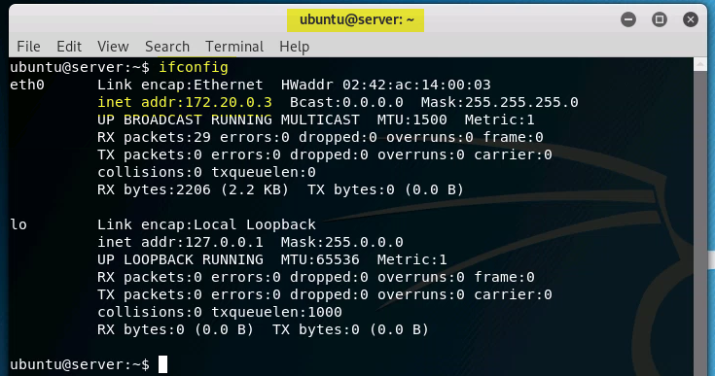

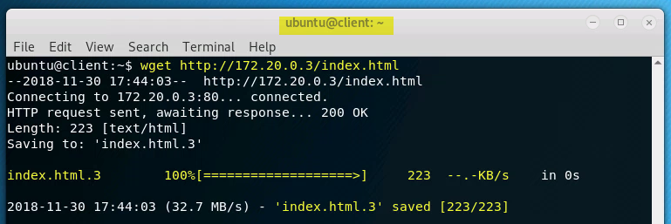

Where <IPADDR> is the server network address, which you can learn by running "ifconfig" on the server.

Observe the network traffic from tcpdump. Note plain-text html in the data stream.

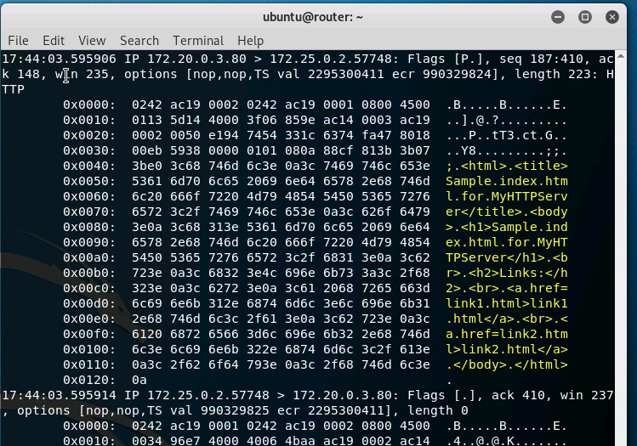

3.3 Start the openvpn program on the server:

sudo openvpn --config server.conf --daemon

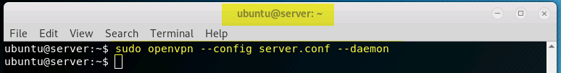

3.4 Start the openvpn program on the client:

sudo openvpn --config client.conf –daemon

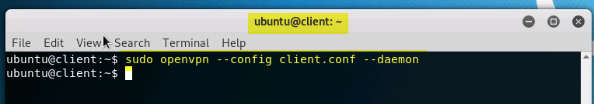

3.5 Use wget again, but this time using the server's tunnel address, (which appears in interface "tun0" of output from ifconfig).

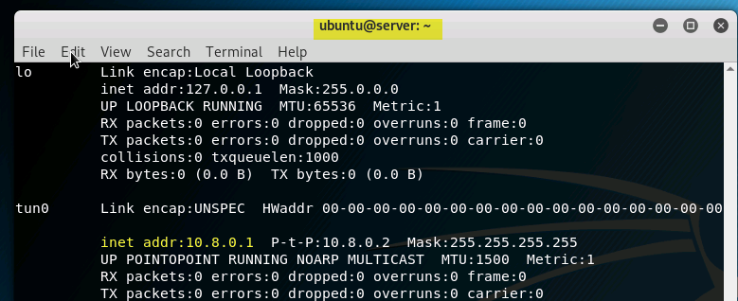

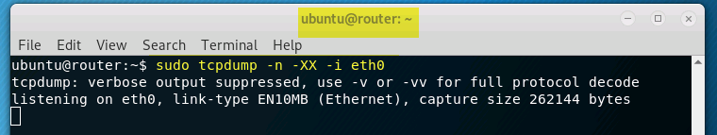

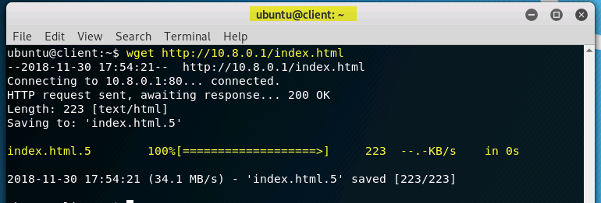

Observe the network traffic in tcpdump.

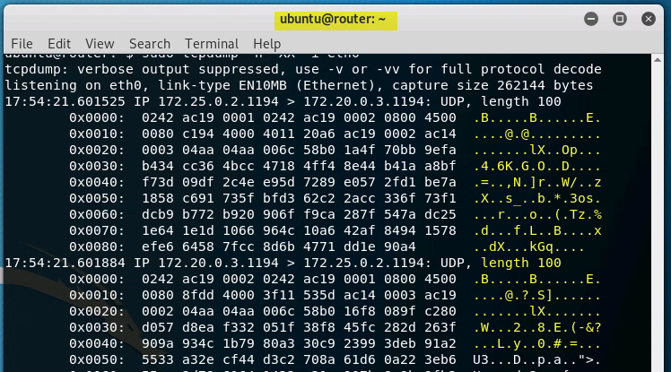

4. Stop the Labtainer

When the lab is completed, or you'd like to stop working for a while, run

stoplab vpnlab

from the host Labtainer working directory. You can always restart the

Labtainer to continue your work. When the Labtainer is stopped, a

zip file is created and copied to a location displayed by the stoplab

command. When the lab is completed, send that zip file to the instructor.