Title: VPN Lab Exercise (host-to-gateway VPN)

1. Background

This Labtainer exercise illustrates a simple host-to-gateway vpn implemented with openvpn, and a static shared key.

The example network is identical to that in the "host-to-host VPN" lab exercise, except there is now gateway in front of the server.

As with the previous exercise, the server offers a simple HTTP service, and the student will use wget on the client to retrieve html files from the server.

The openvpn application is pre-installed on the client and the gateway, and the corresponding openvpn configuration files already exist. To create an encrypted tunnel, the student only has to execute openvpn on the client and the gateway.

In this exercise, the student will observe that the client is unable to reach the server until the openvpn tunnel is established. And, use of the gateway allows the client to name the server using the server's network address rather than the network address associated with the tunnel as was required in the host-to-host VPN lab exercise.

2. Performing the lab

The lab is started from the Labtainer working directory on your Docker-enabled host, e.g., a Linux VM.

From there, issue the command:

labtainer vpnlab

If an error occur like shown below

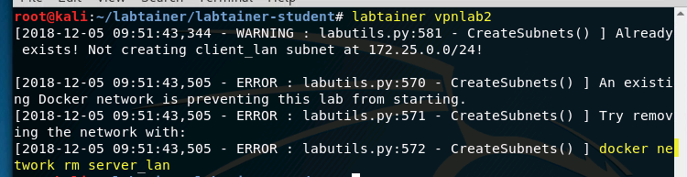

Use command shown below.



Now try again to execute

labtainer vpnlab2

The resulting virtual terminals include a display of these instructions, a terminal connected to a client, and a terminal connected to a server.

To navigate this instruction, the arrow keys along with with the Space/Home/End/Page-Up/Page-Down keys are usable. To exit navigation of this instruction, type 'q'.

3. Tasks

3.1 Use tcpdump on the router to display network traffic:

sudo tcpdump -n -XX -i eth0

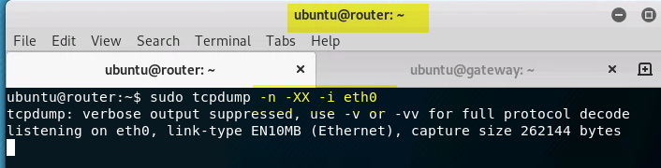

3.2 Use wget on the client to fetch the index.html file

wget <http://<IPADDr>/index.html>

Where <IPADDR> is the server network address, which you can learn by running "ifconfig" on the server.

Observe that wget fails. Use "<ctrl> c" to exit wget.

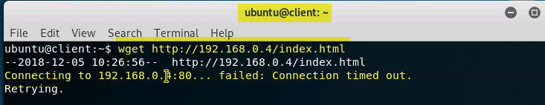

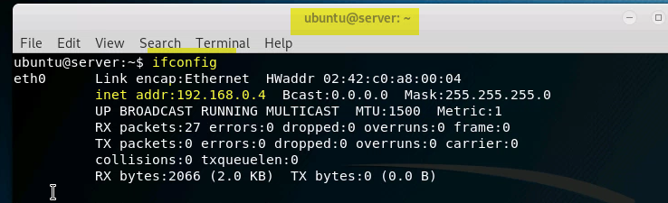

3.3 Start the openvpn program on the gateway:

sudo openvpn --config gateway.conf --daemon

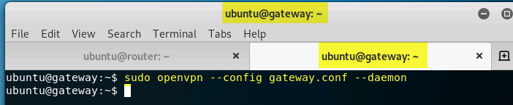

3.4 Start the openvpn program on the client:

sudo openvpn --config client.conf --daemon

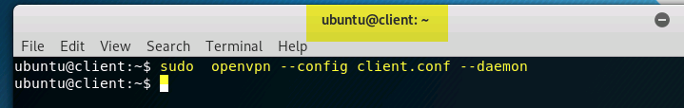

3.5 Use wget again, just as was done previously.

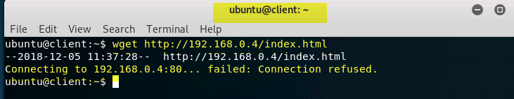

If the connection failed like shown above, please make sure port 80 is open on the server. In n order to enable the connection port 80, use command below. This command executes the file containing the instructions regarding opening port 80 on the server.

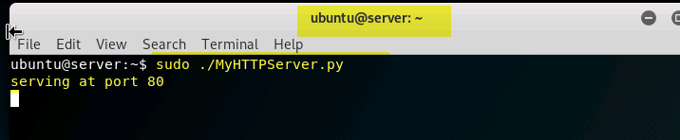

Note the wget succeeds this time.

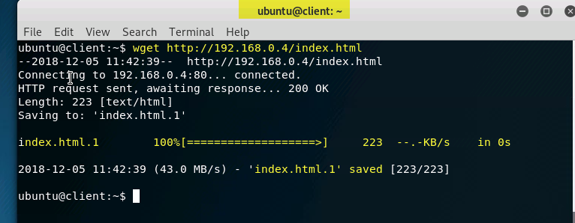

Note you are using the server's network address rather than the address associated with an encrypted tunnel.

Observe the network traffic in tcpdump.

4. Stop the Labtainer

When the lab is completed, or you'd like to stop working for a while, run

stoplab vpnlab2

or

docker stop $(docker ps -a -q)

from the host Labtainer working directory. You can always restart the Labtainer to continue your work. When the Labtainer is stopped, a zip file is created and copied to a location displayed by the stoplab command. When the lab is completed, send that zip file to the instructor.