Today I updated and upgraded my Kali machine using “apt-get update” and “apt-get upgrade” command. Everything was going smoothly until the machine restarted. I was not able to login. I was getting the screen shown below and I will show how I came around this issue and got my screen back.

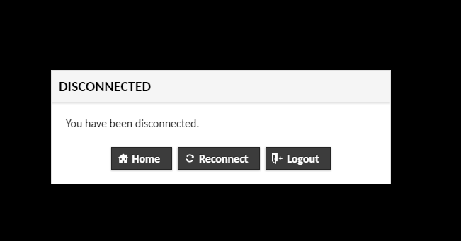

Open vSphere Client and click on “Launch Web Console”.

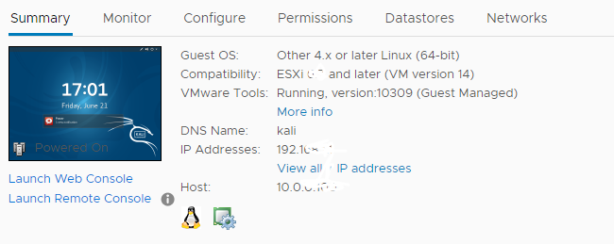

In the new tab you will see login page for Kali machine.

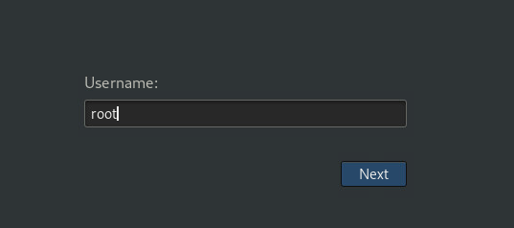

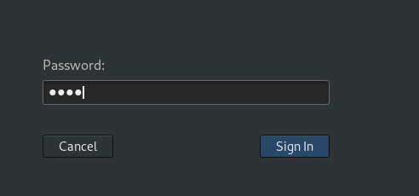

The login page stuck into a loop.

To reach out the terminal press “Ctrl+Alt+F2”.

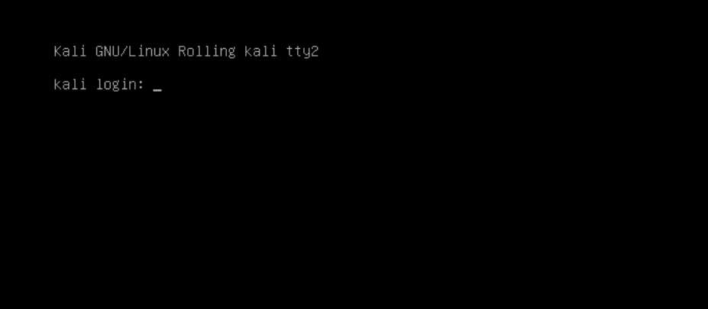

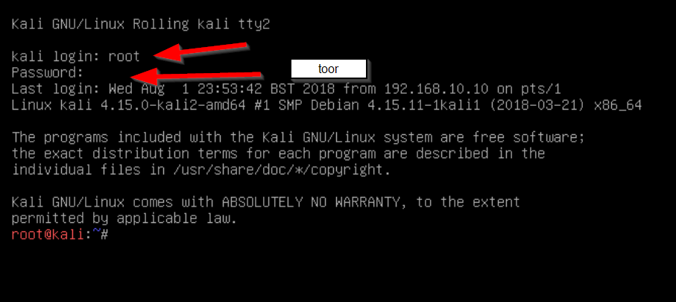

Our 1st command is “sudo apt-get update”.

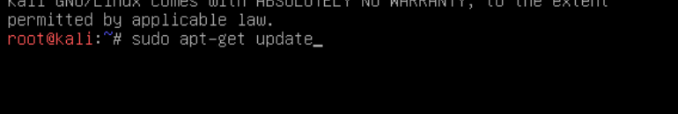

2 -sudo apt-get upgrade

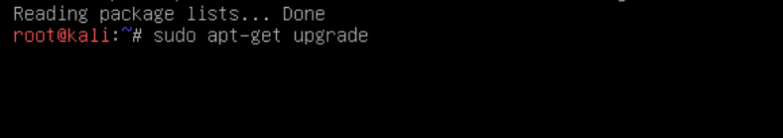

3 sudo dpkg --configure -a



4 -sudo apt-get install cinnamon-control-center-data



5 -gdm3 –version



6 -apt-get --reinstall install gdm3

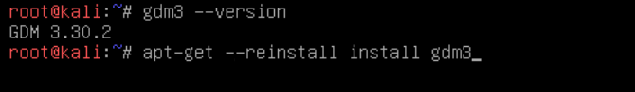

7 -apt-get --reinstall install gnome

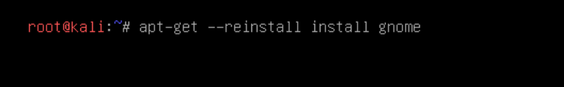

8 -apt-get --reinstall install gnome-shell

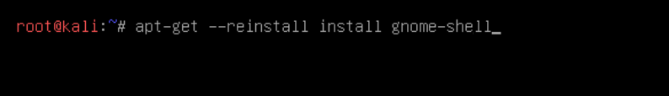

9 -dpkg-reconfigure gdm3

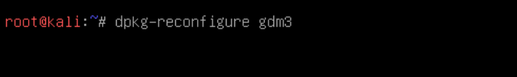

10-reboot

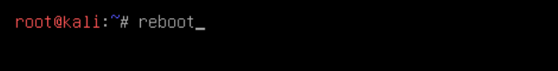

Type login credential:

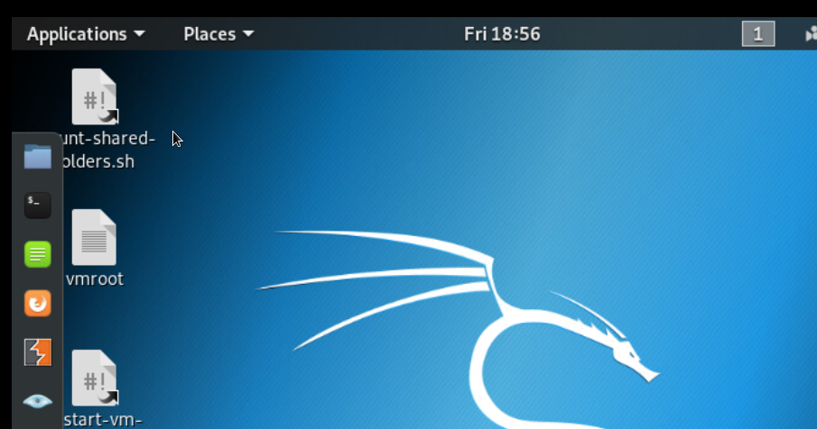

We are done.