File Deletion

File Deletion



The goal of this lab is to familiarize students with some issues related to file deletion.

**Introduction**

As an introduction to this lab, you need to understand that there are different designs for how data and metadata could be organized and managed on a disk to create a file system. Linux has been using what is called the *extended file system* (ext) for many years. This design has undergone some changes that have been called ext2, ext3, and now ext4. In DOS, Microsoft started out with what is called the *file allocation table* (FAT), which continued on with its early Windows products (i.e., Windows version 1, 2, 3, 95, 98 and ME). When Microsoft designed Windows NT1 they did a total redesign of the file system and called it the *NT File System* (NTFS), which has also undergone a few redesigns since it was first introduced around 1995.

In an ideal world the instructor would hand each student a small external USB hard disk for this exercise, but at least two things get in the way of doing that: 1) money, and 2) the current DoD restrictions on the use of external USB drives. Another option would be to examine the results of deleting things on your own hard drive, but that is tricky and risky. So instead of attempting any of those options, in this lab you use what is called a *virtual hard disk* or a *disk image*, which is a file that is used to emulate a disk.

The Windows OS uses the idea of “drive letters” to differentiate different places to store data, such as “C:” and “D:” and “H:”. Unix does not use such an abstraction. Instead, **all** data is accessed off some path from the root of the file system. When a disk is added, then the OS must be told where to “mount” it in the file system; sometimes this is configured and performed automatically, and sometimes it must be done manually. Today you will manually need to “mount” your virtual disks to a spot in your home directory hierarchy.

As an aside, the phrase “mounting a disk” is a leftover from older computing days when large things called *disk packs* had to be physically mounted in place. Today, the term “mounting a disk” usually means making the contents of a connected disk available to users as a file system.

**Getting Started**

Boot your Linux system or VM. If necessary, log in and then open a terminal window and cd to the labtainer/labtainer-student directory. The pre-packaged Labtainer VM will start with such a terminal open for you. Then start the lab:

labtainer file-deletion

Note the terminal displays the paths to two files on your Linux host:

1) This lab manual



1 NT stands for *New Technology*.

File Deletion

2) The lab report template

On most Linux systems, these are links that you can right click on and select “Open Link”. **If you** **chose to edit the lab report on a different system, you are responsible for copying the completed report back to the displayed path on your Linux system before using “stoplab” to stop the lab for the last time.**

**Note**: There is an appendix of basic Unix commands at the end of these instructions.

**Task 1: EXT2 Virtual Disk Mounting**

In this task you will mount a virtual disk.

1. Work within the home directory of the “file-deletion” computer, i.e., where the virtual terminal named “file-deletion” starts.

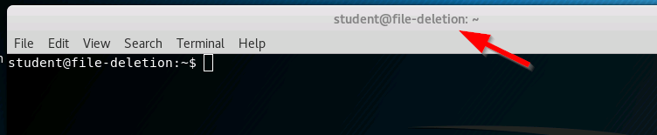

1. Use the ‘ll’ command to display your home directory content. Notice the “mnt” directory, and use ‘ll mnt/’ to view the content of that directory.

Also notice the “myfs.img” file, which is a virtual EXT2 file system, and “ntfs.img”, which is a virtual NTFS file system. We will first work with the EXT2 file system.

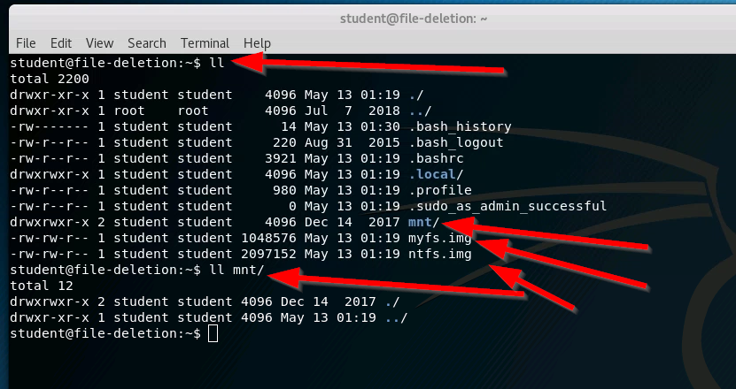

1. Disks are mounted on “mount points”, which are directories. We will use the “mnt” directory as our mount point. You can mount your virtual disk by entering the following:

sudo mount -o loop myfs.img mnt

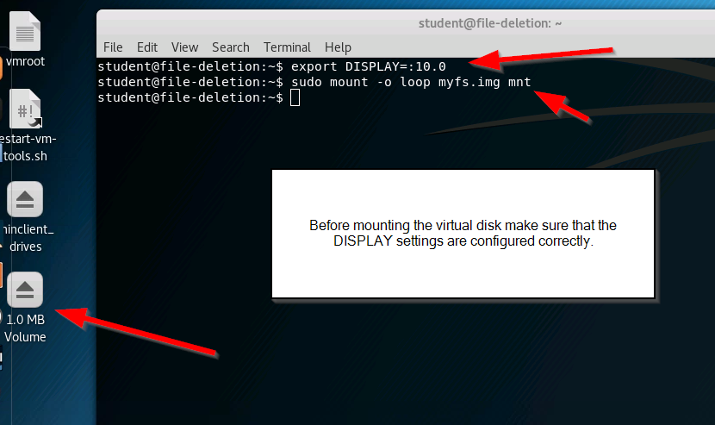

Your file system is now mounted under the mnt directory.

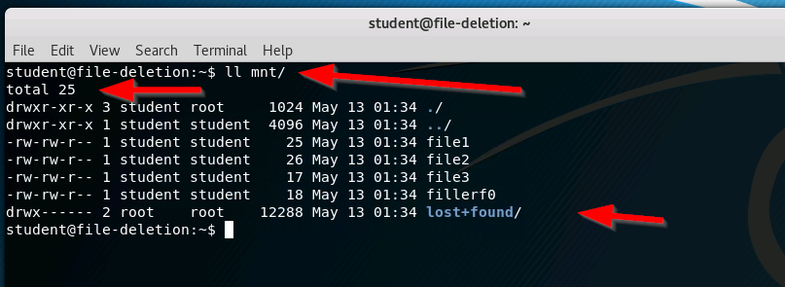

1. Use the command ‘ll mnt/’ to display the size (in bytes) of the files under the directory mnt. The file size is displayed before the Month.

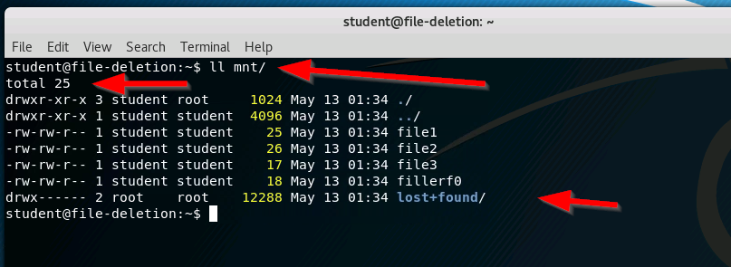

**In item #1 of the report, record the size of each file, as displayed in the output*.***

1. Un-mount the “disk” by doing the following2:

sudo umount mnt

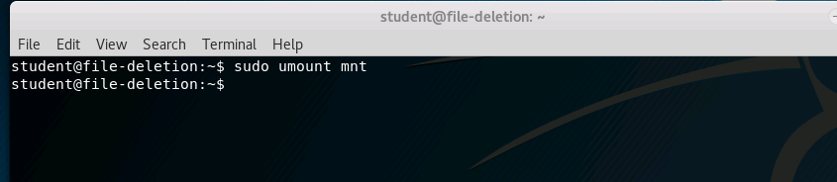

This un-mounting is *similar* to removing a USB drive.



**Task 2: Deleting a File on Unix**

1. Try to display the contents of the “disk” myfs.img using the cat command:

cat myfs.img

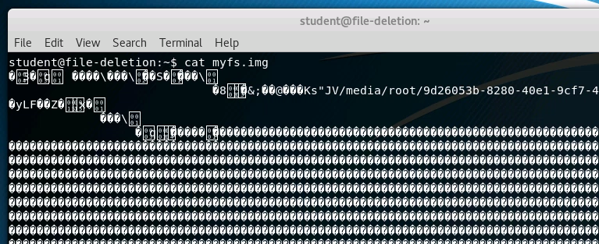

1. The output from the cat command may have been a lot of gibberish and junk. The terminal is not equipped to display arbitrary data; it only displays ASCII data well. Display the contents of myfs.img as raw data in hexadecimal notation, using the command:

hexdump -C myfs.img

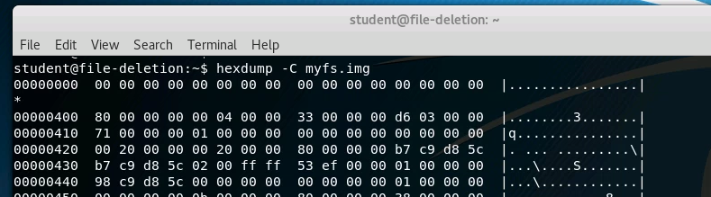

The output of this command is in three columns: 1) the offset (i.e., location) in the disk image where the data is located, 2) the raw data (in hex), and 3) an ASCII representation of the same data (where possible).

|  |  |  |  |  |  |  |  |
| --- | --- | --- | --- | --- | --- | --- | --- |
| **offset** | **data (hex)** |  |  |  | **data (ASCII)** | |  |
| 00000000 | 00 00 00 00 00 00 00 00 | 00 00 00 00 | 00 | 00 00 00 | | | ................ | | |
| * |  |  |  |  |  |  |  |
| 00000400 | 80 00 00 00 00 04 00 00 | 33 00 00 00 | d7 | 03 00 00 | | | ........3....... | | |

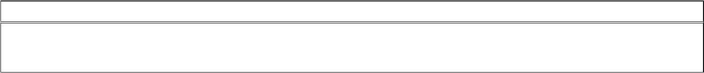

Notice: the ‘*’ in the offset column replaces repeated data. For example, in the above

output, the data at offsets 00000000, 00000010, … 000003f0 are all the same: 16 bytes, where each byte has the value 0x00. Thus, the output is abbreviated with the asterisk in place of repeated data. Further, this data does not have an ASCII representation, so the third column displays the data as dots. Also in the example, at offset 0x408 is hex value 0x33, which is ASCII value ‘3’.

1. If we are interested only in the ASCII data in the file, we can extract this using the strings command. Use the following command to display the ASCII data and the offset of that data in myfs.img:

strings -td myfs.img

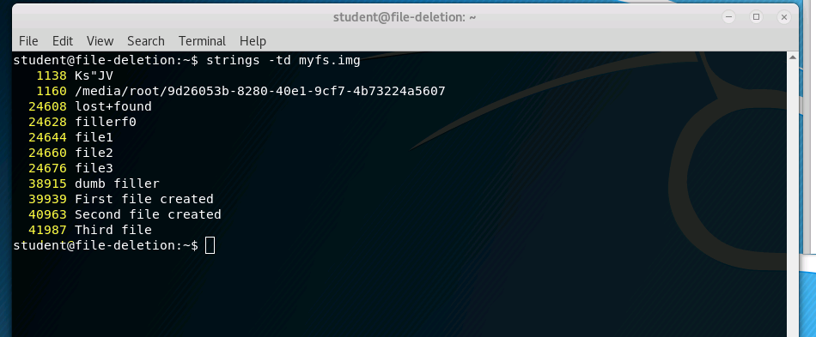

**In item #2 of the report, record the offsets for the file names and file data, as displayed in the output.**

1. Re-mount your file system:

sudo mount -o loop myfs.img mnt

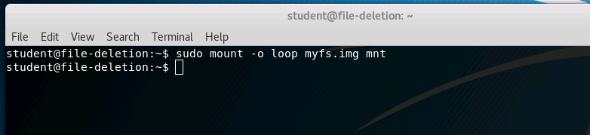

1. Use the below command to delete file2: rm mnt/file2

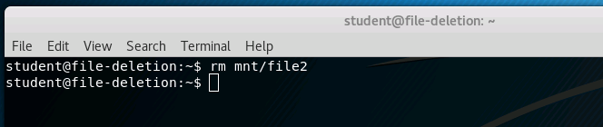

1. Use the ‘ls mnt’ command to verify that the deleted file is no longer present.

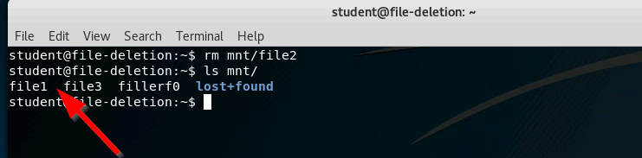

1. Once again, un-mount your file system:

sudo umount mnt

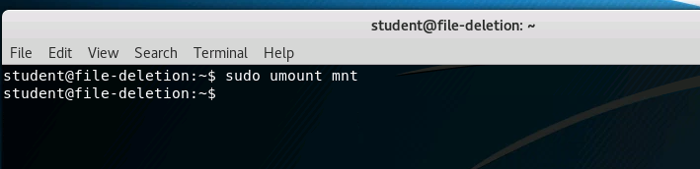

1. Again, display all the ASCII text in the “disk” by entering the following: strings -td myfs.img

**In item #3 of the report, record the offsets for the file names and file data, as displayed in the output.**

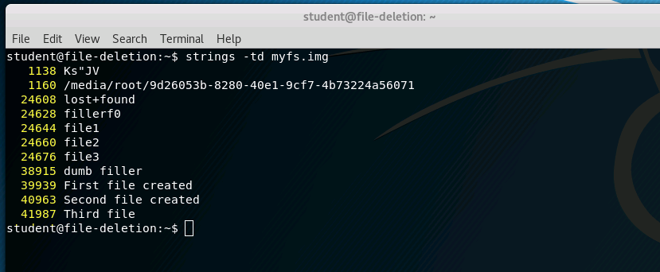

**Note that item #4 asks a follow-up question.**

**Task 3: Undeleting a File on Unix**

In this task you will attempt to undelete the file you deleted earlier. In Unix this can be a tricky and difficult task, reserved for knowledgeable system administrators. Even then, when attempting to delete a file there should not be anyone on the system creating new files, or the data may be lost permanently anyway.

Later, we will undelete files using tools that know how to interpret the file system layout. These are especially useful when the file systems grow large and when the formats are complex. For this task, however, we will undelete files “manually” by looking at the raw bytes of the drive and without the assistance of any special file recovery tools.

1. Refer to item #3 of the report. Find the offset to the content of file 2 (i.e., where “Second file created” is located). You will need this number in the next step.

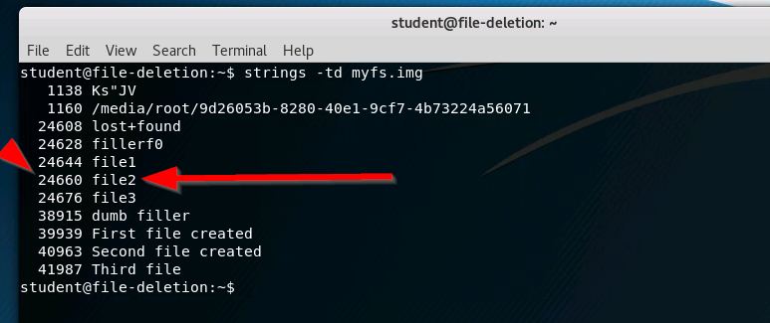

1. Use the dd command (shown below) to copy the data from the location on the disk to a new file (rfile2) that will hold the recovered data. Below, replace SKIPNUMBER with the offset you found above, and replace FILESIZE with the size of file2 (from item #1 of the report):

dd if=myfs.img bs=1 skip=SKIPNUMBER count=FILESIZE of=rfile2

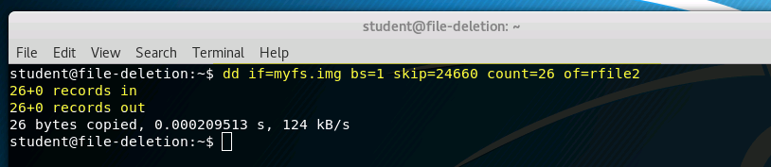

This command yanked the data out of the virtual disk into another file, called rfile2. To fully restore the file, it may need to be put back into the file system, but for now we will leave it where it is.

1. Display the contents of the file you just recovered:

cat rfile2

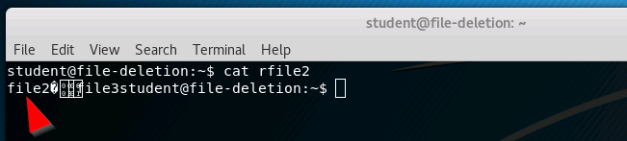

**Task 4: Securely Deleting a File on Unix**

For some, it is comforting to know that it may be possible to undelete files. For others, it is frightening to know that something that was deleted may still be there. For the latter group, this task will show one way to securely delete a file on Ubuntu. You will be using a command called shred, which may not be installed on all Linux distributions; although, most operating systems give you *some* utility or operation that will allow you to securely delete files.

1. Use the strings command to verify the existence of file3 and its data:

strings myfs.img

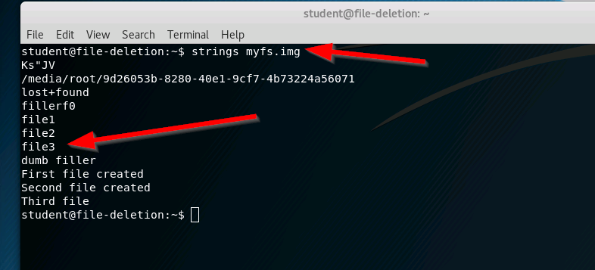

1. Re-mount your file system:

sudo mount -o loop myfs.img mnt

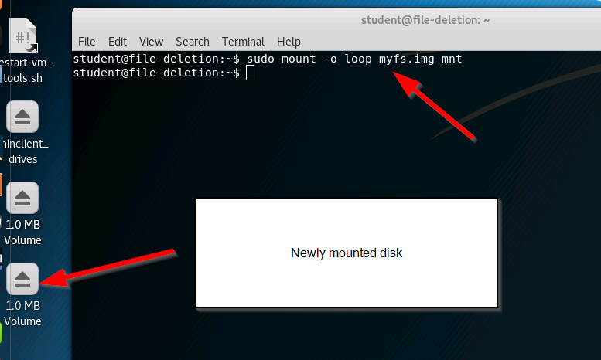

1. Use the following commands to view the files, securely delete file3, and then to confirm the deletion:

ls mnt

shred –uxz mnt/file3

ls mnt

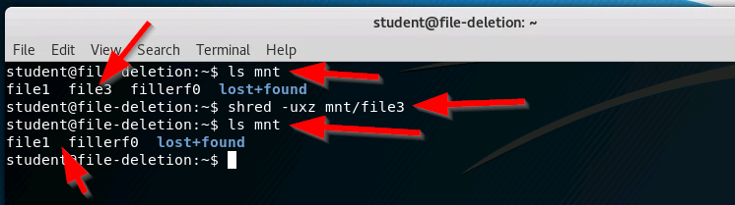

1. Once again, un-mount your file system:

sudo umount mnt

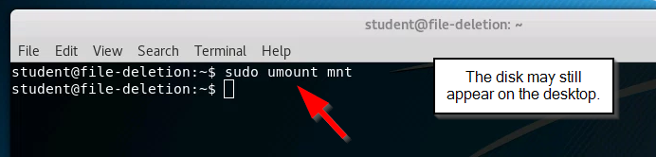

1. Repeat the use of the strings command:

strings -td myfs.img

**In item #5 of the report, record the offsets for the file names and file data, as displayed in the output*.***

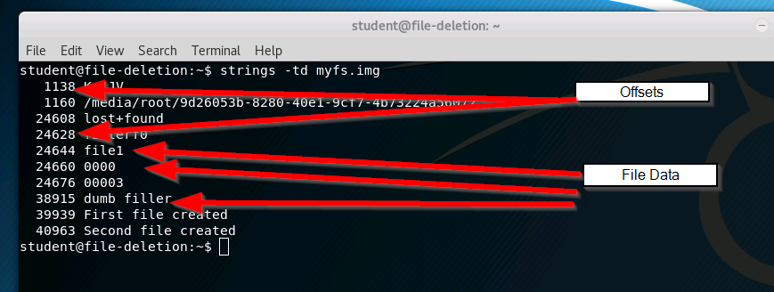

**Task 5: NTFS Virtual Disk**

As mentioned in the Introduction section, NTFS is the file system used by the professional versions of Windows. Because of the way NTFS manages files, it is much easier to undelete them, as long as new files have neither overwritten the metadata nor the “deleted” data on the disk.

1. Mount the virtual disk:

sudo mount -o loop ntfs.img mnt

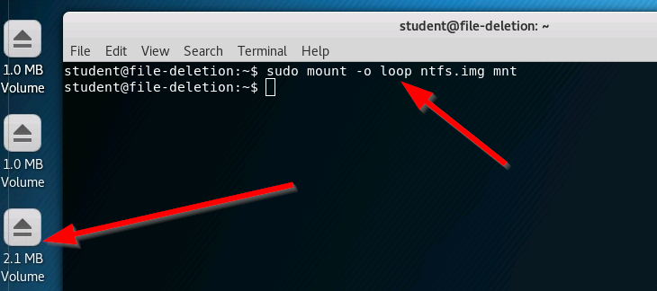

1. Use the command ‘ll mnt/’ to display the size (in bytes) of the files under the directory mnt. The file size is displayed before the Month.

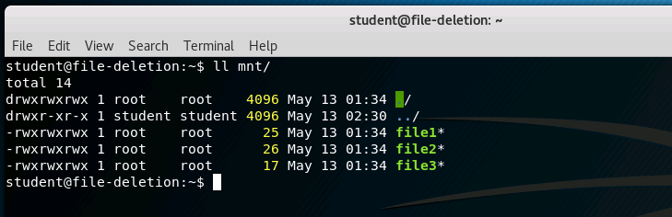

**In item #6 of the report, record the size of the files, as reported by ll.**

1. Delete file1 and **securely** delete file3, using the commands:

rm mnt/file1

shred -uxz mnt/file3

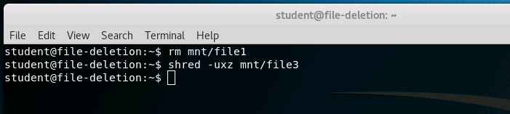

1. Un-mount the “disk” by doing the following:

sudo umount mnt

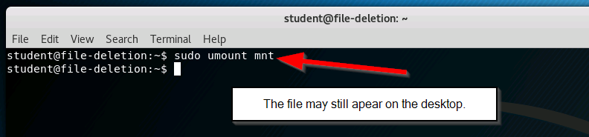

1. Verify that the data still exists on the virtual disk by entering the following command: strings -td ntfs.img | grep file

**In item #7 of the report, record the offsets for the file names and file data, as displayed in the output.**

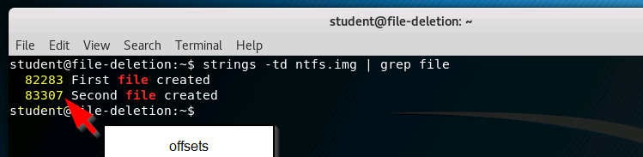

1. Use the ntfsundelete command to find information about deleted files, as shown below:

ntfsundelete -p 100 ntfs.img

Note that the inode number is the left-most number in the output.

**Record in item #8 of the report the inode numbers associated with file1.**

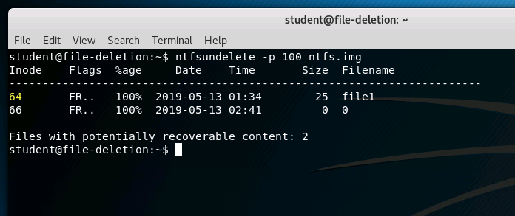

1. Undelete file1 using the following command (replacing INODE with the number of the recoverable file):

Rev: 2018-2-9 Page 6 of 9

File Deletion

ntfsundelete --undelete --inodes INODE --output rfile1 ntfs.img

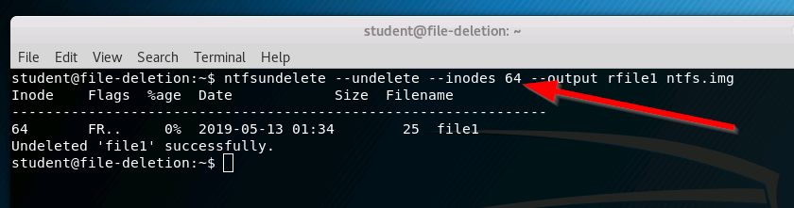

1. Use ll to list the contents of the current directory. You should see the deleted file. Once again, this utility yanks the file out of the file system.

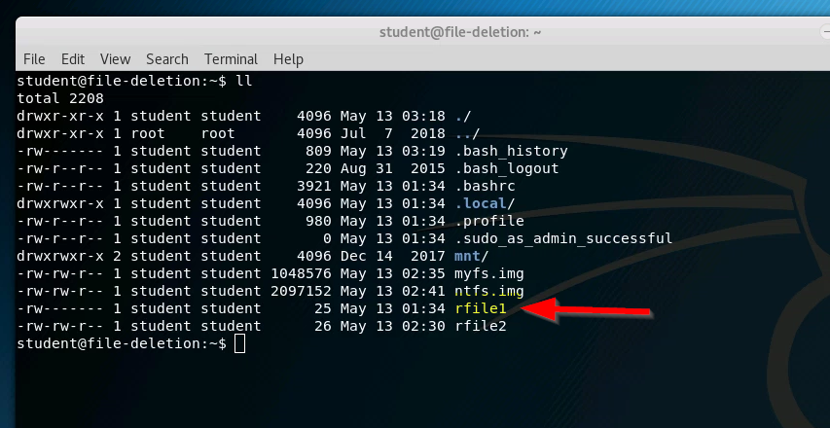

1. Use the cat command to display the content of rfile1.

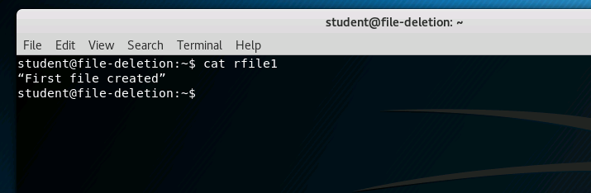

**Note that there are some additional follow-up questions in the Report.**

**Submission**

After finishing the lab, go to the terminal on your Linux system that was used to start the lab and type:

stoplab file-deletion

If you modified the lab report on a different system, you must copy that completed file into the directory path displayed when you started the lab, and you must do that before typing “stoplab”. When you stop the lab, the system will display a path to the zipped lab results on your Linux system. Provide that file to your instructor, e.g., via the Sakai site.

**Appendix – Some Unix Commands**

cd Change the current directory.

cd destination

With no “destination,” the current directory will be changed to your home directory. If “destination” is “..”, then the current directory will be changed to the parent of your current directory.

cp Copy a file.

cp source destination

This will copy the file with the name “source” to a new file with the name

“destination.” The “destination” can include a path to new directory.

clear Erase all the output on the current terminal and place the shell prompt at

the top of the terminal.

less Display a page of a text file at a time in the terminal. (Also see more).

less file

To see another page press the space bar. To see one more line press the

Enter key. To quit at any time press ‘q’ to quit.

Rev: 2018-2-9 Page 7 of 9

File Deletion

ls List the contents and/or attributes of a directory or file

ls directory

ls file

With no “directory” or “file,” this will display the contents of the current working directory.

1. This is a shortcut for “ls –l” to provide a more detailed (i.e., “long”) printout of the information in the current directory.

man Manual

man command

Displays the manual page for “command”. To see another page, press the

space bar. To see one more lines, press the Enter key. To quit before reaching the end of the file, enter ‘q’.

more Display a text file, a page at a time using the terminal. (Also, see less).

more file

To the next page, press the space bar. To see one more line, press the

Enter key. At any time, press ‘q’ to quit.

mv Move and/or Rename a file/directory

mv source destination

The “source” file will be moved and/or renamed to the “destination.”

pwd Display the present working directory

pwd

Rev: 2018-2-9 Page 9 of 9