Project

Summarizing and Analyzing Research Papers

**Learner Name**: Vishal Chauhan

**Learner Email**: vishalnamo057@gmail.com

**Topic**: Summarize and analyze research on advancements in renewable energy technologies.[Engineering]

**Research Paper**: <https://www.fepbl.com/index.php/estj/article/view/800>

**Initial Prompt**

**Description:** Generate a clear and concise summary of paper keeping the key advancements in 100 words.

**Generated Summary :** The paper reviews key advancements in renewable energy technologies, focusing on solar, wind, hydropower, biomass, and geothermal energy. Solar energy has progressed with efficient perovskite solar cells, while wind energy benefits from optimized turbine designs and offshore farms. Hydropower innovations include eco-friendly dams and hybrid systems, and biomass advances involve efficient biofuel production. Geothermal energy is expanding through enhanced systems and advanced drilling. The study also highlights the integration of renewables into smart grids and the role of AI in optimizing energy systems, emphasizing future trends like decentralized systems and floating offshore wind farms.

**Iteration 1**

**Description:** Provide a concise summary of the research study in max 100 words with all key advancements.

**Generated Summary :** The study explores significant advancements in renewable energy technologies, including efficient perovskite solar cells, optimized wind turbines, eco-friendly hydropower systems, and advanced biomass biofuel production. It also highlights geothermal energy's expansion through enhanced systems and innovative drilling. The integration of these technologies into smart grids, aided by AI, is emphasized for improved efficiency and stability. Emerging trends like decentralized energy systems and floating offshore wind farms are identified as crucial for future development, with supportive policies and financial incentives deemed essential for driving adoption and innovation in sustainable energy.

**Iteration 2**

**Description:** Analyze advancements in solar, wind, hydropower, biomass, and geothermal energy, smart grid integration, AI's role, and emerging trends like decentralized systems and floating wind farms in 100 words.

**Generated Summary :** Renewable energy technologies are advancing rapidly across various domains. Solar energy improvements include photovoltaic materials and enhanced storage, boosting efficiency. Wind energy focuses on larger turbines and offshore/floating farms. Hydropower evolves with eco-friendly designs and hybrid systems, while biomass advances through second and third-generation biofuels, reducing environmental impacts. Geothermal energy benefits from enhanced geothermal systems and advanced drilling. AI plays a crucial role in smart grids, optimizing energy management and stability. Emerging trends like decentralized energy systems and floating wind farms signify the future of sustainable energy.

Users also ask these questions:

How does AI optimize energy management in smart grids?

What are the benefits and challenges of floating wind farms?

How do decentralized energy systems contribute to energy resilience?

**Final Prompt**

**Description:** Summarize the research study in 100 words focusing on the key study areas and advancements with highlighting emerging tech.

**Generated Summary :T**he research study reviews advancements in renewable energy technologies, emphasizing solar, wind, hydropower, biomass, and geothermal energy. Key advancements include efficient photovoltaic materials, larger wind turbines, eco-friendly hydropower designs, second-generation biofuels, and enhanced geothermal systems. The study also explores the integration of these technologies into smart grids, driven by AI for optimized energy management. Emerging trends such as decentralized energy systems and floating offshore wind farms are highlighted as future directions for sustainable energy. The study underscores the need for continued innovation and interdisciplinary collaboration to achieve a resilient and sustainable energy future.

**Insights and Applications**

The research paper provides an overview of current advancements in renewable energy technologies, focusing on solar, wind, hydropower, biomass, and geothermal energy. Solar energy have had significant progress with innovations in photovoltaic materials and energy storage systems, enhancing efficiency and reliability. Coming to Wind energy, it includes the development of larger, more efficient turbines and the expansion of offshore and floating wind farms. Hydropower is evolving with eco-friendly dam designs and the integration of hybrid systems combining multiple renewable sources. Biomass energy is advancing through the production of second and third-generation biofuels, reducing environmental impacts and improving sustainability. Geothermal energy is gaining momentum with enhanced geothermal systems and innovative drilling techniques. The paper also highlights the role of AI in integrating these renewable energy sources into smart grids, optimizing energy management and enhancing grid stability.

**Applications:**

Emerging technologies such as decentralized energy systems and floating wind farms are identified as crucial for the future of sustainable energy development.

**1. Residential and Commercial Power Supply:** Improved photovoltaic materials and energy storage systems enable more efficient and reliable solar power for homes and businesses.

**2. Grid Integration:** Enhanced turbine performance helps integrate wind energy into the power grid more effectively, supporting overall energy stability.

**3. Small-Scale Hydropower:** Innovative designs enable the development of small-scale or micro-hydropower systems, which can be used in remote or rural areas.

**Evaluation**

**Clarity :** The final summary is short and concise highlighting the research study and emerging technologies.

**Accuracy :** The accuracy of the final summary and insights is high but some repetitive context is more.

**Relevance :** The applications are relevant and aligns with the emerging technologies mentioned in the research study with addition of future enhancements.

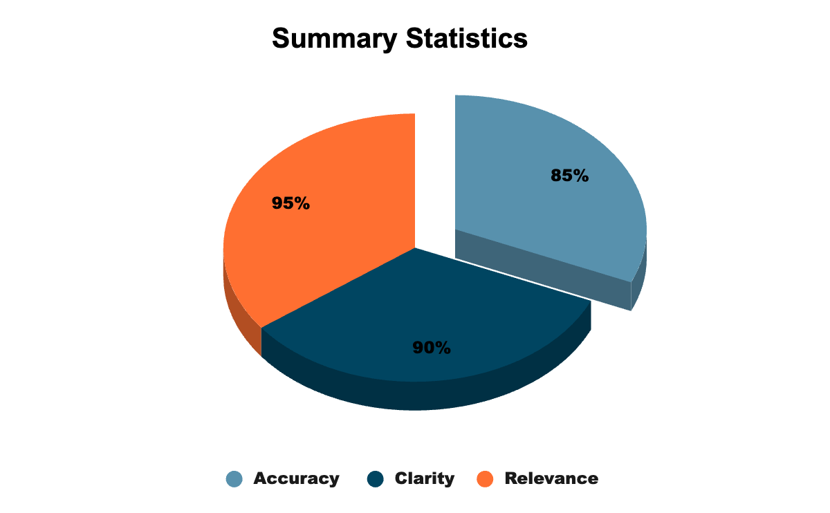

**Reflection**

This internship has provided me with invaluable experience focusing on areas of emerging trends and most used technology nowadays i.e Generative AI with hands on experience on Prompt Engineering techniques. The modules and quizzes has helped me gain knowledge on prompt engineering.

Creating accurate and highly concise prompts that in return outputs content aligning with the deep context of the data input, is itself a challenge. It had helped me create better and more effective prompts through various prompting techniques like zero-shot prompting, open-ended prompting etc.