**General**

|  |  |  |  |
| --- | --- | --- | --- |
|  | Team #____ | Team #____ | Team #3061 |
| Overview |  |  |  |
| *Preferred tote acquisition site* |  |  |  |
| *Max Height – Totes* |  |  |  |
| *Max Height – RC* |  |  |  |
| Drivetrain |  |  |  |
| *Type* |  |  |  |
| *Drive over Platform (Y/N)* |  |  |  |
| Intake |  |  |  |
| *RC’s (Y/N)* |  |  |  |
| Active? |  |  |  |
| Upside? |  |  |  |
| Sideways? |  |  |  |
| From Step? |  |  |  |
| *Totes (Y/N)* |  |  |  |
| Active? |  |  |  |
| Upside? |  |  |  |
| Upside-Down? |  |  |  |
| From Landfill? |  |  |  |
| From Feeder Station? |  |  |  |
| From Step? |  |  |  |
| Manipulator |  |  |  |
| *RC’s (Y/N)* |  |  |  |
| Upside? |  |  |  |
| Sideways? |  |  |  |
| To Right Sideways? |  |  |  |
| *Totes (Y/N)* |  |  |  |
| Upside? |  |  |  |
| Upside Down? |  |  |  |
| *Stacking (Y/N)* |  |  |  |
| On Robot? |  |  |  |
| Internal? |  |  |  |
| Other |  |  |  |
| *Deposit totes on step (Y/N)* |  |  |  |
| *Push litter into landfill (Y/N)* |  |  |  |

**Autonomous**

|  |  |  |  |
| --- | --- | --- | --- |
|  | Team #____ | Team #____ | Team #3061 |
| Starting Configurations |  |  |  |
| RC’s |  |  |  |
| # Staging 🡪 Auto |  |  |  |
| # from Step |  |  |  |
| # Step🡪 Auto |  |  |  |
| Totes |  |  |  |
| # Staging 🡪 Auto |  |  |  |
| Stacked (Y/N) |  |  |  |
| Required RC movement (Y/N) |  |  |  |
| Knocked over RC’s (Y/N) |  |  |  |
| Mobility |  |  |  |
| Moves to auto zone (Y/N) |  |  |  |

**Cooperition**

|  |  |  |  |
| --- | --- | --- | --- |
|  | Team #____ | Team #____ | Team #3061 |
| Set/Stack/Nothing |  |  |  |
| # totes contributed |  |  |  |

**Teleoperated**

|  |  |  |  |
| --- | --- | --- | --- |
|  | Team #____ | Team #____ | Team #3061 |
| RC’s |  |  |  |
| # from Step |  |  |  |
| Totes |  |  |  |
| # From Feeder Station |  |  |  |
| # From Landfill |  |  |  |
| Other |  |  |  |
| # Fouls |  |  |  |
| Robot Tips Over (Y/N) |  |  |  |
| Calculated Contribution |  |  |  |

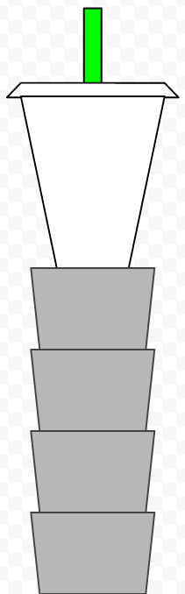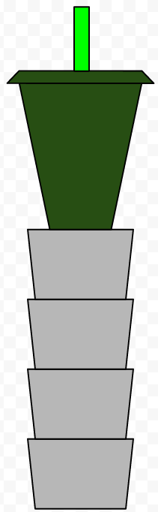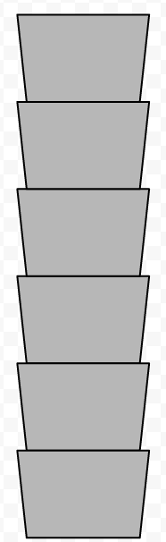

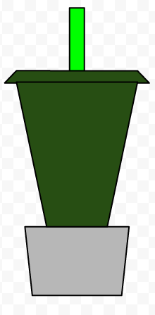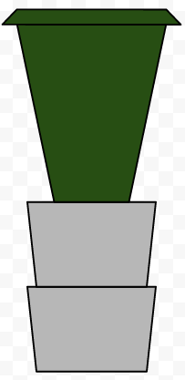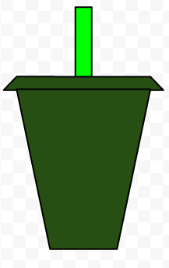

*Team #_____ - Last 10 Stacks*

*Team #_____ - Last 10 Stacks*