Tasean Cunningham

March 3rd, 2021

Foundations of Databases and SQL Programming

Assignment #7: Views

<https://github.com/Husky711/DBFoundations-Module07>

**Functions**

**Introduction**

There are various built-in functions that a programmer is able to reuse in their code for processing and manipulating data. A programmer can also create their own functions, a user defined function, which can either return a single value or a table. Below, we will learn more about the different functions that a programmer can use.

**Explain when you would use a SQL UDF**

User defined functions are a helpful type of object in sql that can reduce time spent on retrieving, formatting and organizing data. With a user defined function, a programmer can control the input, define the structure or type of output and decide permissions on who will be able to use them and in what way. The below user defined function, figure 1.1, references a view and allows a user to filter on specific criteria when executing the function.

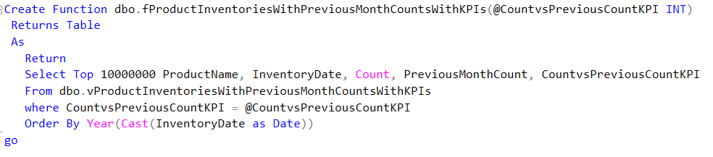

Figure 1.1 is a user defined function that allows a user to input a value to return a certain set of criteria.

**Explain the differences between Scalar, inline, and Multi-Statement Functions**

A scalar user defined function is a defined function that returns a single value. An inline function returns a result set, similar to a view. The multi-statement function is similar to an inline function expect that the multi-statement function can contain more than one statement and the structure of the table returned from the function can be defined by the user.

**Conclusion**

Functions are an essential tool for any programmer. It can be written once and then reused multiple times. This helps to save time and effort and improve performance and efficiency of a database.