**CC-215-L: Database Systems Lab**

*Faculty of Computing & Information Technology*



**BS(CS) Morning - Fall 2021, Semester Fall 2023**

**LAB – 09**

# Topics

* Revision from last Lab
* DDL
* DML
* Database Objects (Indexes , Sequences , Synonyms , Views)

# Learning Objectives

* Revising the Concepts about DDL and DML
* Practicing and understanding the Database objects
* Creating Sequences , Synonymous
* Creating different Views of the Database.

# General Instructions:

* In this Lab, you are **NOT** allowed to discuss your solution with your colleagues, even not allowed to ask how s/he is doing; this may result in negative marking. You can **ONLY** discuss with your Teaching Assistants (TAs) or Lab Instructor.
* Your TAs will be available in the Lab for your help. Alternatively, you can send your queries via email to one of the followings.

|  |  |  |
| --- | --- | --- |
| **Lab Instructors** | | |
| Course Instructor | Dr. Asif Sohail | [asif@pucit.edu.pk](mailto:asif@pucit.edu.pk) |
| Teaching Assistants | Kabeer Ali | [bitf20m018@pucit.edu.pk](mailto:bitf20m018@pucit.edu.pk) |
| Hamza Farooqi | [bitf20m031@pucit.edu.pk](mailto:bitf20m018@pucit.edu.pk) |

Hope you are fine and feeling yourself comfortable and exciting to play with Structured Query Language (SQL) in this first lab. *You have been taught in the lecture about SQL and query writing. Why not to get all what you have learned with a hands-on experience?* So, let’s Start!

*Allowed time: 1.5 hour*

***Note: Do follow these instructions while you are sitting in the lab and performing the tasks.***

1. ***Gossips are not allowed. So be gentle and do what you know. The lab is not to deduct your sessional marks but to prepare you to achieve good marks in quizzes, mids and finals and finally have good grades. So, try to perform all your tasks in time and at your own.***
2. ***Teacher assistants are for your help, so be nice with them. Respect them as they are teaching you. Raise your hands if you have some problem and need help from TA. Avoid calling them by raising your voice and disturbing the environment of Lab.***
3. ***You must revise the content of the past lectures before starting the lab, it will help you resolve most of your general queries and give you the confidence that you can do it.***
4. ***Evaluation will be considered final and you cannot debate for the marks. So, focus on performing the tasks when the time is given to you.***
5. ***TA may deduct your marks for any kind of ill-discipline or misconduct from your side.***
6. ***Finally, pray before you start. And, Best of Luck!***

* **Kindly paste the query as well as result table screenshot as a result of each task**

**Sample:**

**Display All the Employees from emp table**

**Solution:**

**Select * from emp**

|  |  |  |  |  |  |  |  |
| --- | --- | --- | --- | --- | --- | --- | --- |
| **EMPNO** | **ENAME** | **JOB** | **MGR** | **HIREDATE** | **SAL** | **COMM** | **DEPTNO** |
| 7369 | SMITH | CLERK | 7902 | 12/17/1980 | 800 | - | 20 |
| 7499 | ALLEN | SALESMAN | 7698 | 02/20/1981 | 1600 | 300 | 30 |
| 7521 | WARD | SALESMAN | 7698 | 02/22/1981 | 1250 | 500 | 30 |
| 7566 | JONES | MANAGER | 7839 | 04/02/1981 | 2975 | - | 20 |
| 7654 | MARTIN | SALESMAN | 7698 | 09/28/1981 | 1250 | 1400 | 30 |

**Task 0: (Pre-Lab Task) [0 Marks]**

**The following relational schema was created before the midterm exams.**

|  |  |  |
| --- | --- | --- |
| Table Name: **customer** | | |
| **Col Name** | **Data Type** | **Constraints** |
| cust# | NUMBER(5) | Primary Key |
| c_name | VARCHAR2(20) | Not Null |
| city | VARCHAR2(30) |  |
| cnic | CHAR(16) | Unique |

|  |  |  |
| --- | --- | --- |
| Table Name: **invoice** | | |
| **Col Name** | **Data Type** | **Constraints** |
| invoice# | NUMBER(5) | Primary Key |
| inv_date | DATE | DEFAULT sysdate |
| cust# | NUMBER(5) | Foreign Key references Customer  Not Null |
| payment | CHAR(12) | Cash, Cheque, Credit Card |

|  |  |  |
| --- | --- | --- |
| Table Name: **product** | | |
| **Col Name** | **Data Type** | **Constraints** |
| prod# | NUMBER(5) | Primary Key |
| p_name | VARCHAR2(50) | Not Null |
| price | NUMBER(5) | Above 5 |

|  |  |  |
| --- | --- | --- |
| Table Name: **invoice_details** | | |
| **Col Name** | **Data Type** | **Constraints** |
| invoice# | NUMBER(5) | Primary Key,  Foreign Key references Invoice |
| prod# | NUMBER(5) | Primary Key,  Foreign Key references Product |
| qty_ordered | NUMBER(4) | In the range 1-500 |
| sale_price | NUMBER(5) | Above 5 |

**Task 01: [20 Marks]**

**Perform the following tasks on the above relational schema.**

1. Add the following attributes in the product table:

|  |  |  |
| --- | --- | --- |
| **Col Name** | **Data Type** | **Constraints** |
| stock | NUMBER(5) | Must not be negative |

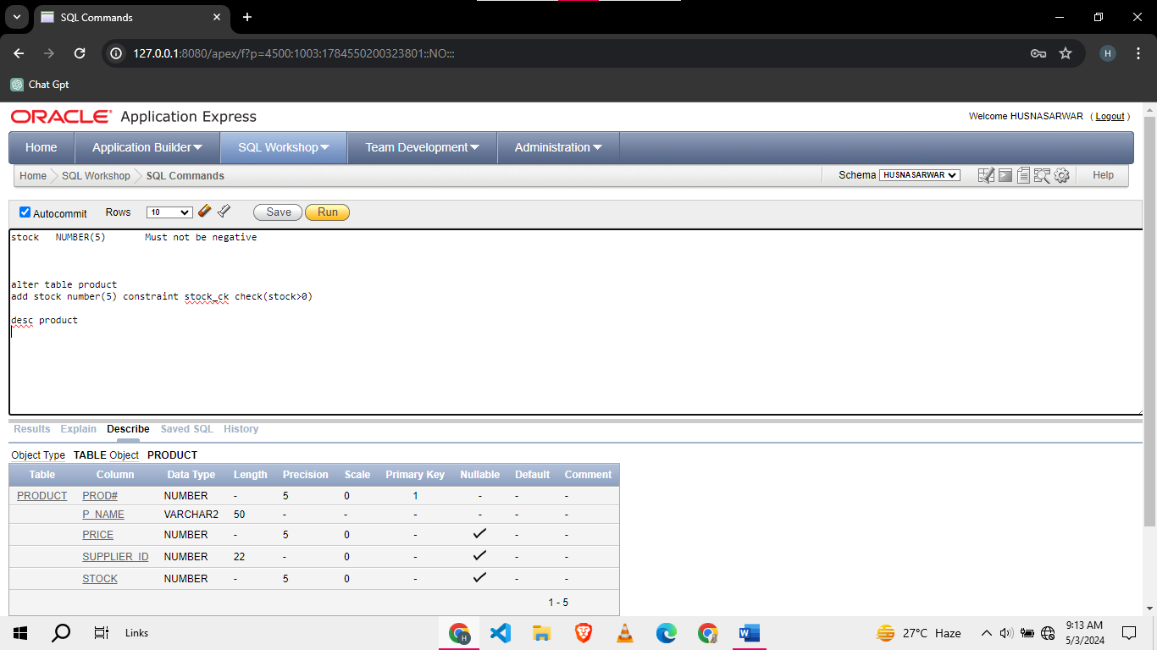

1. Change the table name **invoice** to **sales_invoice.**

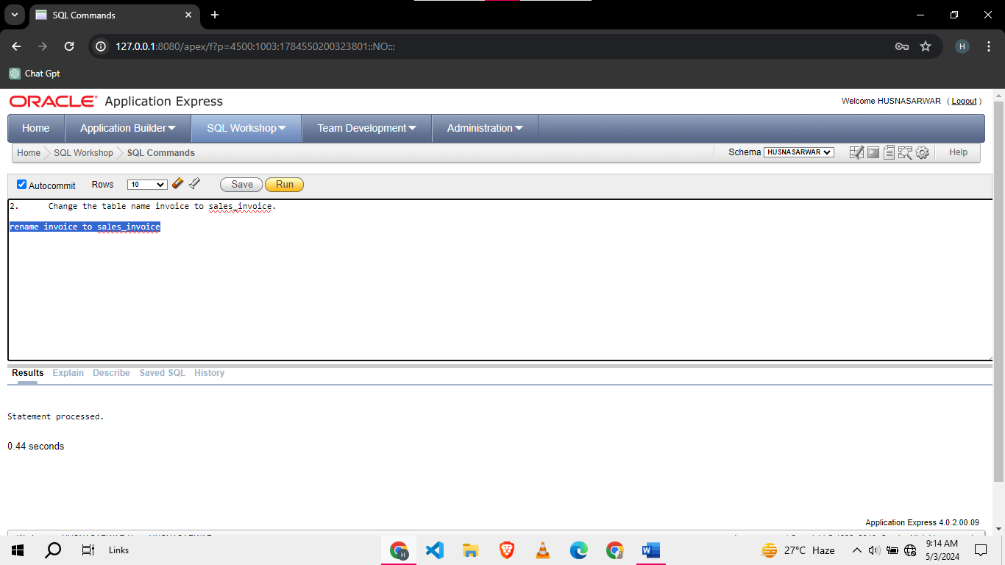

1. Change the column name price (of product) to cost_price.

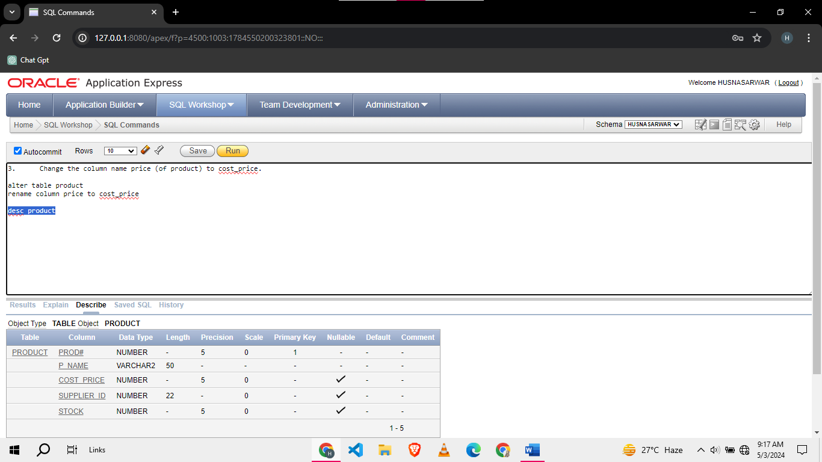

1. Change the column names (of sales_invoice) invoice# and inv_date to s_invoice# and s_inv_date respectively of

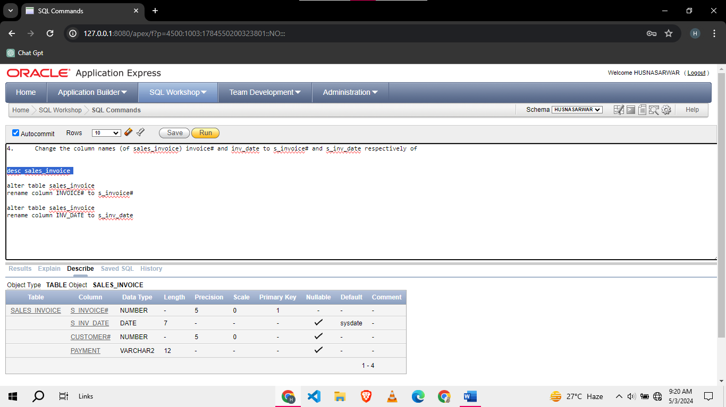

1. Change the table name **invoice_details** to **sales_invoice_details.**

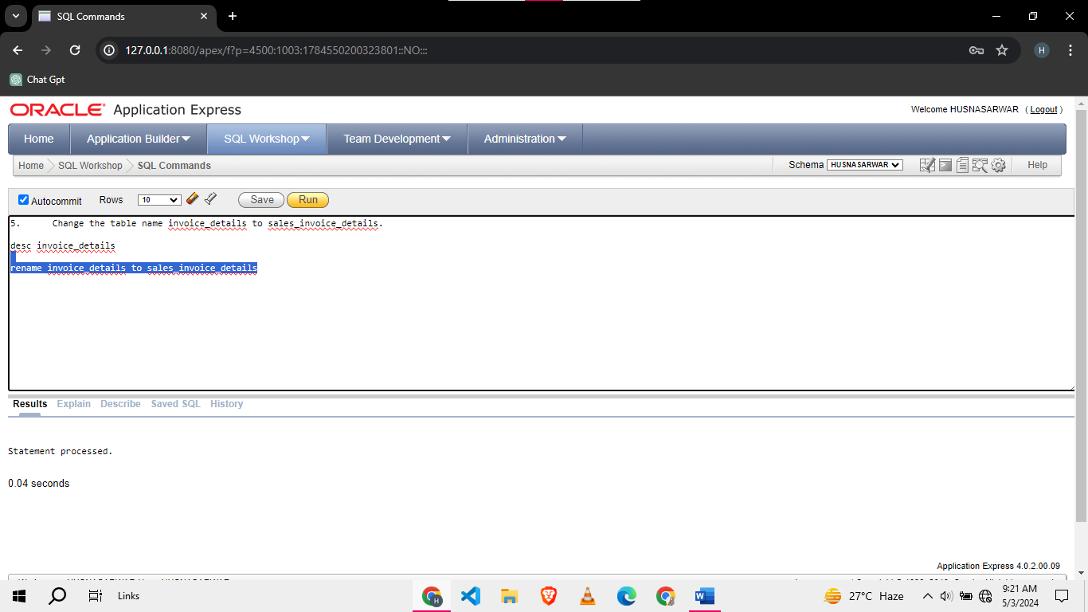

1. Change the column names (of sales_invoice_details) invoice# to s_invoice#.

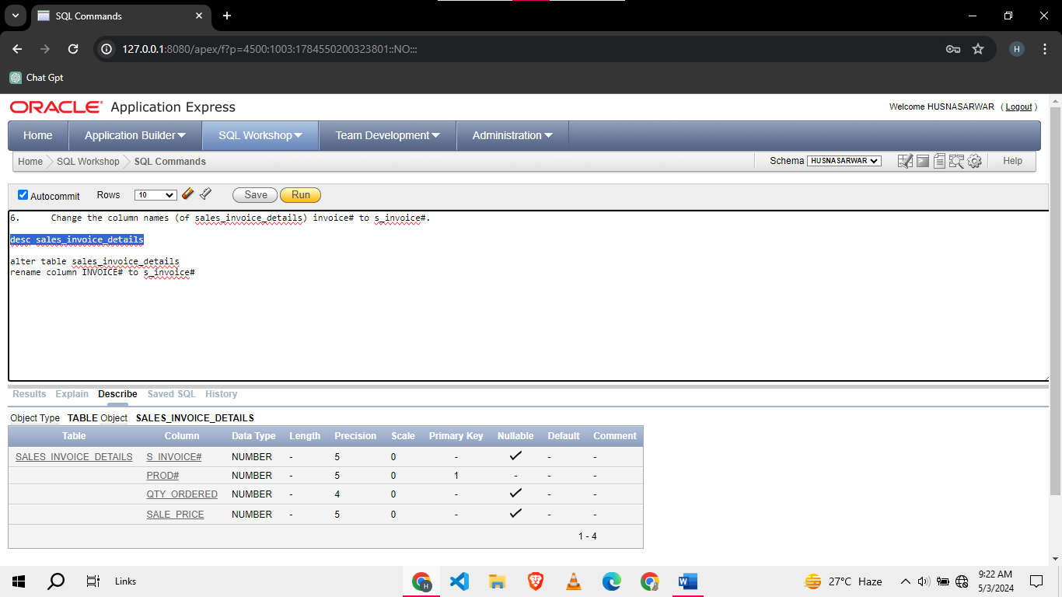

1. Populate the above tables with the following data.

**Customer**

|  |  |  |  |
| --- | --- | --- | --- |
| cust# | c_name | City | Cnic |
| 49273 | Ali | Karachi | 35202-5698632-1 |
| 86741 | Fatima | Lahore | 35202-4659876-5 |
| 21598 | Ahmed | Islamabad | 35202-4987320-1 |
| 73956 | Khadija | Rawalpindi | 56987-1727537-3 |
| 60482 | Hassan | Faisalabad | 42569-2369715-7 |
|  |  |  |  |
|  |  |  |  |

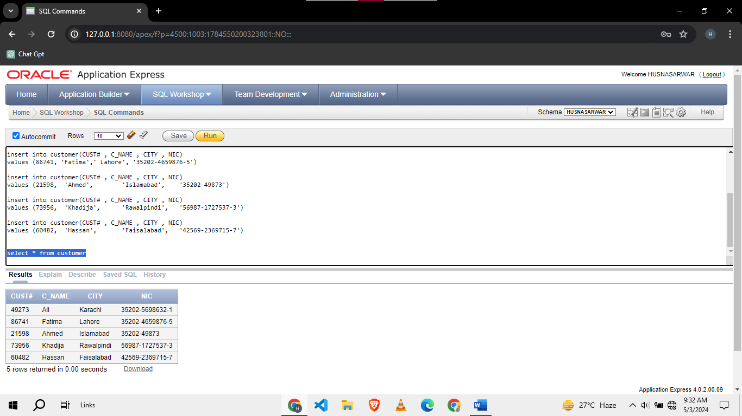**Product**

|  |  |  |  |
| --- | --- | --- | --- |
| prod# | p_name | cost_price | Stock |
| 86741 | Wireless Keyboard | 2500 | 200 |
| 21598 | Leather Wallet | 1500 | 50 |
| 73956 | LED Bulb | 500 | 70 |
| 60482 | Smart Watch | 3500 | 40 |
| 16532 | Bluetooth Earphones | 1200 | 150 |
|  |  |  |  |

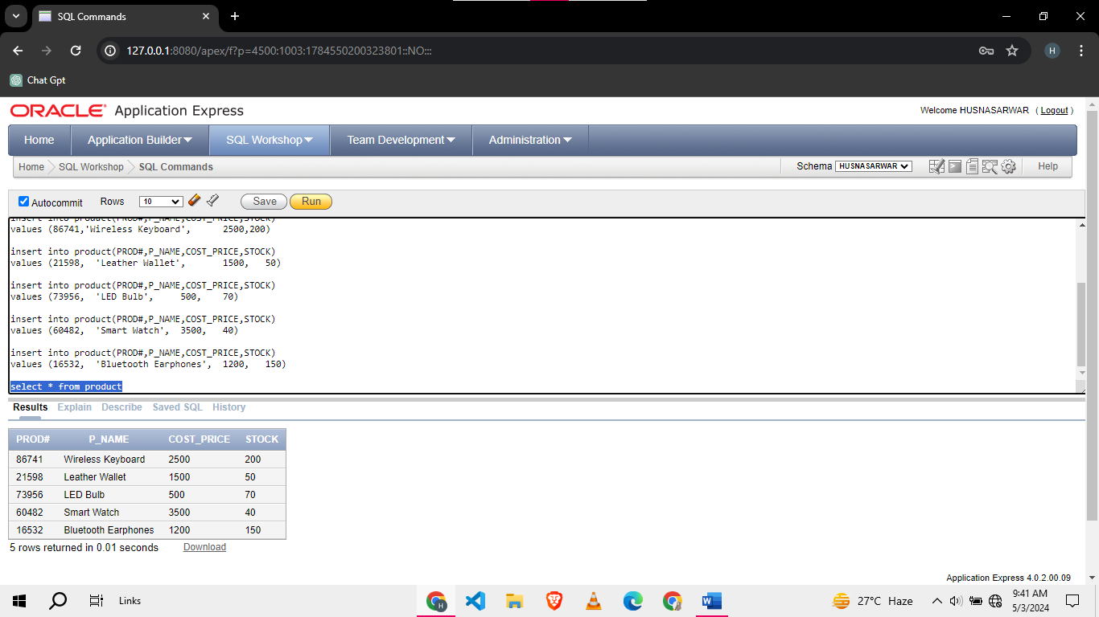**sales_invoice**

|  |  |  |  |
| --- | --- | --- | --- |
| s_invoice | s_inv_date | cust# | Payment |
| 101 | May 3, 2024 | 49273 | Cash |
| 102 | May 3, 2024 | 86741 | Cheque |
| 103 | May 3, 2024 | 21598 | Credit card |
|  |  |  |  |

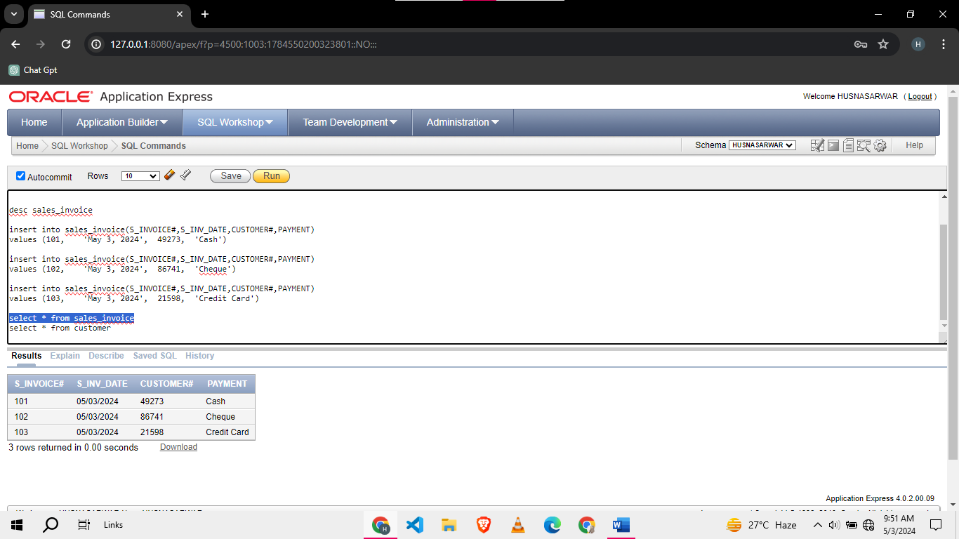**Sales_invoice_details**

|  |  |  |  |
| --- | --- | --- | --- |
| s_invoice# | prod# | qty_ordered | sale_price |
| 101 | **21598** | **1** | **1600** |
| 101 | **73956** | **1** | **550** |
| 102 | **16532** | **5** | **1250** |
| 102 | **60482** | **1** | **3600** |
| 102 | **86741** | **2** | **2500** |
| 103 | **86741** | **2** | **2600** |
| 103 | **60482** | **1** | **3600** |
| 103 | **21598** | **1** | **1600** |
| 103 | **73956** | **1** | **550** |
| 103 | **16532** | **1** | **1250** |
|  |  |  |  |

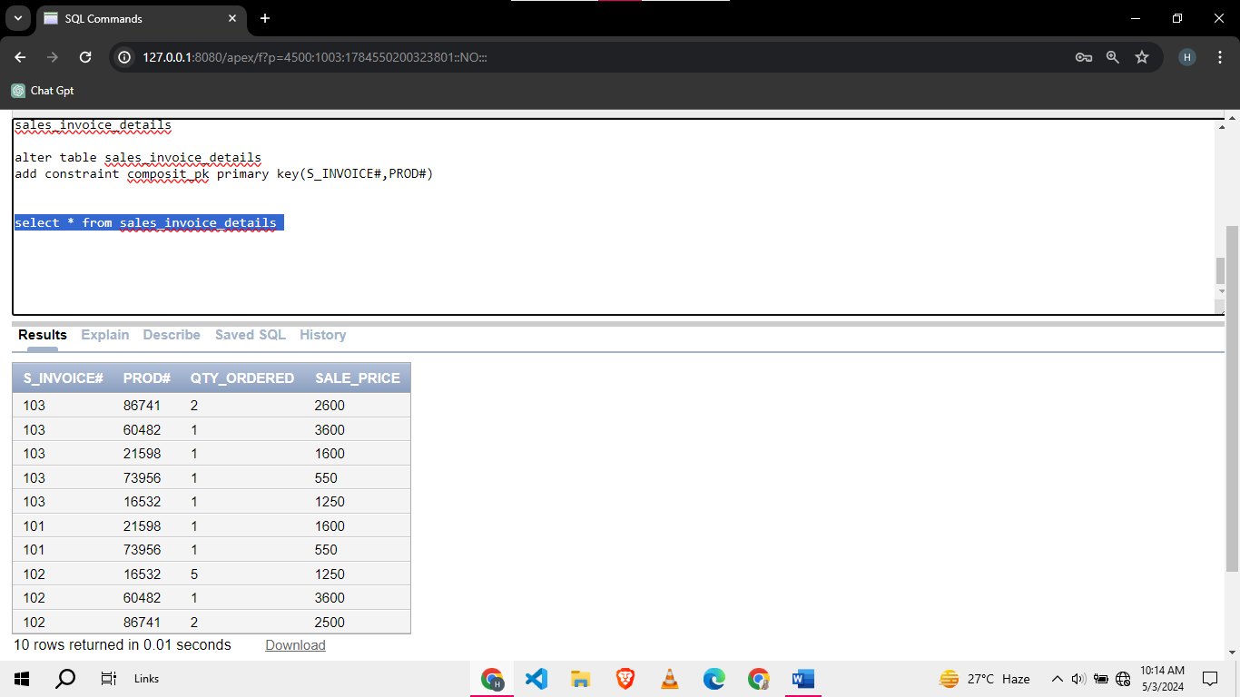

1. Create a table sales_invoice_copy using sales_invoice.

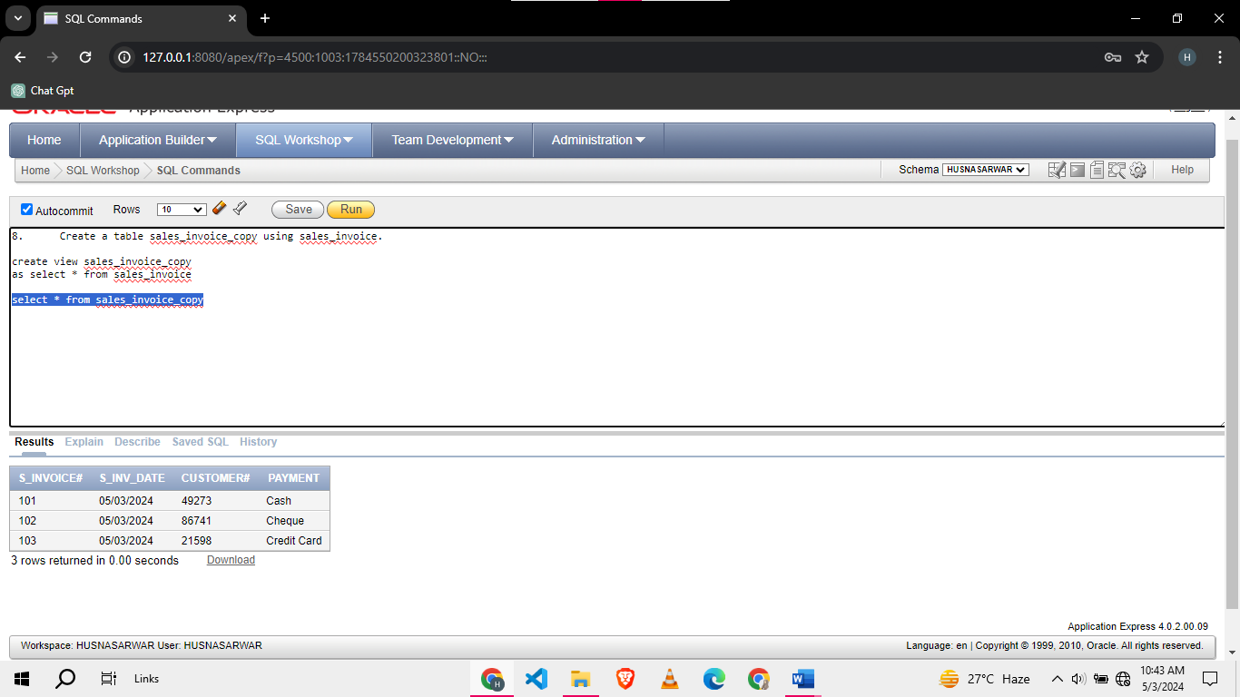

1. Create an empty table client using customer table.

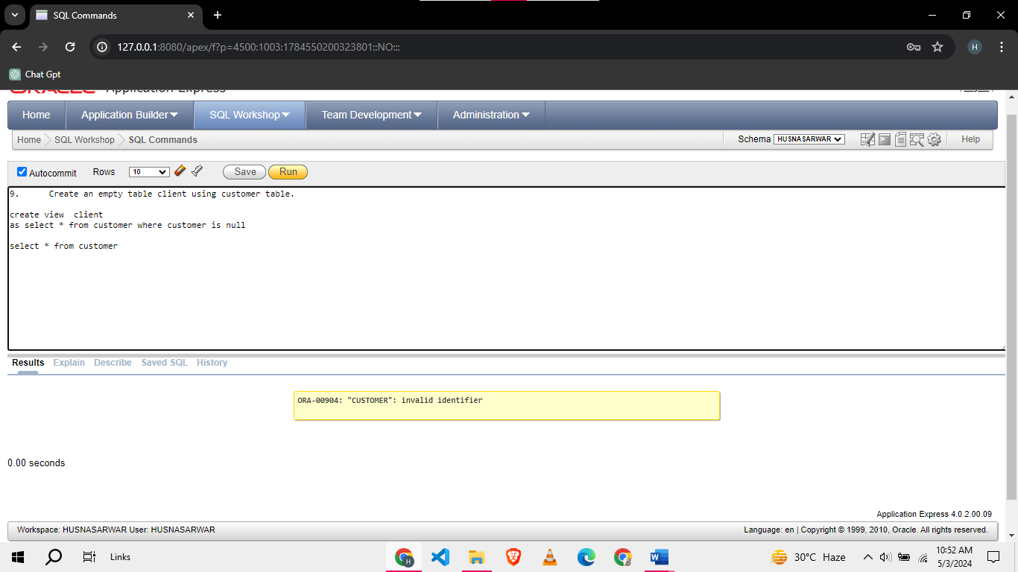

1. Create a view **costly_products_view** that maintains the products with price above 50000. Furthermore, convert the price into US Dollars (=280 PKR).
2. Insert a new product using **costly_products_view.**
3. Create a view sales_invoice_view that keeps s_invoice#, s_inv_date, *s_inv_total*, and c_name. The attribute *s_inv_total* is a derived attribute.

**Task 02: [20 Marks]**

1. Create a sequence sales_invoice_sequence using all the options available for the sequence creation.

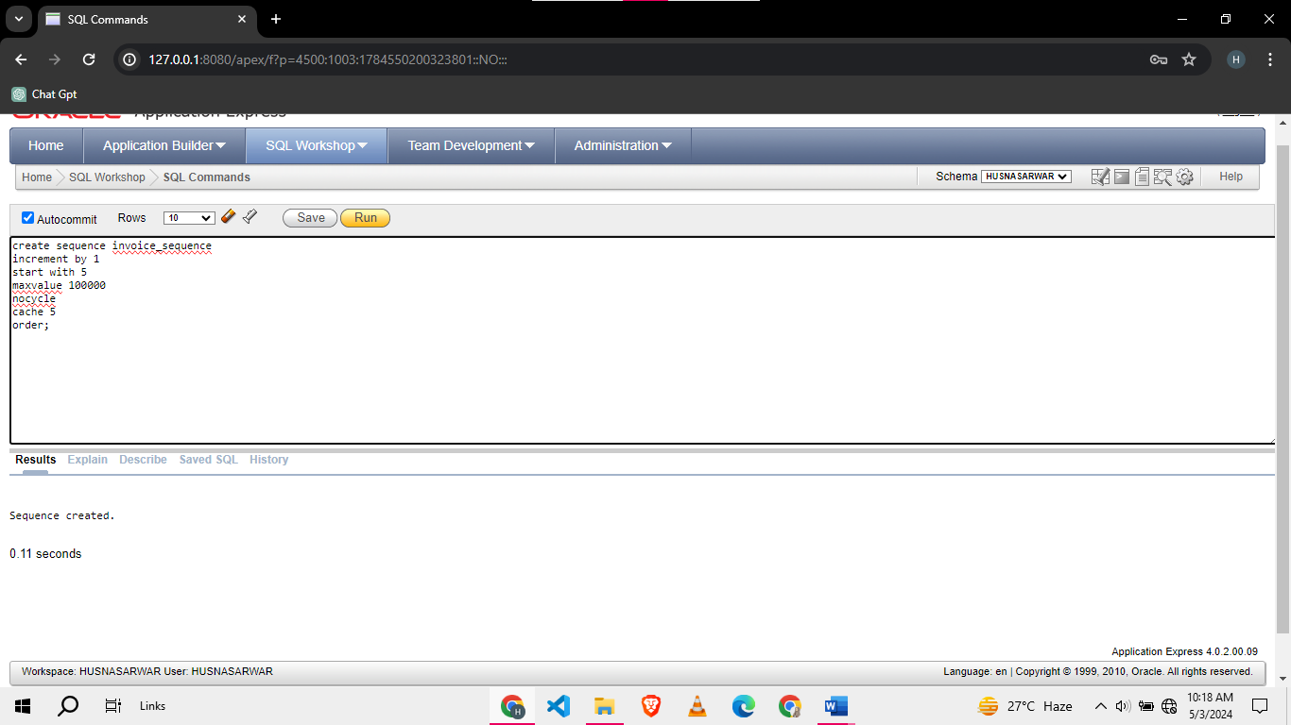

1. View the sequence.

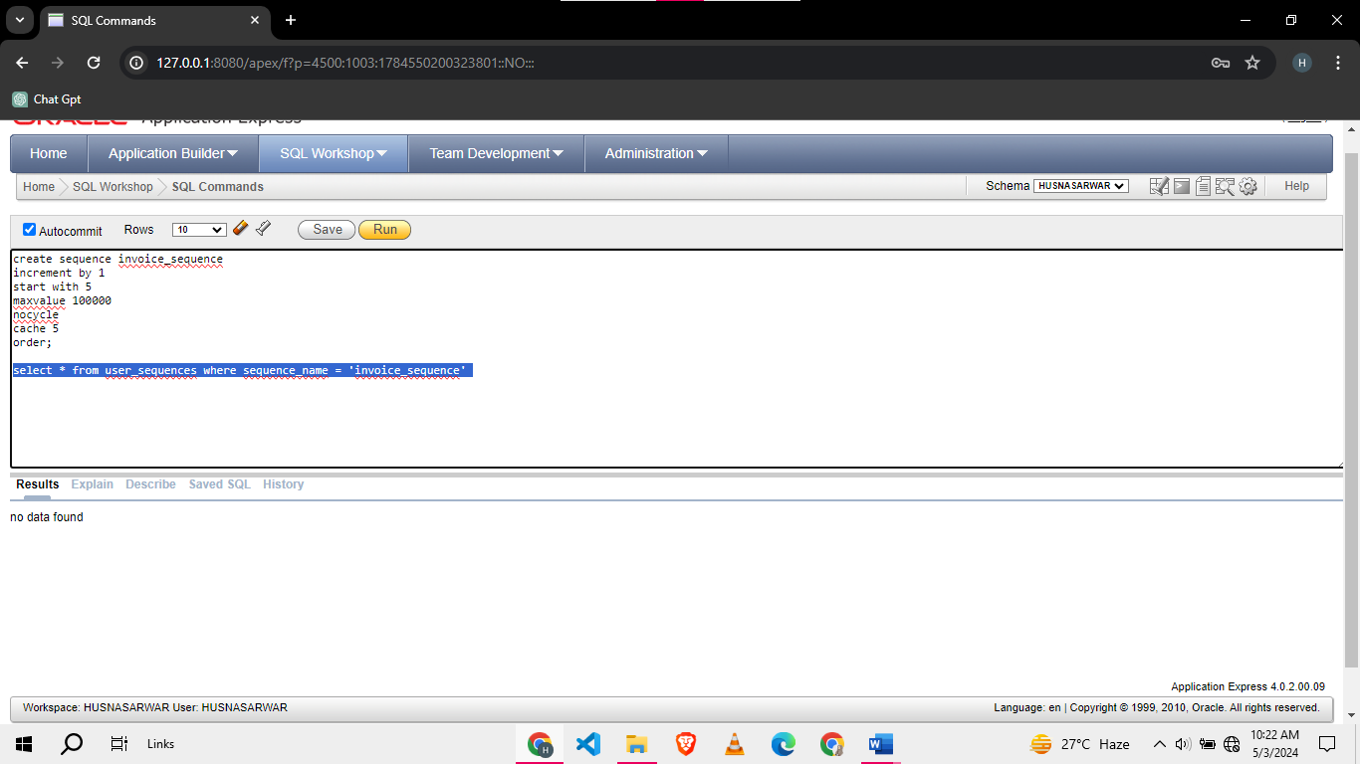

1. View the current and next value of the sequence.

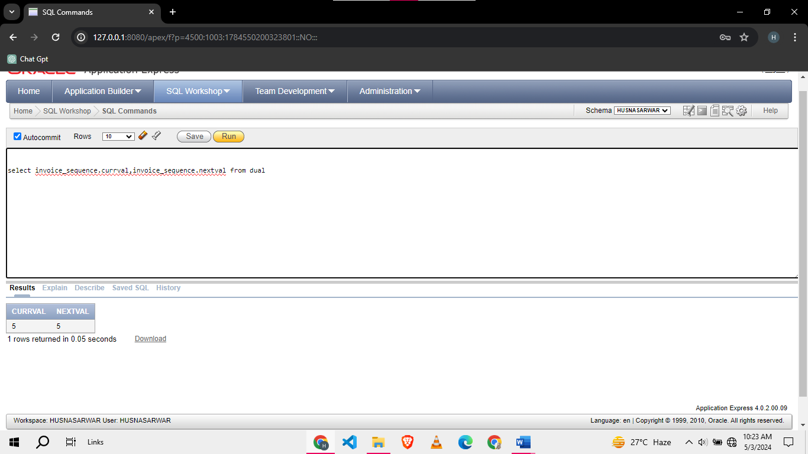

1. Insert 3 rows in the sales_invoice table by populating the s_invoice# column using the sequence.

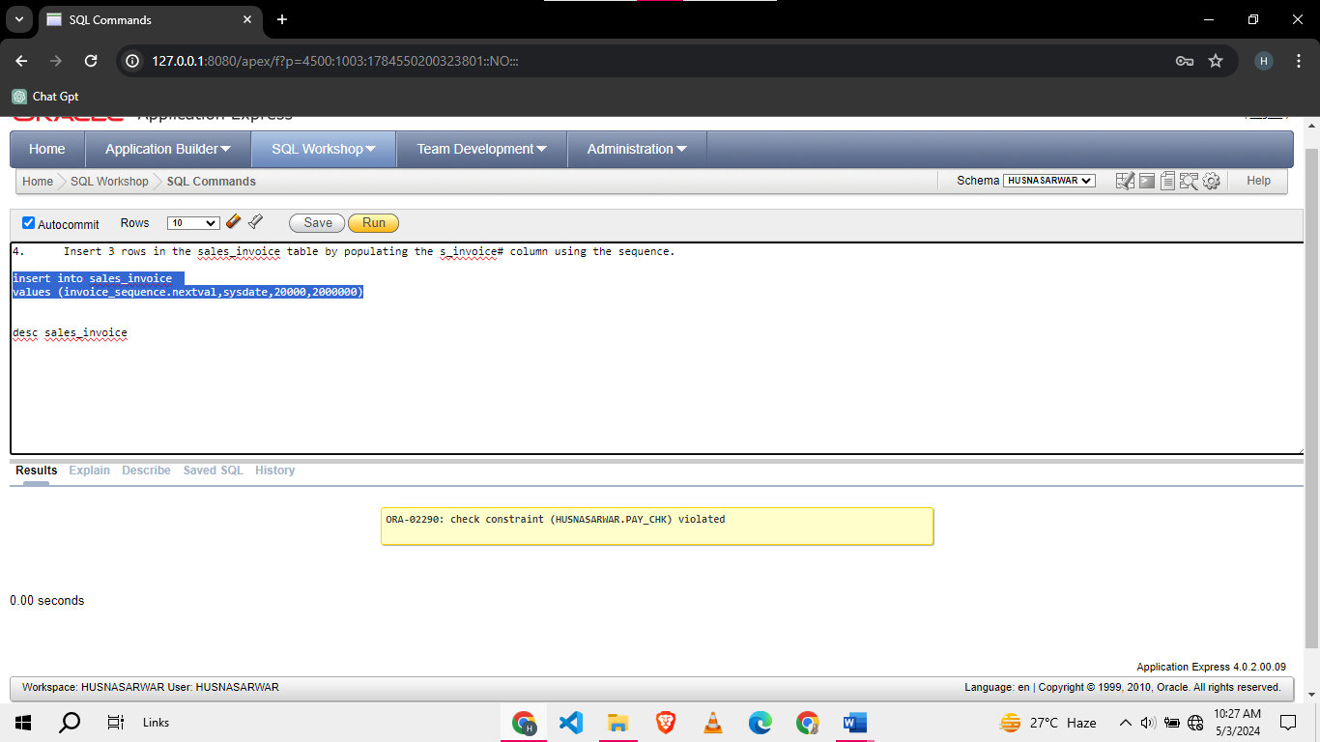

1. Find the name of the most sold product.
2. Find the name of the customer with the highest number of invoices.

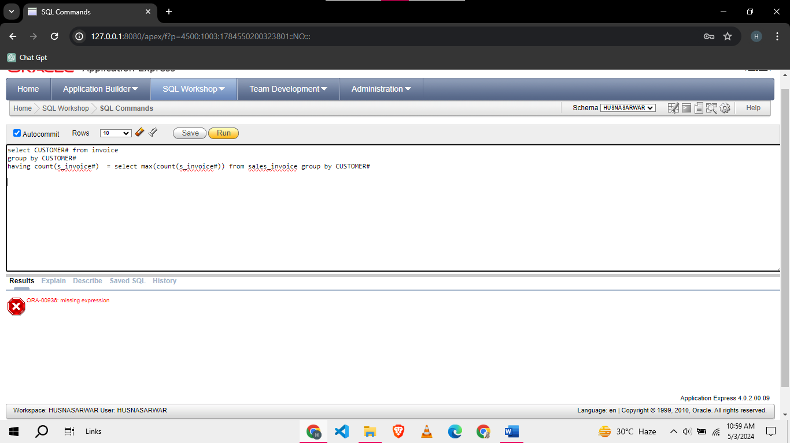

1. Create an index on p_name of the **product** table.

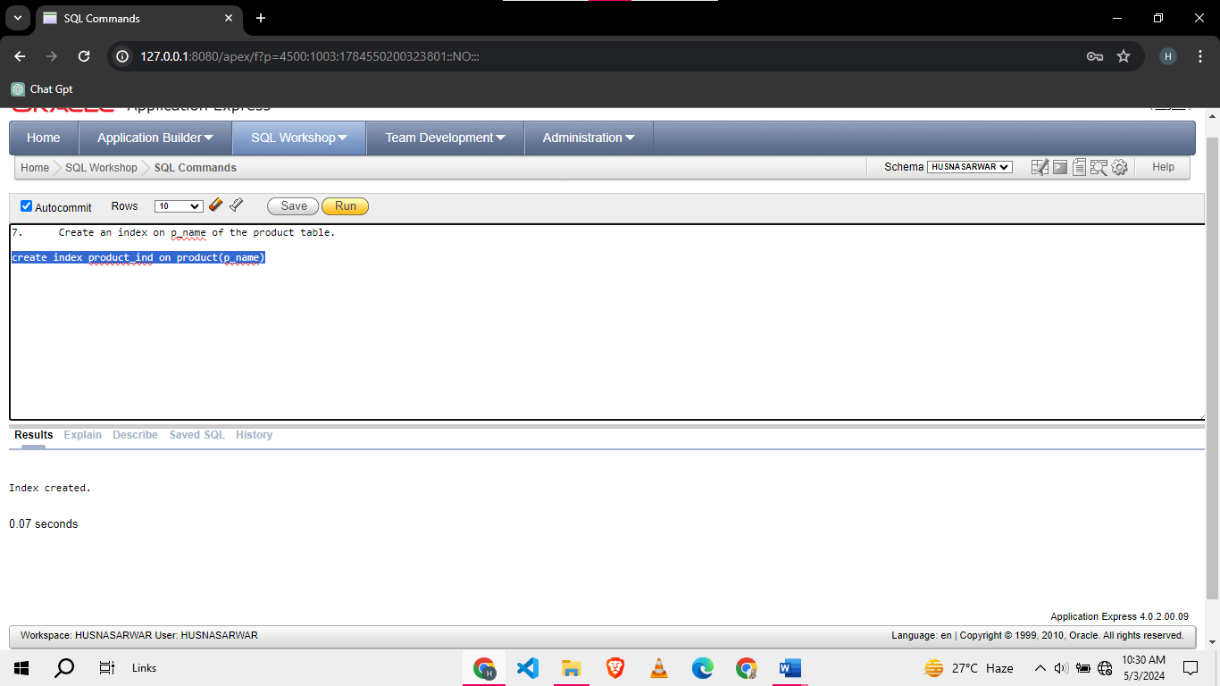

1. View the index.

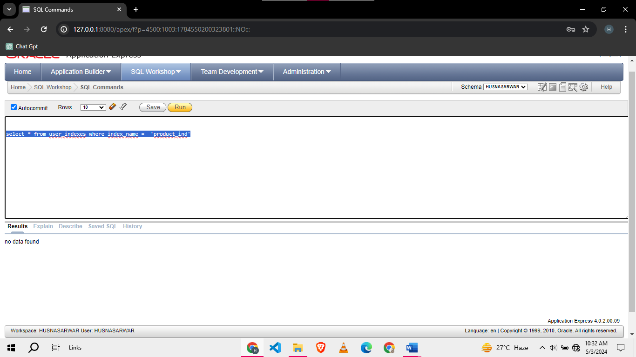

1. Create a public synonym item for the product table.

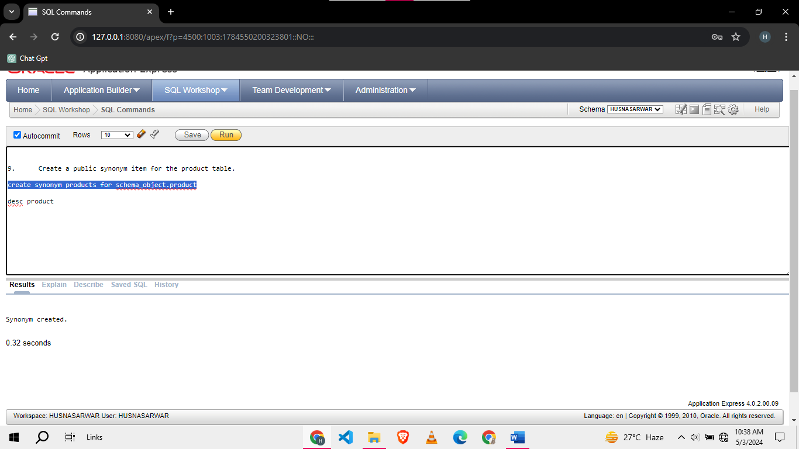

1. Find the names of the all the customers who have purchased a certain product.

**Task 03: ( Viva) [5 Marks]**

**Task 04: Post Lab [5 Marks]**

1. Create the following tables:

|  |  |  |
| --- | --- | --- |
| Table Name: **vendor** | | |
| **Col Name** | **Data Type** | **Constraints** |
| v_code | CHAR(5) | Primary Key |
| v_name | VARCHAR2(20) | Not Null |
| v_addr | VARCHAR2(30) |  |

|  |  |  |
| --- | --- | --- |
| Table Name: **purchase_invoice** | | |
| **Col Name** | **Data Type** | **Constraints** |
| p_invoice# | NUMBER(5) | Primary Key |
| p_invoice date | DATE | DEFAULT sysdate |
| v_code | NUMBER(5) | Foreign Key references vendor  Not Null |

|  |  |  |
| --- | --- | --- |
| Table Name: **purchase_invoice_details** | | |
| **Col Name** | **Data Type** | **Constraints** |
| p_invoice# | NUMBER(5) | Primary Key,  Foreign Key references purchase_ invoice |
| prod# | NUMBER(5) | Primary Key |
| qty_purchased | NUMBER(4) | Must not be negative |

1. Populate the above tables with the following data.

**VENDOR**

|  |  |  |
| --- | --- | --- |
| V_CODE | V_NAME | V_ADDR |
| V001 | **ALI** | **1234 Main Market** |
| V002 | **HAMZA** | **5678 Johar Town** |
| V003 | **HASSAN** | **91011 Garden Town** |

**PURCHASE_INVOICES_DETAILS**

|  |  |  |
| --- | --- | --- |
| p_invoice# | prod# | qty_purchased |
| 10001 | **21598** | **10** |
| 10001 | **73956** | **11** |
| 10002 | **16532** | **50** |
| 10002 | **60482** | **15** |
| 10002 | **86741** | **22** |
| 10003 | **86741** | **25** |
| 10003 | **60482** | **16** |
| 10003 | **21598** | **13** |
| 10003 | **73956** | **10** |
| 10003 | **16532** | **10** |