**CC-215-L: Database Systems Lab**

*Faculty of Computing & Information Technology*



**BS(CS) Morning - Fall 2021, Semester Fall 2024**

**LAB – 05**

**Topics:**

1. Joins
2. Rollup
3. Cube

**Course & Lab Instructor:** Dr. Asif Sohail

Hope you are fine and feeling yourself comfortable and exciting to play with Structured Query Language (SQL) in this first lab.

*You have been taught in the lecture about SQL and query writing. Why not to get all what you have learned with a hands-on experience?* So, let’s Start!

*Allowed time: 1.5 hour*

***Note: Do follow these instructions while you are sitting in the lab and performing the tasks.***

1. ***Gossips are not allowed. So be gentle and do what you know. The lab is not to deduct your sessional marks but to prepare you to achieve good marks in quizzes, mids and finals and finally have good grades. So, try to perform all your tasks in time and at your own.***
2. ***Teacher assistants are for your help, so be nice with them. Respect them as they are teaching you. Raise your hands if you have some problem and need help from TA. Avoid calling them by raising your voice and disturbing the environment of Lab.***
3. ***You must revise the content of the past lectures before starting the lab, it will help you resolve most of your general queries and give you the confidence that you can do it.***
4. ***Evaluation will be considered final and you cannot debate for the marks. So, focus on performing the tasks when the time is given to you.***
5. ***TA may deduct your marks for any kind of ill-discipline or misconduct from your side.***
6. ***Finally, pray before you start. And, Best of Luck!***

* **Kindly paste the query as well as result table screenshot as a result of each task**

**Sample:**

**Display All the Employees from emp table**

**Solution:**

**Select * from emp**

|  |  |  |  |  |  |  |  |
| --- | --- | --- | --- | --- | --- | --- | --- |
| **EMPNO** | **ENAME** | **JOB** | **MGR** | **HIREDATE** | **SAL** | **COMM** | **DEPTNO** |
| 7369 | SMITH | CLERK | 7902 | 12/17/1980 | 800 | - | 20 |
| 7499 | ALLEN | SALESMAN | 7698 | 02/20/1981 | 1600 | 300 | 30 |
| 7521 | WARD | SALESMAN | 7698 | 02/22/1981 | 1250 | 500 | 30 |
| 7566 | JONES | MANAGER | 7839 | 04/02/1981 | 2975 | - | 20 |
| 7654 | MARTIN | SALESMAN | 7698 | 09/28/1981 | 1250 | 1400 | 30 |

**Task 01: [15 Marks]**

1. Write query to display ename, sal and dname of all the employees.

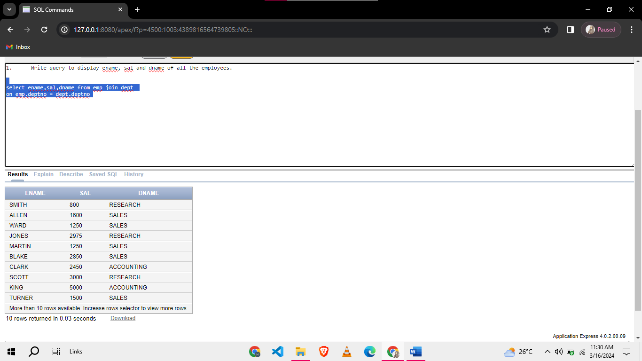

1. Display sal, comm and salgrade of each employee.

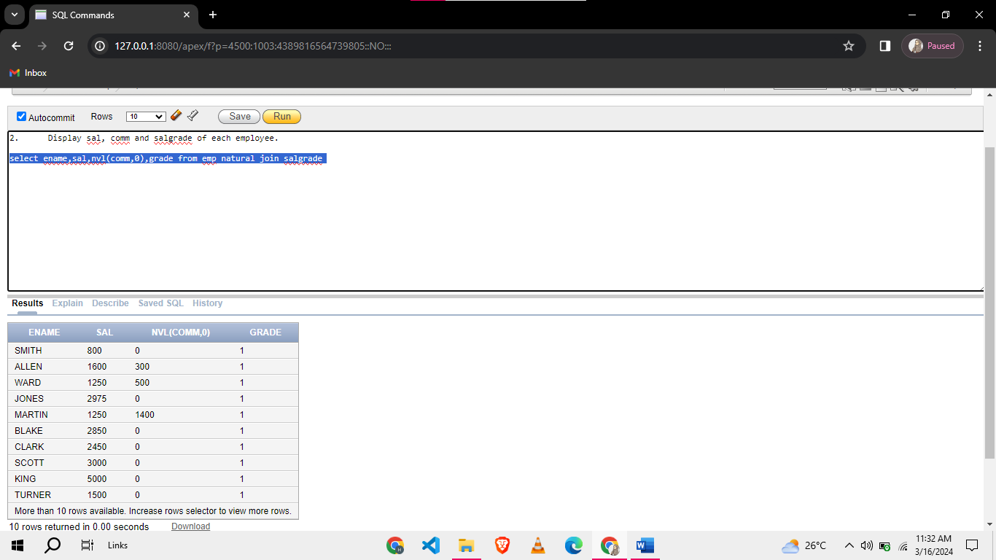

1. List down salaries distribution for each job in different departments. Also display the department-wise sum of the salaries.

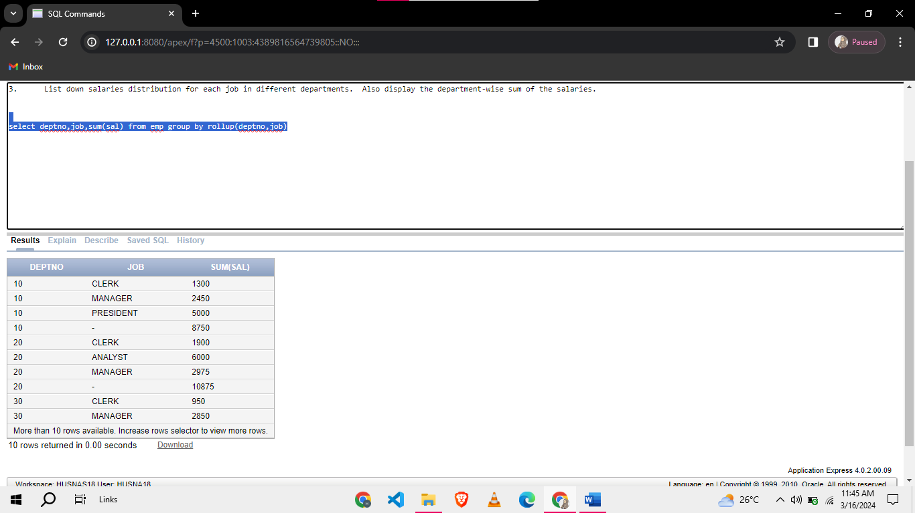

1. List all employees who works in New York.

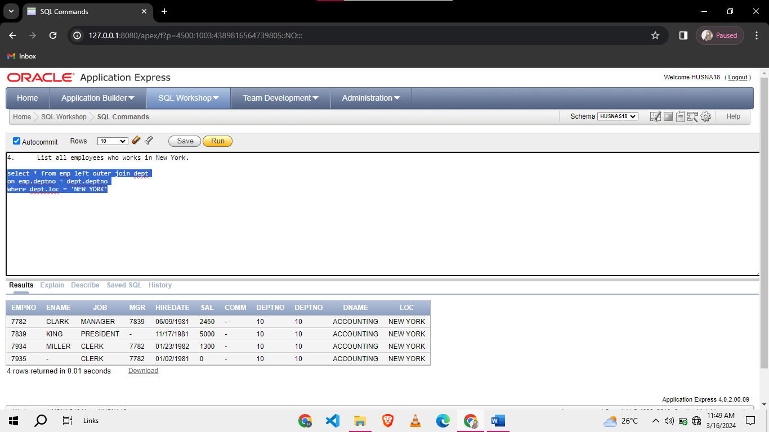

1. Display Ename, sal, job, deptno of Blake.

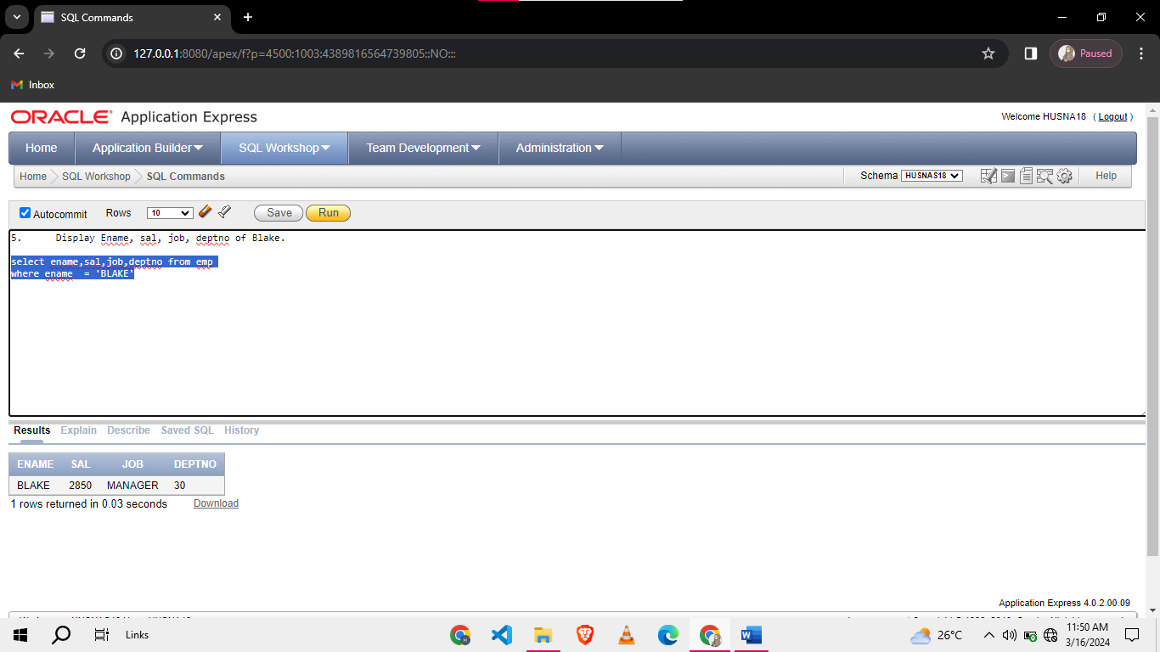

1. Display ename, job, and manager’s name of all employees whose manager is from different department.

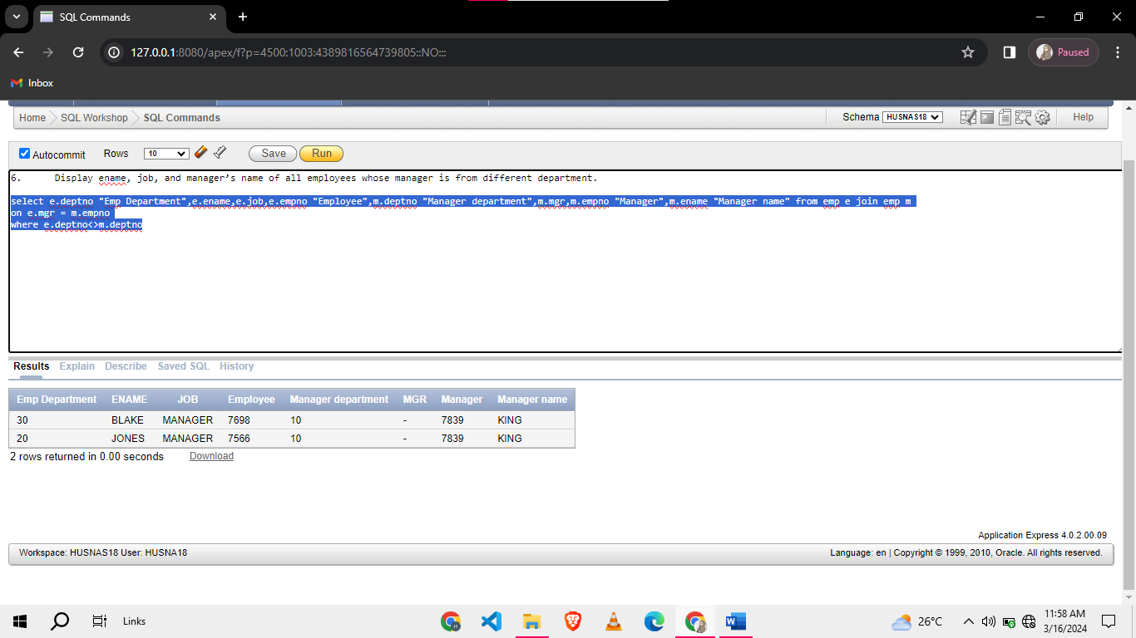

1. List all employees who works in Sales department.

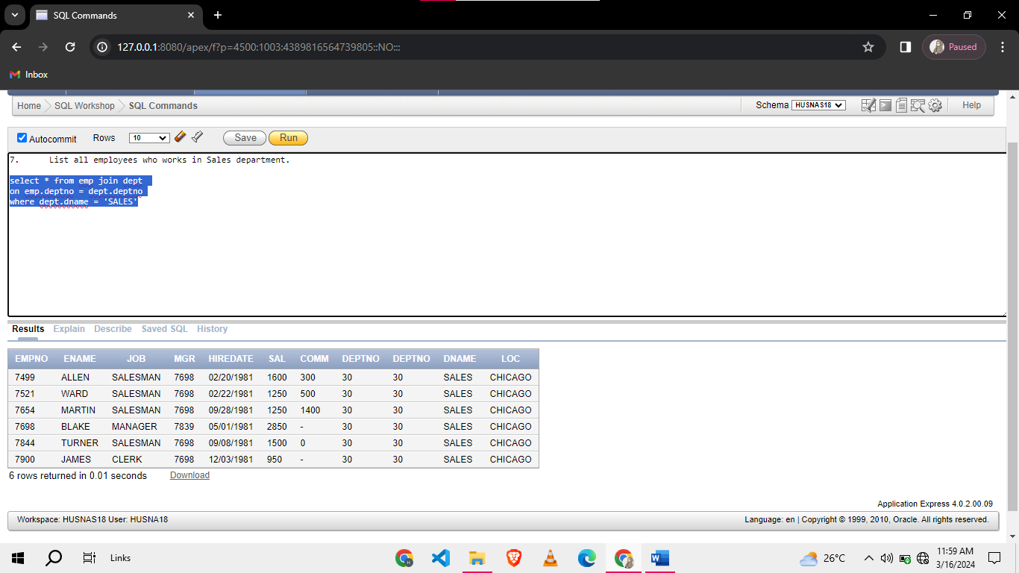

1. Calculate number of employees working at each job along with grand total of employees.

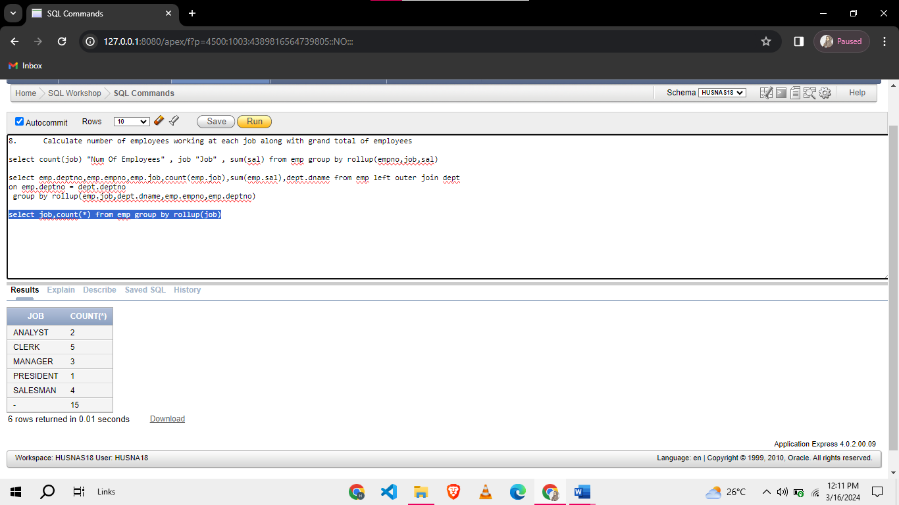

1. Display all department names with even number of employees. Consider 0 is an even number.

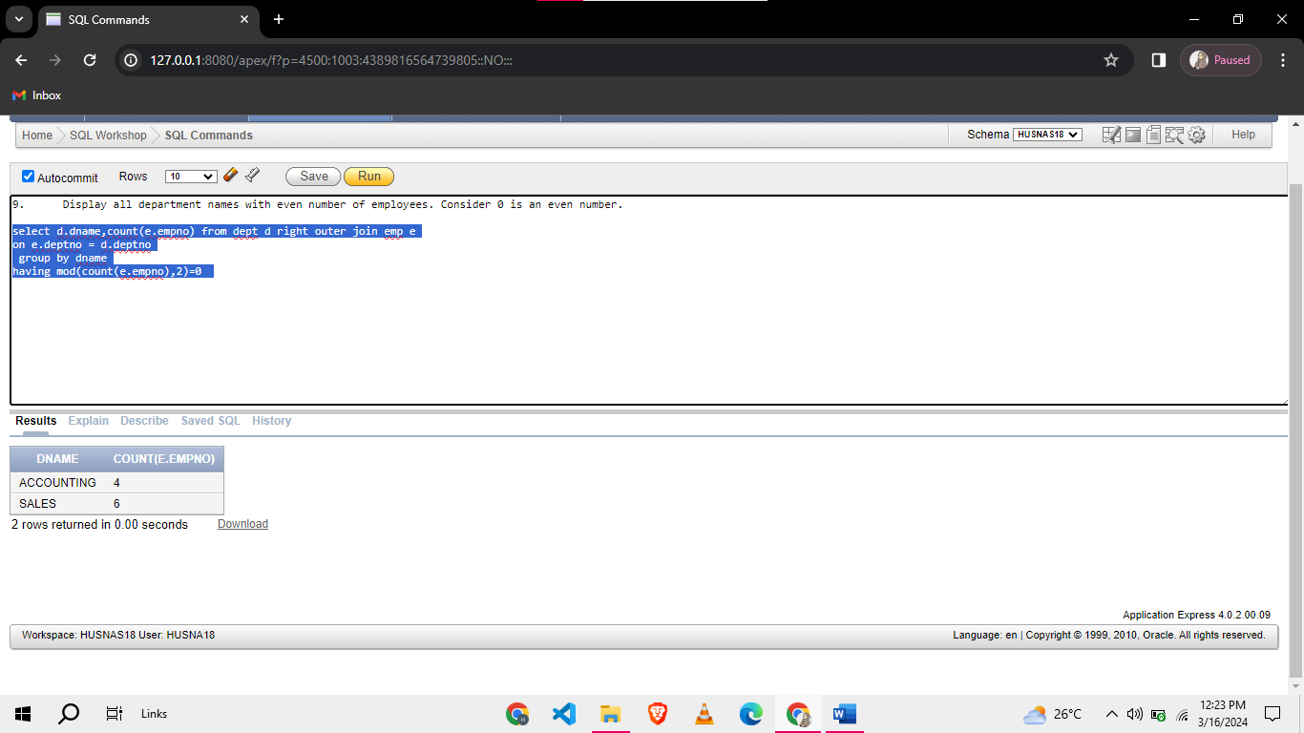

1. Display the department details of employee-less departments.

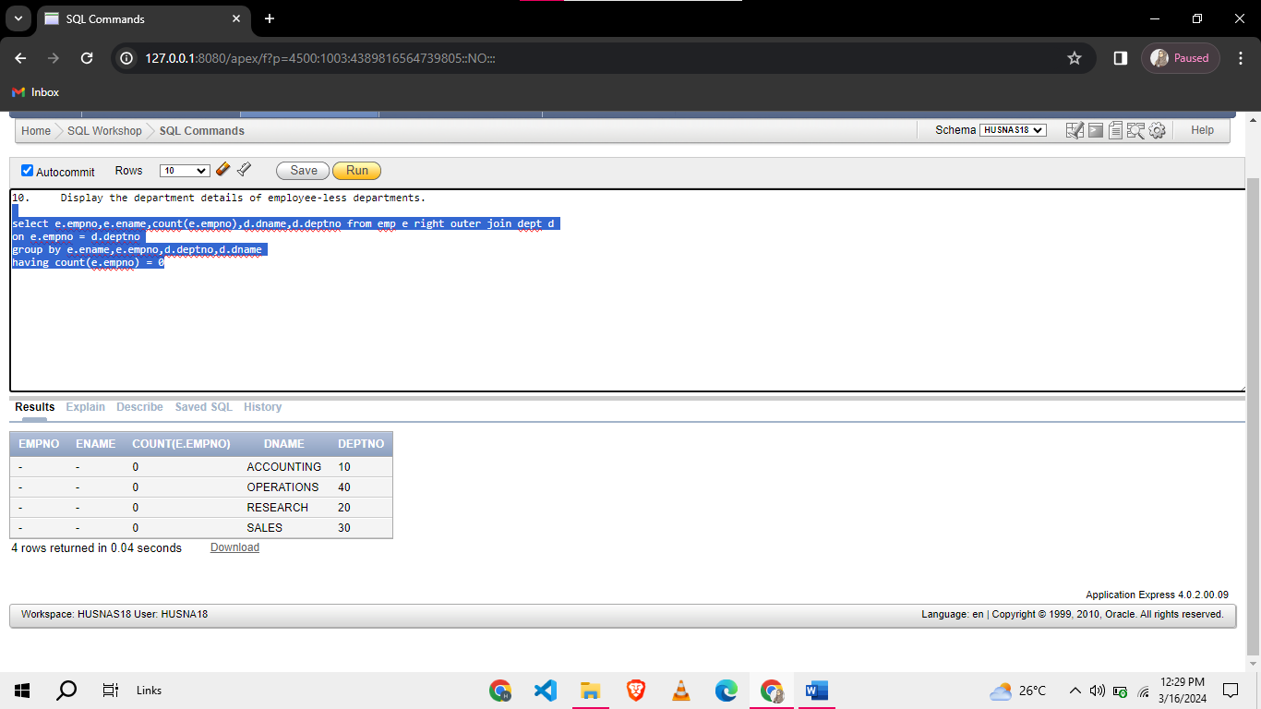

**Task 02: [12 Marks]**

1. We want to assign a special code for each employe in emp table based on its salary. The sal is rounded it to its nearest thousand value. The special code is assigned on the basis of the following rules:
2. A for 1000
3. B for 2000
4. C for 3000
5. D for 4000
6. E for 5000
7. S for 0

Note: You are not allowed to use decode or case for this question

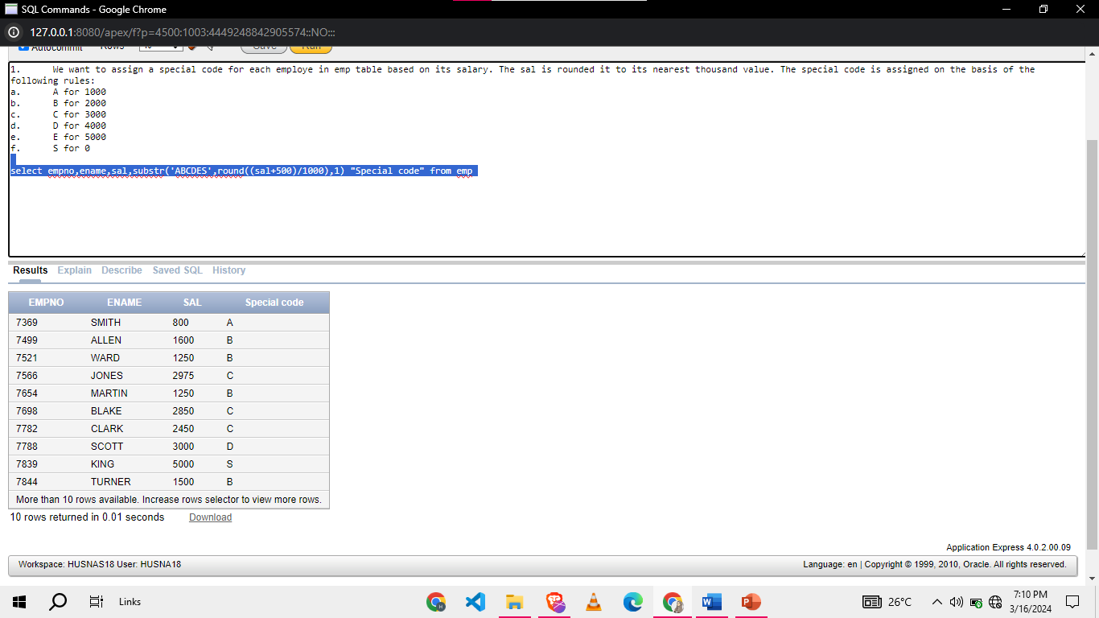

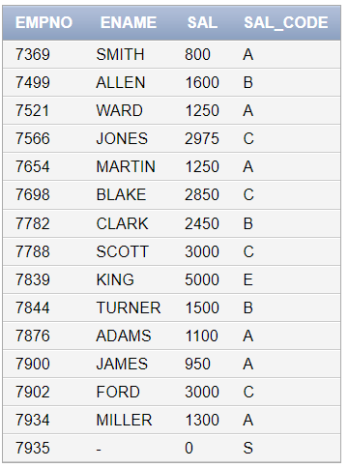

1. Display the employee names , department numbers, department locations, and job titles in ascending order of job titles for those employees who joined after the first half of 1981.

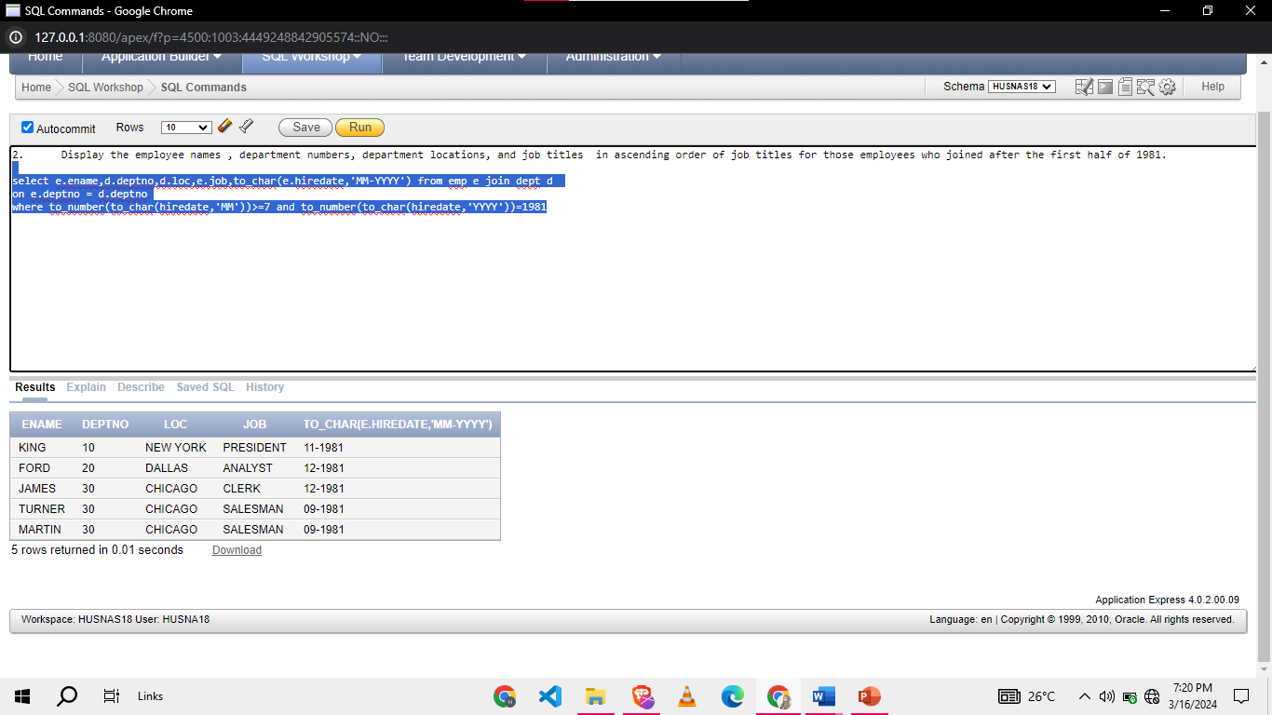

1. Display employee name, emp hiredate, manager name,manager hiredate from emp for those employees who were hired before their manager.

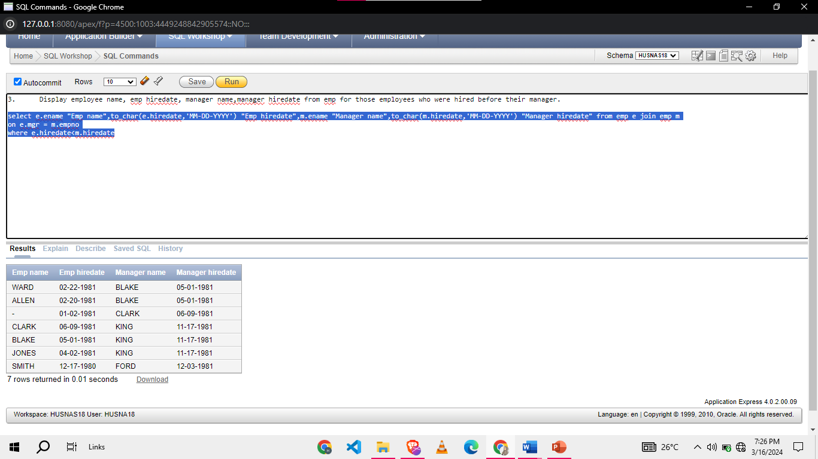

1. Display year wise hiring count of company along with the department wise hiring count in that year.

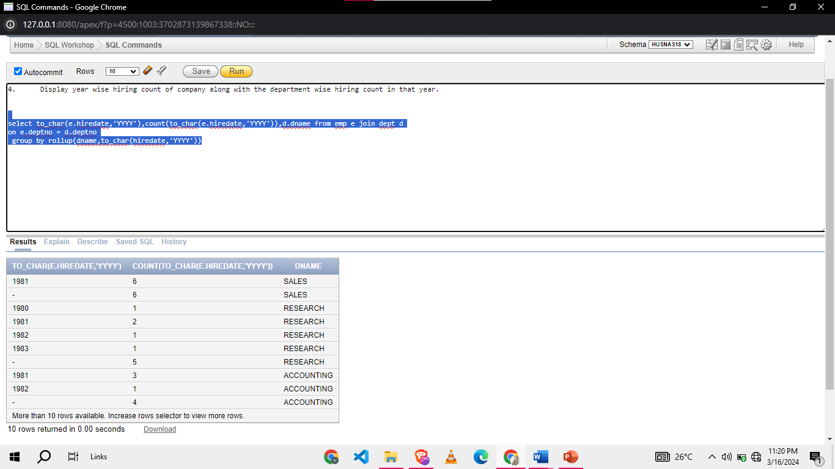

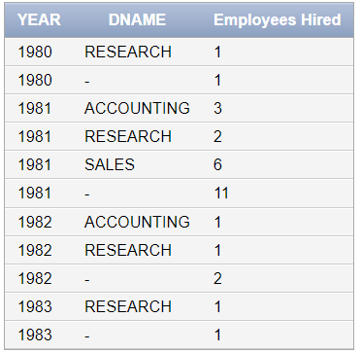

1. Display ename,manager name,employee salary and manager’s salary in emp table for those employees who have same salgrade as their managers.

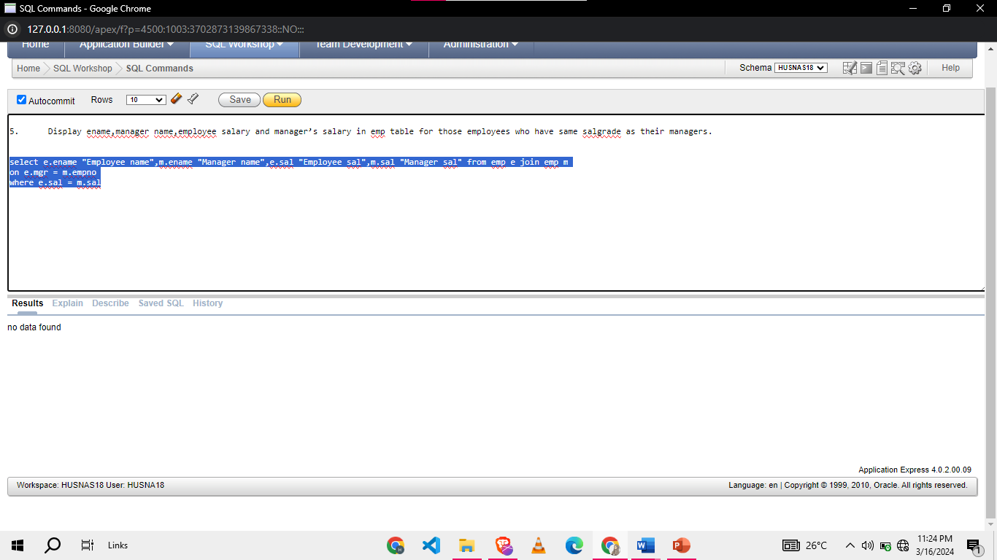

1. Display Departments number and department names in which no employee earns any commission.

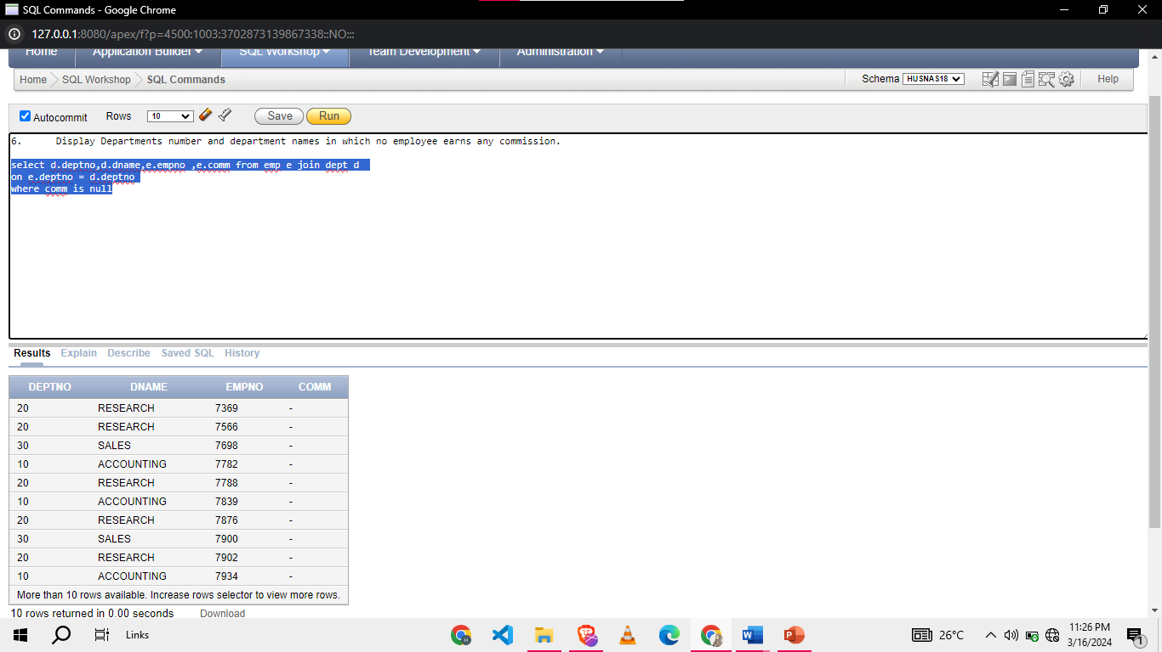

**Task 03: [15 Marks]**

1. Display the manager name, manager number, and salary of the lowest-paid employee for each manager. Exclude anyone whose manager is not known. Sort the output in descending order of the salary.

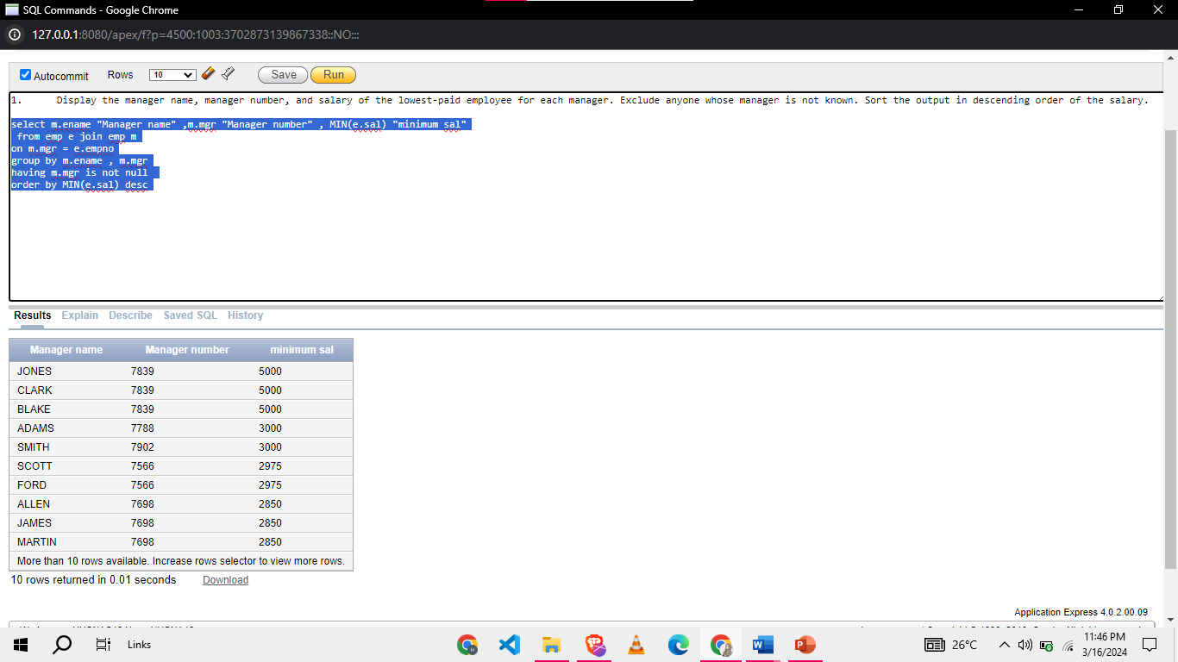

1. Display names, salary, salary grade, department name and rank of employees in emp table. Rank of employee is number of stars assigned to him based on the saray grade of employee. The output must follow the given sample

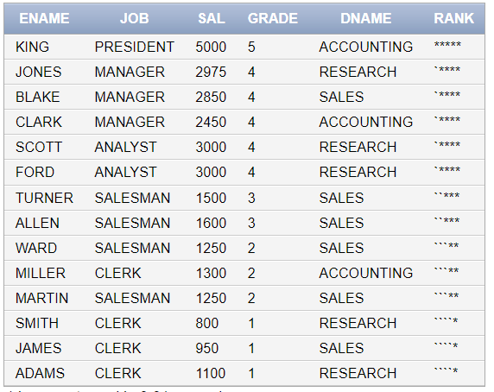

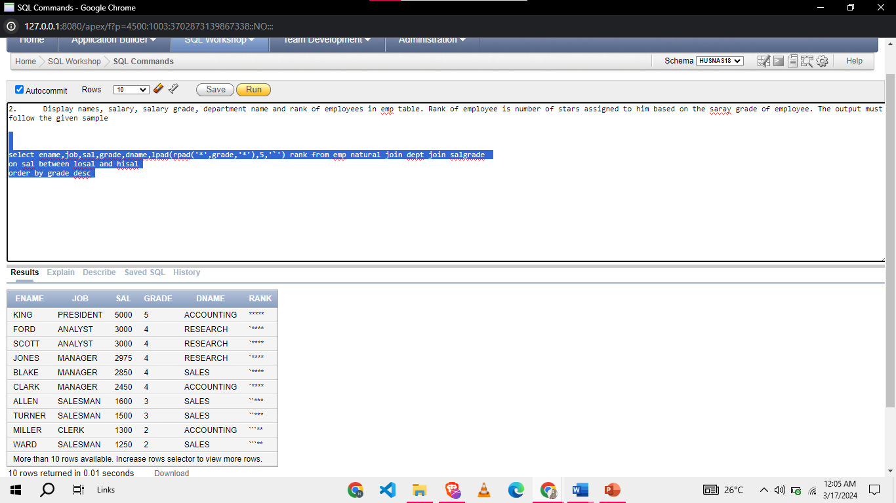

1. Display the intro of employees who don’t manage anybody in company in give format

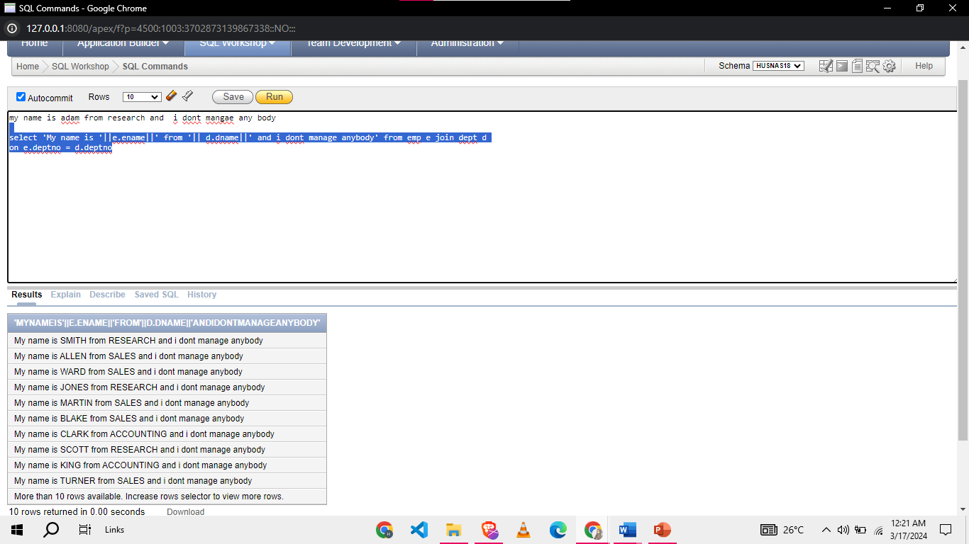

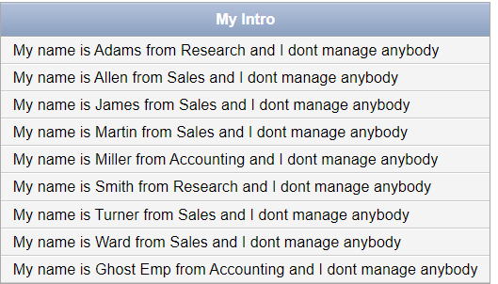

1. List EMPNO, ENAME, JOB, SAL, DEPTNO, DNAME, RANK, TAX, NET_SAL. Tax is a derived attribute computed on the basis of GRADE. All the employees with rank 1 are exempted from tax. For the employees with GRADE 2,3, the tax rate is 10% of the salary. For the employees with GRADE above 3, the tax rate is 12% of the salary. NET_SAL is computed as SAL-TAX.

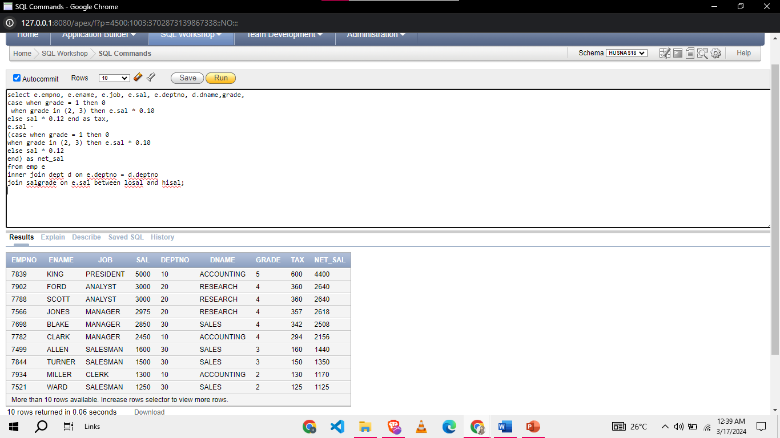

1. Display the count of employees in each department and also display number of employees working for each job catageory in single output. Note: you are not allowed to use join key word

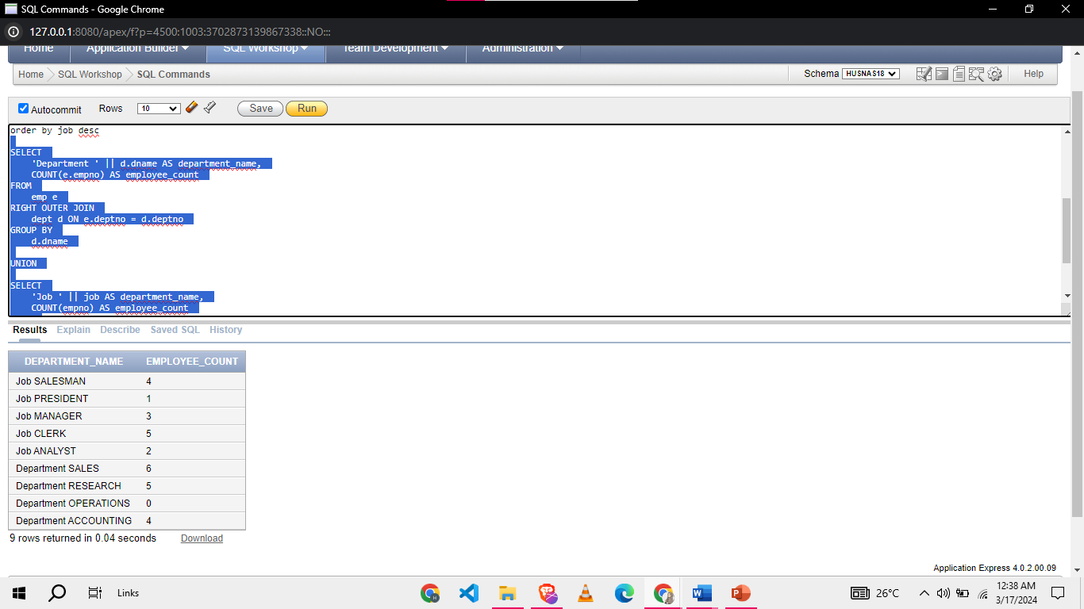

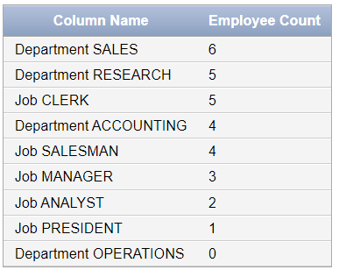

**Task 04: [3 Marks] Viva Questions.**