**CC-215-L: Database Systems Lab**

*Faculty of Computing & Information Technology*



**BS(CS) Morning - Fall 2021, Semester Fall 2024**

**LAB – 07**

**Topics:**

1. Correlated Sub Query
2. DDL

**Course & Lab Instructor:** Dr. Asif Sohail

Hope you are fine and feeling yourself comfortable and exciting to play with Structured Query Language (SQL) in this first lab.

*You have been taught in the lecture about SQL and query writing. Why not to get all what you have learned with a hands-on experience?* So, let’s Start!

*Allowed time: 1.5 hour*

***Note: Do follow these instructions while you are sitting in the lab and performing the tasks.***

1. ***Gossips are not allowed. So be gentle and do what you know. The lab is not to deduct your sessional marks but to prepare you to achieve good marks in quizzes, mids and finals and finally have good grades. So, try to perform all your tasks in time and at your own.***
2. ***Teacher assistants are for your help, so be nice with them. Respect them as they are teaching you. Raise your hands if you have some problem and need help from TA. Avoid calling them by raising your voice and disturbing the environment of Lab.***
3. ***You must revise the content of the past lectures before starting the lab, it will help you resolve most of your general queries and give you the confidence that you can do it.***
4. ***Evaluation will be considered final and you cannot debate for the marks. So, focus on performing the tasks when the time is given to you.***
5. ***TA may deduct your marks for any kind of ill-discipline or misconduct from your side.***
6. ***Finally, pray before you start. And, Best of Luck!***

* **Kindly paste the query as well as result table screenshot as a result of each task**

**Sample:**

**Display All the Employees from emp table**

**Solution:**

**Select * from emp**

|  |  |  |  |  |  |  |  |
| --- | --- | --- | --- | --- | --- | --- | --- |
| **EMPNO** | **ENAME** | **JOB** | **MGR** | **HIREDATE** | **SAL** | **COMM** | **DEPTNO** |
| 7369 | SMITH | CLERK | 7902 | 12/17/1980 | 800 | - | 20 |
| 7499 | ALLEN | SALESMAN | 7698 | 02/20/1981 | 1600 | 300 | 30 |
| 7521 | WARD | SALESMAN | 7698 | 02/22/1981 | 1250 | 500 | 30 |
| 7566 | JONES | MANAGER | 7839 | 04/02/1981 | 2975 | - | 20 |
| 7654 | MARTIN | SALESMAN | 7698 | 09/28/1981 | 1250 | 1400 | 30 |

**Task 01: [05 Marks]**

1. Find the name of the departments with the newest hired employee.

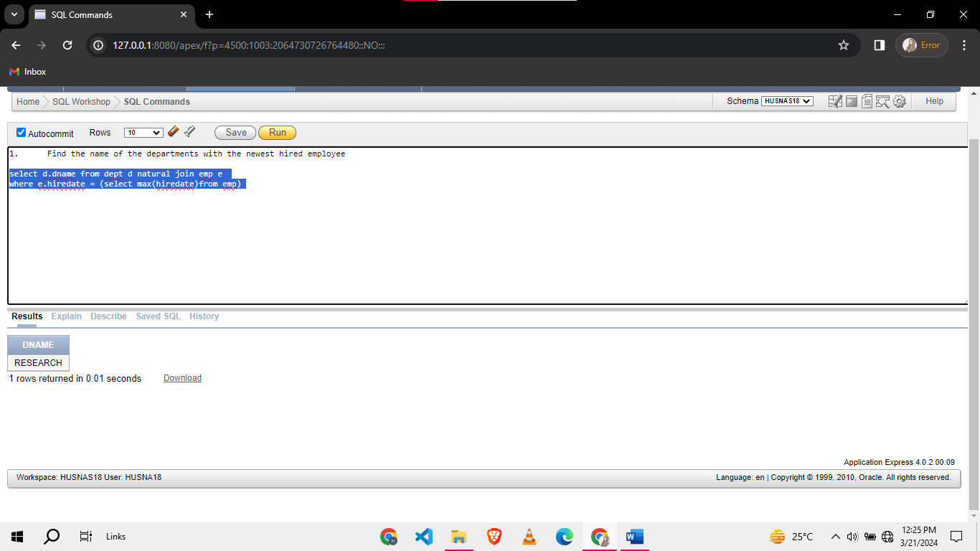

1. Find employees who have the same salary grade as the employees in department 10
2. Find the number of employee who are earning the same salary as their manager.
3. Get the maximum salaries of each department using subquery.
4. List all the employees those who are hired same date as their manager and from dept 20.

**Task 02: [12 Marks]**

1. Display the output in the following format (hint : using union and subquery)

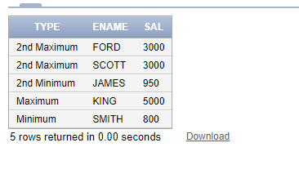

1. Display the department name and the number of employees working in each department.

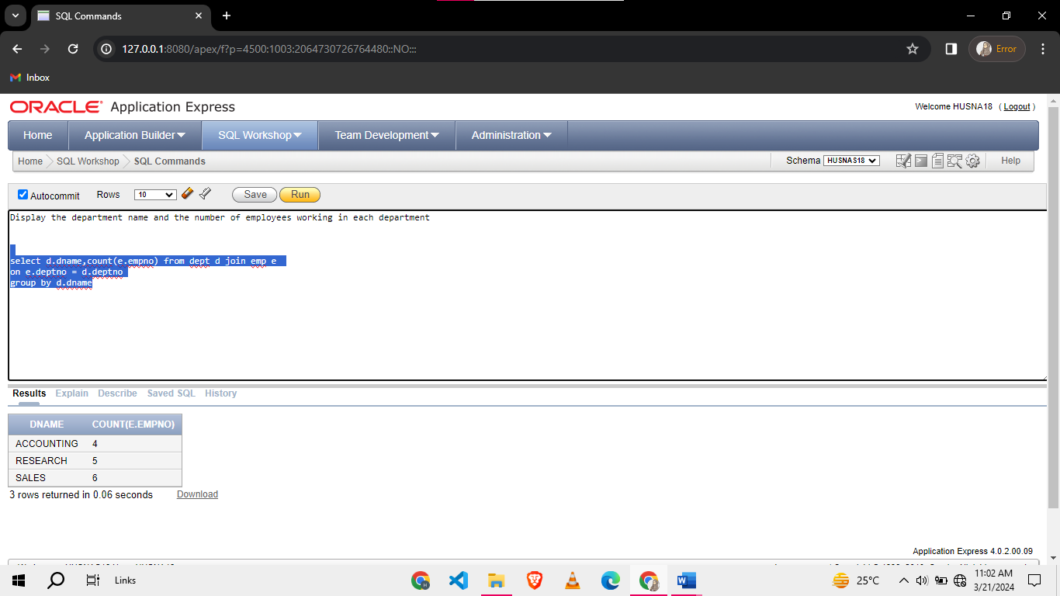

1. List all the employees who earn more than salary with the lowest grade in the RESEARCH department.

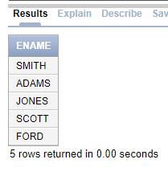

1. Find the employees who are not managers and who joined after any of the managers in their department.

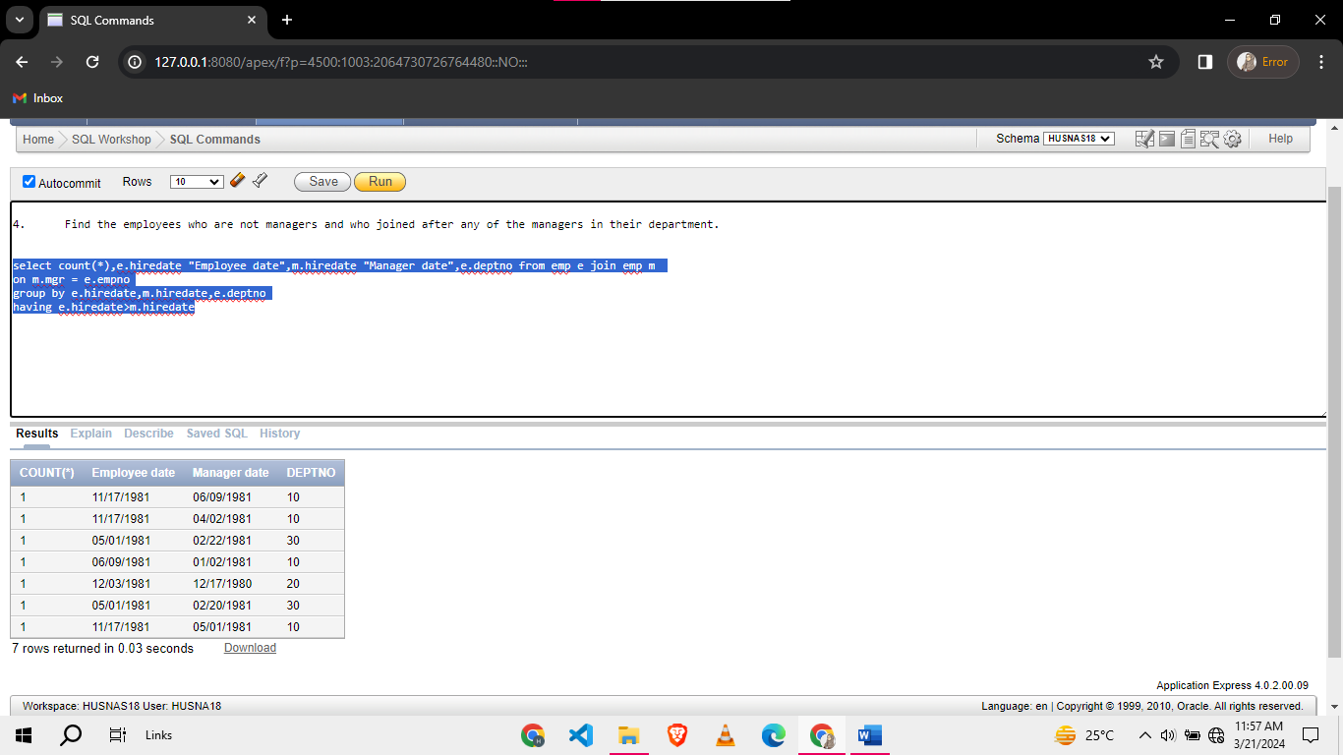

1. List employees who have a salary greater than the salary of at least one employee in department 10 and at least one employee in department 30. (Only Use sub query)

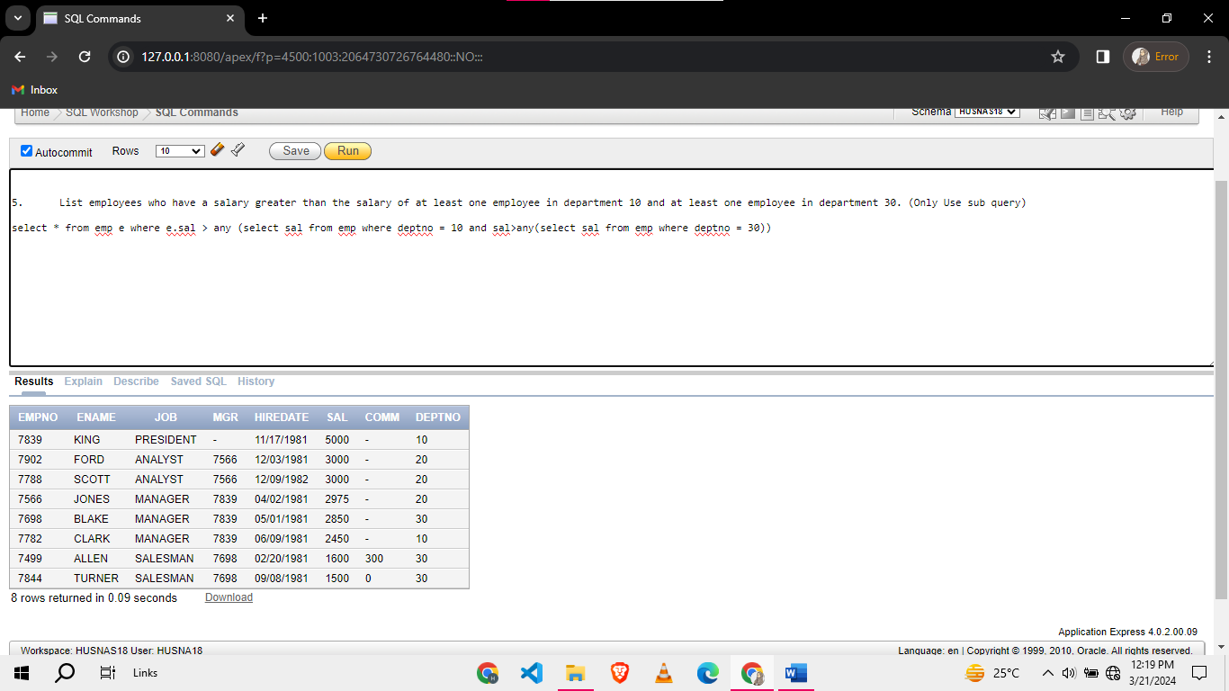

1. Find the employee name, empno, department name and salary grade who have a salary grade greater than or equal to salary grade of highest paid employees in department 20 or 30.

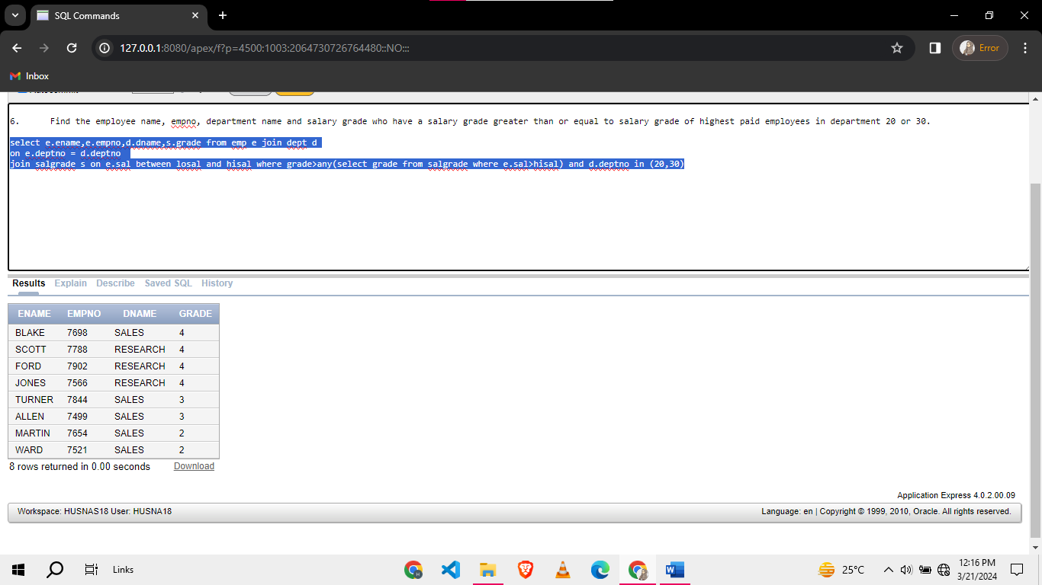

**Task 03: [15 Marks]**

**Create the following tables for a Sales System. You must give meaningful names to all the constraints.**

|  |  |  |
| --- | --- | --- |
| Table Name: **customer** | | |
| **Col Name** | **Data Type** | **Constraints** |
| cust# | NUMBER(5) | Primary Key |
| c_name | VARCHAR2(20) | Not Null |
| city | VARCHAR2(30) |  |
| nic | CHAR(16) | Unique |
|  |  |  |

|  |  |  |
| --- | --- | --- |
| Table Name: **invoice** | | |
| **Col Name** | **Data Type** | **Constraints** |
| invoice# | NUMBER(5) | Primary Key |
| inv_date | DATE | DEFAULT sysdate |
| cust# | NUMBER(5) | Foreign Key references Customer  Not Null |
| payment | CHAR(12) | Cash, Cheque, Credit Card |
|  |  |  |

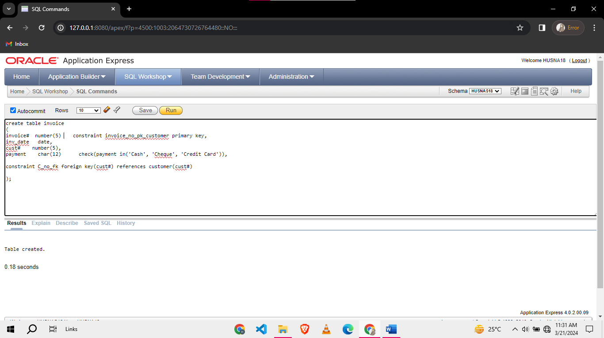

|  |  |  |
| --- | --- | --- |
| Table Name: **product** | | |
| **Col Name** | **Data Type** | **Constraints** |
| prod# | NUMBER(5) | Primary Key |
| p_name | VARCHAR2(50) | Not Null |
| price | NUMBER(5) | Above 5 |

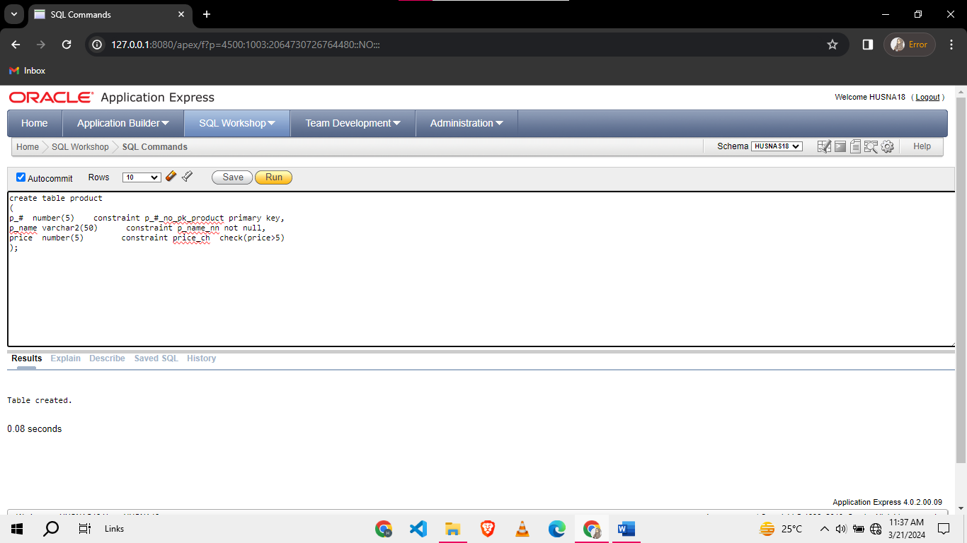

|  |  |  |
| --- | --- | --- |
| Table Name: **invoice_details** | | |
| **Col Name** | **Data Type** | **Constraints** |
| invoice# | NUMBER(5) | Primary Key,  Foreign Key references Invoice |
| prod# | NUMBER(5) | Primary Key |
| qty_ordered | NUMBER(4) | In the range 1-500 |
| sale_price | NUMBER(5) | Above 5 |
|  |  |  |

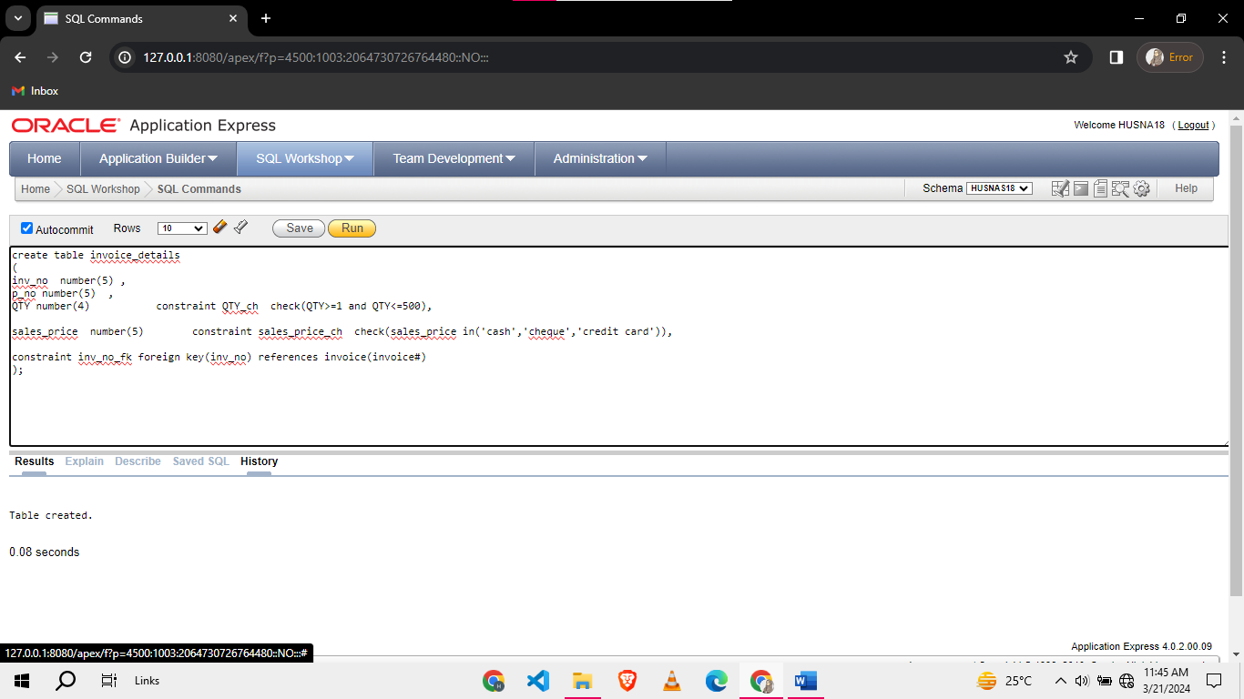

**Task 04: Viva [03 Marks]**