


National University of Computer and Emerging Sciences



GatherForGood
Deliverable 3

ProjectTeam
Husnain Barkat Ali (23L-0860)

Supervised by
Mam Ansa Liaqat

Date of Submission: 24th March,2026

FAST School of Computing
National University of Computer and Emerging Sciences
Lahore, Pakistan

A. Project Introduction:
GatherForGood is a specialized Android application designed to bridge the gap in communal coordination by streamlining congregational prayers and Islamic volunteer initiatives. The platform empowers users to effortlessly create, discover, and participate in local prayer gatherings and community service projects.
The platform allows users to create, discover, and join prayer gatherings while also facilitating the organization and management of community service events. The system integrates location services, event lifecycle management, participant tracking, temporary communication channels, approval workflows, and notification mechanisms to ensure efficient coordination among community members.This community platform facilitates the creation, discovery, and participation in prayer gatherings, as well as the organization and management of community service events. To ensure efficient coordination among members, the system incorporates several integrated features: location services, comprehensive event lifecycle management, participant tracking, temporary communication channels, structured approval workflows, and robust notification mechanisms.

B. User Stories for Sprint 2

Story ID: US-06 Story Title: Create Prayer Gathering
User Story:  As a user, I want to create a prayer gathering so that others can join me for congregational prayer.  Description:  This story involves building a form that allows authenticated users to create a new prayer gathering by specifying key details including prayer type, date, time, location, and gender setting. The gathering is saved to Firestore and becomes visible to other users.  Sub User Stories:  - As a user, I want to select a prayer type (Fajr, Zuhr, Asr, Maghrib, Isha, Jumu'ah) for my gathering.  - As a user, I want to set a date and time for the gathering.  - As a user, I want to set a location for the gathering using GPS or manual input.  - As a user, I want to set a gender setting (All, Brothers Only, Sisters Only) for the gathering.  - As a user, I want the gathering to be saved and visible to other users after creation.  Acceptance Criteria:  - User must be logged in to create a gathering.  - All fields (prayer type, date, time, location) must be filled before submission.  - Gathering is saved to Firestore prayerGatherings collection with correct hostUid.  - Newly created gathering appears in the prayer gatherings list.  - Host is automatically added as a participant. | Priority: High  Estimated Hours: 8

Structured Specifications:

US-06.1: Select a prayer type
Type | Specification
Functional | A dropdown or selection control must be available for prayer type (Fajr, Zuhr, Asr, Maghrib, Isha, Jumu'ah).
Functional | Prayer type must be a required field — form cannot be submitted without a selection.
UX | Selected prayer type must be visually highlighted in the form.

US-06.2: Set a date and time
Type | Specification
Functional | A date picker and time picker must be available on the create gathering form.
Functional | The selected date and time must be stored in Firestore as a formatted timestamp.
UX | Past dates must not be selectable — only future dates are allowed.

US-06.3: Set a location using GPS or manual input
Type | Specification
Functional | A Use My Location button must fetch the device's current GPS coordinates.
Functional | Location coordinates (latitude and longitude) must be saved with the gathering document.
UX | A visual confirmation of the selected location must be displayed to the user before submission.

US-06.4: Set a gender setting
Type | Specification
Functional | A toggle or selection for gender setting (All, Brothers Only, Sisters Only) must be available.
Functional | Gender setting must default to All if no option is selected.
UX | The active gender setting must be clearly highlighted in the UI.

US-06.5: Gathering saved and visible after creation
Type | Specification
Functional | On successful submission, the gathering document is saved to the Firestore prayerGatherings collection.
Functional | The gathering must appear in the prayer gatherings list within the same session.
Performance | Firestore write and UI update must complete within 3 seconds on a standard network connection.

Story ID: US-07 Story Title: Join Prayer Gathering
User Story:  As a user, I want to join a prayer gathering so that I can participate in congregational prayer.  Description:  This story involves enabling users to join an existing prayer gathering with a single tap. The system checks gender settings, verifies the user has not already joined, updates the participant count in Firestore, and reflects the change in the UI immediately.  Sub User Stories:  - As a user, I want to see a Join button on each prayer gathering card.  - As a user, I want to be added to the participants list when I click Join.  - As a user, I want the participant count to update immediately after joining.  - As a user, I want to be prevented from joining if the gathering has a gender restriction that does not match my profile.  - As a user, I want to be notified if I have already joined a gathering.  Acceptance Criteria:  - Join button is visible on gathering cards and detail screen.  - User's UID is added to participants array in Firestore upon joining.  - Participant count increments by 1 after joining.  - Gender restriction is enforced based on user's gender from Firestore profile.  - User cannot join a gathering that has already finished.  - A success confirmation message is shown after joining. | Priority: High  Estimated Hours: 6

Structured Specifications:

US-07.1: Join button visible on gathering card
Type | Specification
Functional | A Join button must be displayed on each prayer gathering card and on the gathering detail screen.
UX | The Join button must change to a Leave button once the user has joined.
UX | The Join button must be disabled and visually grayed out for finished gatherings.

US-07.2: User added to participants list
Type | Specification
Functional | On clicking Join, the user's UID must be added to the participants array field of the gathering document in Firestore.
Functional | The join action must use a Firestore transaction to prevent race conditions.
Functional | Duplicate join requests for the same UID must be rejected.

US-07.3: Participant count updates immediately
Type | Specification
Functional | The participantCount field in Firestore must be incremented by 1 upon a successful join.
UX | The participant count displayed in the UI must update without requiring a page refresh.
Performance | Count update must be reflected in the UI within 2 seconds on a standard connection.

US-07.4: Gender restriction enforced
Type | Specification
Functional | Before joining, the system must compare the user's gender from their Firestore profile against the gathering's genderSetting field.
Functional | If the gender does not match, the join must be blocked and an informative message shown.
UX | The restriction message must clearly state the reason (e.g. This gathering is Brothers Only).

US-07.5: User notified if already joined
Type | Specification
Functional | The system must check if the user's UID already exists in the participants array before processing a join.
UX | If already joined, a toast message must inform the user they have already joined this gathering.
UX | The Join button must not be visible if the user has already joined.

Story ID: US-08 Story Title: Leave Prayer Gathering
User Story:  As a user, I want to leave a prayer gathering before it starts so that I can update my participation.  Description:  This story allows users who have already joined a prayer gathering to leave it before the gathering begins. The system removes the user from the participants list, decrements the count, and updates the UI to reflect the change.  Sub User Stories:  - As a user, I want to see a Leave button on a gathering I have already joined.  - As a user, I want to be removed from the participants list when I click Leave.  - As a user, I want the participant count to decrease after leaving.  - As a user, I want to be prevented from leaving a gathering that has already started or finished.  Acceptance Criteria:  - Leave button is only visible to users who have already joined the gathering.  - User's UID is removed from participants array in Firestore.  - Participant count decrements by 1 after leaving.  - Leave is not allowed if gathering status is Ongoing or Finished.  - A confirmation message is shown after successfully leaving. | Priority: Medium  Estimated Hours: 4

Structured Specifications:

US-08.1: Leave button visible on joined gathering
Type | Specification
Functional | The Leave button must only be visible to users whose UID exists in the participants array of the gathering.
UX | The Leave button must replace the Join button once the user has joined.
UX | Leave button must be hidden or disabled if the gathering status is Ongoing or Finished.

US-08.2: User removed from participants list
Type | Specification
Functional | On clicking Leave, the user's UID must be removed from the participants array in Firestore.
Functional | The remove operation must use a Firestore atomic update to avoid data inconsistency.
Functional | If the user's UID is not found in the array, the operation must fail gracefully.

US-08.3: Participant count decreases
Type | Specification
Functional | The participantCount field must be decremented by 1 in Firestore upon a successful leave.
UX | The updated count must be reflected in the UI immediately without a full refresh.
Performance | Count update must complete and reflect in the UI within 2 seconds on a standard connection.

US-08.4: Cannot leave an ongoing or finished gathering
Type | Specification
Functional | The system must check the gathering's status field before processing a leave request.
Functional | Leave must be blocked if status is Ongoing or Finished and an error message must be displayed.
UX | The Leave button must be visually disabled or hidden for gatherings that are no longer Upcoming.

Story ID: US-09 Story Title: Filter Prayer Gatherings
User Story:  As a user, I want to filter prayer gatherings by prayer type, date, and gender restriction so that I can find relevant gatherings.  Description:  This story involves implementing filter chips on the prayer gatherings screen that allow users to narrow down the list of gatherings by prayer type. Gender filtering is applied automatically based on the user's gender stored in their profile.  Sub User Stories:  - As a user, I want to filter gatherings by prayer type using filter chips.  - As a user, I want gatherings that do not match my gender setting to be hidden automatically.  - As a user, I want to see all gatherings when the All filter is selected.  - As a user, I want the filter to update the list in real time without refreshing.  Acceptance Criteria:  - Filter chips for All, Fajr, Zuhr, Asr, Maghrib, Isha, and Jumu'ah are displayed.  - Selecting a chip filters the RecyclerView to show only matching gatherings.  - Gender restriction is applied silently based on user profile data.  - All filter shows every gathering matching the user's gender setting.  - Active filter chip is visually highlighted. | Priority: Medium  Estimated Hours: 6

Structured Specifications:

US-09.1: Filter by prayer type using chips
Type | Specification
Functional | Filter chips for All, Fajr, Zuhr, Asr, Maghrib, Isha, and Jumu'ah must be displayed horizontally above the gathering list.
Functional | Tapping a chip must filter the gathering list to show only gatherings of that prayer type.
UX | Only one chip can be active at a time — selecting a new chip deselects the previous one.

US-09.2: Gender setting hidden automatically
Type | Specification
Functional | On loading the prayer list, the system must fetch the current user's gender from Firestore and apply it as a silent filter.
Functional | Gatherings with a genderSetting that does not match the user's gender must not appear in the list.
UX | No gender filter chip is shown to the user — the filter is applied invisibly in the background.

US-09.3: All filter shows all gatherings
Type | Specification
Functional | Selecting the All chip must remove the prayer type filter and show all gatherings that match the user's gender setting.
Functional | All chip must be selected by default when the screen is first opened.
UX | All chip must be visually highlighted when active.

US-09.4: List updates in real time
Type | Specification
Functional | The gathering list must update immediately when a filter chip is tapped, without navigating away or refreshing the screen.
Performance | Filter application must complete and update the list within 1 second of chip selection.
UX | If no gatherings match the selected filter, a clear empty state message must be displayed.

Story ID: US-10 Story Title: Manage Prayer Gathering Status
User Story:  As a host, I want to manage the status of my prayer gathering (upcoming, ongoing, finished) so that participants know the event status.  Description:  This story allows the host of a prayer gathering to update the status of their event through the gathering detail screen. The host can transition the status from Upcoming to Ongoing and then to Finished. The updated status is saved to Firestore and reflected immediately for all participants.  Sub User Stories:  - As a host, I want to mark my gathering as Ongoing when it begins.  - As a host, I want to mark my gathering as Finished when it ends.  - As a host, I want to delete my gathering if it has not started yet.  - As a user, I want to see the current status badge on each gathering card.  Acceptance Criteria:  - Status management buttons are only visible to the host of the gathering.  - Status transitions follow the order: Upcoming → Ongoing → Finished.  - Status update is saved to Firestore immediately.  - Status badge on gathering cards updates to reflect the current state.  - Users cannot join a gathering with Finished status.  - Host can delete the gathering only when its status is Upcoming. | Priority: High  Estimated Hours: 5

Structured Specifications:

US-10.1: Mark gathering as Ongoing
Type | Specification
Functional | A Mark as Ongoing button must be available on the gathering detail screen, visible only to the host.
Functional | Tapping the button must update the status field in Firestore from Upcoming to Ongoing.
UX | The status badge on the gathering card must change from Upcoming to Ongoing immediately after the update.

US-10.2: Mark gathering as Finished
Type | Specification
Functional | A Mark as Finished button must be available to the host when the gathering status is Ongoing.
Functional | Tapping the button must update the status field in Firestore from Ongoing to Finished.
UX | Once marked Finished, the status badge must update and join/leave actions must be disabled for all participants.

US-10.3: Delete gathering
Type | Specification
Functional | A Delete button must be available to the host only when the gathering status is Upcoming.
Functional | Tapping Delete must permanently remove the gathering document from Firestore.
UX | A confirmation dialog must appear before deletion to prevent accidental removal.

US-10.4: Status badge visible on gathering cards
Type | Specification
Functional | Each gathering card must display a status badge reflecting the current status (Upcoming, Ongoing, Finished).
UX | Status badges must use distinct colors: green for Upcoming, amber for Ongoing, and grey for Finished.
Performance | Status badge must reflect Firestore changes within 3 seconds on a standard network connection.

C. Design

- Architecture Diagram

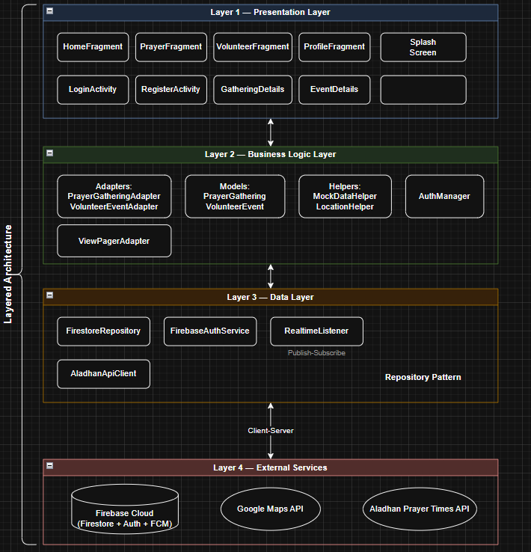

- Component Diagram

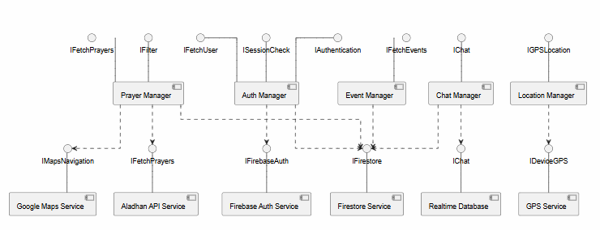

- Data Flow Diagrams

Level 0:

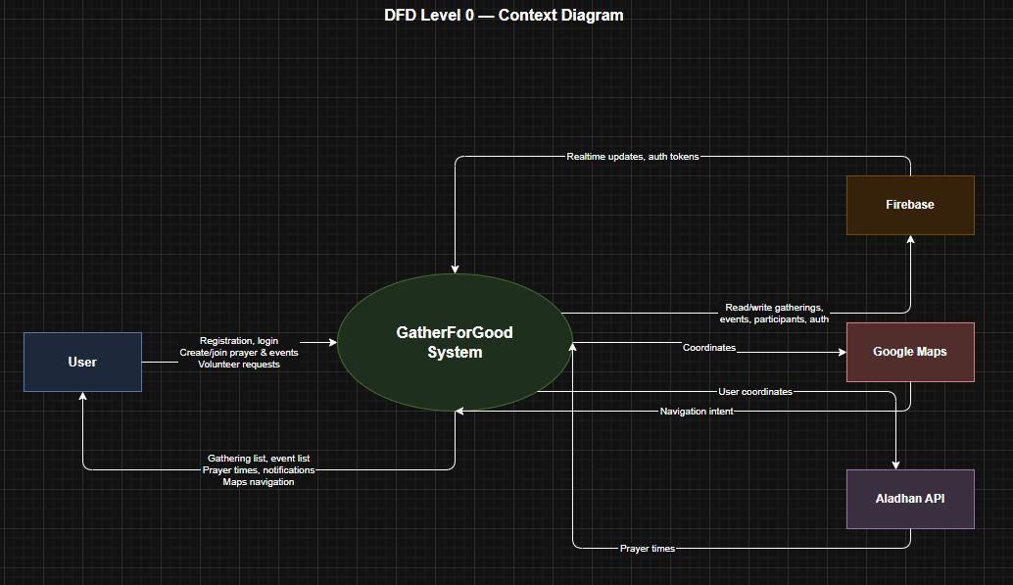

Level 1:

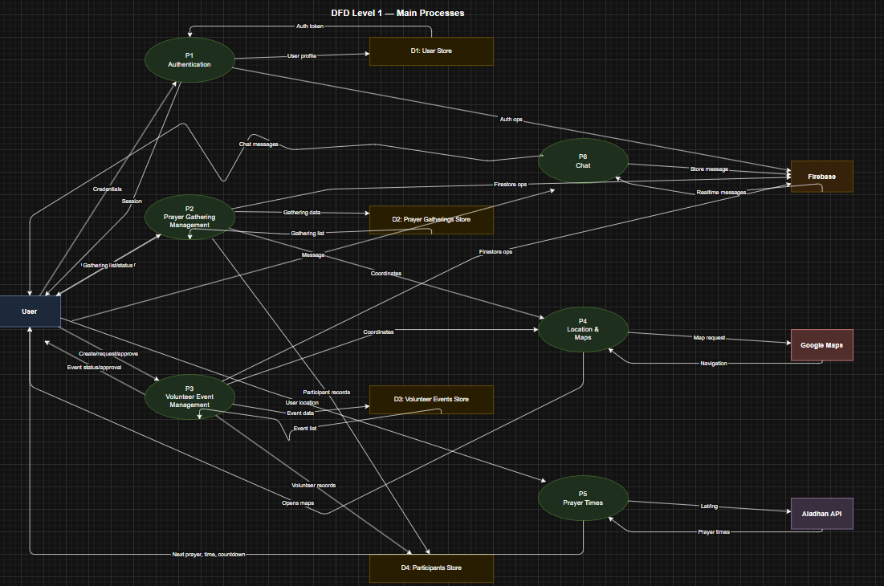

Level 2:

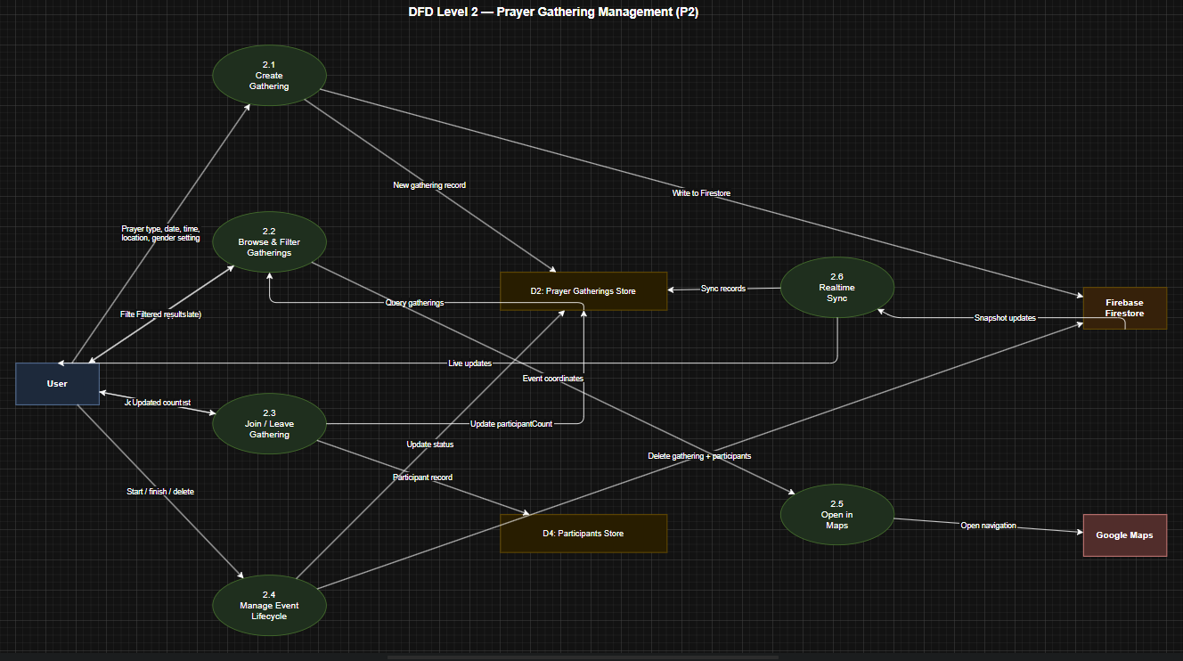

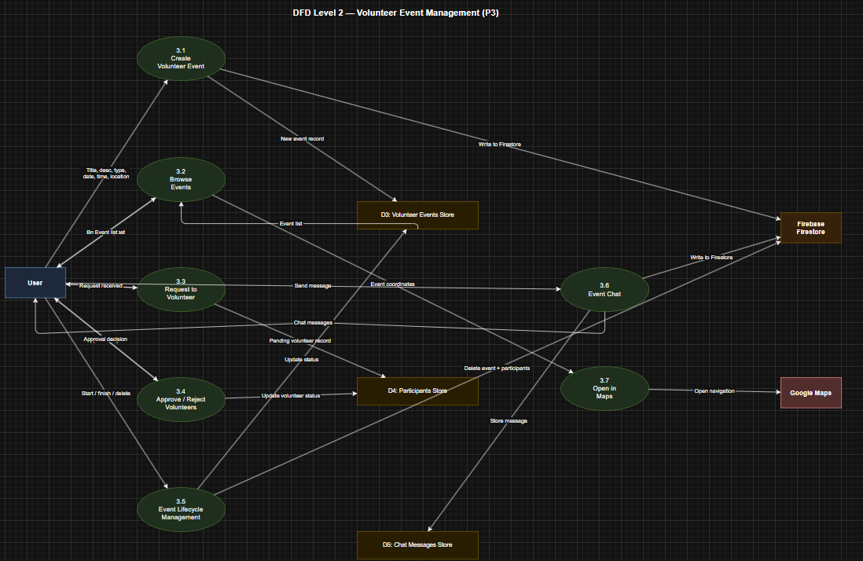

- Activity Diagrams

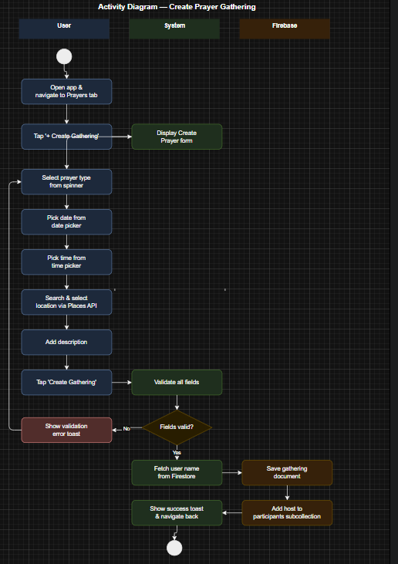

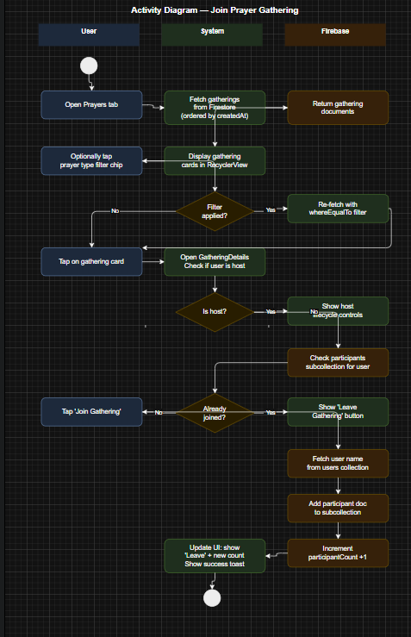

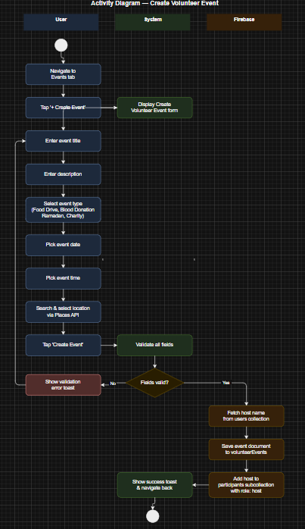

- Use Case Diagram

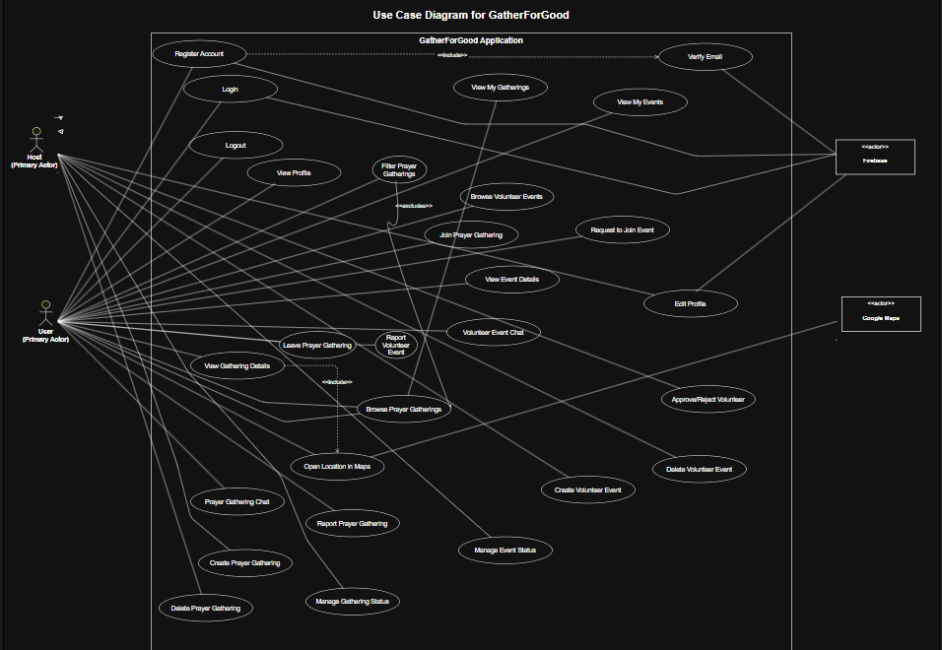

- Sequence Diagrams

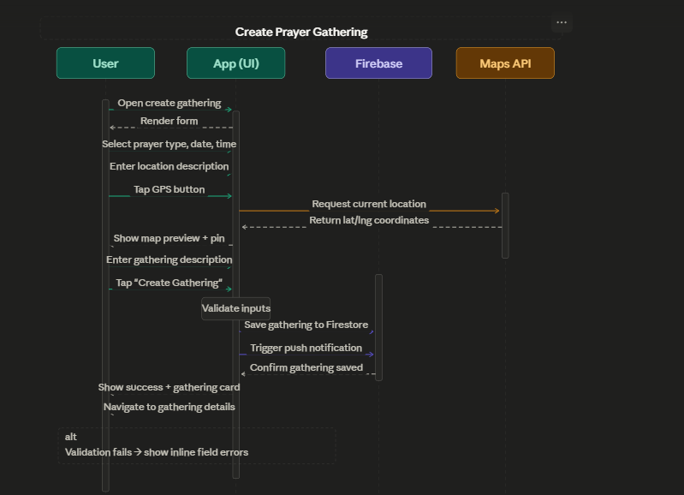
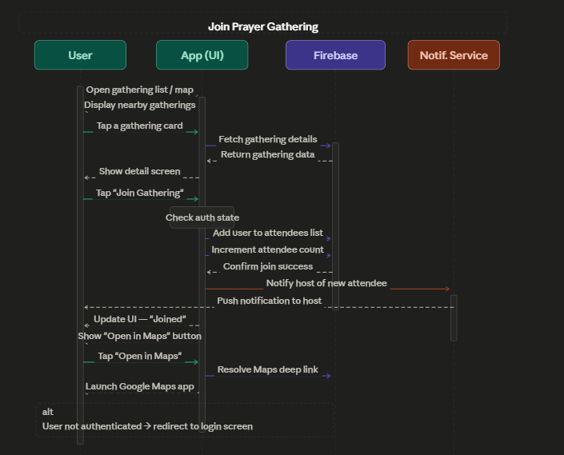
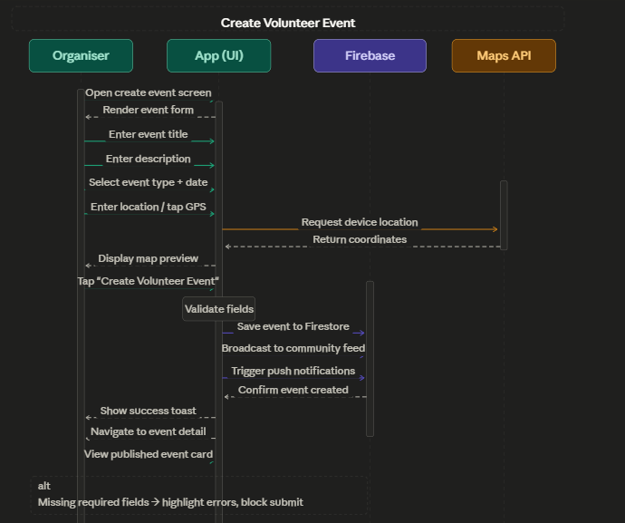

- Class Diagrams

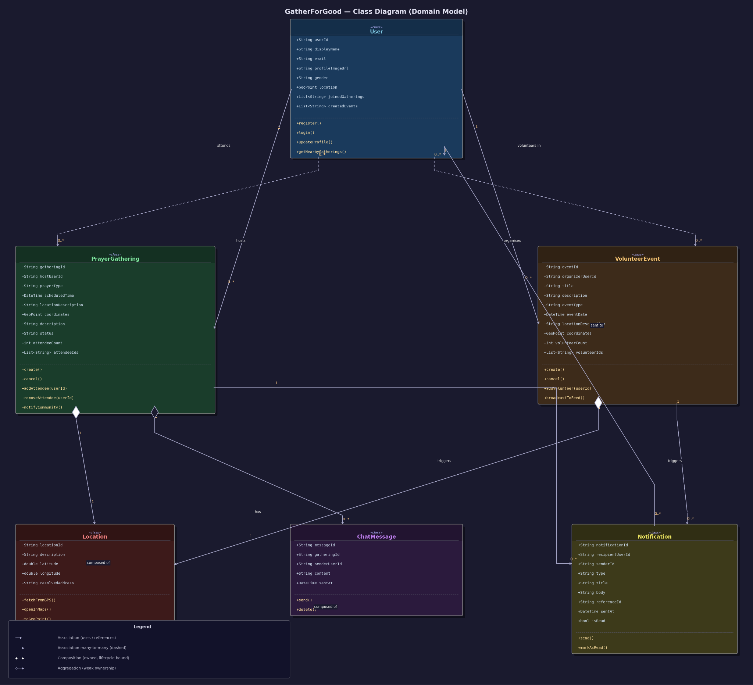

D. Scrum Board

- Initial Planning

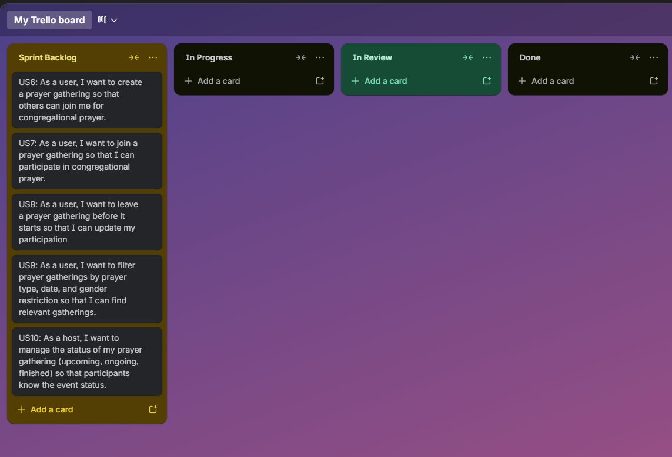

- Mid Sprint Execution

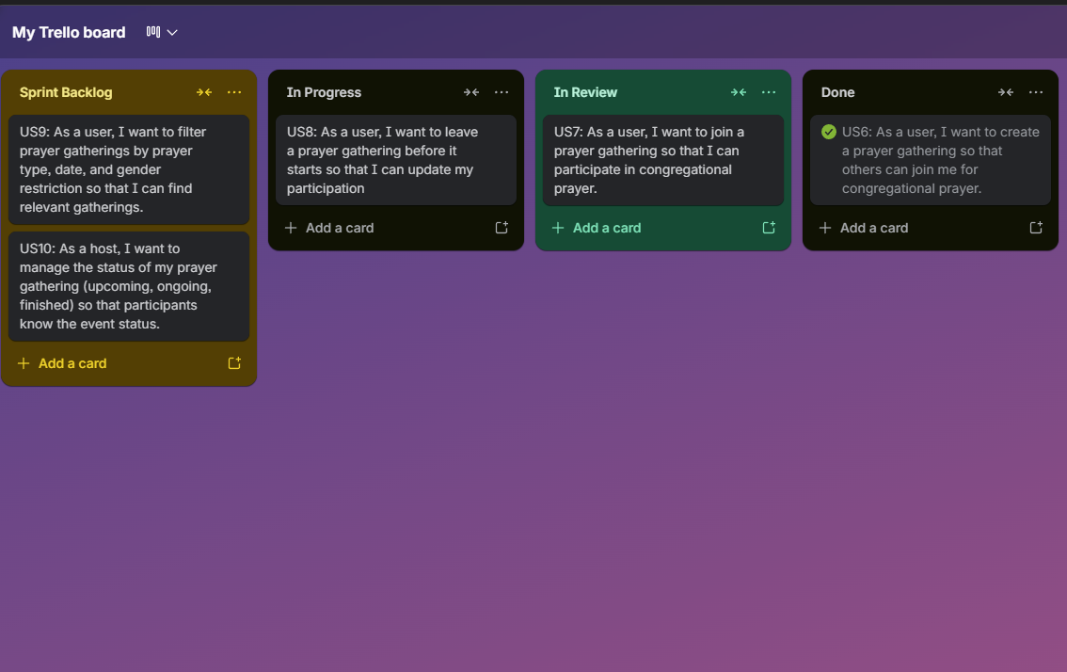

- Final Sprint

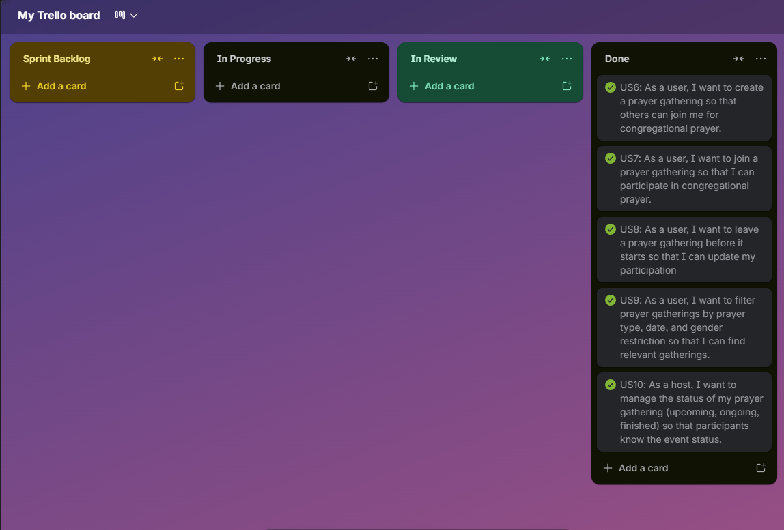

E. Work division

Work Division
To ensure the comprehensive delivery of Iteration 2, all development and documentation tasks were executed as follows:
- Husnain: Full-Stack Developer & Lead Architect. Responsible for the end-to-end lifecycle of the sprint, including:
  - UI/UX Design: Developing all XML layouts for Registration, Login, Home, Prayer, UserProfile and Gathering Details.
  - Java Backend Development: Implementing the core logic for Firebase Authentication, Firestore database synchronization, and local data persistence via SharedPreferences.
  - Integration & Logic: Developing the core data models and navigation systems to ensure a smooth flow of information between the application's different screens.
  - API & Services: Integrating Google Maps Geo-Intents and AlAdhan Api for location-based navigation and implementing the mandatory Email Verification security gate.
  - Testing & Quality Control: Performing manual tests on the login/signup flows to ensure security, verifying that the UI looks correct on different phone sizes, and testing the "Back" button navigation to prevent app crashes.
  - Documentation

F. Implementation Screenshots

