Semester Project Report
Heart Disease Risk Prediction and Statistical Analysis System
Team: CardioSense
Group Leader: Husnain Khalid
Submission Date: 06 May 2026
[Team Logo Placeholder]

Records | Variables | Target Rate
1025 | 14 | 51.3%

Group Members
Roll Number | Name | Section
22f-3190 | ________ | ______
22f-8758 | ________ | ______
22f-3812 | ________ | ______
22f-3143 | ________ | ______
22f-3335 | ________ | ______

1) Problem Statement
Heart disease is a major health risk. This project analyzes a real-world dataset to identify key factors and provide a risk prediction tool using statistical methods and regression modeling.

2) Objective
Build a web-based system that performs statistical analysis, probability modeling, and regression-based prediction for heart disease risk, and present results in a clear visual format.

3) Data Description
Dataset Name: Heart Disease Dataset (Kaggle)
Link: https://www.kaggle.com/datasets/johnsmith88/heart-disease-dataset?select=heart.csv
Variables:
- age
- sex
- cp
- trestbps
- chol
- fbs
- restecg
- thalach
- exang
- oldpeak
- slope
- ca
- thal
- target

Brief Summary
This project uses a real-world heart disease dataset with multiple variables to perform statistical analysis, probability modeling, and predictive regression through a web-based application for heart disease risk assessment.
Dataset Summary:
Metric | Value
Rows | 1025
Columns | 14
Target Rate | 51.3%

4) Results
Include screenshots of the application and key results, such as descriptive statistics, confidence intervals, probability summaries, and regression model metrics.
[Insert screenshot: Overview dashboard]
[Insert screenshot: Descriptive statistics and confidence intervals]
[Insert screenshot: Probability summary]
[Insert screenshot: Model metrics and prediction form]

Visual Results
Charts generated from the dataset are included below.
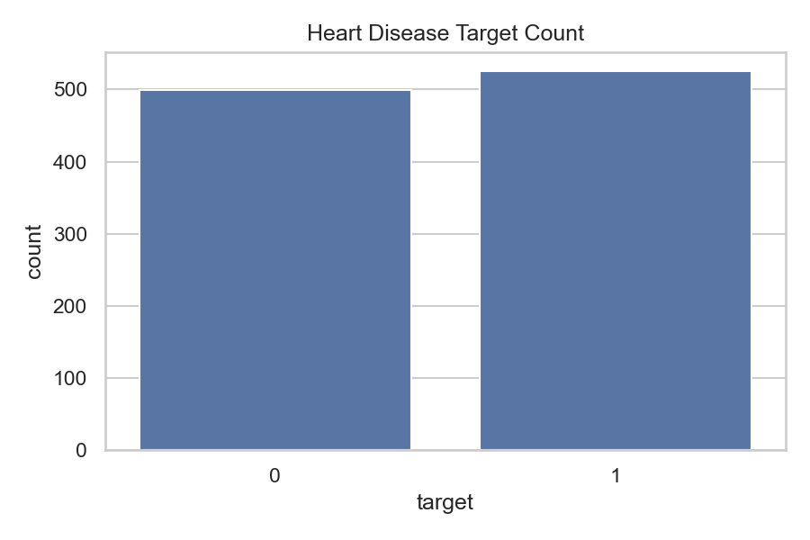
Figure 1: Target count distribution
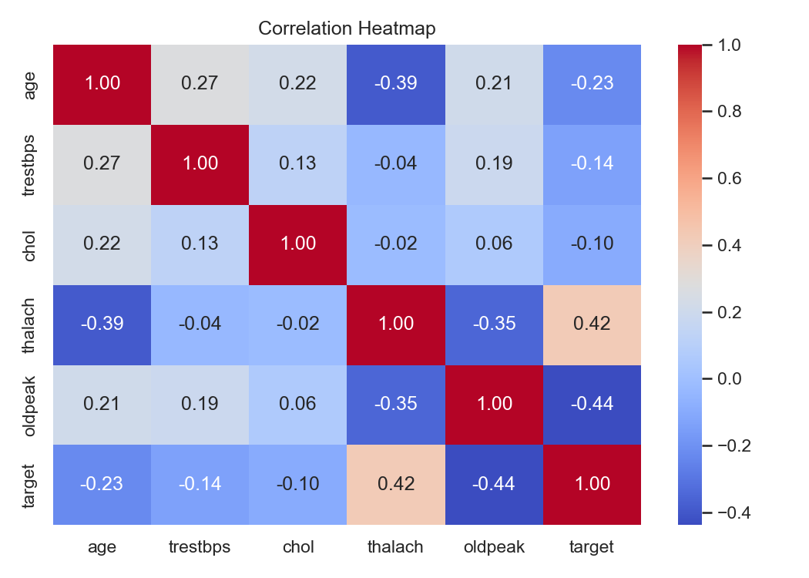
Figure 2: Correlation heatmap
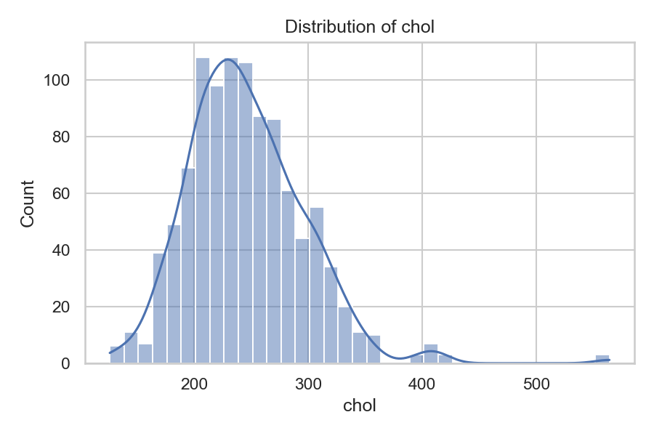
Figure 3: Cholesterol distribution
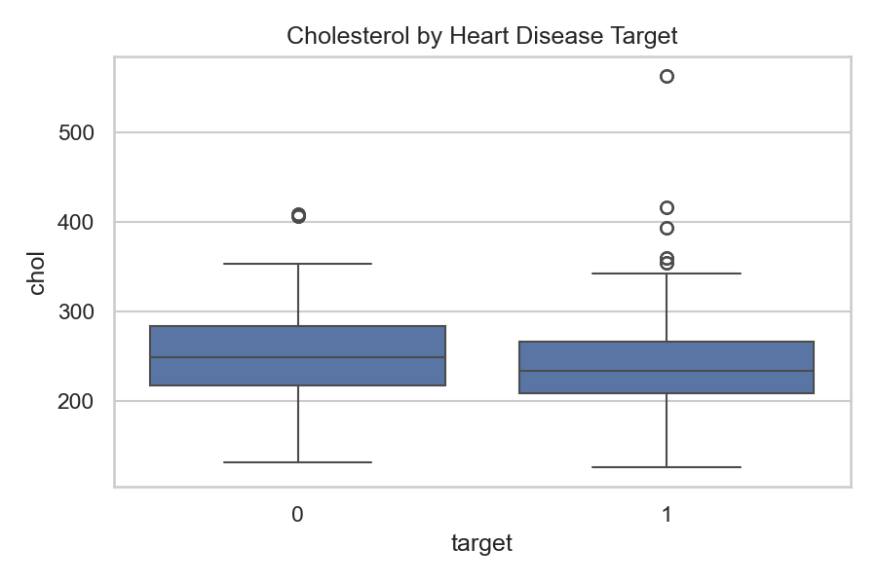
Figure 4: Cholesterol by target

5) Codes
Paste the full source code here. Use font size 9 with line spacing 1, and add proper titles and comments.

6) Conclusion
The dataset is nearly balanced with 51.3% target=1, so the analysis reflects both outcomes. Probability results show a higher observed target rate for females (72.4%) than males (42.1%), and about 54.6% of records have cholesterol greater than 240. Visual analysis indicates higher average max heart rate (thalach) for target=1 (158.6) compared with target=0 (139.1), while average cholesterol is slightly higher for target=0 (251.3) than target=1 (241.0). The logistic regression model performs strongly (accuracy 0.873, precision 0.856, recall 0.905, AUC 0.944), showing the variables provide useful predictive signal. Overall, the system summarizes key risk patterns and delivers a practical early screening aid, but results should be interpreted as supportive analytics rather than a clinical diagnosis.

