MOHD HUSNI BIN ABD HALIM  Principal Consultant | Certified Process Kaizen Engineer  Lean, Kaizen, OEE and operational excellence for Malaysian manufacturers that need measurable shop-floor improvement. | 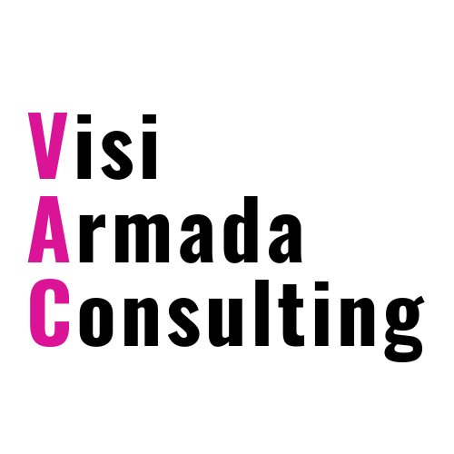  VISI ARMADA  CONSULTING
16+  Years industry experience | 500+  Professionals trained | 80+  Organisations / project sites | 11  Countries of project exposure

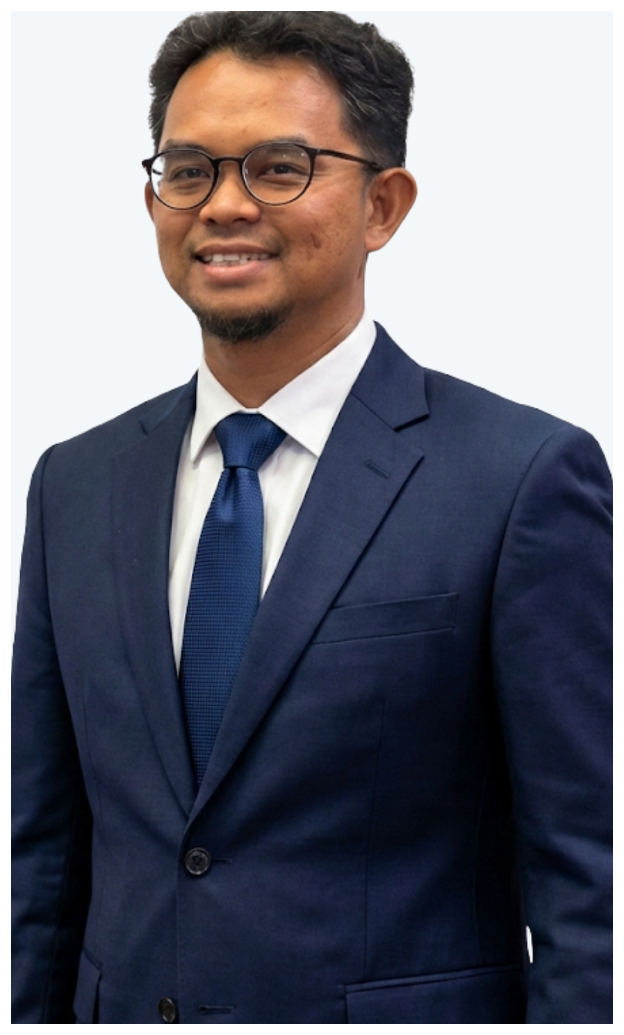  CONTACT  +60 16-526 1901  husnihalim@visiarmada.com  linkedin.com/in/husni-halim-7436b01b  Shah Alam, Selangor, Malaysia  CREDENTIALS  EFESO Certified Process Kaizen Engineer, Milan  HRDC TTT Accredited Trainer, ID 11294  MPC QE5.0 External Auditor / Productivity Expert  BSc Aerospace Engineering, University of Arizona  ISO 9001:2008 Internal Auditor  INDUSTRY EXPOSURE  Semiconductor, electronics, automotive, aerospace MRO, oil & gas, FMCG, food & beverage and general industrial. | PROFESSIONAL PROFILE  Husni Halim is a manufacturing transformation consultant and HRDC-accredited trainer specialising in Lean, Kaizen, OEE implementation and factory productivity improvement. His work is grounded in practical gemba execution: diagnosing operational losses, coaching internal teams, and building improvement systems that continue after the engagement ends.  He brings more than 16 years of hands-on manufacturing experience, including a decade with Prysmian, and has led improvement projects across Malaysia, Italy, Brazil, China, Indonesia and Norway.  CORE EXPERTISE  OEE Implementation Measurement design, Six Big Losses analysis, dashboards and improvement sprints. Kaizen & CI Gemba assessment, waste mapping, rapid events, A3 and standard work development.  Lean Capability 5S, VSM, TPM, problem solving and internal champion development. Factory Advisory Productivity audits, IR 4.0 readiness and practical improvement roadmaps.  SELECTED ENGAGEMENTS  • Lead Consultant for TERAJU Pritech4.0 OEE implementation across 30 Bumiputera factories.  • Lead Trainer for MARii Automotive IPC Program, training 330+ participants at UPM and PESDC.  • Year-long 5S workplace organisation and Kaizen culture consulting for Carotino operations.  • Training and consulting exposure with organisations and project sites including Intel, Safran, Panasonic, Petronas, Maxeon and Sharp.  POSITIONING  Best fit: Malaysian manufacturers seeking a practitioner-led partner for OEE improvement, Kaizen culture building, HRDC-claimable training, and practical operational excellence programs.
Visi Armada Consulting | HRDC Registered Training Provider | www.husnihalim.com | www.visiarmada.com

