**MIDDLE EAST TECHNICAL UNIVERSITY**

**DEPARTMENT OF ELECTRICAL & ELECTRONICS ENGINEERING**

**EE568 – Selected Topics on Electrical Machines**

**Project #1**

*Torque in a Variable Reluctance Machine*

**Hüsnü Oğuz Yorgancılar - 2305787**

**Introduction**

In this project, a variable reluctance machine is investigated. Knowing its dimensions, permeability, and the number of turns and current of the winding, the machine is first analyzed analytically to find reluctance, inductance and torque and plot them as a function of rotor angle under DC excitation of stator windings. Then, the machine is modelled in a 2D FEA software to examine flux density vectors, inductance, stored energy, and torque of the system having a linear material core. These phenomena are analyzed also for a system having non-linear effects. Moreover, a control method to make the rotor turn continuously is proposed.

**Q1)**

**a)**

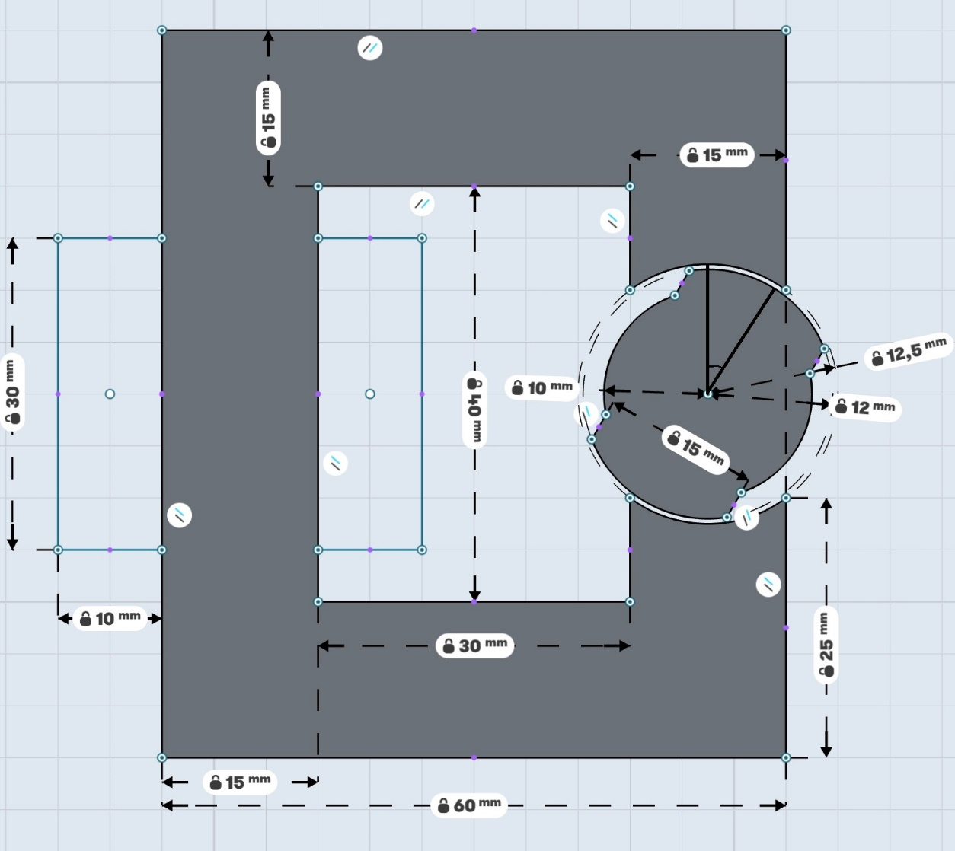

Fig-1: Variable Reluctance Machine

As seen in Fig-1, the minimum airgap length is 0.5mm and the maximum airgap length is 2.5mm. Assuming core is infinitely permeable, and area of the airgap is rectangular, maximum and minimum reluctance and inductance values can be found as follows:

$$R_{g,min}=\frac{2*l_{g,min}}{µ_{0}A_{g}}≅2.65x{10}^{6}\left(1/H\right){ R}_{g,max}=\frac{l_{g,max}}{µ_{0}A_{g}}≅13.26x{10}^{6}\left(1/H\right)$$

$$L_{min}=\frac{N^{2}}{R_{g,max}} ≅ 4.71 mH L_{max}=\frac{N^{2}}{R_{g,min}} ≅23.5 mH$$

$where N=250, l_{g,min}=0.5mm, l_{g,max}=2.5mm, µ_{0}= 4π{10}^{-7}, A_{g} =300{mm}^{2}$

Also, it is assumed that the inductance varies with a sinusoidal expression shown below where θ is the angle between the stator and rotor as shown in Fig-1:

Hence, the resulting graph is as seen in Fig-2.



Fig-2: Inductance vs Rotation Angle graph

**b)**



$$T\left(θ\right)=-\frac{∂W}{∂θ} =\frac{1}{2}I^{2}\frac{dL(θ)}{dθ}= -I^{2}\frac{L_{max} - L_{min}}{2}\sin\left(2θ\right) =0.0845*sin(2θ) where I=3A$$

Fig-3: Torque vs Rotation Angle graph

**c)**

It is assumed that the flux density is uniform, and core has an infinite permeability, but that is not the case for real world. To show these effects, permeability of the core should be a non-zero number, and integral should be taken over the area of the core to calculate the reluctance.

**Q2)**

**a)**

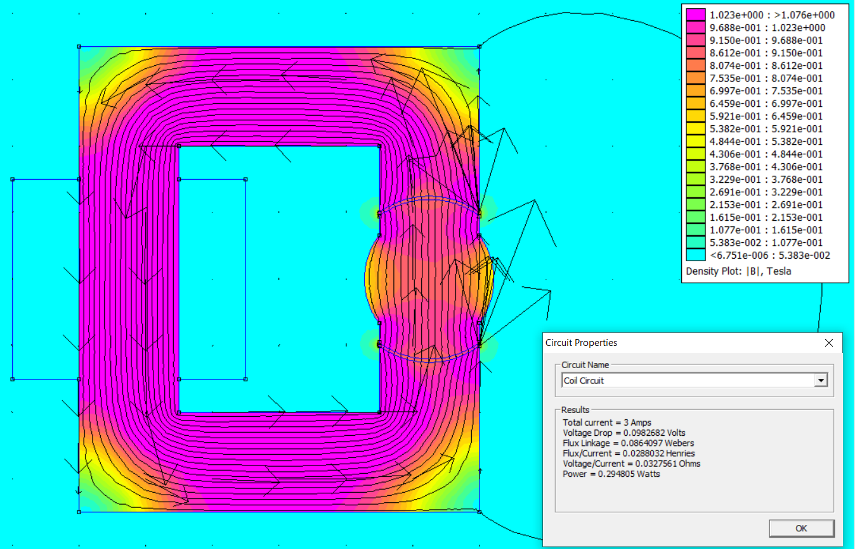

Fig-4: Flux Density Vectors for 0°

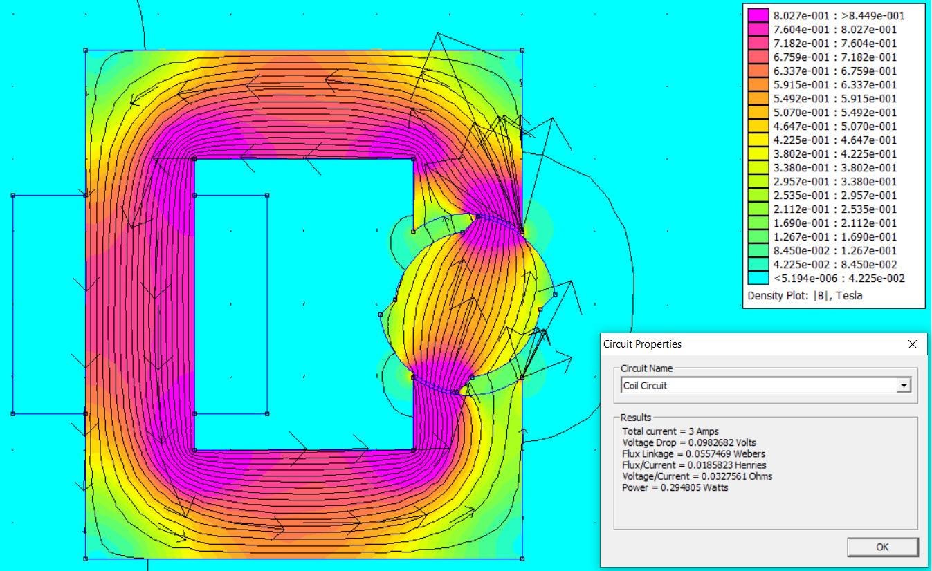

Fig-5: Flux Density Vectors for 45°

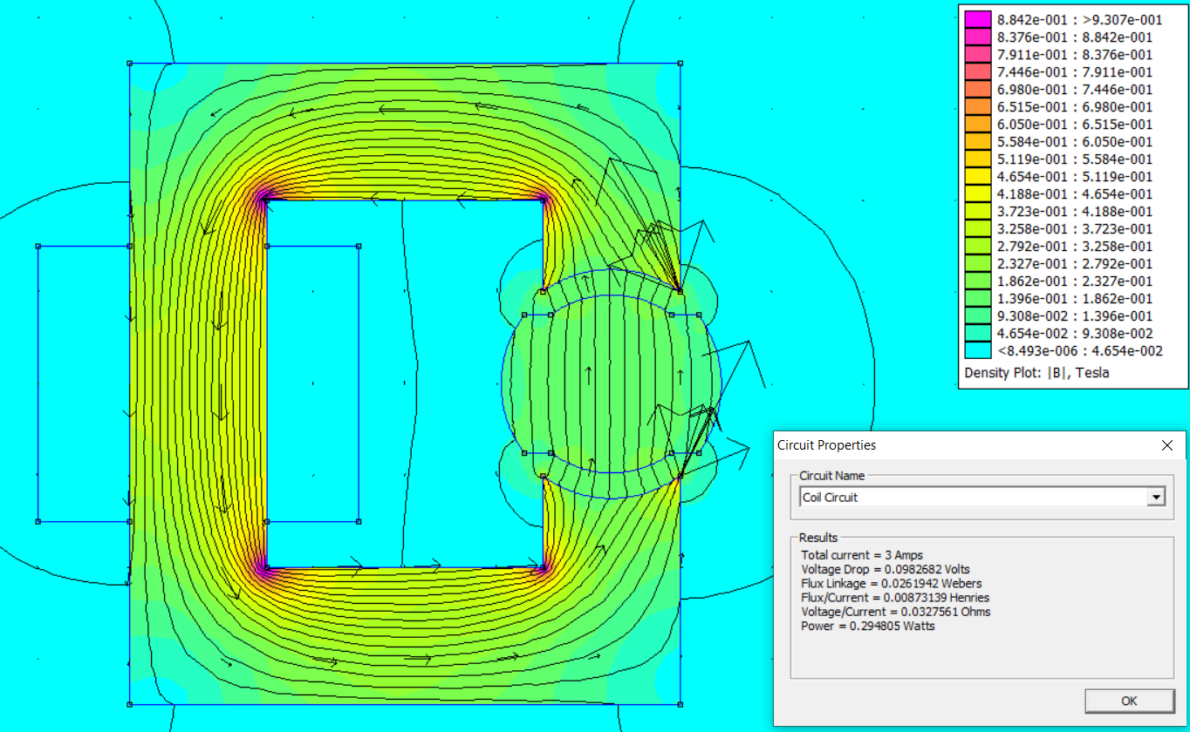

Fig-6: Flux Density Vectors for 90°

**b)**

As seen in Fig-4-5-6, flux linkages are found as 0.08640 Webers, 0.05574 Webers, 0.02619 Webers for 0°, 45° and 90°, respectively. Since λ=L*I and W=0.5*L*I2 where I=3A, inductances are calculated as 28.8mH, 18.5mH and 8.73mH, and the stored energy in the systems are calculated as 0.12922 J, 0.08378 J and 0.0386 J for 0°, 45° and 90°, respectively.

**c)**