**FEE MANAGEMENT SYSTEM**

**MALAIKA HAROON (22PWCSE2207)**

**HUSN-UL-MAAB (22PWCSE2113)**

**AMBER ISLAM (22PWCSE2194)**

**ENTITY DESCRIPTION TABLE:**

|  |  |  |
| --- | --- | --- |
| Entity Name | Description | Key Attributes |
| Student | An individual enrolled in an institution. Each student has a unique identity and may be associated with fee payments, dues, and reports. | Student_ID, Name, Email, Phone, Address, Class and Section etc. |
| Fee Structure | A defined schedule and breakdown of tuition and other fees applicable to a specific course or program. It is assigned to students and helps determine dues. | FeeStructure_ID, Class, Tuition_Fee, Exam_Fee ,  Lab_ Fee, Other_Charges and Total_Fee etc. |
| Payment | A transaction representing the payment made by a student against their dues. Each payment is recorded and linked to a receipt | Payment_ID, Student_ID, Amount_Paid, Date, etc. |
| Due | Represents the amount a student still owes as per the fee structure. Due entries are updated based on payments. | Due_ID, Student_ID, Amount_Due, Due_Date etc. |
| Receipt | A formal document acknowledging a payment made by a student. Generated for each successful payment | Receipt_ID, Payment_ID, Student_ID, Amount, Date_Issued, etc. |
| Report | A compiled summary of a student’s financial activity including fee payments, dues, and balances. Can be generated for individual students or entire courses. | Report_ID, Generated_Date, ReportType, etc. |

**BUSINESS RULES:**

1. A **STUDENT** must be assigned exactly **one FEE STRUCTURE**.  
   A FEE STRUCTURE defines the tuition and other fees for a specific STUDENT.  
   A FEE STRUCTURE may be assigned to **many STUDENTS**, or to **none** if not in use.
2. A **STUDENT** may make **zero or more PAYMENTS**.  
   Each **PAYMENT** must be made by exactly **one STUDENT**.  
   Some STUDENTS may be enrolled but have not made any PAYMENTS yet (e.g., pending fee submission).
3. A **PAYMENT** must always result in the generation of exactly **one RECEIPT**.  
   A **RECEIPT** cannot exist without an associated **PAYMENT**.  
   A RECEIPT must also be linked to the same **STUDENT** as the PAYMENT.
4. A **STUDENT** may have **one or more DUEs**, each representing outstanding amounts based on their assigned FEE STRUCTURE.
5. A **PAYMENT** may settle **one or more DUEs**, and a **DUE** may be cleared through **one or more PAYMENTS**.  
   This is a **one-to-many relationship**,
6. A **REPORT** may be generated for a single **STUDENT** or a **CLASS**.  
   Each REPORT summarizes the financial activity (dues, payments, balances).  
   A REPORT must include **GeneratedDate** and **ReportType** (e.g., "Student Summary", "Class Overview").
7. A **STUDENT** must have a unique **StudentID** and contain valid contact information (Email, Phone, etc.)  
   This ensures accurate communication, billing, and reporting.
8. A **FEE STRUCTURE** must have a unique **FeeStructureID** and define the **Class** it applies to, with fields like TuitionFee and ExamFee.  
   Fee Structures can change over terms or academic years.
9. A **RECEIPT** includes the **Amount Paid**, **Date Issued**, and references to both the related **PAYMENT** and **STUDENT**.  
   A RECEIPT cannot be manually altered once issued, except through authorized cancellation procedures.
10. A **DUE** includes status values such as Pending, Paid, or Overdue.

**E-R Diagram:**

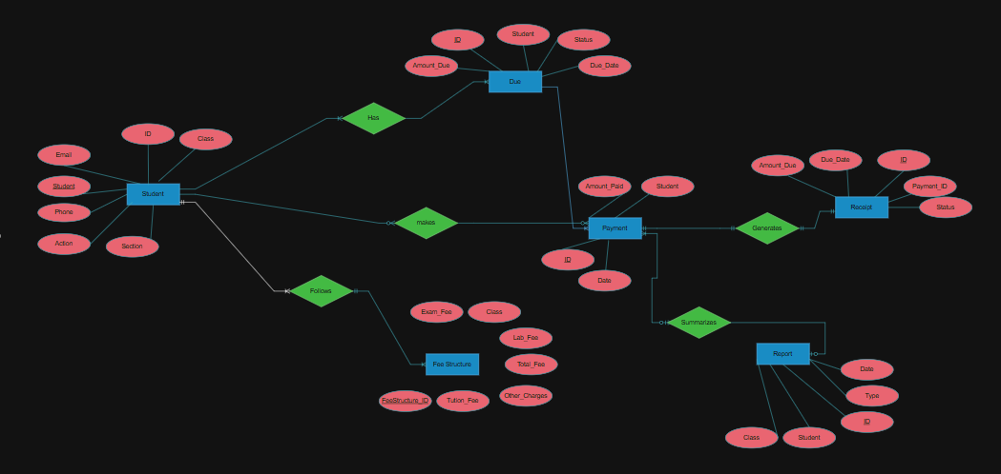

**REFERENCES:**

* ChatGpt
* Google (Great Learning)