**FEE MANAGEMENT SYSTEM**

**MALAIKA HAROON (22PWCSE2207)**

**HUSN-UL-MAAB (22PWCSE2113)**

**AMBER ISLAM (22PWCSE2194)**

**Conceptual Schema:**

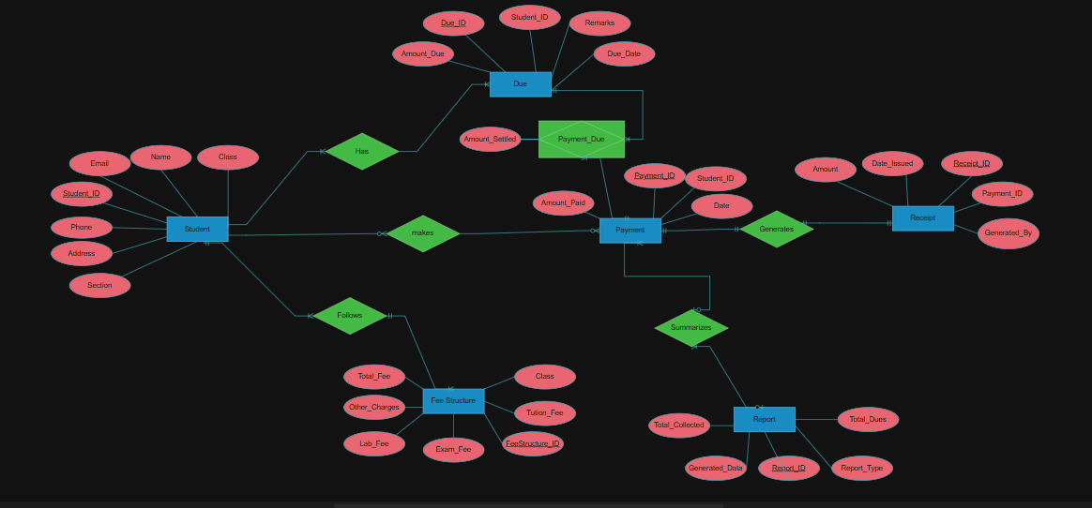

**Relational Schema:**

The relational schema is represented in the form of normalized relational tables below:

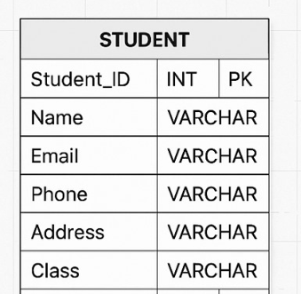

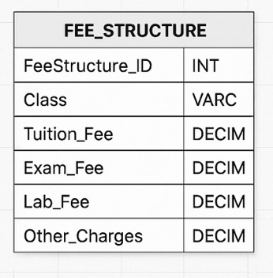

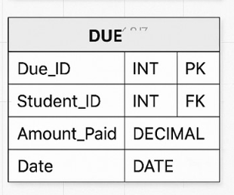

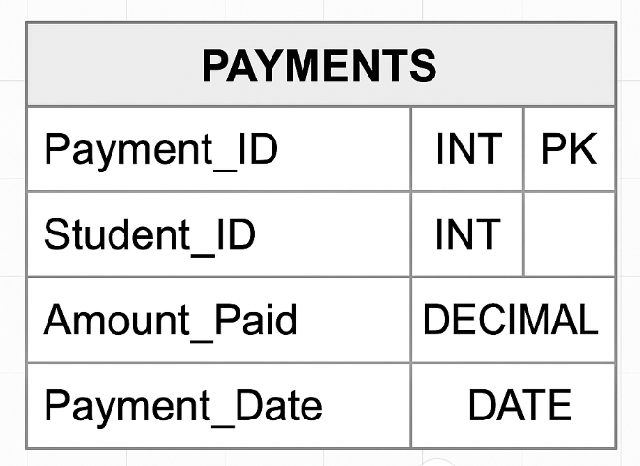

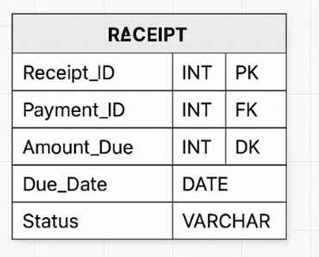

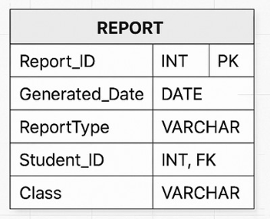

**Step 1: First Normal Form (1NF):**

**Requirements for 1NF:**

* All attributes must have atomic values (no repeating groups or arrays).
* Each record must be uniquely identifiable.

All tables in our schema already satisfy 1NF:

* Atomic attribute values.
* Properly defined primary keys (PK).

## Step 2: ****Second Normal Form (2NF):****

**Requirement for 2NF:**

* Satisfies 1NF.
* **No partial dependencies** on a **composite primary key.**
* Amount_Settled is fully dependent on both Payment_ID and Due_ID → **No partial dependency.**

All other tables use simple (single-column) primary keys → Automatically in 2NF.

## Step 3: ****Third Normal Form (3NF):****

**Requirements for 3NF:**

* Must be in 2NF.
* No **transitive dependencies** (non-key attributes must not depend on other non-key attributes).

After evaluating each table we come to know that tables **student, fee-structure, payment** and **report** are already in 3 normalized form but **receipt** and **due** are not in 3 normal form so we will fix them.

**RECEIPT:**

**Before 3 Normal form:**

**Receipt (Receipt_ID [PK], Payment_ID [FK], Amount_Due, Due_Date, Status)**

• **Problem**: Amount_Due, Due_Date, and Status are already in the **DUE** table.

• They likely **depend on Due_ID**, which is missing here.

**After fixing:**

Add Due_ID [FK], and remove duplicated fields.

**Receipt (Receipt_ID [PK], Payment_ID [FK], Due_ID [FK])**

**DUE:**

**Before 3 Normal form:**

**Due (Due_ID [PK], Student_ID [FK], Amount_Paid, Date)**

• **Field name issue**: Amount_Paid should likely be Amount_Due (confusing otherwise).

• Amount_Paid usually belongs to PAYMENT, not a DUE.

**After fixing:**

Rename field to Amount_Due.

**Due (Due_ID [PK], Student_ID [FK], Amount_Due, Due_Date, Status)**