
AIR UNIVERSITY, ISLAMABAD
Department of Cyber Security

COMPUTER NETWORKS LAB
Project Phase 3 Report
AVIONICS BASE NETWORK PROJECT

Course Code | CS260L
Subject | Computer Networks Lab
Instructor | Sir Mohsin Sarfraz
Class | BSCYSeve-F-23-A
Submitted By | Hussain Ali (232095)  Ahmad Ali (232147)
Date of Submission | 15 December 2024

Executive Summary
The Avionics Base Network Project models a secure and scalable network infrastructure for an aviation and military base environment inspired by PAC Kamra. The design connects PAC Headquarters with major factory locations through routed point-to-point links, while VLAN segmentation separates departmental traffic and centralized services such as DNS, FTP, web, and mail support the network. The refined report corrects the VLAN mapping, improves table readability, clarifies routing and security design, and keeps the submitted team members consistent with the cover page.
Table of Contents
Executive Summary 2
1. Project Introduction 3
2. Network Design Objectives 3
3. Network Topology Overview 3
3.1 PAC Headquarters 4
3.2 Factory Locations 4
4. VLAN Configuration and IP Addressing 4
5. Point-to-Point Connectivity 5
6. Routing Design 5
7. Device and Services Configuration 6
7.1 Router and Switch Configuration 6
7.2 Server Configuration 6
8. Security Features 7
9. Testing and Validation 7
9.1 Recommended Verification Commands 7
10. Team Contributions 7
11. Conclusion 7
11.1 Future Improvements 7
12. References 8

1. Project Introduction
The Avionics Base Network Project is designed to simulate the network architecture of an aviation military base with operational needs similar to PAF Base Minhas, Kamra. The purpose of the project is to design a scalable, segmented, and secure network that supports headquarters services, factory operations, inter-departmental communication, and centralized network services.
The network connects PAC Headquarters with multiple factory locations: Aircraft Manufacturing Factory (AMF), Avionics Production Factory (APF), Aircraft Rebuild Factory (ARF), and Mirage Rebuild Factory (MRF). Cisco Packet Tracer was used to model the topology, configure devices, and validate connectivity.

2. Network Design Objectives
- Establish a secure and scalable network design for aviation base operations.
- Provide controlled communication between departments and factory locations.
- Use VLANs to isolate departments and reduce unnecessary broadcast traffic.
- Use OSPF routing for dynamic route exchange between HQ and factory routers.
- Provide centralized services including DNS, FTP, web, and mail.
- Apply basic security controls such as firewall placement, ACL concepts, SSH access, encrypted passwords, logging, and warning banners.
- Validate the design through connectivity and service testing in Cisco Packet Tracer.

3. Network Topology Overview
The topology follows a hierarchical design. PAC HQ acts as the central site with firewall, main router, distribution switch, server infrastructure, SOC, data center, and control center networks. Factory sites connect to PAC HQ through point-to-point routed links. Within each location, departmental VLANs separate user groups such as design, production, repair, testing, support services, and operations.
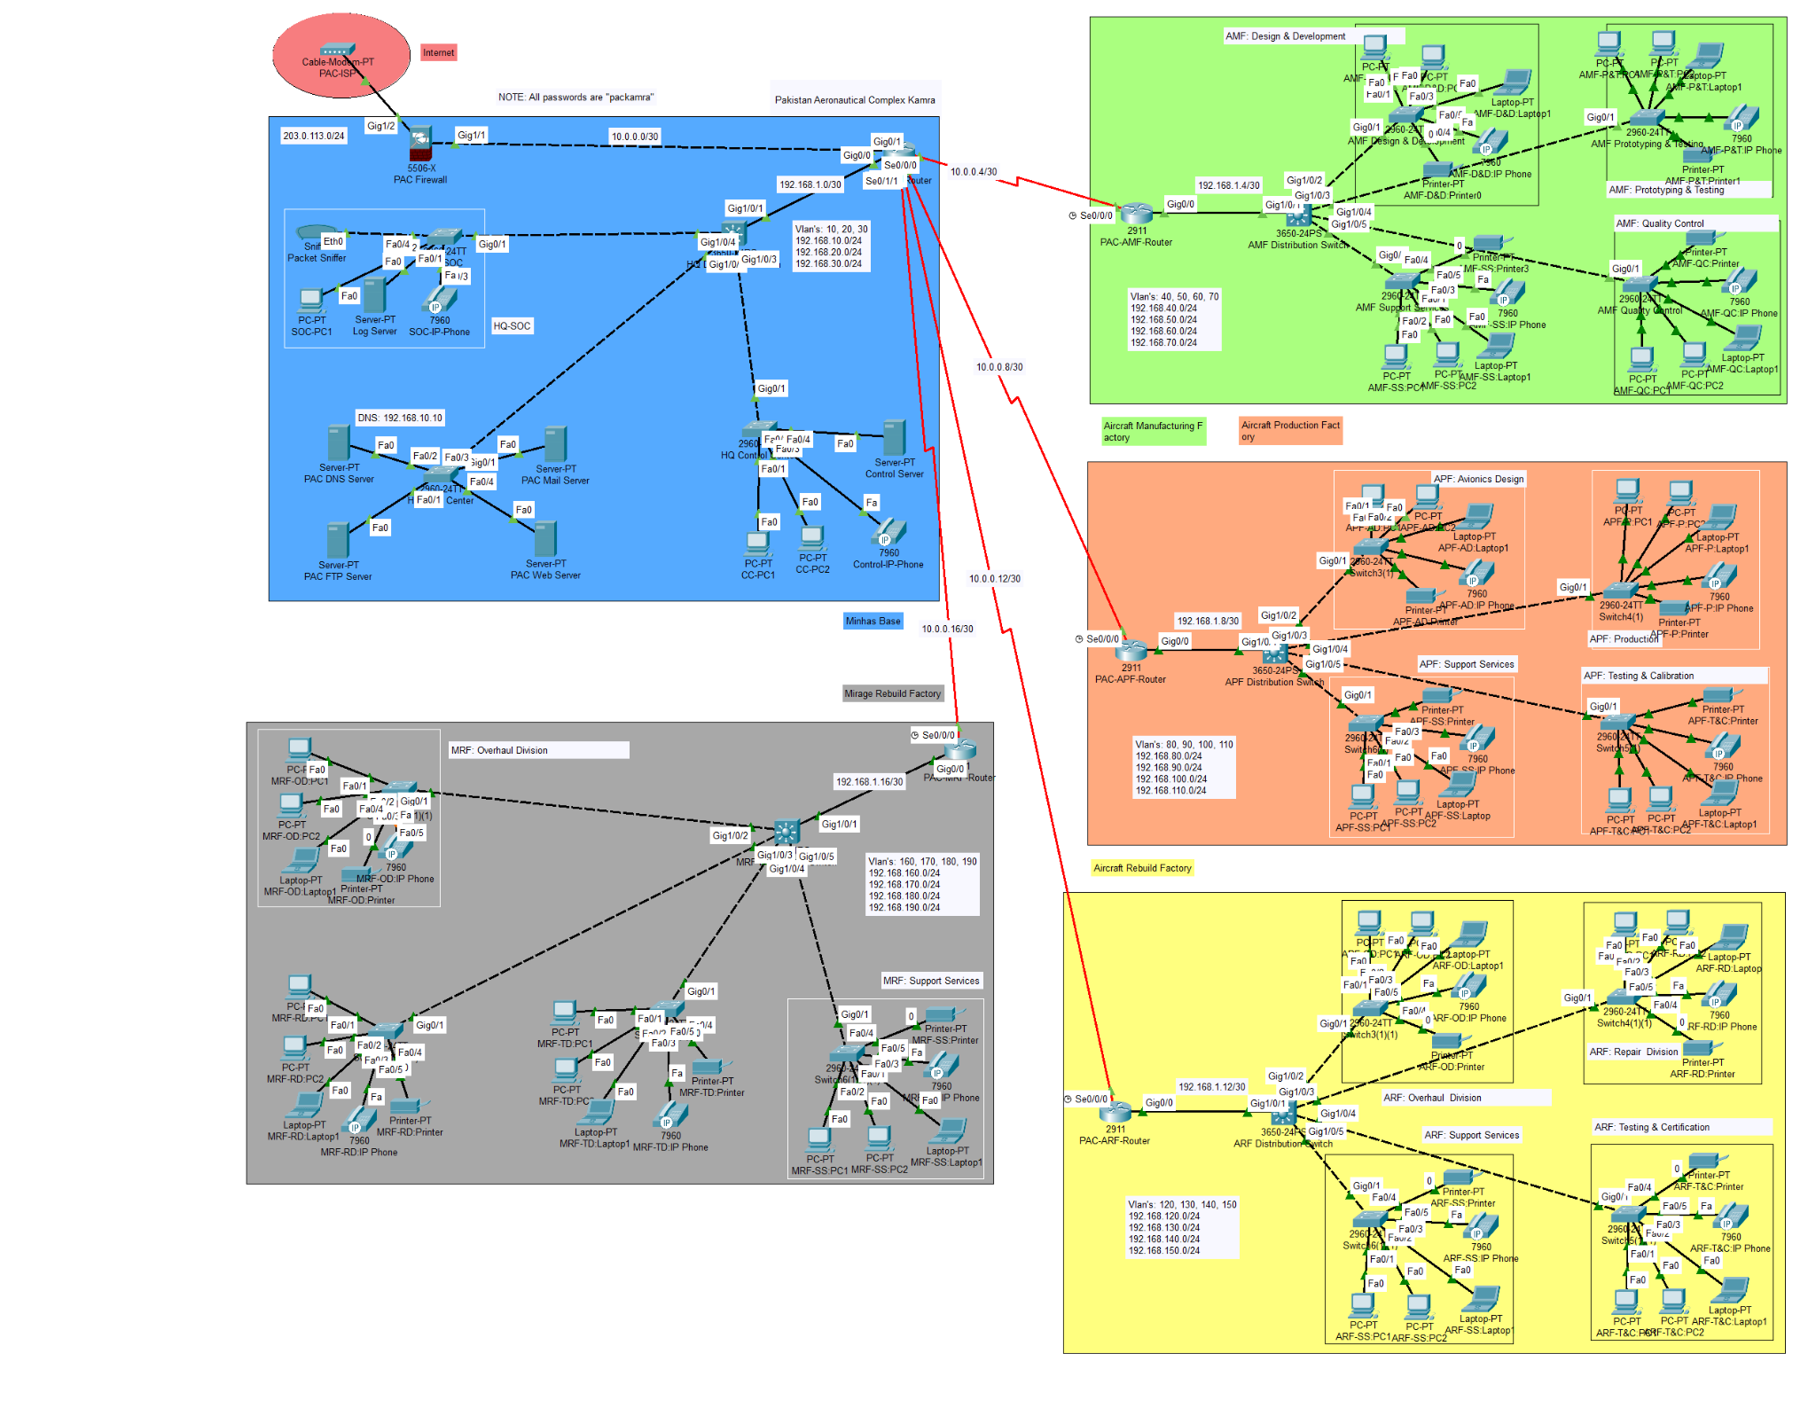
Figure 1: Logical topology diagram of the Avionics Base Network.

3.1 PAC Headquarters
- Core Infrastructure: PAC firewall, main router, and PAC HQ distribution switch.
- Server Network: DNS, FTP, web, and mail servers in the Data Center VLAN.
- Operational Segments: Data Center, Control Center, and SOC networks.
- Security Edge: Firewall positioned between the external ISP and internal PAC network.

3.2 Factory Locations
Site | Full Name | Departments
AMF | Aircraft Manufacturing Factory | Design & Development, Prototyping & Testing, Quality Control, Support Services
APF | Avionics Production Factory | Avionics Design, Production, Testing & Calibration, Support Services
ARF | Aircraft Rebuild Factory | Overhaul, Repair, Testing & Certification, Support Services
MRF | Mirage Rebuild Factory | Overhaul, Repair, Testing, Support Services

4. VLAN Configuration and IP Addressing
Each department is placed in a separate VLAN with a /24 subnet. This design provides segmentation, improves manageability, and simplifies policy enforcement. The corrected mapping used in this report assigns APF to VLANs 80-110 and ARF to VLANs 120-150, as requested for the final version.
VLAN | Subnet | Gateway | Department / Purpose
10 | 192.168.10.0/24 | 192.168.10.1 | HQ-Data Center
20 | 192.168.20.0/24 | 192.168.20.1 | HQ-Control Center
30 | 192.168.30.0/24 | 192.168.30.1 | HQ-SOC
40 | 192.168.40.0/24 | 192.168.40.1 | AMF-Design & Development
50 | 192.168.50.0/24 | 192.168.50.1 | AMF-Prototyping & Testing
60 | 192.168.60.0/24 | 192.168.60.1 | AMF-Quality Control
70 | 192.168.70.0/24 | 192.168.70.1 | AMF-Support Services
80 | 192.168.80.0/24 | 192.168.80.1 | APF-Avionics Design
90 | 192.168.90.0/24 | 192.168.90.1 | APF-Production
100 | 192.168.100.0/24 | 192.168.100.1 | APF-Testing & Calibration
110 | 192.168.110.0/24 | 192.168.110.1 | APF-Support Services
120 | 192.168.120.0/24 | 192.168.120.1 | ARF-Overhaul Division
130 | 192.168.130.0/24 | 192.168.130.1 | ARF-Repair Division
140 | 192.168.140.0/24 | 192.168.140.1 | ARF-Testing & Certification
150 | 192.168.150.0/24 | 192.168.150.1 | ARF-Support Services
160 | 192.168.160.0/24 | 192.168.160.1 | MRF-Overhaul Division
170 | 192.168.170.0/24 | 192.168.170.1 | MRF-Repair Division
180 | 192.168.180.0/24 | 192.168.180.1 | MRF-Testing Division
190 | 192.168.190.0/24 | 192.168.190.1 | MRF-Support Services
200 | 192.168.200.0/24 | 192.168.200.1 | PAC-WAP

5. Point-to-Point Connectivity
Point-to-point links use /30 subnets to conserve IP addresses while providing exactly two usable addresses per routed connection. The ISP-to-firewall link is documented as a /30 network for consistency with the rest of the point-to-point design.
Link | Subnet | Source IP | Destination IP
ISP -> Firewall | 203.0.113.0/30 | 203.0.113.1 | 203.0.113.2
Firewall -> Main Router | 10.0.0.0/30 | 10.0.0.2 | 10.0.0.1
Main Router -> AMF | 10.0.0.4/30 | 10.0.0.5 | 10.0.0.6
Main Router -> APF | 10.0.0.8/30 | 10.0.0.9 | 10.0.0.10
Main Router -> ARF | 10.0.0.12/30 | 10.0.0.13 | 10.0.0.14
Main Router -> MRF | 10.0.0.16/30 | 10.0.0.17 | 10.0.0.18
Main Router -> Dist-SW | 192.168.1.0/30 | 192.168.1.1 | 192.168.1.2
AMF Router -> Dist-SW | 192.168.1.4/30 | 192.168.1.5 | 192.168.1.6
APF Router -> Dist-SW | 192.168.1.8/30 | 192.168.1.9 | 192.168.1.10
ARF Router -> Dist-SW | 192.168.1.12/30 | 192.168.1.13 | 192.168.1.14
MRF Router -> Dist-SW | 192.168.1.16/30 | 192.168.1.17 | 192.168.1.18

6. Routing Design
OSPF is used as the dynamic routing protocol for route exchange between PAC HQ and factory routers. All router-to-router and router-to-distribution networks are advertised in area 0. This allows network routes to update dynamically and reduces the need for manually configured static routes across the full topology.
- PAC Main Router advertises WAN links to AMF, APF, ARF, and MRF.
- Factory routers advertise local routed links toward distribution switches.
- Layer-3 switches or routed interfaces provide gateways for VLANs.
- Default routing is used toward the ISP/firewall side where required.

7. Device and Services Configuration

7.1 Router and Switch Configuration
Device Type | Configuration Scope
Routers | IP addressing, OSPF routing, default routes, WAN links, and access control concepts.
Layer-3 Switches | VLAN interfaces, inter-VLAN routing, trunk links, default gateway, and OSPF advertisements.
Access Switches | Access ports for end devices, departmental VLAN assignment, and device-level security.
Firewall | Edge filtering between ISP and PAC HQ and policy enforcement for external access.

7.2 Server Configuration
Service | Purpose
DNS Server | Resolves internal service names such as web, FTP, and mail services.
FTP Server | Supports authenticated file transfer between HQ and factory departments.
Web Server | Hosts internal web services for base operations and information access.
Mail Server | Supports internal messaging and coordination between departments.
Syslog Server | Receives logs from network devices, especially the SOC logging server.

8. Security Features
Security Feature | Purpose
VLAN Segmentation | Separates departments to reduce unnecessary exposure and improve traffic management.
Firewall Policies | Controls traffic between external networks and PAC internal networks.
Access Control Lists | Restricts unauthorized communication between factories, VLANs, and critical services.
SSH Remote Access | Provides a more secure method for remote device management than Telnet.
Password Encryption | Prevents plaintext passwords from being easily visible in running configurations.
MOTD Banner | Warns users that unauthorized access is prohibited.
Syslog Logging | Forwards device logs to a central SOC logging host for monitoring.

9. Testing and Validation
Testing was performed in Cisco Packet Tracer to verify network reachability, routing behavior, and service availability.
Test Area | Validation Performed
Ping Tests | Verified connectivity within VLANs, between VLANs, and between factory sites and PAC HQ.
Routing Verification | Checked route availability using OSPF and IP route tables.
Service Verification | Validated DNS, FTP, web, and mail service reachability where configured.
Security Checks | Reviewed VLAN segmentation, password protection, logging, and firewall/ACL concepts.

9.1 Recommended Verification Commands
- show ip interface brief
- show ip route
- show ip ospf neighbor
- show vlan brief
- show interfaces trunk
- show running-config
- show logging

10. Team Contributions
Member | Role | Contribution
Hussain Ali (232095) | Team Leader | Designed the network topology, planned VLAN/IP segmentation, implemented security concepts, and coordinated documentation.
Ahmad Ali (232147) | Network Engineer | Worked on router and switch configuration, connectivity validation, and Packet Tracer implementation support.

11. Conclusion
The Avionics Base Network Project successfully models a segmented and scalable network infrastructure for a military aviation base. The final design uses VLANs for departmental separation, OSPF for dynamic routing, point-to-point WAN links for factory connectivity, and centralized services for operational support. The corrected VLAN mapping and improved documentation make the project easier to understand, verify, and present.

11.1 Future Improvements
- Add HSRP or VRRP for default gateway redundancy.
- Implement EtherChannel between distribution and access layers.
- Add centralized AAA using RADIUS or TACACS+.
- Document ACL rules in a separate access-control matrix.
- Add test screenshots for ping, DNS, FTP, web, and mail services.
- Add wireless security using WPA3 and wireless intrusion detection concepts.
- Introduce redundant links and failover testing for mission-critical departments.

12. References
- https://www.pac.org.pk/
- https://en.wikipedia.org/wiki/PAF_Base_Minhas
- Cisco Packet Tracer Documentation.
- Cisco Networking Academy, Routing and Switching Concepts.
- Cisco Network Security Guidelines.
- Computer Networks Lab course material, CS260L.
Academic simulation prepared for Computer Networks Lab. No real military network details are represented.

