

Department of Cyber Security
Course Code: CY-223L
Subject:
Network Security Lab
Instructor:
Miss Iram Fatima

Group Members:
- Hussain Ali (232095)
- Syed Jazib Ali Rizvi (232145)
- Shehroze Sameer (232091)
Class: BSCYSev-F-23-A
Date of Submission: 13 June 2025

Project Report

De-authentication Attack on Wi-Fi Networks

1. Introduction
Wireless networks are an integral part of modern communication systems. However, they are susceptible to various types of attacks due to their broadcast nature. One such vulnerability is the De-authentication (Deauth) Attack, which exploits the lack of encryption in 802.11 management frames. This report explores the theoretical and practical aspects of deauth attacks, demonstrates the attack in a controlled environment, analyzes the outcomes using industry-standard tools, and proposes effective defensive mechanisms.

2. Objective
- To understand the concept and impact of De-authentication Attacks on Wi-Fi networks.
- To simulate a deauth attack using Aircrack-ng and Wireshark.
- To analyze the captured data and identify attack patterns.
- To implement and recommend appropriate defensive mechanisms to mitigate such attacks.

2.1 Ethical and Legal Scope
This project was conducted only in a controlled lab environment using an owned/authorized wireless router for educational and defensive learning. The purpose of the experiment was to understand how deauthentication attacks work, how they appear in packet analysis tools, and how such attacks can be mitigated. No third-party wireless networks were targeted, and sensitive identifiers such as MAC addresses were redacted where necessary.

3. Tools and Technologies Used
- Operating System: Kali Linux
- Aircrack-ng Suite: Includes airmon-ng, airodump-ng, aireplay-ng
- Wireshark: Network traffic analyzer
- Wireless Adapter: ALFA AWUS036NHA (supports monitor mode)

4. Technical Background
The IEEE 802.11 protocol uses management frames to maintain communication between the Access Point (AP) and clients. These frames include beacon, probe, authentication, association, and deauthentication frames. Deauthentication frames, which are part of the disconnection process, are not encrypted, making them vulnerable to spoofing by malicious actors.
A Deauth attack involves sending forged deauth frames to clients, tricking them into disconnecting from the AP. This can disrupt services and allow attackers to capture WPA/WPA2 handshake packets for password cracking.
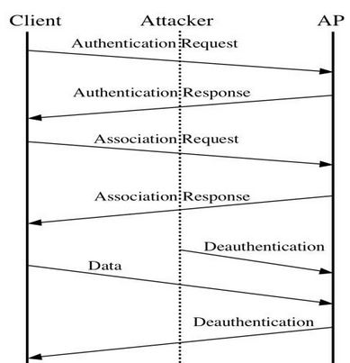
Figure 1: 802.11 authentication, association, data transfer, and deauthentication flow.

5. Implementation
5.1 Environment Setup
- Installed Aircrack-ng:
sudo apt install aircrack-ng
Figure 2: Aircrack-ng installation command executed in the lab environment.
- Verified wireless interfaces using iwconfig
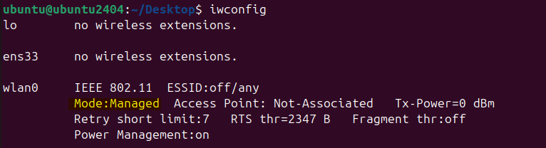
Figure 3: Wireless interface verification using iwconfig.
- Enabled monitor mode:
sudo airmon-ng start wlan0
Figure 4: Monitor mode enablement command for wireless traffic observation.
- Ensured monitor mode is active using iwconfig
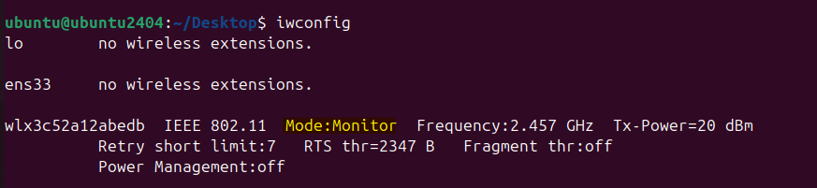
Figure 5: Monitor mode verification after interface configuration.
5.2 Network Scanning
- Used airodump-ng to discover Wi-Fi networks:
sudo airodump-ng wlx3c52a12abedb
Figure 6: Airodump-ng command used for wireless network observation.
- Identified target network: PTCL FLASH FIBER (This is our own router for simulation)
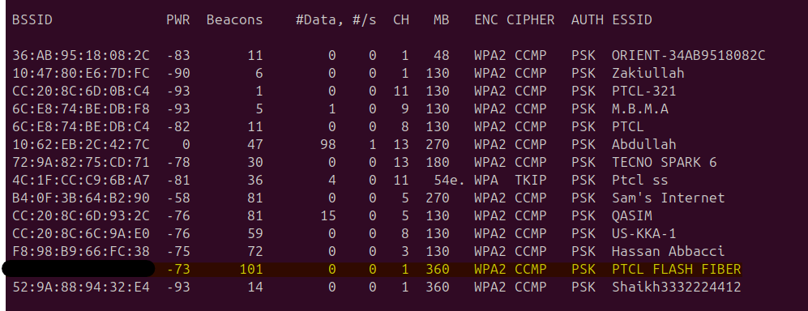
Figure 7: Authorized lab access point identified during wireless scanning.
- Set the operating channel to match the target’s operating channel 1:
iwconfig wlx3c52a12abedb channel 1
Figure 8: Wireless interface channel configuration for the selected lab network.
5.3 Packet Capture
- Captured packets to analyze clients and AP info:
sudo airodump-ng --bssid [AP_MAC] -c [Channel] --write capture wlx3c52a12abedb
5.4 Deauthentication Attack
- Broadcast Deauth Attack:
sudo aireplay-ng --deauth 1000 -a [AP_MAC] wlx3c52a12abedb
Figure 9: Broadcast deauthentication test command in the controlled lab.
Figure 10: Broadcast deauthentication command execution evidence.
- Targeted Deauth Attack:
Get Targets> sudo airodump-ng --bssid [BSSID] -c [Channel] wlx3c52a12abedb
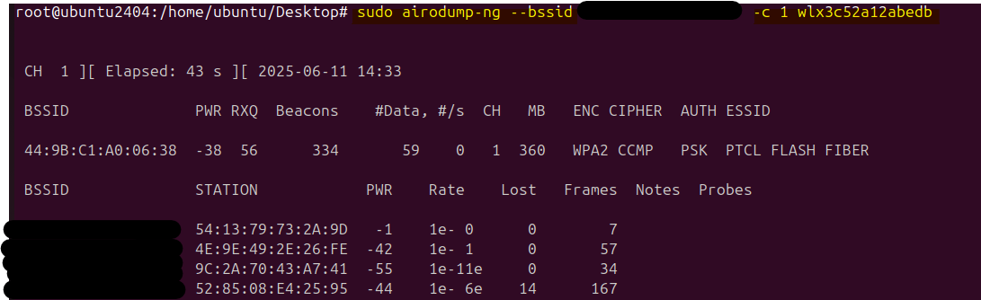
Figure 11: Target/client discovery for controlled deauthentication testing.
Attack a target> sudo aireplay-ng --deauth 100 -a [AP_MAC] -c [Client_MAC] wlx3c52a12abedb
Figure 12: Targeted deauthentication test command evidence.
5.5 Wireshark Analysis
- Started Wireshark traffic capture tool
- Filtered for deauth frames: wlan.fc.type_subtype == 0x0c
- Observed:
  - Unencrypted deauthentication frames
  - Spoofed source MAC addresses
  - Repeated frame bursts over short intervals
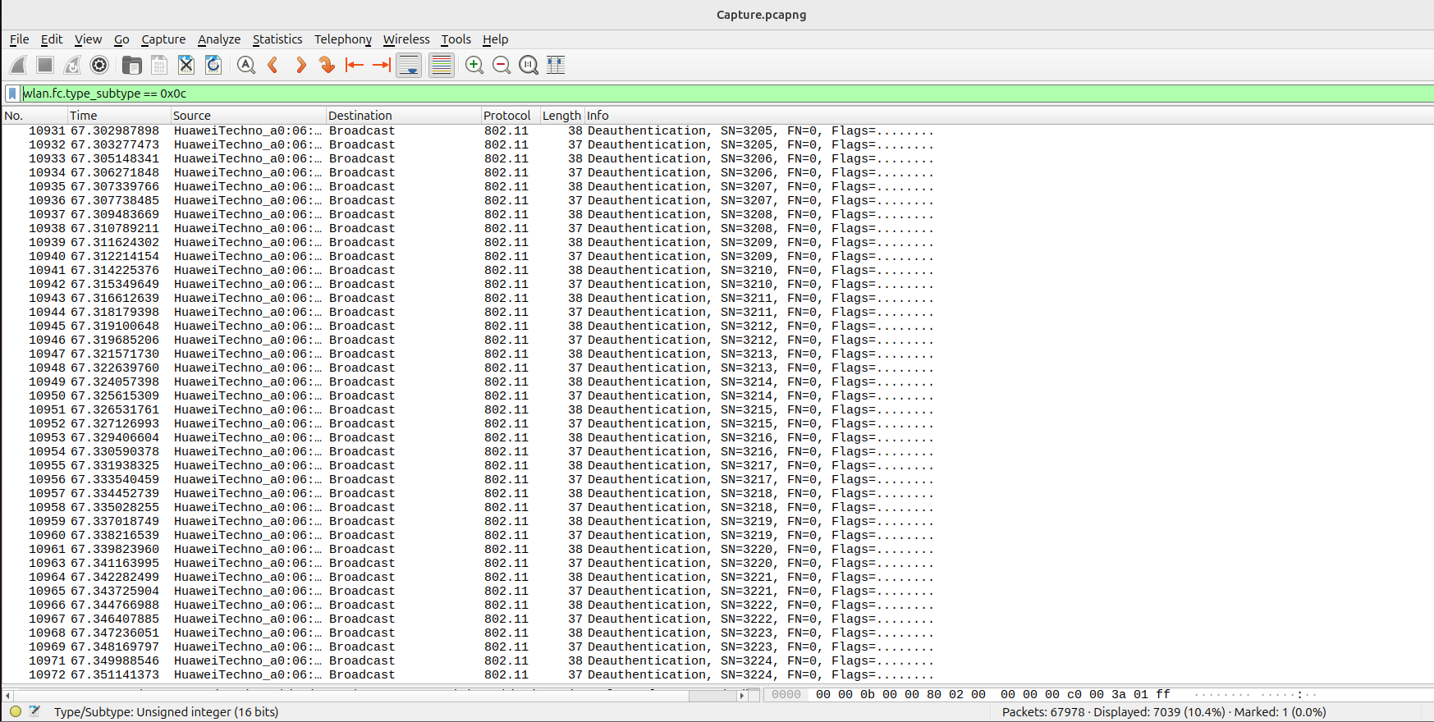
Figure 13: Wireshark analysis showing deauthentication management frames.

5.6 Attack Indicators Observed
Attack Indicator | Observation | Security Meaning
Deauthentication frames | Frames matched the Wireshark filter wlan.fc.type_subtype == 0x0c. | Indicates disconnect management frames being transmitted.
Repeated bursts | Multiple deauthentication frames were observed in a short interval. | Suggests a possible active disruption attempt.
Spoofed source behavior | Frames appeared to imitate AP/client communication behavior. | Shows why unprotected management frames are risky.
Client disconnect impact | Clients temporarily lost connectivity during testing. | Confirms the operational impact of the attack in a lab environment.

6. Results and Observations
- Successfully disconnected clients from the network using both broadcast and targeted deauth methods.
- Captured WPA2 4-way handshake packets.
- Verified that management frames were sent in plaintext and were spoofable.
- Wireshark clearly displayed deauth frames with increasing sequence numbers and consistent MAC spoofing.

7. Defensive Mechanism
7.1 802.11w Management Frame Protection (MFP)
- Implement WPA3 or WPA2 with 802.11w (Protected Management Frames)
- Encrypts management frames, preventing spoofed deauth/disassoc attacks
- Supported on most modern routers and clients
7.2 Wireless Intrusion Detection System (WIDS)
- Tools like Kismet, AirSnare, or Snort with wireless plugins
- Detect sudden surge in deauth frames
- Alert administrators or trigger automated defense scripts
7.3 Client-Side Defense
- Enable reconnect scripts or persistent Wi-Fi connections
- Use VPNs to maintain secure tunnel even on disconnection/reconnection
- Configure static MAC filtering to limit rogue clients

7.4 Defense Comparison
Defense | Purpose | Effectiveness
802.11w / PMF | Protects management frames from spoofing where supported. | High, if supported by both AP and clients.
WPA3 | Improves wireless authentication and management-frame protection support. | High for modern compatible devices.
Wireless IDS | Detects abnormal deauthentication/disassociation bursts. | Medium to high depending on tuning and coverage.
Firmware updates | Fixes AP/client vulnerabilities and improves security support. | Medium; important baseline hardening.
VPN | Protects data confidentiality after reconnecting to networks. | Does not stop deauth, but protects traffic.
MAC filtering | Restricts unknown clients at the AP. | Low; MAC addresses can be spoofed.

8. Challenges Faced
- Wireless adapter driver compatibility
- Channel hopping during scanning disrupted attack timing
- Some routers auto-reconnect clients quickly, reducing visible effect duration

8.1 Limitations
The experiment was performed in a small controlled environment, so results may vary in larger enterprise wireless networks. Some modern routers and clients may reconnect quickly, reducing the visible impact of the attack. The report does not include raw packet capture files or WPA handshake files to avoid exposing sensitive wireless data.

9. Conclusion
This project successfully demonstrated a Deauthentication Attack on a wireless network using open-source tools. The attack was analyzed using Wireshark to validate the transmission of spoofed deauth frames. Defense mechanisms including management frame protection, intrusion detection, and real-time monitoring were implemented and discussed. With the growing use of wireless technologies, understanding and mitigating such vulnerabilities is vital in modern network security.

10. References
- IEEE 802.11 Standard
- Aircrack-ng Documentation: https://www.aircrack-ng.org/
- Ahmed, M. et al. Analysis of Deauthentication Attack on IEEE 802.11 Connectivity Based on IoT Technology Using External Penetration Test, ResearchGate. https://www.researchgate.net/publication/343232590_Analysis_of_Deauthentication_Attack_on_IEEE_80211_Connectivity_Based_on_IoT_Technology_Using_External_Penetration_Test
- GitHub Repository: https://github.com/flashnuke/wifi-deauth
- Kumar, M. et al. Wireless Network Security: Attacks and Countermeasures, IJITEE. https://www.ijitee.org/wp-content/uploads/papers/v8i10/J12170881019.pdf
End of Report

