Secure Software Design and Development
Secure Student Management System

Submitted by: Syed Jazib Ali Rizvi, Hussain Ali
Technology Stack: Flask, Flask-SQLAlchemy, Flask-WTF, SQLite, Bootstrap, Docker
Project Type: Secure CRUD Web Application

1. Introduction
The Secure Student Management System is a Flask-based web application designed to manage student records through an authenticated admin dashboard. The application supports admin registration/login, student record creation, record listing, update, and deletion. The final version applies secure software design principles such as password hashing, input validation, CSRF protection, secure session settings, and safe project structure.

2. Objectives
- Develop a functional student management system using Flask.
- Apply secure coding practices in authentication, form handling, and CRUD operations.
- Use validation to reduce invalid or unsafe input.
- Organize all application code inside a dedicated src/ directory.
- Avoid committing secrets, database files, virtual environments, or generated cache files.

3. Application Features
Feature | Description
Admin Registration | Only the first admin can be registered through the app.
Admin Login | Admin credentials are checked using hashed passwords.
Dashboard | Authenticated users can view the student management dashboard.
Add Student | Validated form fields are used to add student records.
Edit Student | Existing records can be updated through a protected route.
Delete Student | Deletion is handled using POST requests with CSRF protection.

4. Secure Design Practices Applied
Security Control | Implementation
Password Hashing | Admin passwords are stored using Werkzeug password hashing instead of plaintext storage.
CSRF Protection | Flask-WTF CSRF protection is enabled globally and applied to login, register, logout, add, edit, and delete forms.
POST-only Delete | Delete operations use POST instead of GET to avoid unsafe state-changing links.
Input Validation | Flask-WTF and WTForms validators enforce required fields, length limits, numeric ranges, email format, and alphabetic name/city input.
Session Security | HTTPOnly, SameSite=Lax, and environment-based Secure cookie settings are configured.
Secret Management | Real .env files are excluded. A .env.example file documents required variables without exposing secrets.
Safe Repository Hygiene | The final repository excludes .git, env, __pycache__, database files, and runtime artifacts.

5. Final Repository Structure
secure-student-management-system/
├── src/
│ ├── app.py
│ ├── forms.py
│ ├── create_db.py
│ ├── templates/
│ └── static/
├── docs/
│ └── secure-student-management-system-report.docx
├── screenshots/
├── requirements.txt
├── Dockerfile
├── .dockerignore
├── .env.example
├── README.md
├── PROJECT_NOTES.md
├── RUN_GUIDE.md
└── .gitignore

6. Screenshots
Figure: Dashboard
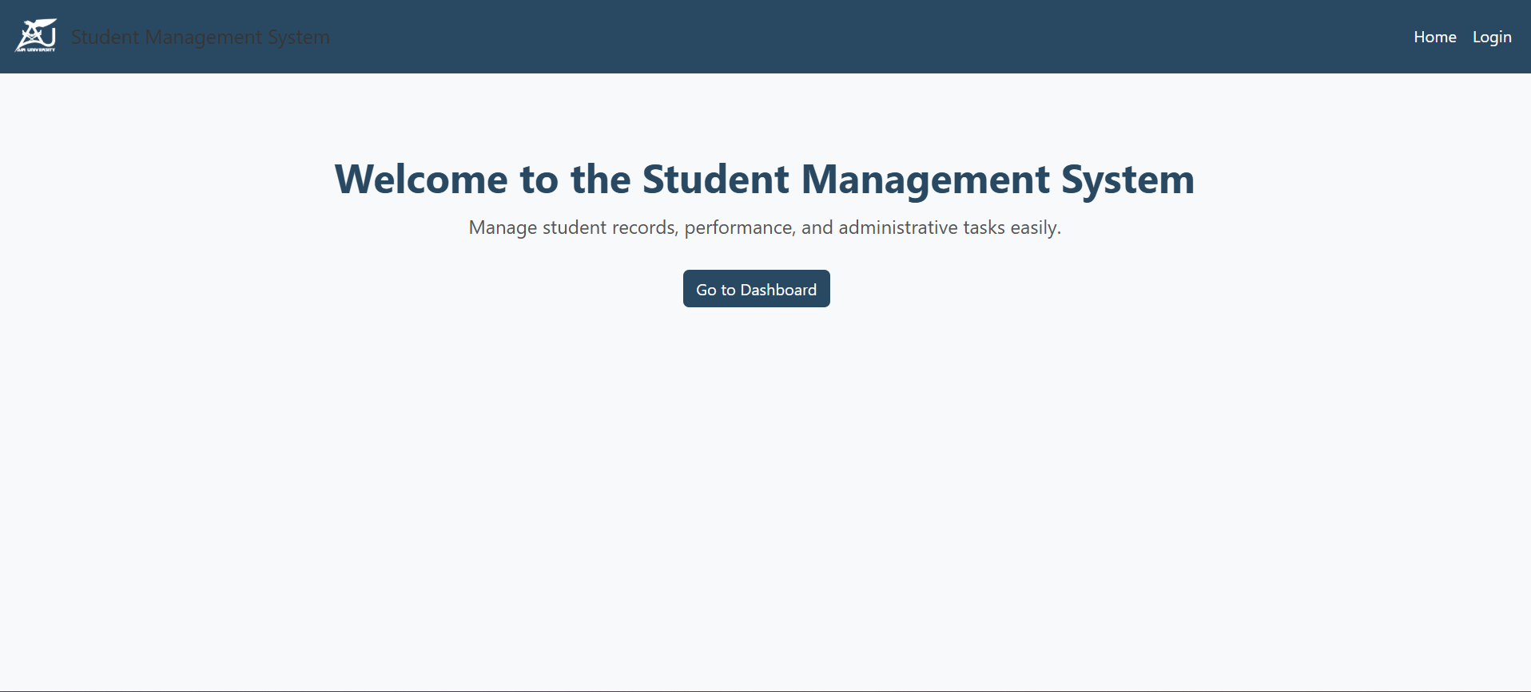
Figure: Code Preview
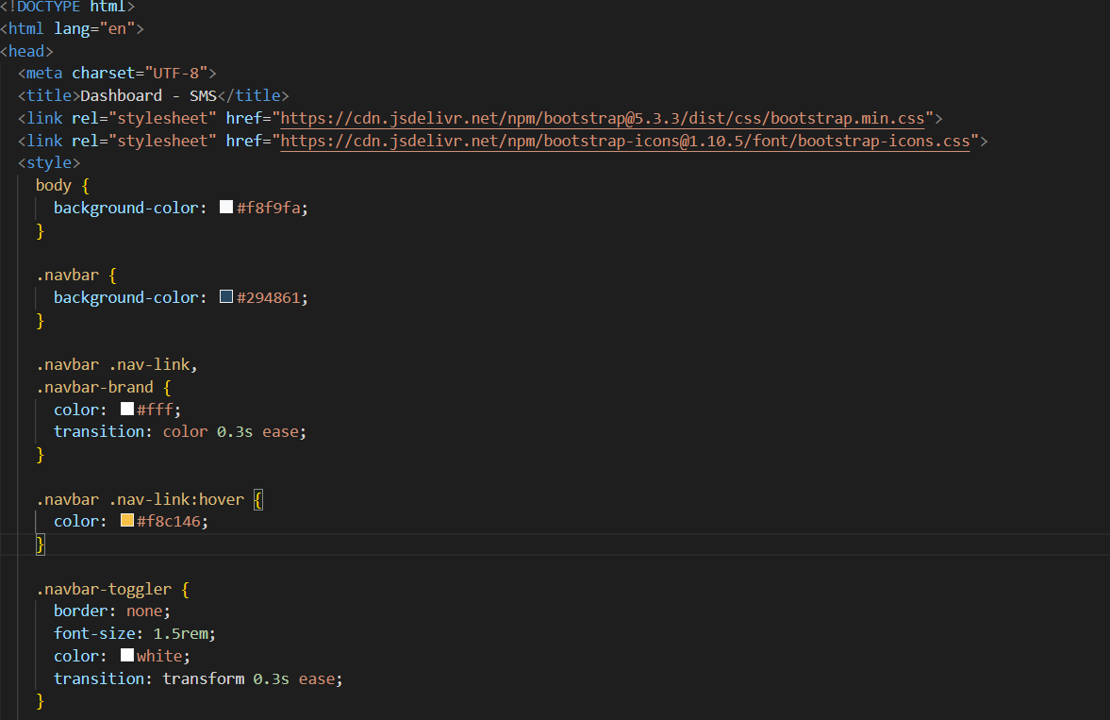
Figure: Admin Login
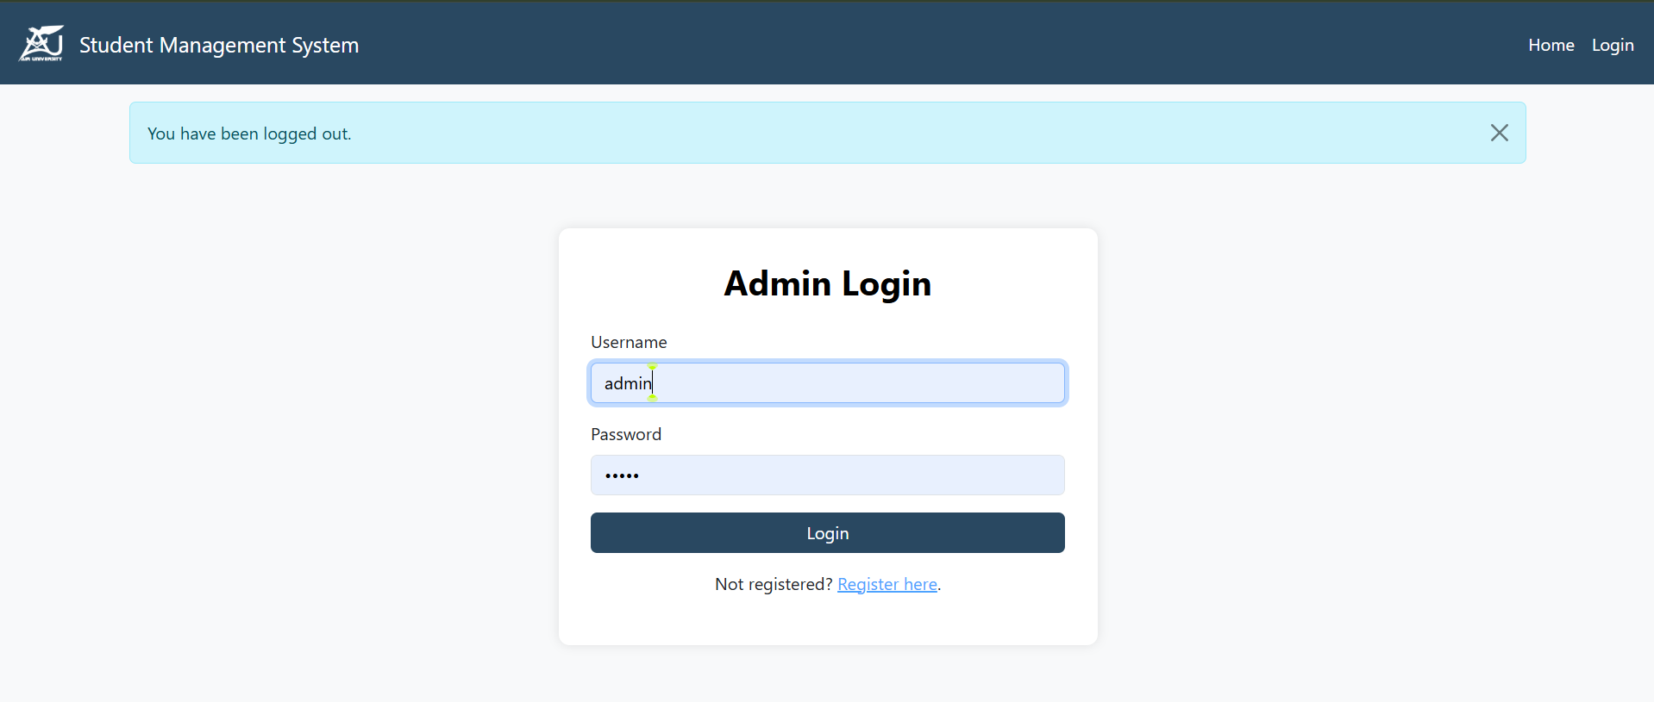
Figure: Add Student Form
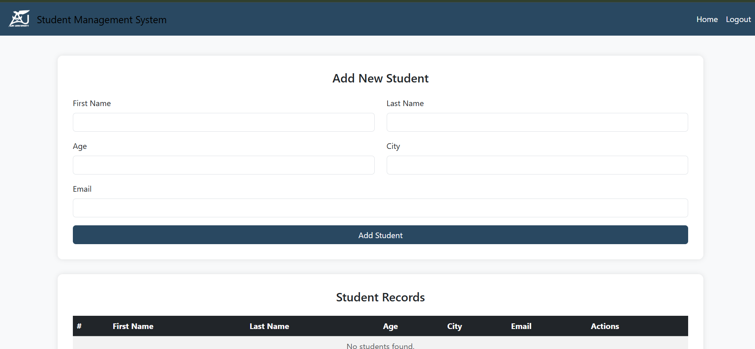
Figure: Student Record Added
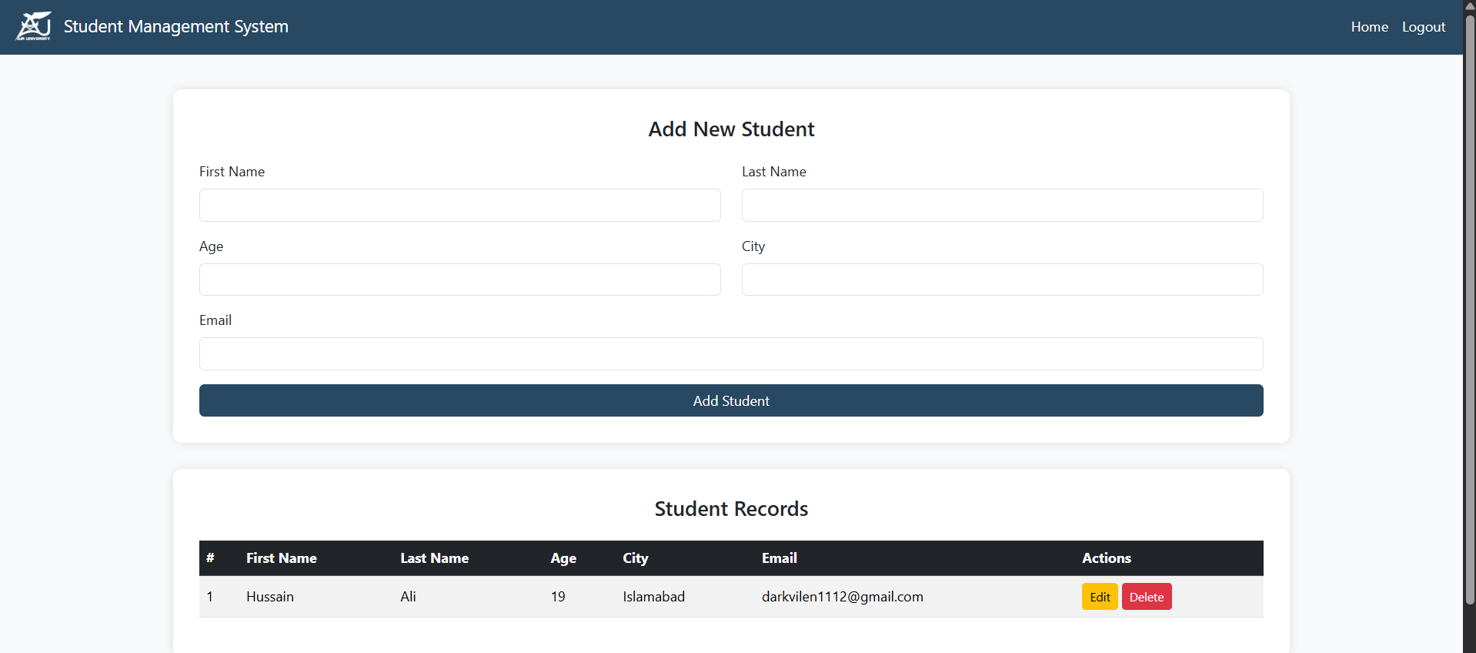
Figure: Edit Student Record
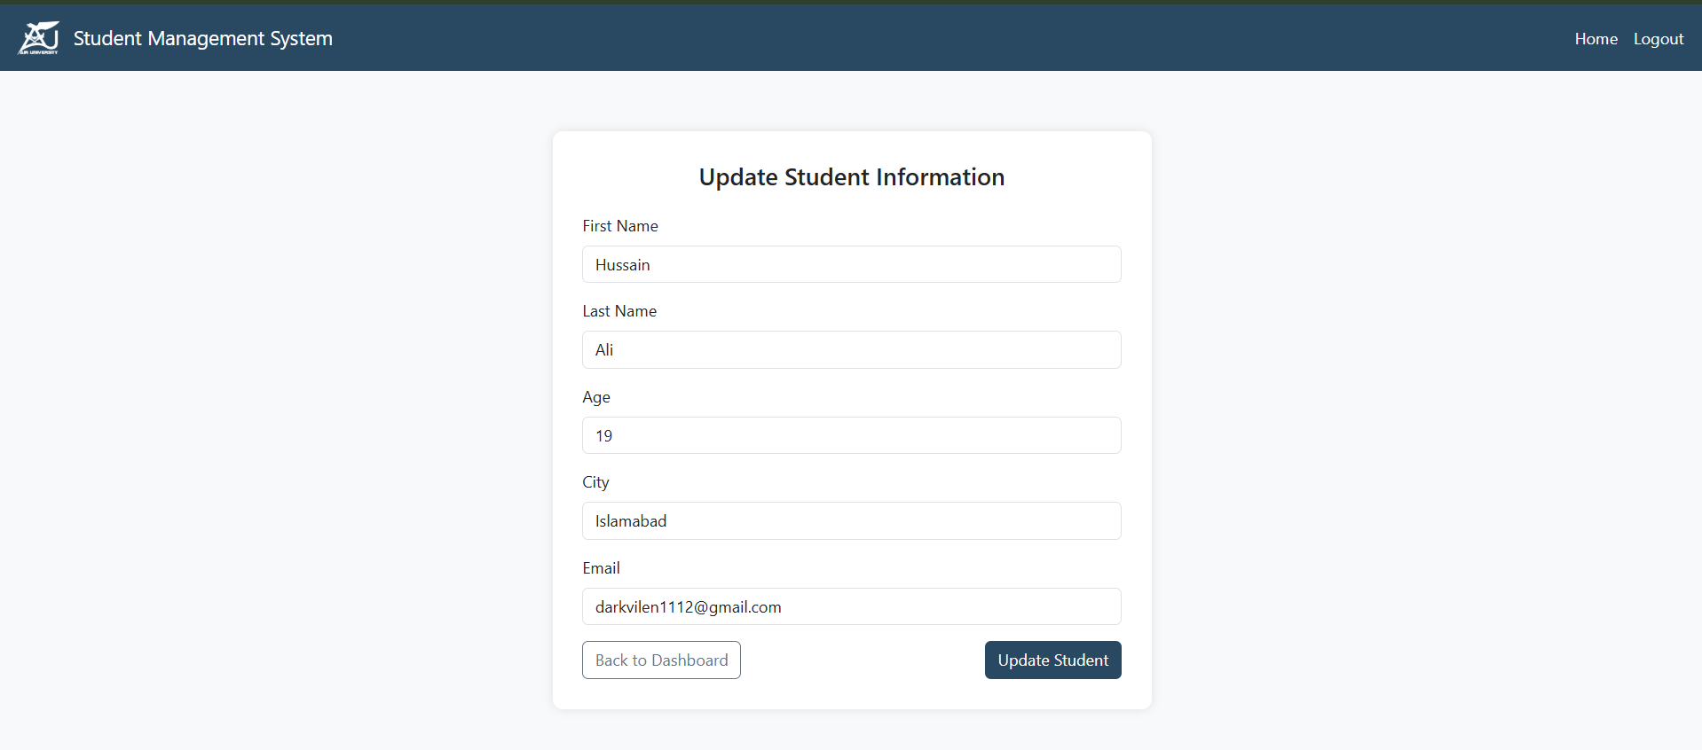
Figure: Duplicate Admin Warning
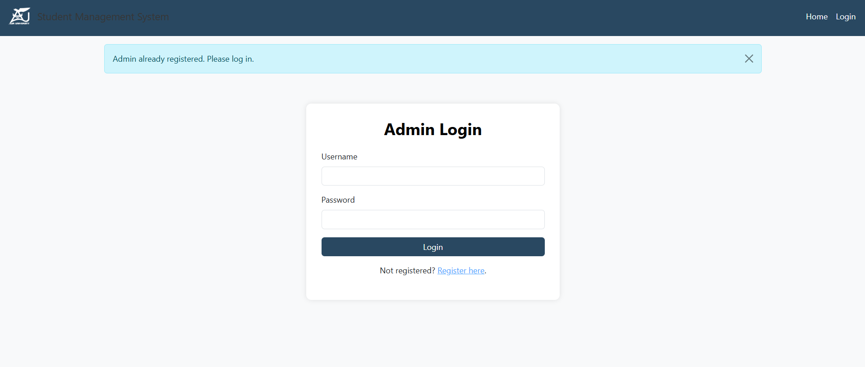

7. Limitations
- The application is a coursework-level secure CRUD system, not a production Student Information System.
- SQLite is used for simplicity; production deployments should use a managed database.
- Role-based access control is not implemented because the application has a single-admin model.
- Additional production hardening such as HTTPS termination, rate limiting, audit logging, and deployment secrets management can be added later.

8. Future Improvements
- Add password confirmation and stronger password complexity checks.
- Add rate limiting for login attempts.
- Add audit logs for create, update, and delete actions.
- Add role-based access control for admin and staff users.
- Add unit tests for forms, routes, and security behavior.
- Move inline CSS into static files for cleaner maintainability.

9. Conclusion
The Secure Student Management System demonstrates how a basic Flask CRUD application can be improved using secure software design and development practices. The final project protects authentication with password hashing, validates user input, applies CSRF protection, changes destructive actions to POST requests, and removes sensitive runtime files from the public repository. These changes make the project more suitable for academic submission and GitHub portfolio presentation.

10. References
- Flask Documentation: https://flask.palletsprojects.com/
- Flask-WTF Documentation: https://flask-wtf.readthedocs.io/
- SQLAlchemy Documentation: https://docs.sqlalchemy.org/
- Werkzeug Security Helpers: https://werkzeug.palletsprojects.com/
- OWASP Secure Coding Practices Quick Reference Guide.

