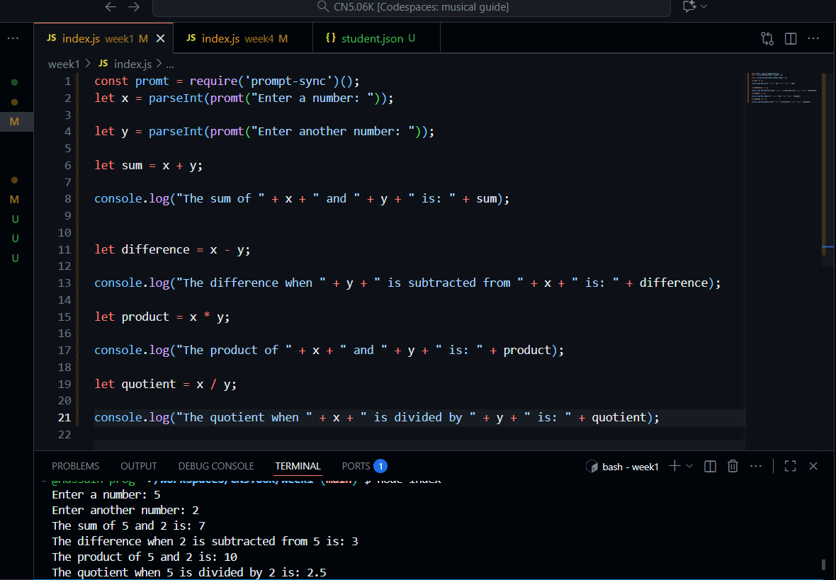

Experience
Javascript is also fun language for me as I know the basics in programming, like for instance that console.log, it was bit confusing when I saw it first, but it was just the statement to show the output on screen, just like the sys.out.print in java, so by comparing, the things were easy.
Challenge
For me honestly, the challenge is managing time to learn these things, as I spend hours on YouTube tutorials which are actually worth.

