**Continuous Integration Using Jenkins, Nexus, Sonarqube, Docker, AWS ECS and Slack**

Github :- For Repository

Jenkins :- For CICD Integration

Nexus :- For Storing & Retriving our built Artifact

Sonarqube Scanner :- To check the Quality of Code

Docker :- To Containerize the App

AWS Services :- To continue the flow of execution

AWS ECR :- To Register our Image that we built

AWS ECS :- To Run on a Container

Slack :- To Get the Notifications of the Jobs(Execution)

1. Installation of Jenkins:-

Let’s install Jenkins on Ubuntu Server

Go to EC2 > Launch Instance >



Name : Jenkins-server

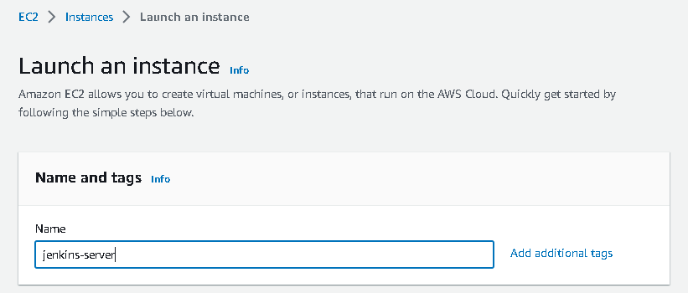

Select **Ubuntu 20.04 LTS**

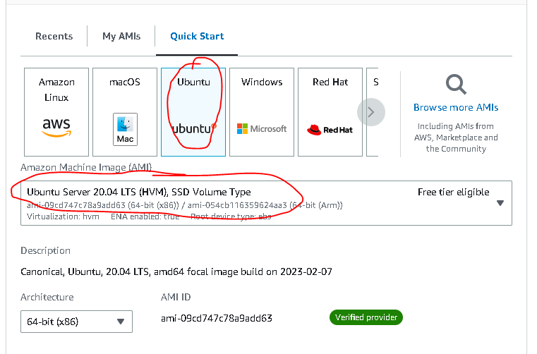

Create a **New Key Pair**: Jenkins-key

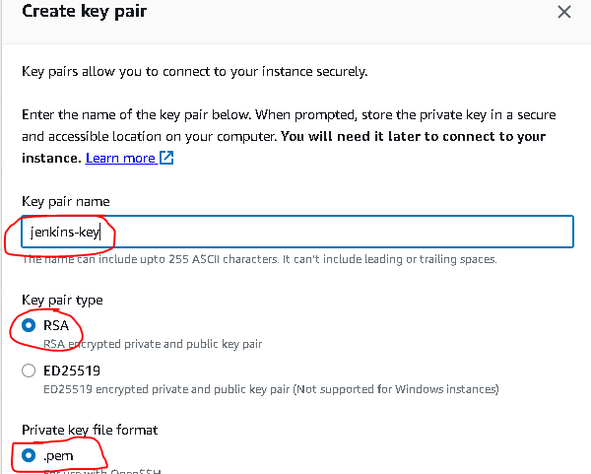

Create a New Security Group : Jenkins-SG

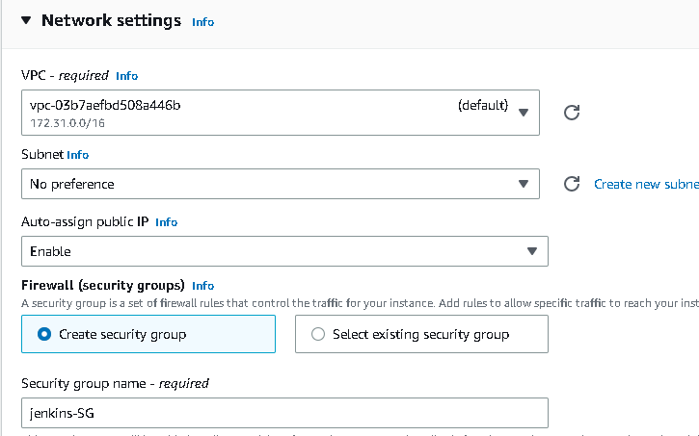

Add these **Inbound Rules**:- SSH : 22 : Anywhere

Custom TCP : 8080 : Anywhere

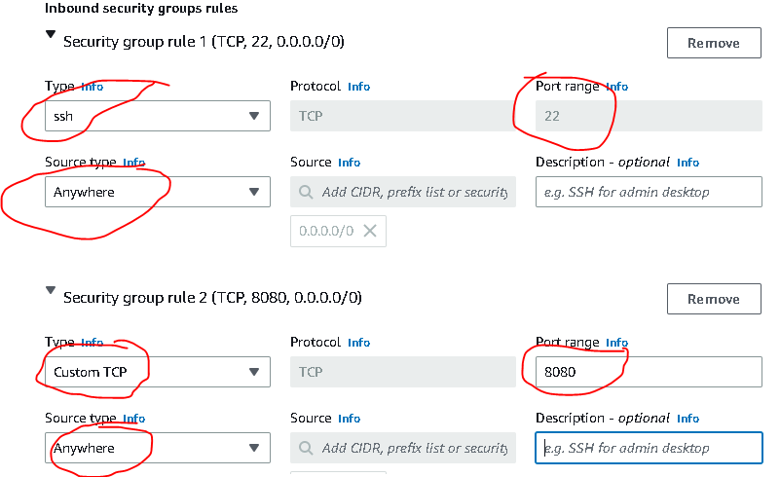

Click On Advanced Details > Go to User Data > Paste the Jenkins Installation Scripts which is given in the Link :

**Note : This script will not only install Jenkins, but also Java & Maven**

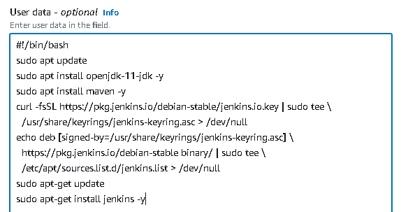

Now, Click on **Launch Instance**

Now, copy the Public Ipv4 Address & paste it in the URL with Port 8080: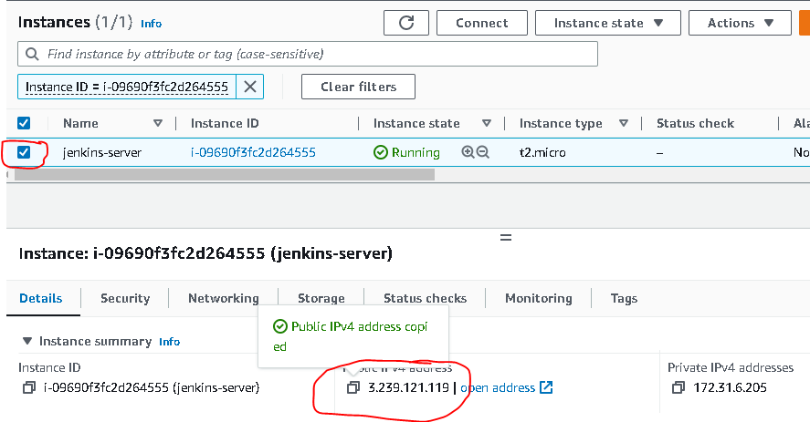



You will get the Jenkins welcome page

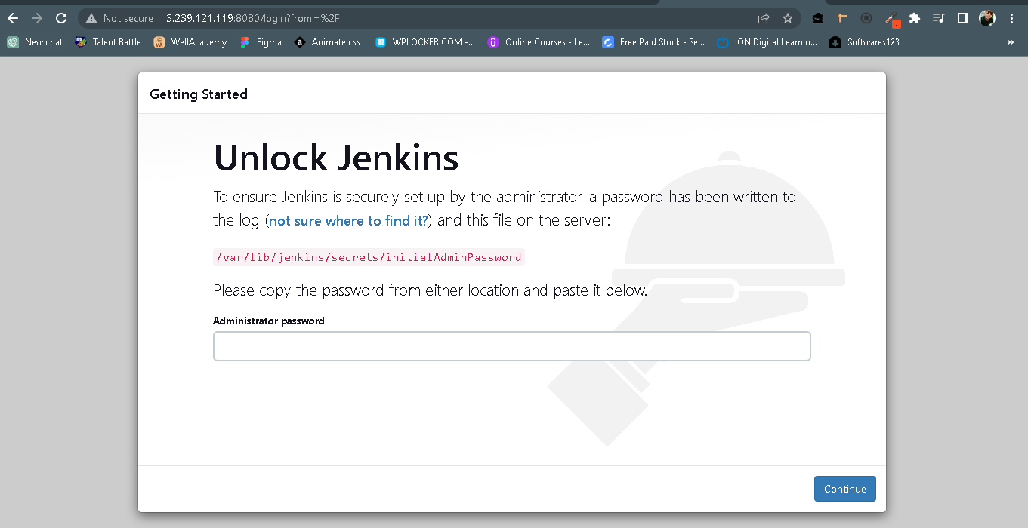

Now, Connect via SSH >

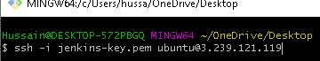

Read the content of this directory :- /var/lib/jenkins/secrets/initialAdminPassword

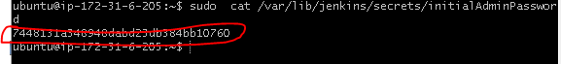

Copy the Admin Password & paste it in the Jenkins Page

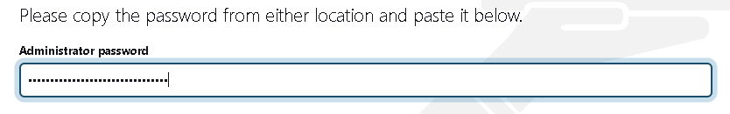

Click **Continue**

Click on **Install Suggested Plugins**

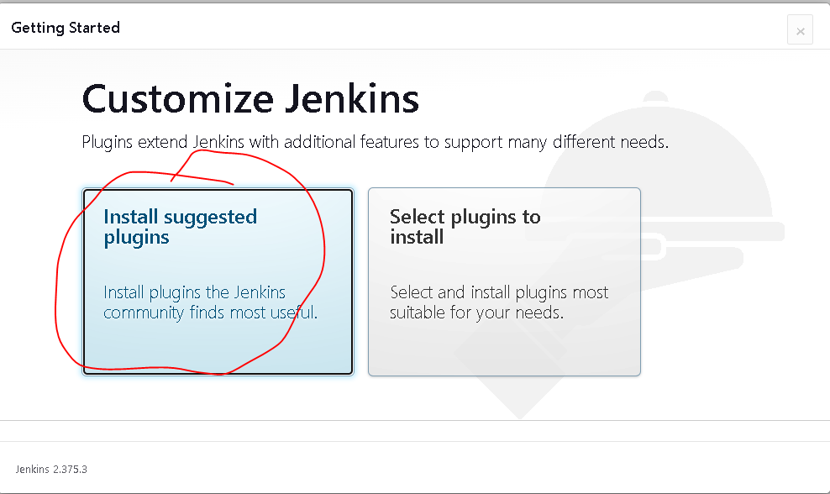

Setup the Credentials >

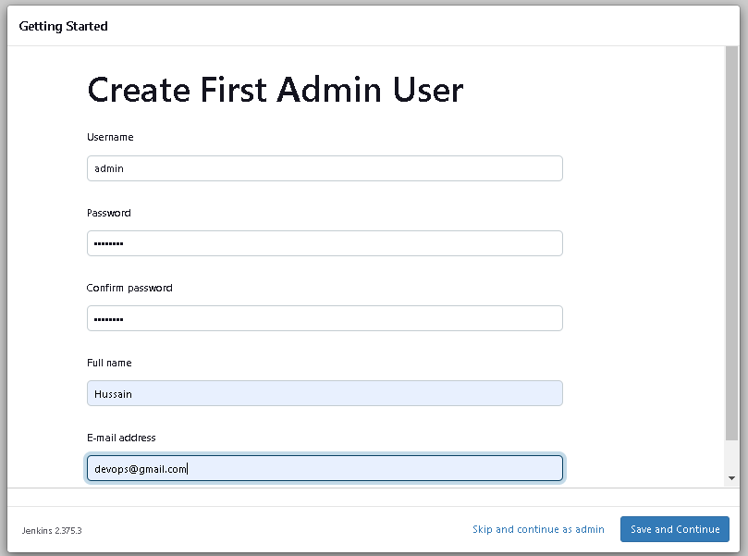

Click on **Save & Continue** > **Save & Finish** > **Start Using Jenkns**

**You will see the UI as below:-**

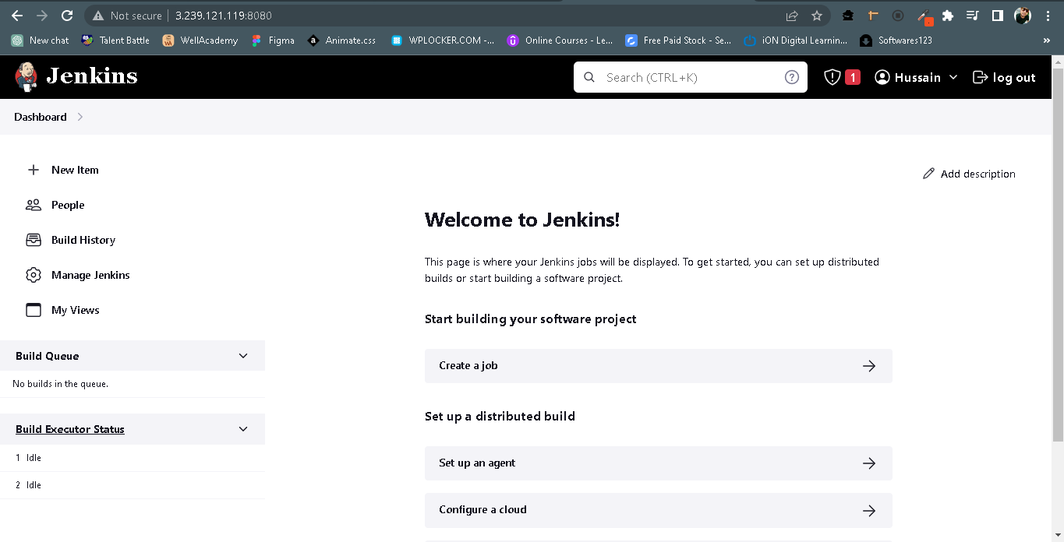

Now, Go to Manage Jenkins > Global Tool Configuration > JDK > Click on Add JDK

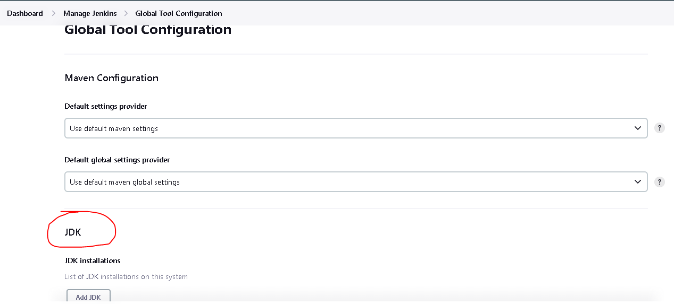

Name : OracleJDK11 (remember it)

Path : /usr/lib/jvm/java-1.11.0-openjdk-amd64

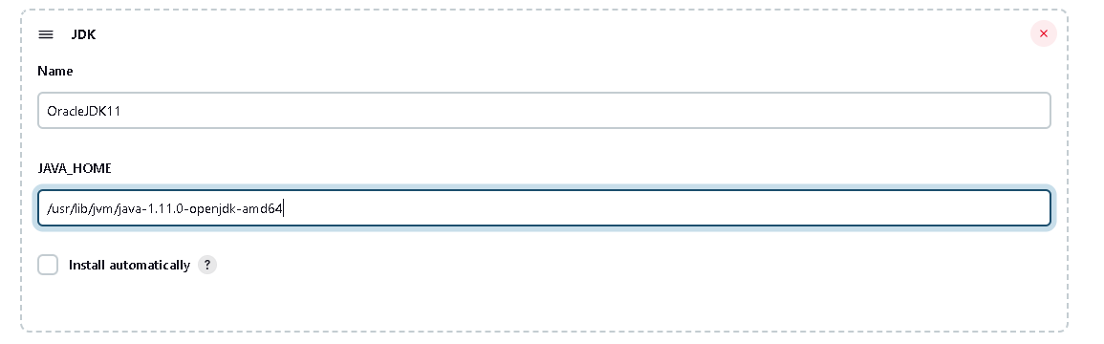

On that page only, Go to MAVEN : Click on Add Maven

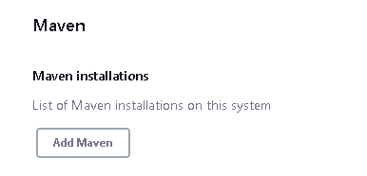

Name : MAVEN3

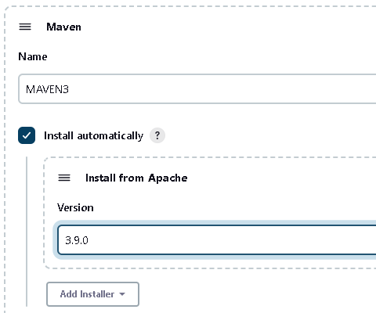

Then Click on **SAVE**

1. **Flow of Continuous Integration Pipeine:-**

Developer

(Jenkins) (Maven)

Github Fetch Code Build

Code Analysis (Sonarqube)

Upload Artifact (Nexus)

1. **Plugins for CI:-**

Goto Manage Jenkins > Manage Plugin :-

**Install these plugins:-**

Build Timestamp - for versioning our artifact,

Pipeline Maven Integration,

Pipeline Utility Steps,

Git (if installed, then it won’t show)

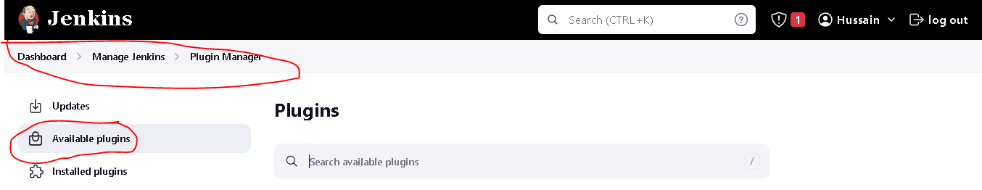

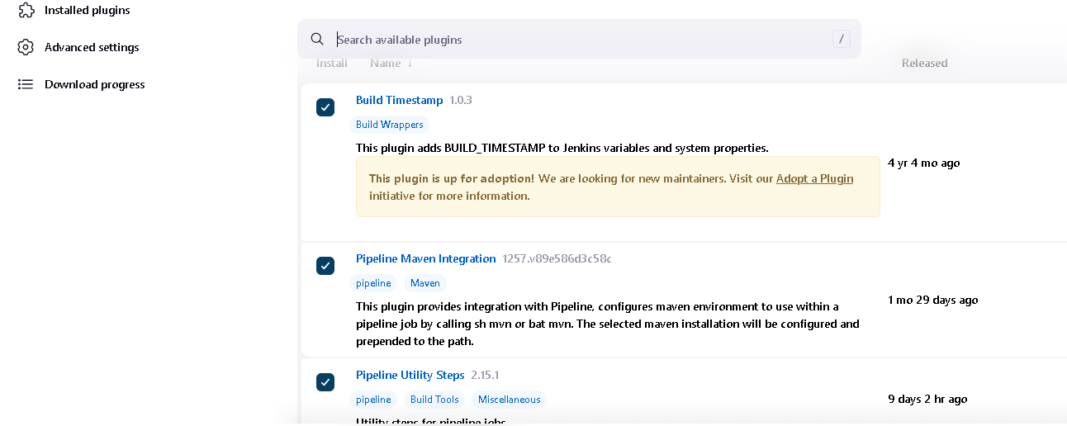

**Click Install without Restart**

1. **Slack Setup:-**

Slack setup is used to get the notification whether our build job pass or fail.

Go to **Slack** in google or in application on your local machine **> Sign Up** with your gmail account.

Give a **Workspace Name** : ecs-cicd

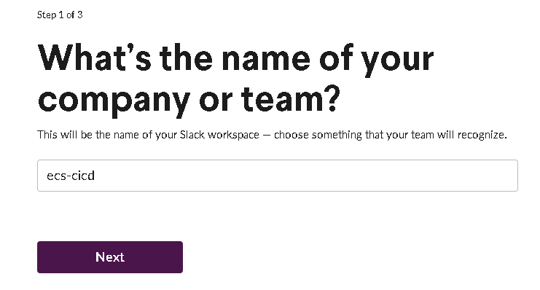 Click Next

Add Teammates mail id’s or skip this step (I’m skipping this step for now).

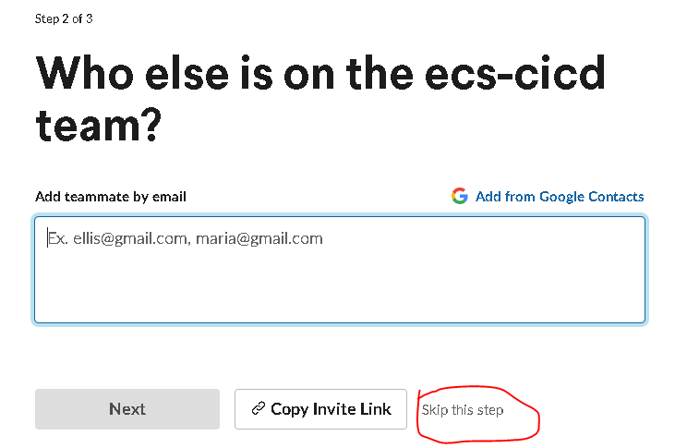

Give a **channel name** : ecs-cicd-project

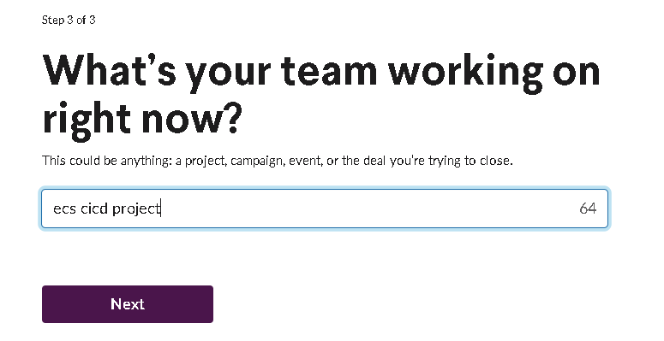

Click **Next**

You will see the Dashboard like below:-

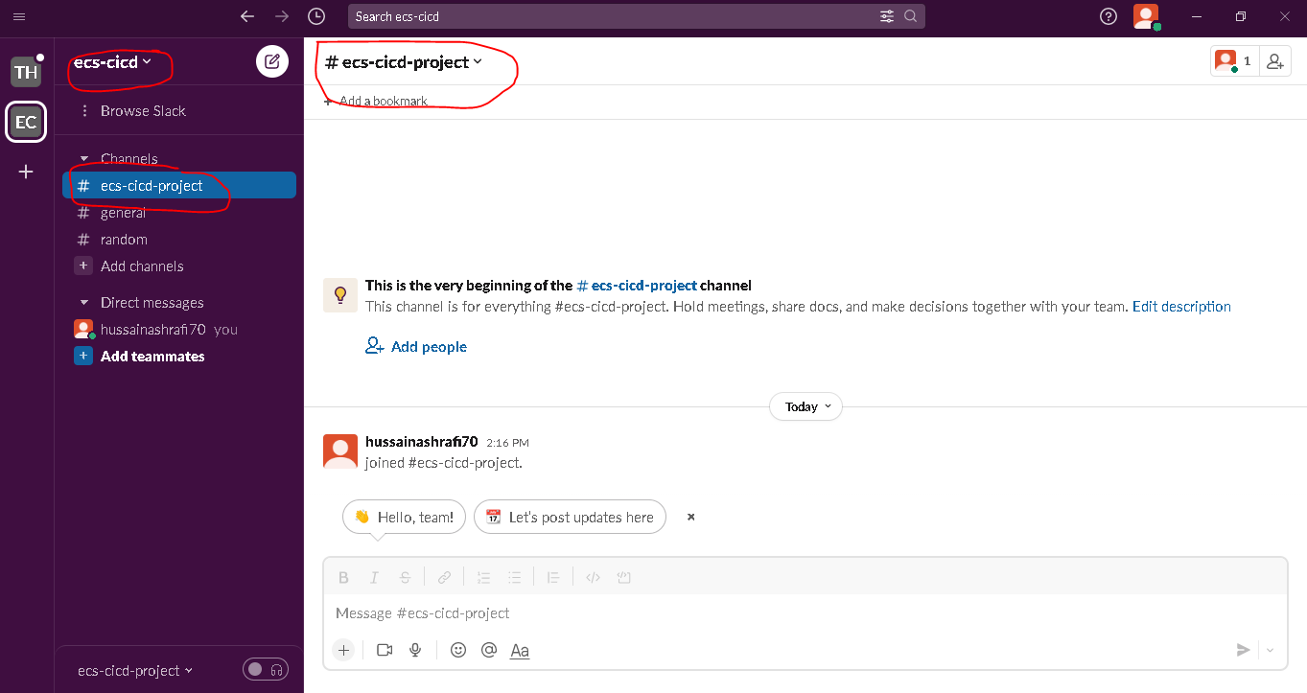

Now, go to Google > Type add apps to slack > Click on Adds apps to slack link | Apps and integrations

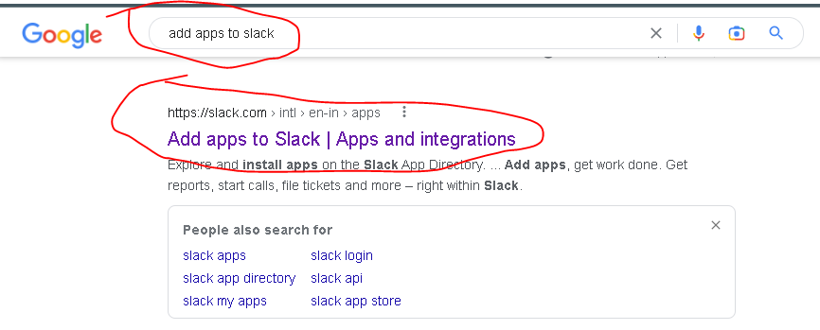

You will automatically redirected to your created workspace(ecs-cicd) and in search bar, type Jenkins ci

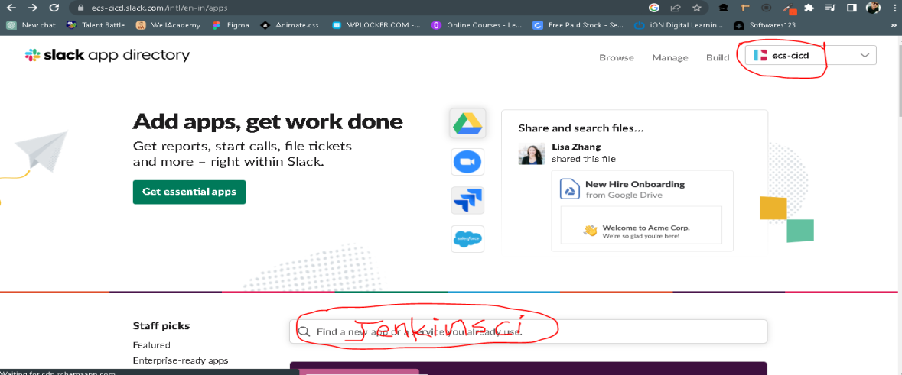

Click on Jenkins Ci

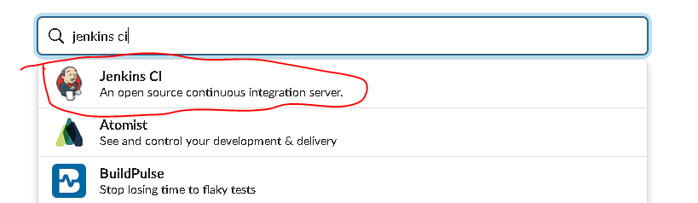

Click on **Add to Slack**

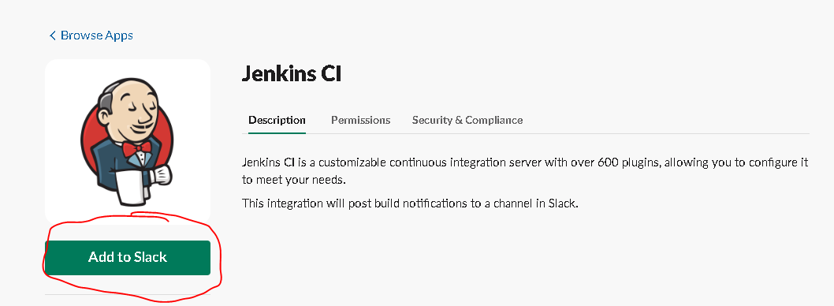

Now, **Choose our channel** : ecs-cicd-project

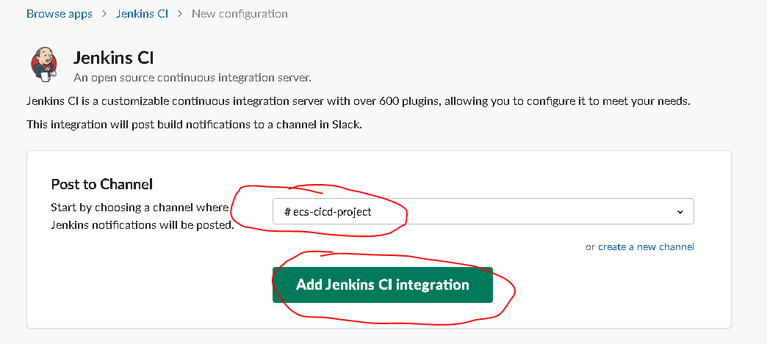

Click **Add Jenkins CI Integration**

**In Step 3, Copy the Integration Token & paste somewhere(notepad)**

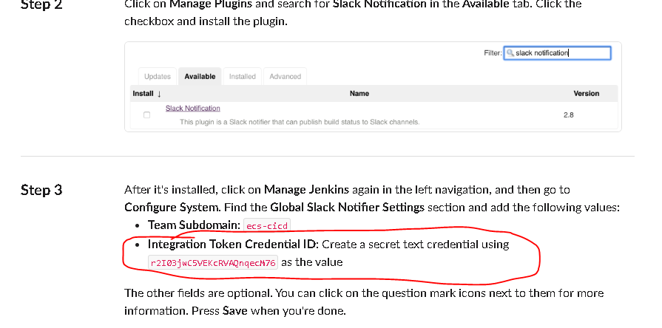

And **Scroll Down** & click **Save Settings**

**Now, Come to Jenkins Dashboard**

Go to Manage Jenkins > Manage Plugins > Install **Slack Notification**

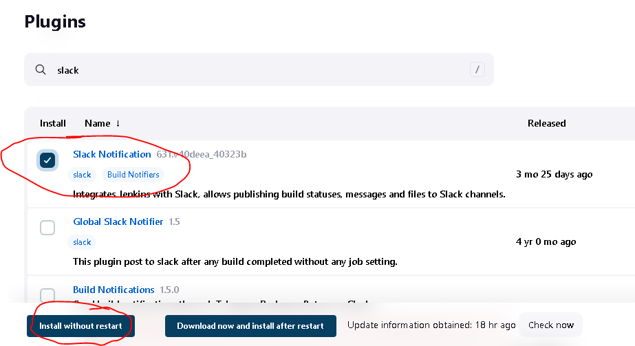

Click on **Install without restart**

Now Goto Manage Jenkins > configure System >

Scroll Down, you will see the Slack settings

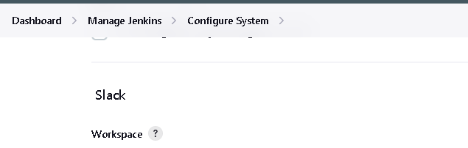

Give our **workspace name**: ecs-cicd

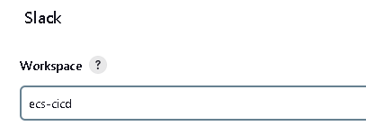

Click on Add to add Credentails

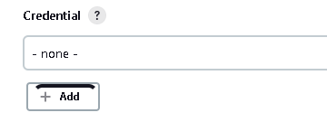

Select **kind** : Secret Text

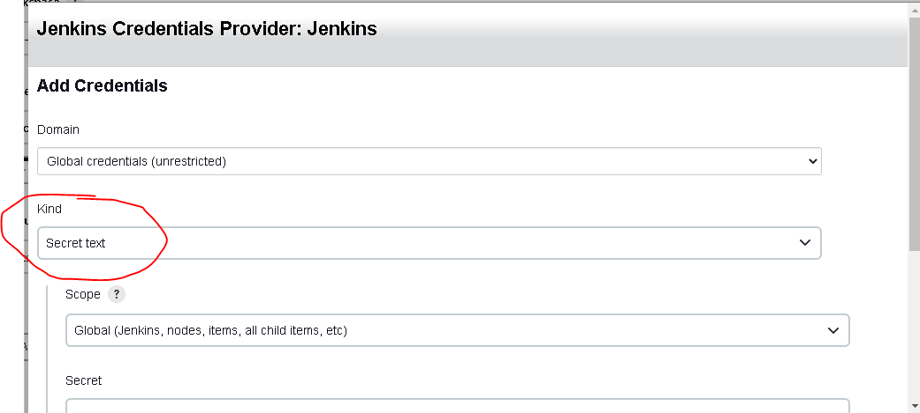

Paste our Slack token from Notepad that we copied earlier & Give any ID name, description. Click on **Add**

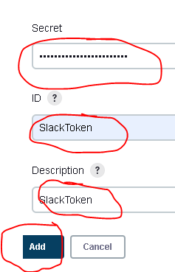

Now **Select** SlackToken

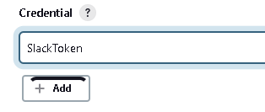

Give our channel name: #ecs-cicd-project

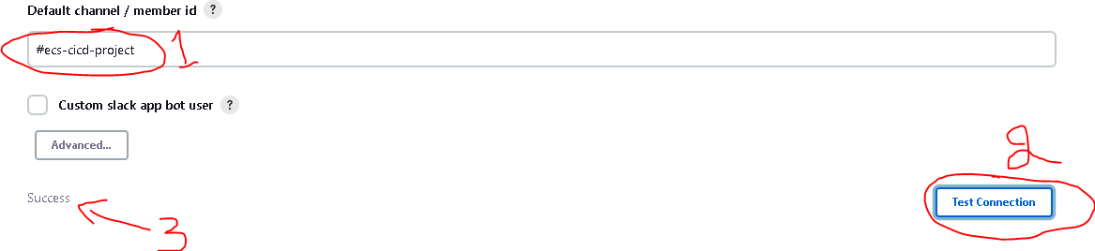

Click on **Test Connection**, you will get the success msg(means your successfully configured..!)

Now Click on **Sav**

1. **Docker Installation on Jenkins Server:-**

Connect to Jenkins server via SSH



Be the Root user :- sudo su

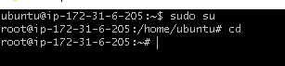

Now go to this link -> <https://docs.docker.com/engine/install/ubuntu/>

Install Docker as per the documentation:-

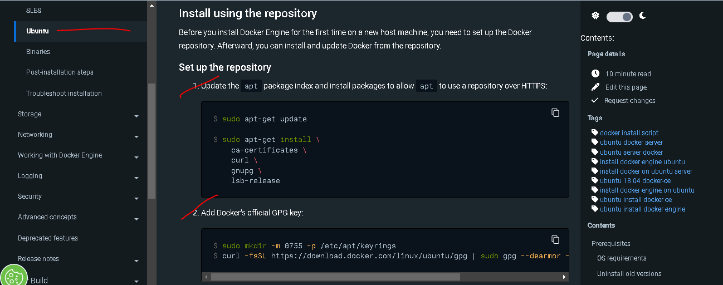

Once it is installed, validate the docker :- docker ps

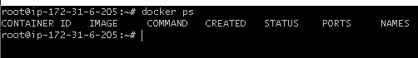

Now, add our **Jenkins** **user** to the **Docker** **Group**. So that the Jenkins will use the docker.

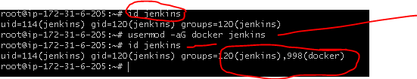

**Install** **AWSCLI** for future purpose while delivering the artefact



Now **reboot** the server



Now, Come to AWS Console > IAM > Add Users

User Name : jenkins

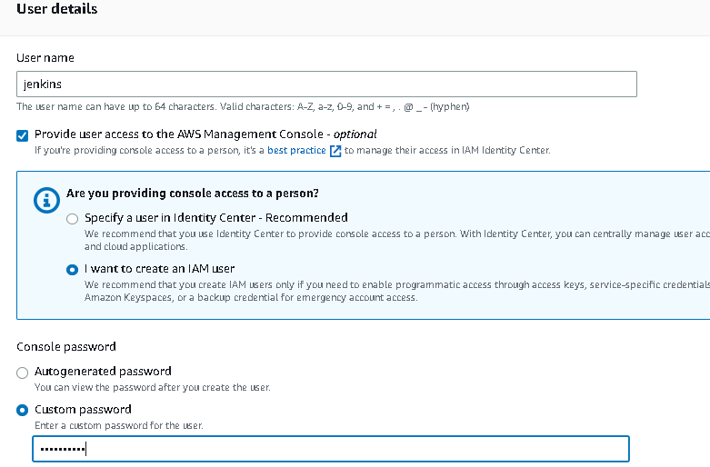

Click **Next**

**Now add permissions:-**

AmazonEC2_FullAccess & AmazonEC2ContainerRegistryFullAccess

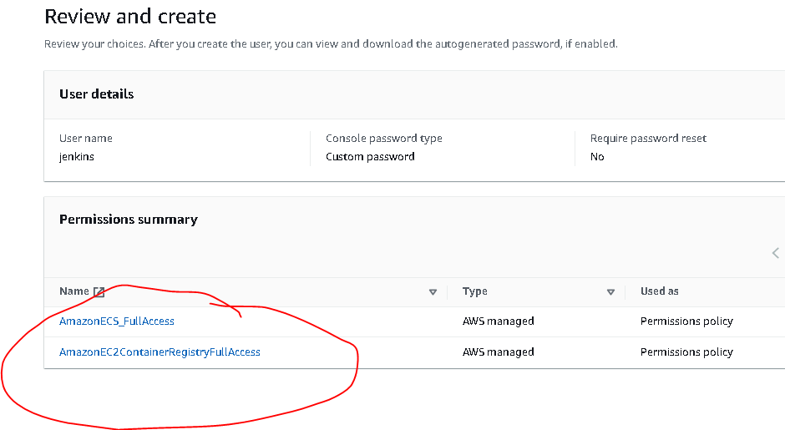

Click **Create User**

Now, Click our user (jenkins) > Security Credentails

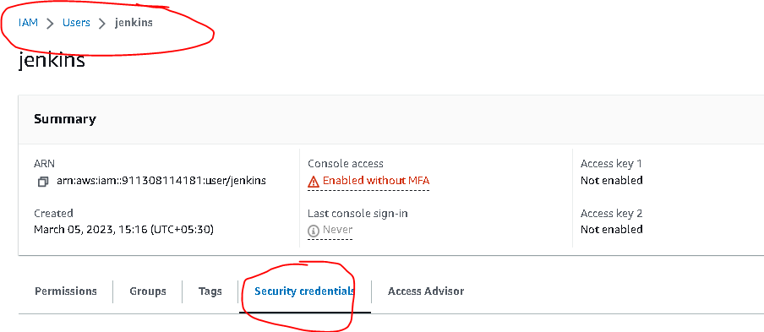

Click on **Create Access Key**

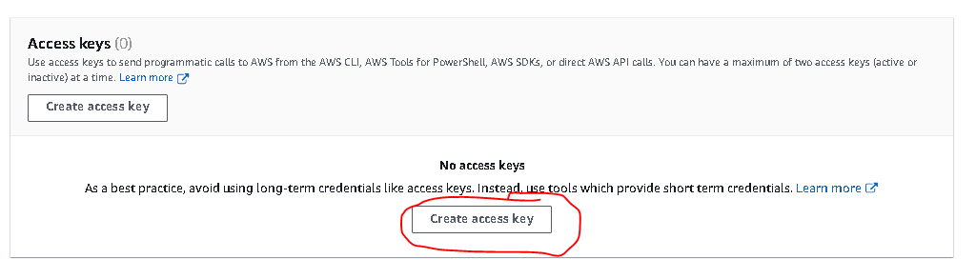

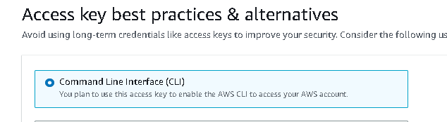

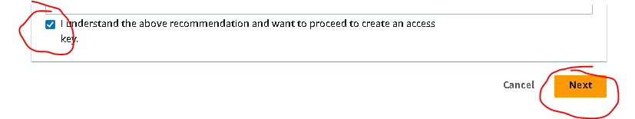

Click Next > Click Create > Download the CSV file > Done

Note:- Keep it safe the CSV file somewhere

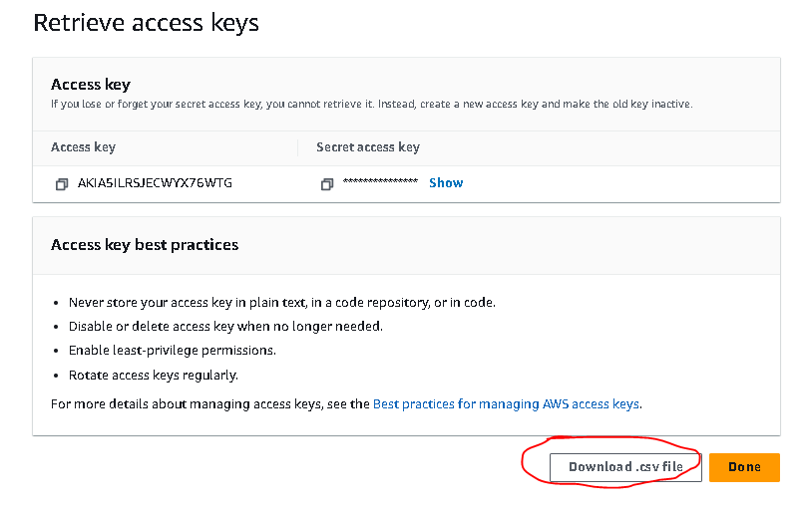

Now, Goto **AWS ECR**(Elastic Container Resgistry)

AWS > ECR > Get Started

Keep it private

Repo Name : techieappimg

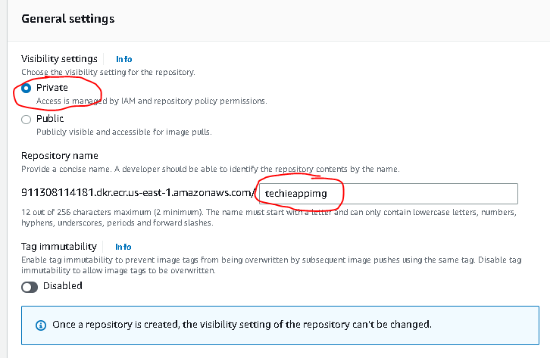

Click on **Create Repository**

Copy the URI & store it somewhere in notepad

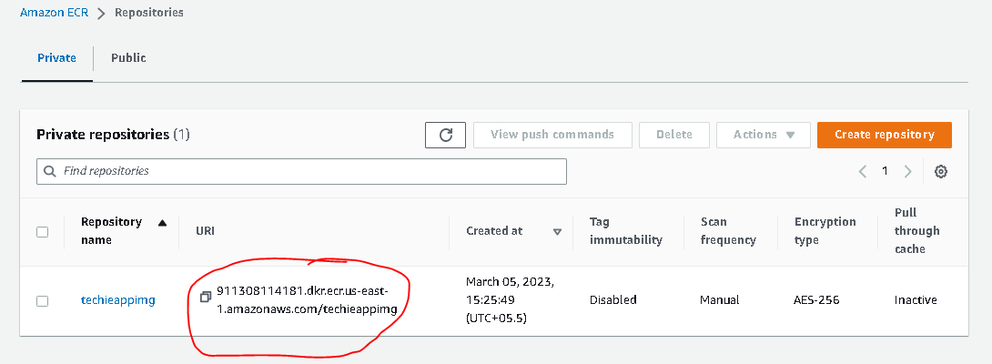

Now go to Jenkins Dashboard > Manage Jenkins > Manage Plugins > Available

Install these plugins :

* Docker
* Docker Pipeline
* Amazon ECR
* Amazon web services SDK:All
* Cloudbees docker build and publish

Now Go to Manage Jenkins > Manage Credentials >

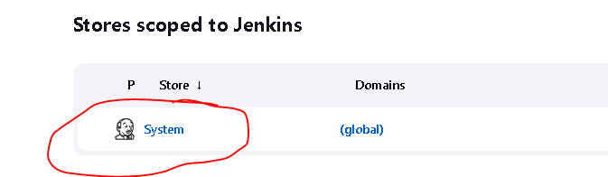

Click on System/Jenkins(in some systems)

Click on Global Credentials

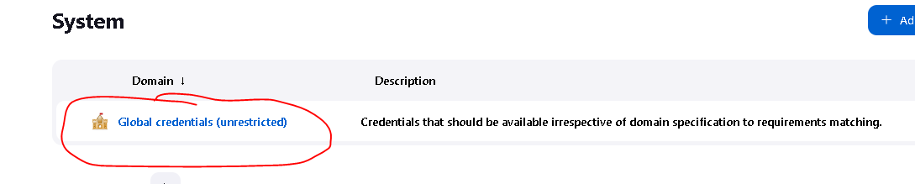

Click on **Add Credentials**

Select **Kind : AWS Credentials**

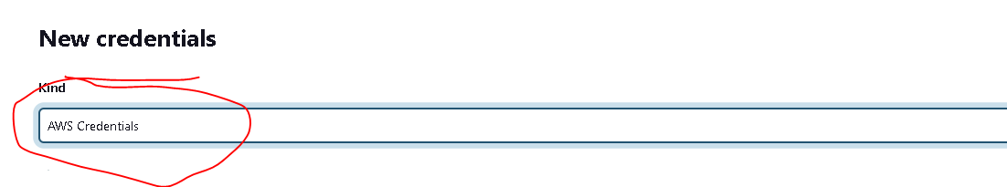

ID: awscreds (any name but remember)

Desc : awscreds (any desc)

Access Key : paste it which was downloaded earlier when we created the user Jenkins

Secret Key : paste it which was downloaded earlier when we created the user Jenkins

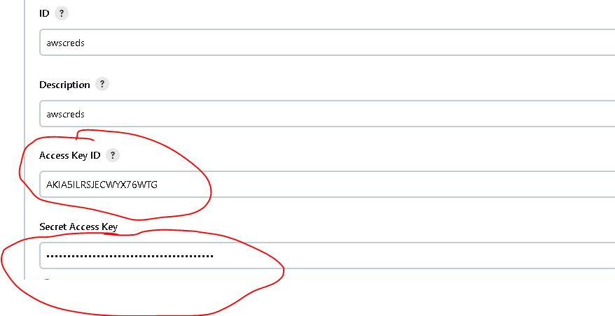

Click **Create**

1. Docker CICD Code
2. AWS ECS Setup Manually
3. AWS ECS with Jenkins Pipeline