**Topics in Computer Science II**

**Group Assignment**

**Section:**

Bcs-8A

**Group Members:**

**FA21-BCS-066 Hussain Ali**

**FA21-BCS-080 Ali Shan**

**Project Title:**

Real time Weapon Detection

**Noted Points:**

1. Problem Statement
2. Major Functionalities Defined
3. Dataset
4. Existing model studied/Executed
5. Outcomes/Results

**Code Link:**

<https://colab.research.google.com/drive/1qSBC3GYZnbK>

**Video Used:**



1. **Problem Statement**   
   Human watching of cameras is slow and not always right. Dangerous weapons may go unseen. There should be an AI system that finds weapons live and alerts quickly.

**Why we need Real time weapon detection**

* Quick warning can save lives
* No breaks — watches all the time
* Less chance of missing threats
* Easy to use with old systems
* Good for schools, malls, stations

1. **Major Functionalities Defined**
2. **Real-Time Video Capture**  
   Continuously streams live footage from cameras for processing.
3. **AI-Based Weapon Detection**  
   Utilizes machine learning models to identify potential weapons in the video feed.
4. **Object Classification**  
    Differentiates between weapon types (e.g., gun, knife) for accurate recognition.
5. **Instant Alert System**  
   Triggers real-time alerts via alarms, pop-ups, or messages when a weapon is found.
6. **Live-Visual Output**  
   Displays video with bounding boxes and labels on detected weapons for easy monitoring.
7. **Event-Logging**  
   Automatically stores images, timestamps, and relevant data for each detection.
8. **Accuracy Control**  
   Implements thresholds and filters to avoid false alarms and improve precision.
9. **Security Integration**  
   Compatible with existing safety tools like automatic locks, sirens, or notification systems.
10. **Dataset**

**Concealed Weapon Detection**

The Concealed Weapon Detection dataset is designed to train AI models to identify weapons that are hidden or partially visible under clothing or objects. It contains RGB and infrared (IR) images captured in real-world environments such as airports, train stations, and other public areas.

The dataset includes various scenarios where weapons like guns and knives are either clearly visible, slightly exposed, or fully concealed. These images help the model learn how to detect threats even when the weapon is not fully in view.

This dataset is important for building real-time surveillance systems that need to recognize dangerous items quickly and accurately, improving safety in high-risk public spaces.

1. **Model Studied/Executed**

### ****Model:****

### ****YOLOv11n for Real-Time Weapon Detection****

We used the **YOLOv11n model** for detecting weapons in real-time. YOLOv11n is a lightweight and fast object detection model, ideal for fast and accurate weapon detection, even for **concealed weapons**.

#### 🔸 **Fine-Tuning:**

* The model was **fine-tuned** using our **custom weapon detection dataset**, including both visible and concealed weapons.
* **Transfer learning** helped us adapt the pre-trained YOLOv11n model to our specific task.

#### 🔸 **Training:**

* The model was trained with **data augmentation** to improve accuracy across different conditions, like varying angles and lighting.

#### 🔸 **Outcome:**

* YOLOv11n accurately detects **weapons in real-time**, making it effective for use in **security surveillance systems**.
* **Confusion Matrix**

**The accuracy is approximately 99.64%.**

Ultralytics 8.3.87 🚀 Python-3.11.11 torch-2.5.1+cu124 CUDA:0 (Tesla T4, 15095MiB)

YOLO11n summary (fused): 100 layers, 2,582,347 parameters, 0 gradients, 6.3 GFLOPs

**val:** Scanning /content/Thermal-pistol-1/test/labels.cache... 16 images, 0 backgrounds, 0 corrupt: 100%|██████████| 16/16 [00:00<?, ?it/s]

Class Images Instances Box(P R mAP50 mAP50-95): 100%|██████████| 1/1 [00:00<00:00, 2.26it/s]

all 16 16 1 0.996 0.995 0.728

Speed: 0.2ms preprocess, 5.8ms inference, 0.0ms loss, 1.4ms postprocess per image

Results saved to **runs/detect/val2**

mAP50-95: 0.7281

Precision: 1.0000

Recall: 0.9964

F1 Score: 0.9982

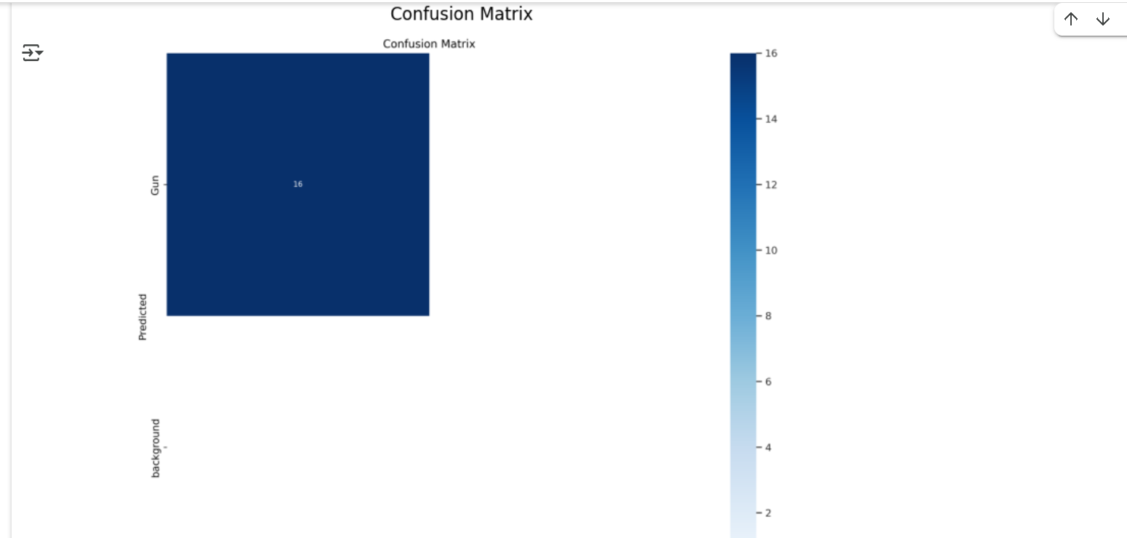

1. **Results/Outcomes**

