**Lab 10**

**Task 1**

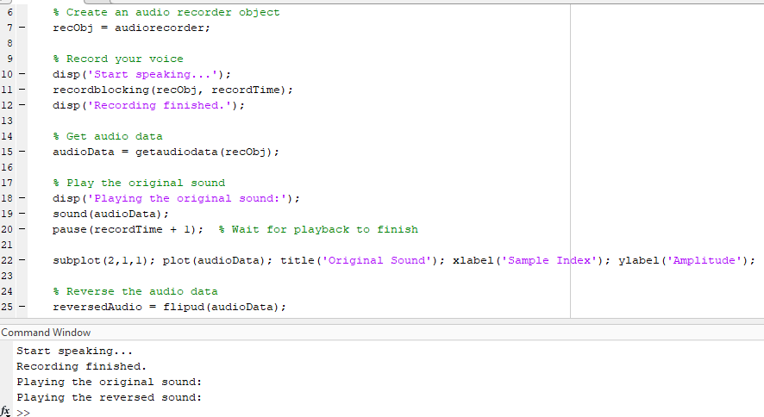

**Task 1 – i**



**Task 1 – ii**



**Task 1 - iii**



**Task 2**

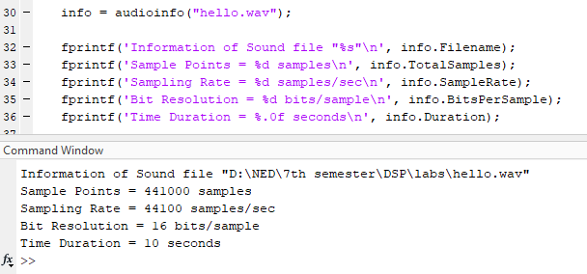

**Task 3**

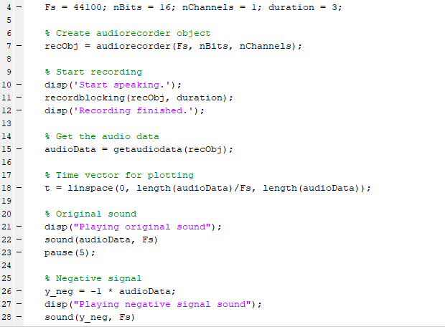

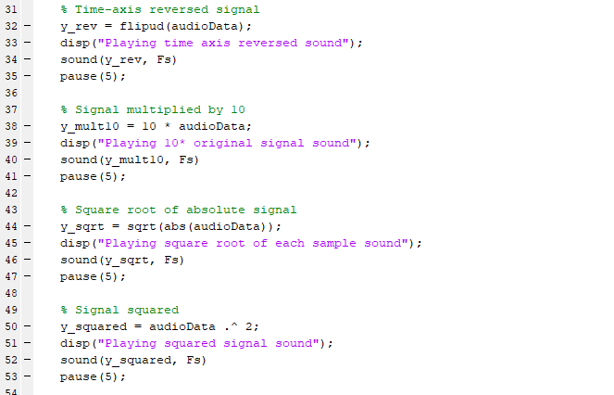



**a. Multiply the audio signals by -1 (Inversion)**

* **Effect**: The waveform inverted vertically. Sounds identical to original as inversion preserves the absolute amplitude and phase relationships. Our ears are insensitive to phase changes

**b. Reverse the audio signals in time axis (Reversing the signal)**

* **Effect**: Reversing the signal plays the audio backward.

**c. Multiply the audio signals by 10**

* **Effect**: Multiplying the signal by 10 scales the amplitude of the waveform, resulting in a 10x louder sound.

**d. Replace each sample by its square root**

* **Effect**: Applying the square root to each sample causes distortion because louder portions become quieter, and the overall signal becomes uneven in amplitude.

**e. Replace each sample by its square**

* **Effect**: Squaring each sample significantly reduces the amplitude. Most audio signals have values near zero so squaring these values results in even smaller numbers, leading to a signal with almost no sound.

**Task 4**

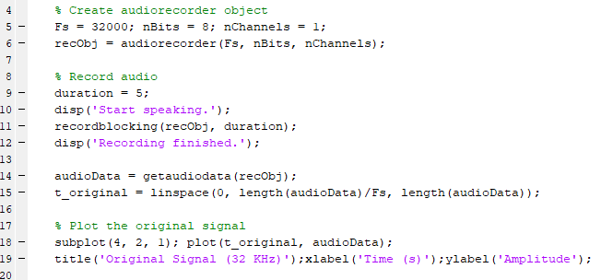

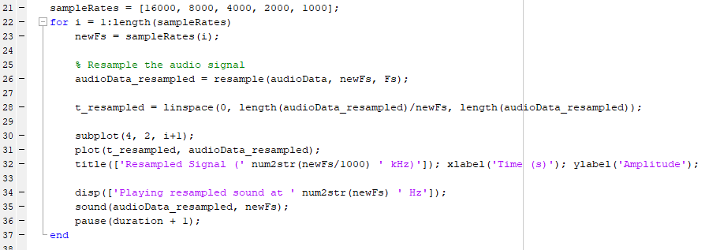



**Task 5**



