**Lab 2**

**Task 1**

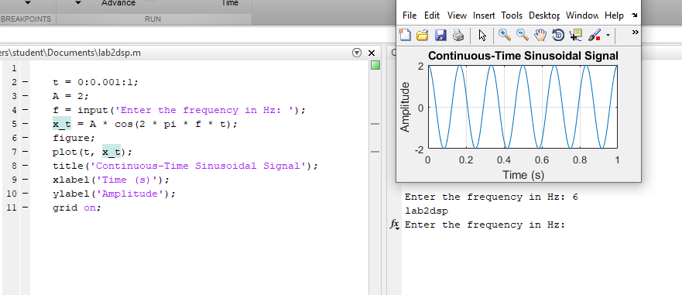

**Task 2**

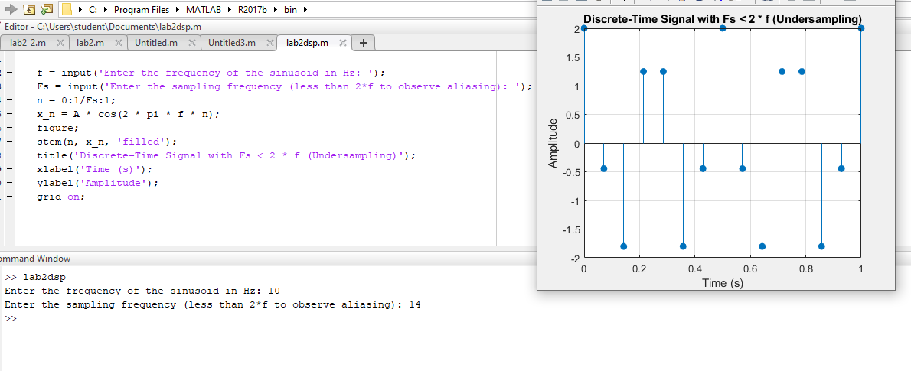

**Task 3**

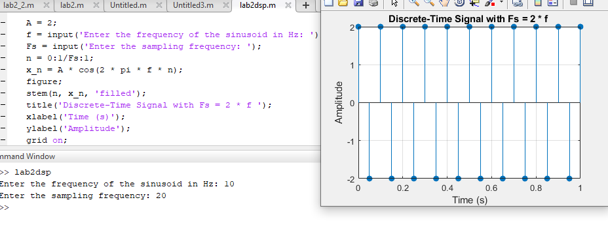

**Task 4**

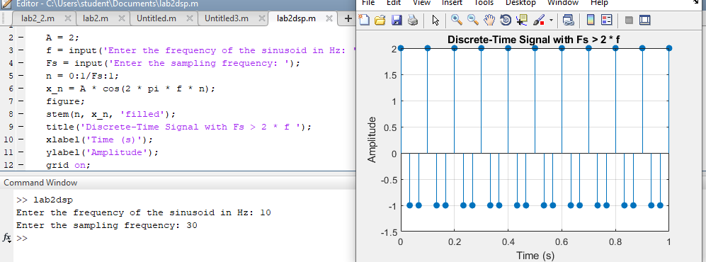

**Task5**

t = 0:0.001:1;

x_t = A * cos(2 * pi * f * t);

Fs1 = 1.5 * f;

n1 = 0:1/Fs1:1;

x_n1 = A * cos(2 * pi * f * n1);

Fs2 = 2 * f;

n2 = 0:1/Fs2:1;

x_n2 = A * cos(2 * pi * f * n2);

Fs3 = 4 * f;

n3 = 0:1/Fs3:1;

x_n3 = A * cos(2 * pi * f * n3);

figure;

subplot(2,2,1);

plot(t, x_t);

title('Continuous-Time Signal');

xlabel('Time (s)');

ylabel('Amplitude');

grid on;

subplot(2,2,2);

stem(n1, x_n1);

title('Fs < 2 * f (Undersampling)');

xlabel('Time (s)');

ylabel('Amplitude');

grid on;

subplot(2,2,3);

stem(n2, x_n2);

title('Fs = 2 * f (Nyquist Rate)');

xlabel('Time (s)');

ylabel('Amplitude');

grid on;

subplot(2,2,4);

stem(n3, x_n3);

title('Fs > 2 * f (Oversampling)');

xlabel('Time (s)');

ylabel('Amplitude');

grid on;

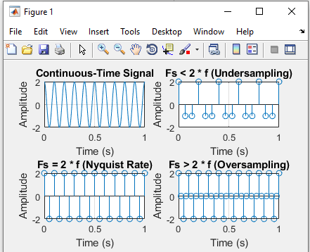

**Task 6**

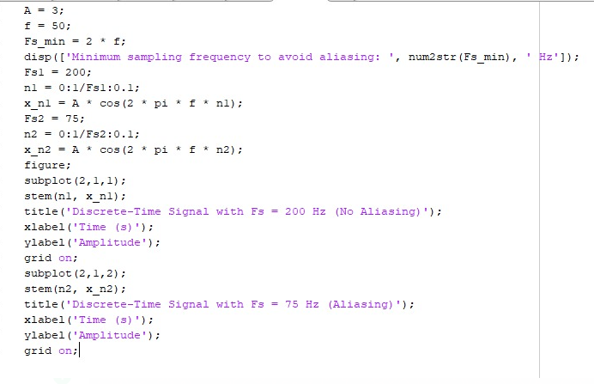

**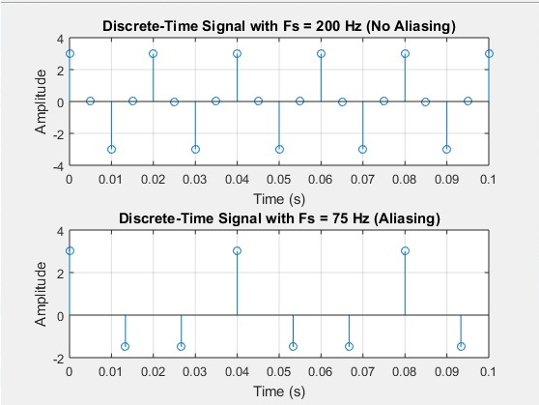  
lab 3**

**task1**

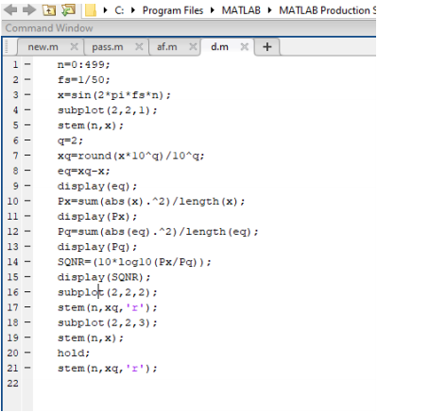

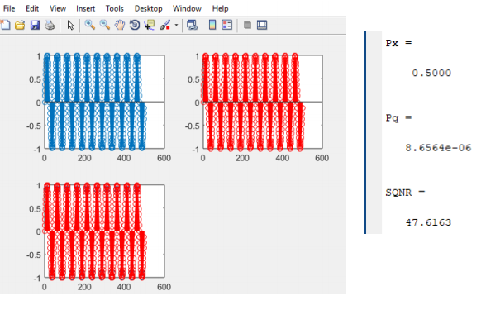

**Task 2**

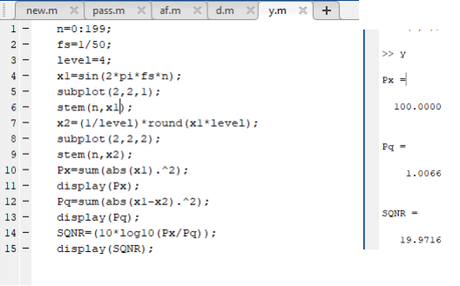

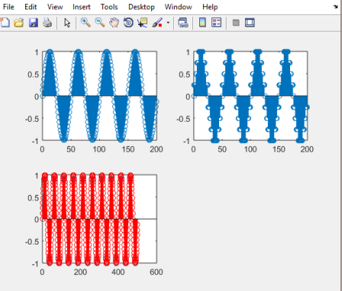

**b)**

