Industry 4.0 IoT Dashboard Implementation Report
Concise public summary of the NI myRIO LabVIEW and Flask monitoring prototype
This condensed version removes tutorial-style setup notes, weekly internship administration, and unrelated research detail from the original report. It keeps the project purpose, system architecture, implementation evidence, validation approach, and final dashboard outcomes.

Executive Summary
The project produced an Industry 4.0 proof of concept that collected sensor data from an NI myRIO, processed it through LabVIEW and Python services, and displayed it in a browser dashboard. The final system monitored smart tool-drop detection, machine vibration, AGV tilt and collision, package drop logging, and worker fatigue or fall monitoring.
The system combined hardware acquisition, network communication, backend APIs, SQLite storage through SQLAlchemy, CSV validation logs, live visualization, browser alerts, and export workflows. It started with communication and acquisition experiments, then evolved into a multi-page monitoring dashboard that tied the hardware, backend, and frontend together.

Project Scope
- Integrate NI myRIO with LabVIEW to read accelerometer and Arduino-compatible sensor inputs.
- Transmit sensor readings to a local Flask backend after testing UDP, TCP, and HTTP prototypes.
- Convert raw readings into derived values such as magnitude, fall state, pitch, and roll.
- Persist readings and events with SQLite, SQLAlchemy models, and CSV logs.
- Build a dashboard with live polling, charts, notifications, thresholds, update toggles, and CSV exports.
- Document validation evidence through captured sensor logs, screenshots, and the final internship report artifacts.

System Architecture
The system was organized as a hardware-to-dashboard pipeline. LabVIEW acquired myRIO and sensor readings. The Flask backend received the data, calculated derived metrics, stored rows, and exposed API routes. The browser dashboard polled those APIs and updated the interface in real time.
SQLite and CSV were both used because they served different needs. SQLite, managed through SQLAlchemy, represented the structured application data model. CSV logs were useful for hardware testing, quick inspection, and export workflows that could be opened without extra tooling.
Layer | Tools | Role
Hardware acquisition | NI myRIO, LabVIEW, Arduino-compatible sensors | Read accelerometer, magnetic, sound, tilt, temperature, light, and flame/environment signals.
Communication | UDP, TCP, HTTP, Node-RED prototypes | Test data transfer methods before settling into the final dashboard workflow.
Backend | Python, Flask, pandas, SQLAlchemy | Receive readings, calculate metrics, persist data, and expose APIs.
Storage | SQLite and CSV | Store structured entities and retain exportable validation logs.
Frontend | HTML, CSS, Bootstrap, JavaScript, Chart.js | Display live module views, charts, alerts, thresholds, and exports.
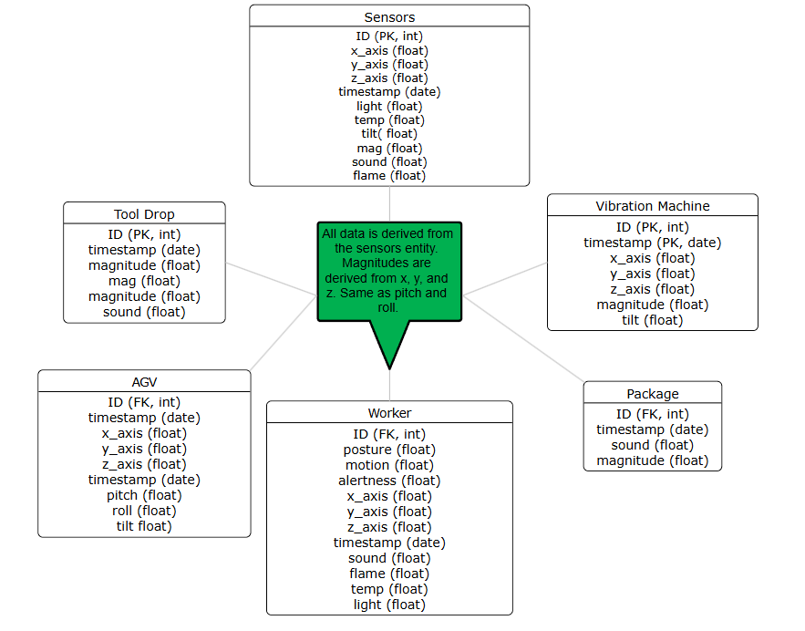
Figure 1. Updated entity relationship model for the dashboard.

Hardware and Data Acquisition
The LabVIEW side handled myRIO acquisition and communication prototypes. Early work tested accelerometer reads, LED feedback, sensor wiring, UDP, TCP, and HTTP. HTTP aligned best with the final Flask API flow because it matched the backend endpoint structure and was easier to inspect during dashboard development.
Arduino-compatible sensors were fitted to the myRIO to improve detection beyond accelerometer-only readings. Additional readings included magnetic latch state, sound level, tilt, light, temperature, and flame/environment indicators where available. This made the final dashboard more realistic because each page could use context from more than one sensor rather than relying only on acceleration magnitude.
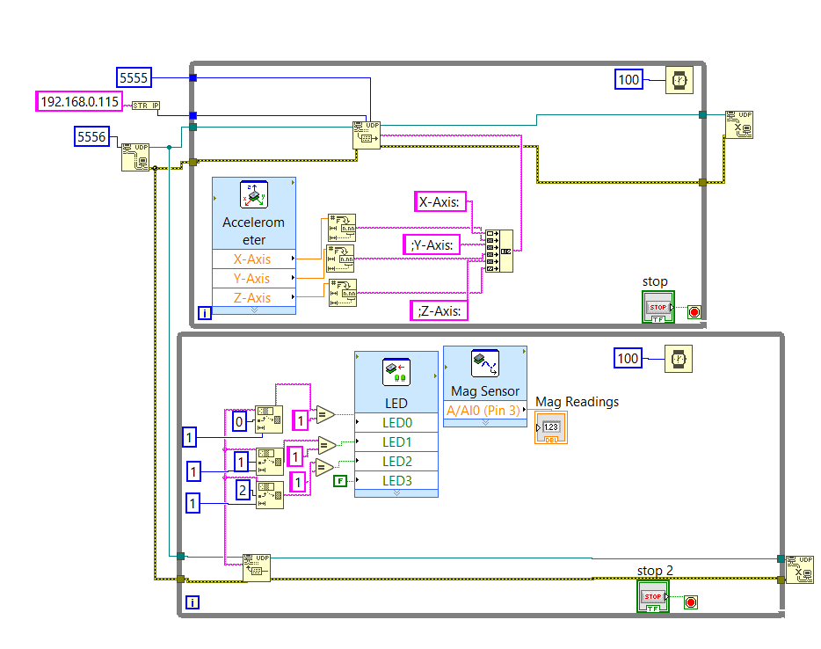
Figure 2. LabVIEW VI prototype for reading accelerometer data and communicating with external services.
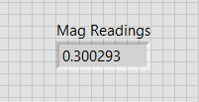
Figure 3. Magnetic sensor reading used to support tool-drop detection.

Protocol and Standards Exploration
UDP, TCP, and HTTP were tested to understand the tradeoffs between simple streaming, reliable transport, and API-style integration. UDP was useful for fast experiments and Node-RED debugging, TCP gave a clearer connection model, and HTTP fit best once the project moved toward Flask routes and browser-facing behavior.
The internship also included research into MTConnect, UMATI, and OPC-UA concepts. That work informed the industrial framing of the dashboard, even though the final prototype focused on local myRIO-to-Flask data flow rather than a full production standard implementation.

Backend and Data Layer
The Flask application served page routes and API endpoints. Incoming readings were transformed into magnitude, orientation, and event indicators, then stored through SQLAlchemy models backed by SQLite. The models represented readings, machines, packages, workers, and event-specific records for tool drops, vibrations, AGV behavior, package drops, and worker monitoring.
CSV outputs were retained because they were easy to inspect and useful as validation artifacts. The dashboard could export logs for individual modules, while the backend continued recording the raw and derived values needed to verify that the hardware pipeline was working.

Dashboard Modules
The dashboard presented five industrial monitoring modules. Each page used the same sensor pipeline but exposed a workflow suited to its scenario. The goal was not just to show raw values, but to turn sensor readings into simple operational signals: good or alert states, magnitude changes, trend charts, and exportable event logs.
Module | Purpose | Main behavior
Tool-drop detection | Detect possible CNC/tool separation or hard drops. | Magnitude threshold, magnetic latch state, sound level, alert status, export.
Machine vibration | Visualize vibration intensity and direction. | Acceleration axes, magnitude chart, tilt, sound level, live updates.
AGV tilt and collision | Warn about tipping or impact-like motion. | Pitch, roll, tilt state, collision indicator, threshold control.
Package drop logging | Record package handling events. | Fall state, magnitude, sound level, timestamped event log.
Worker fatigue and fall monitoring | Monitor posture, motion, alertness, and environmental risk. | Fatigue scores, fall detection, environmental readings, notifications.
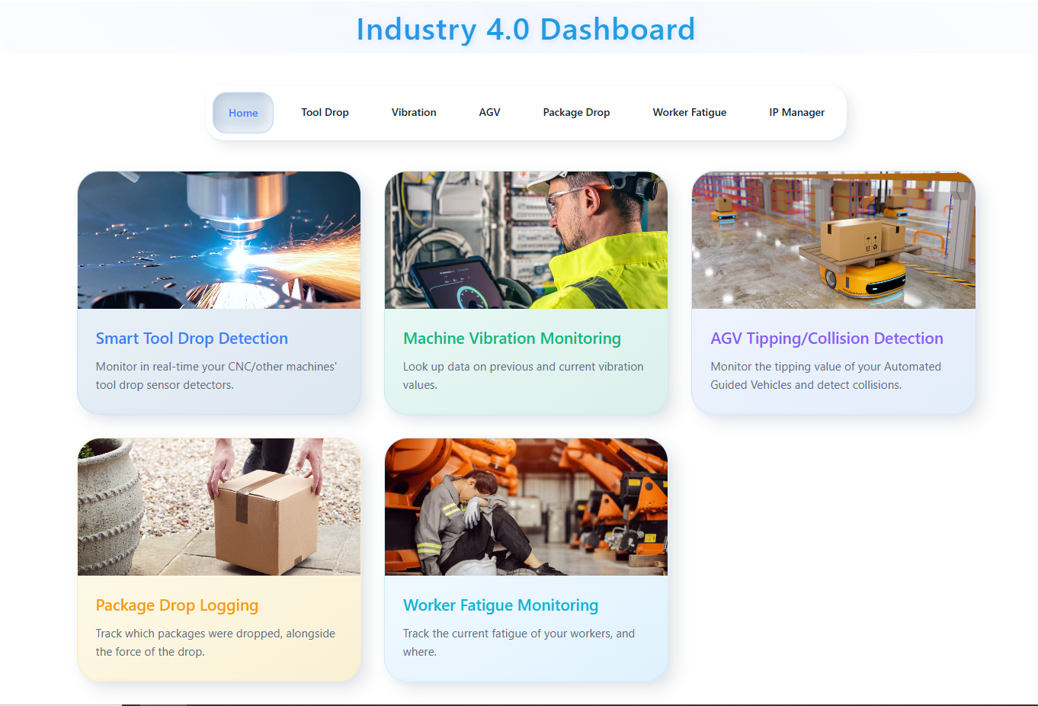
Figure 4. Final dashboard homepage.
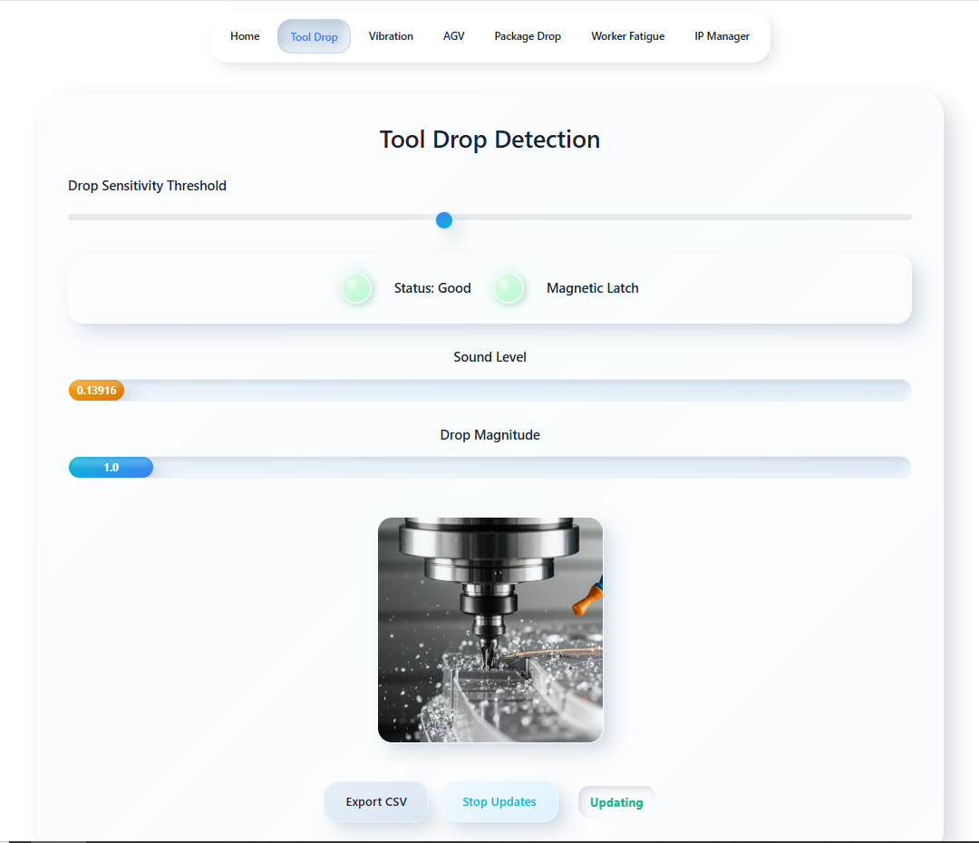
Figure 5. Tool-drop detection page.
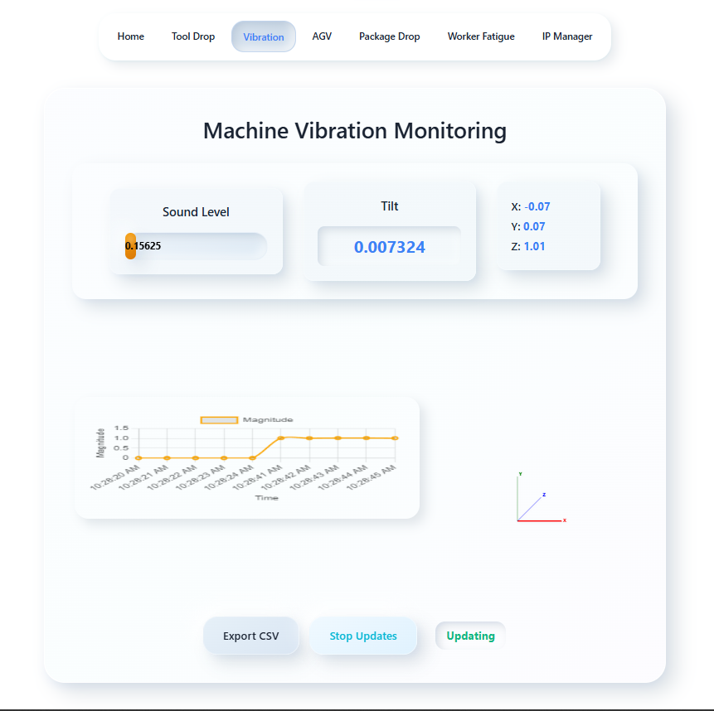
Figure 6. Machine vibration page.
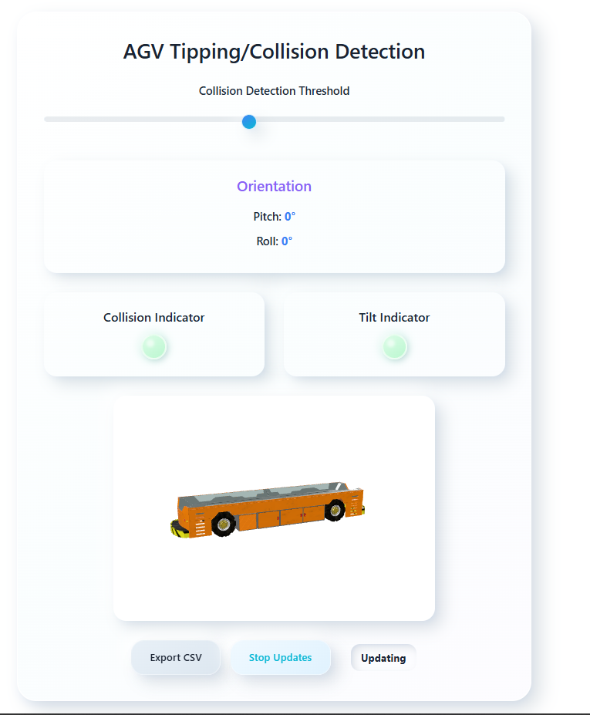
Figure 7. AGV tilt and collision page.
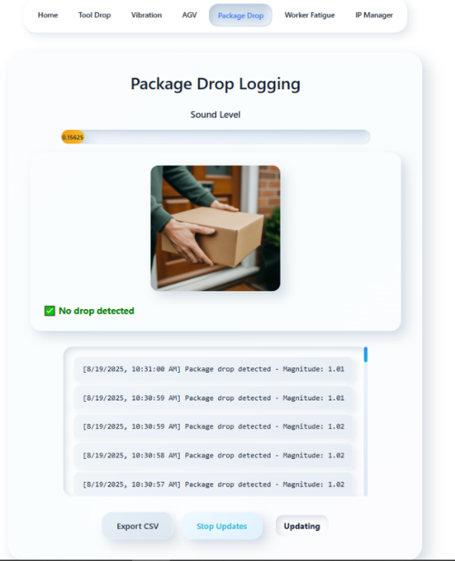
Figure 8. Package drop logging page.
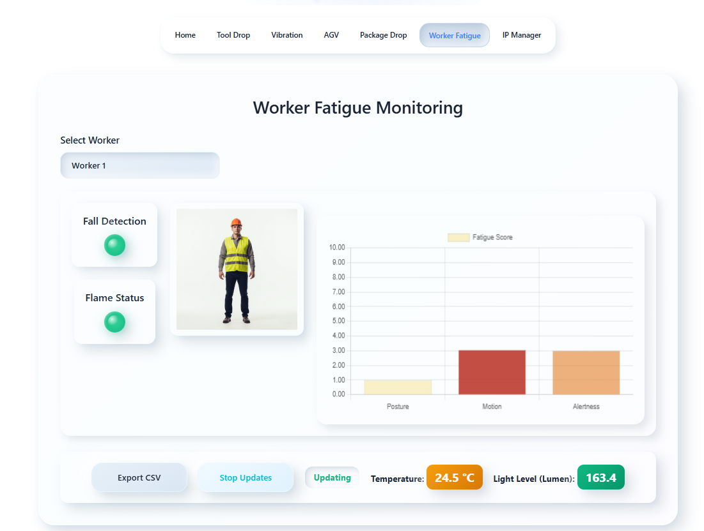
Figure 9. Worker fatigue monitoring page.

Detection and Alerting Logic
The prototype used threshold-based logic to validate end-to-end behavior. Acceleration magnitude supported fall or impact detection, pitch and roll supported orientation checks, and auxiliary sensors reduced ambiguity by adding context such as magnetic separation, sound, tilt, or environmental risk.
The thresholds were intentionally adjustable in the interface because the sensor behavior changed depending on the test setup. That made the dashboard easier to calibrate during demonstrations and helped separate normal sensor movement from events that should be logged or highlighted.
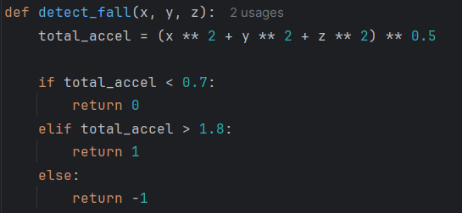
Figure 10. Fall detection function based on acceleration magnitude.

Testing and Validation
Testing focused on whether readings reached the backend, derived values were generated, dashboards updated live, alerts triggered, and event logs could be exported. The sample CSV logs in the repository are validation artifacts from these hardware and dashboard runs.
- Verified myRIO and LabVIEW acquisition using accelerometer and Arduino-compatible sensor readings.
- Tested UDP, TCP, and HTTP communication paths before using HTTP-style API integration for the dashboard workflow.
- Confirmed that the Flask backend wrote readings and events to SQLite/SQLAlchemy models and CSV logs.
- Validated live polling, Chart.js updates, browser notifications, thresholds, update toggles, and CSV export buttons.
- Used sample CSV logs as evidence for acceleration, AGV, collision, posture, vibration, package, and tool-drop scenarios.
The validation was practical rather than formal laboratory calibration. The main goal was to prove the complete pipeline: sensor input, transfer to the backend, processing, storage, dashboard display, alert behavior, and exportable logs.

Challenges and Lessons Learned
The largest challenge was integrating unfamiliar layers at once: myRIO and LabVIEW acquisition, sensor wiring, protocol experiments, Flask APIs, persistence, and frontend visualization. LabVIEW endpoint configuration and communication behavior required iterative troubleshooting.
On the dashboard side, the main tradeoff was keeping the prototype simple while still making it useful. CSV logging supported quick validation and exports, while SQLAlchemy and SQLite provided a clearer structure for machines, packages, workers, and event records. The frontend also needed to be practical enough for monitoring, even though the visual polish could be improved later.

Conclusion
The project resulted in a working Industry 4.0 monitoring prototype that connected embedded sensor acquisition to a full-stack dashboard. It demonstrates hardware integration, communication protocols, backend API development, data persistence, frontend visualization, alerting, and validation logging.
Future improvements would include cleaner runtime-data separation, stronger UI consistency, automated backend tests, deployment packaging, and threshold calibration using larger sensor datasets. The most important result, however, is that the prototype shows a complete hardware-to-software pipeline rather than an isolated dashboard or isolated device script.

