CCNP Route For A Global Health Network - Project Charter - Version 2.0
Project Start Date: 14/9/2025 Project End Date: 31/12/2025
Client overview: Stakeholders register, Client Background, current systems, related policies and procedures.  Project Stakeholders  Client Background:  To allow specialist doctors to communicate with patients in any country in HD (High Definition), the company uses video calls. In addition, the business will use Telnet and operate an internal email system, website, DNS and FTP server  Current Systems  The current system in the Global Health Network (GHN) is very limited to the basic level routing. the system lacks essential capabilities like route redistribution and if it offers minimal connectivity for online services, video conferencing, and email. During times of high traffic, the lack of redundancy and optimal routing increases the risk of packet loss, outage, and poor performance.  Related Policies and Standard Operating Procedures  Global Health Network uses ISO/IEC 27001 compliance requirements. To maintain confidentiality and legal compliance, healthcare legislation like (HIPAA) and (GDPR) that will also affect how patient data is handled. | General Information: Project Purpose, Product Description, Summary of Budget, Schedule, and success criteria.  Project Purpose  This project goal is to develop and implement an advance WAN routing system that allows Global Health Network to Function safely and reliably across its global locations. To support mission-critical applications like encrypted email, centralized services, and high definition (HD) video conferencing, the network must have high availability, robust routing capabilities, and obedience to healthcare IT standards.  Product Description  The final product will include advance WAN routing solution that has been thoroughly tested and documented. This involves prioritizing video conferencing and healthcare data traffic by using internal and external protocols for efficient routing and protocol redistribution where needed. The solution will be implemented in both simulated environments (EVE-NG) and physical Cisco hardware to demonstrate feasibility and reliability.  Schedule Summary  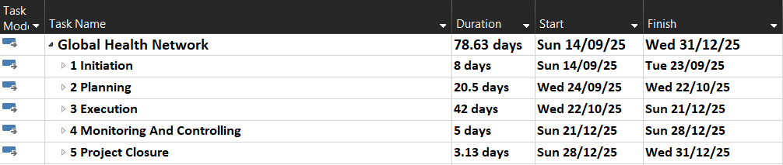  Budget Summary  The sum up of numbers of days: 79 days  Total number of man hours: 79* 8 = 632 hours.  Hourly wages: 20 dollars  Total estimated wages 632*20 = 12,640  Hardware Cost: 200,000 dollars  Total estimated Budget: 212,640 dollars  Success Criteria:  The outcome of the project shall satisfy the client’s needs while sticking to the correct industry and quality standards. The Success criteria will be demonstrated by the following actions:  - The project will be delivered within the time limit that been scheduled  - The project show does not exceed the proposed budget  - The project will have the approve and satisfaction from all stakeholders. | - Project Context: Business assumptions, constraints, and risks.  Business Need, Problem, or Opportunity  Global Health Network rapid expansion has created a pressing need for modern WAN solution. Furthermore, the existing network design is too basic to support international healthcare operations and exposes the organization to risks such as poor performance, downtime and security vulnerabilities. The main outcome is to improve service delivery, enhance data security and ensure reliable communication between sites.  Business Objectives  The main objectives are to strengthen network scalability and reliability, protect sensitive data during transmission, provide uninterrupted (HD) video calls and upskill IT staff with advanced routing knowledge.  - Assumptions  The project assumes that each site has functional WAN connectivity and basic hardware in place with top security for privacy and the down time will be in millisecond.  - Constraints  The Constraints of the project capped budget, fixed deadlines and limited availability of physical equipment. In addition, licensing agreements, some services depend on it.  - Risks  The possible delays in equipment delivery and misconfiguration lead to downtime. There is also the potential for non-compliance with regulations if configurations are not properly secured. A high demand and a high bandwidth. In addition, losing one of the isp that connects the sites may increase latency to avoid this must be used more than one isp provider. | - legal, ethical, social, and professional issues (LESPI).  Potential Legal Issues  According to Bahrain’s Personal Data Protection Law No. (30) of 2018, Global Health Network must not disclose any patient’s personal data to the public and must comply with strict legal frameworks such as HIPAA and GDPR to maintain patient confidentiality. Therefore, as the Project Manager for Global Health Network, I will ensure that the project strictly adheres to data protection best practices, implementing robust security controls and privacy measures to safeguard all patient information.  Potential Ethical Issues  The project must protect sensitive patient data and ensure the IT system is used only for its intended healthcare purpose and not to train any kind of Artificial intelligence.  Potential Social Issues  The introduction of a new network infrastructure may object to the upgrading to a new network because they are unfamiliar with it and the process of tanning the staff may temporarily disrupt the workflow.  Potential Professional Issues  From the professional standpoint the project must adherence to ICT best practice, commitment to information security standers and obligation to provide a solution that improves the healthcare regather than causes disruption with them.
  Role | Name | Contact
  Sponsor | Bahrain polytechnic | +973 1789 7000
  Client | IT department Jon Nolen | Jon.nolen@gmail.com
  Project Manager | Husain Ali | 202202674@student.polytechnic.bh
  Advisor | Dr. Ayman Alani | Ayman.Alani@polytechnic.bh

Approvals and Signatures
Position/Title | Signature- Printed Name/Title | Date
Sponsor Representative
Project Manager | Husain Ali | 10/10/2025

