When Goal-Oriented Error Warnings Agree: A Reproducible Comparison of Relative-Entropy and Information-Weighted Diagnostics
Syed Hussain Ather
Abstract
Diagnostic superiority can depend on whether the comparison method has access to the geometry of the quantity it predicts. We reproduce posterior-predictive trajectories from a published nutrient–algae–rotifer model and compare finite-time relative-entropy approximation errors under initial-nitrogen perturbations. Across 192 fitted posterior draw–chemostat configurations per perturbation amplitude, second-order predictions reduce median divergence error for small perturbations, but their advantage weakens for larger amplitudes. In a posterior-draw confirmation set of 144 configurations, the entropy-correction warning has ROC AUC 0.9777, compared with 0.8965 for a component-scaled state norm and 0.9769 for a Fisher-information-weighted correction. The entropy-specific advantage therefore essentially disappears with an information-matched comparator. The exact goal-gradient-plus-curvature correction is algebraically the entropy correction itself; it is not an independent method. Exploratory held-out biomass forecasting does not outperform persistence. These findings support a restricted methodological conclusion: comparative evaluations of goal-specific error indicators must control for information geometry and should distinguish within-model approximation accuracy from independent observational forecasting. The work is a computational comparison, not a novel general error theorem or a validated ecological forecast.

Introduction
Finite-time reliability of a dynamical approximation and prediction of a measured ecological outcome are different questions. A first- or second-order expansion may approximate a nonlinear model internally without the underlying model forecasting experiments excluded from its fitting. A second ambiguity concerns the choice of diagnostic: a goal-specific indicator can easily outperform an unrelated state norm even when no unique goal-specific information is present. Goal-oriented a posteriori estimation and adjoint methods already address errors in chosen observables (Becker and Rannacher 2001; Cao and Petzold 2004; Giles and Suli 2002). The relevant scientific question is therefore not whether entropy-aware diagnostics can outperform every possible state metric, but what remains when the comparator has equivalent model and geometric information.
We study a reproducible example based on the posterior-fitted ecological ordinary differential equations used by Wojcik, Pfennig, Flamm, Klauschies, et al. (2025). The paper’s contribution is intentionally narrow: (a) reproduce the published posterior-predictive dynamics; (b) examine amplitude-dependent finite-time approximation errors; (c) compare multiple warning indicators under matched reference trajectories, Taylor information and calibration budgets; and (d) show the limit of transferring within-model reliability claims to actual held-out ecological data. We do not introduce a new Bregman identity, a novel adjoint method or a general validated certificate.

Ecological system and numerical protocol

Model and source of parameters
The source chemostat experiment comprises 24 vessels (12 monoculture and 12 polyculture cases). Let $N$ denote nitrogen concentration, $A$ algal biovolume, and $R$ rotifer biovolume. The recovered model is
$$F_{A}=\frac{bNA}{K+N}, F_{R}=\frac{aAR}{1+ahA},$$
$$\dot{N}=0.2\left(80−N\right)−F_{A}/e_{A}, \dot{A}=F_{A}−F_{R}−0.2A, \dot{R}=e_{R}F_{R}−\left(m+0.2\right)R.$$
The model parameters and pre/post initial conditions are supplied by the authors’ publicly archived Bayesian fit and converted into numeric draw tables. Post-pulse segments have separately fitted latent initial states; simulations here modify fitted post-pulse initial nitrogen rather than recreating the physical nutrient-pulse protocol. Posterior draws are not independent experiments.
Using a separate Python integrator, the source study’s posterior-predictive quantiles were reproduced over 43,200 trajectory-quantile-component comparisons. The largest relative discrepancy was approximately 0.0645%, according to the archived reconstruction output. This validates implementation consistency against the study’s published predictions, not independent biological forecast skill.

Taylor approximations and observable
For each fitted parameter vector $θ$ and positive reference $X\left(t\right)$, perturb the initial nitrogen by $εe_{N}$. The first and second variations obey
$$\dot{u}=J\left(X\right)u, u\left(0\right)=e_{N}, \dot{w}=J\left(X\right)w+1/2D^{2}F\left(X\right)\left[u,u\right], w\left(0\right)=0.$$
The state predictions are $p_{1}=X+εu$ and $p_{2}=p_{1}+ε^{2}w$. We use a weighted generalized abundance I-divergence, not thermodynamic entropy or compositional KL divergence:
$$D_{ω}\left(z∣X\right)=\sum_{i=1}^{3}{\frac{z_{i}log\left(z_{i}/X_{i}\right)−z_{i}+X_{i}}{ω_{i}}}, ω_{i}=X_{i}\left(0\right)>0.$$
With $h=p_{2}−p_{1}$, an exact Bregman decomposition is
Dωp2∣X−Dωp1∣X=i​hiωilogp1,iXi+Dωp2∣p1.
This identity is standard Bregman geometry (Bregman 1967; Banerjee et al. 2005). It explains metric alignment, but is not our novel theorem. Positivity of $X,p_{1},p_{2}$ is checked. All first- and second-order comparisons use identical reference and perturbation dynamics. The time-averaged error uses the exact perturbed model divergence as its within-model target, with near-zero divergence times excluded according to the archived numerical protocol.

Results

Approximation accuracy and perturbation amplitude
Eight posterior draws per treatment group were evaluated across all 24 vessel-specific fitted initial states. At each of $ε∈\{5,20,80\}$ µmol/L this gives 192 draw–vessel configurations, or 576 configurations in total. At perturbations +5, +20 and +80, median first-order divergence approximation errors were 0.287%, 1.492%, and 2.980%; second-order medians were 0.0213%, 0.362%, and 2.780%. Second-order error was smaller in 192, 191, and 139 of the 192 configurations, respectively. These comparisons concern within-model approximation, not held-out ecological prediction.
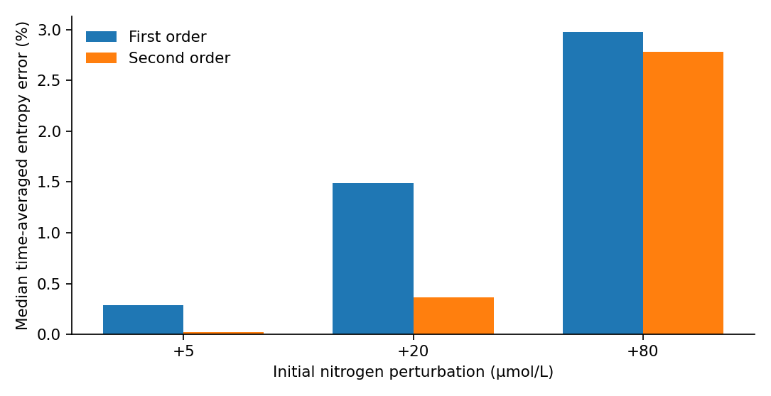
Median time-averaged relative-entropy approximation errors on the three model-internal perturbation regimes. The 192 draw–vessel configurations per amplitude share a fitted posterior.

Equal-information warning comparison
For +20 µmol/L, an exploratory threshold design classifies a configuration as a first-order entropy-prediction failure when its time-averaged relative divergence error exceeds 1%. The choice of threshold and perturbation arose during earlier exploration; it was held fixed for the posterior-draw confirmation experiment but was not preregistered for the entire study. The discovery set contains 192 configurations and the confirmation set 144 additional posterior-draw configurations from the same already fitted posterior distribution. Logistic models apply logarithmic predictor transforms followed by standardization and regularized fitting, with the same discovery data and calibration settings per comparator. No confirmation labels are used in fitting the warning calibrators.
All methods use $X,u,w$ and the same temporal window. The entropy correction predictor measures the normalized magnitude of $D_{ω}\left(p_{2}∣X\right)−D_{ω}\left(p_{1}∣X\right)$. The Fisher-weighted state predictor takes a quadratic metric based on the positive reference/first-order prediction; a component-scaled norm provides the coarse state comparator. A goal-gradient feature uses the first term of the Bregman identity. Importantly, the exact goal-gradient plus curvature sum equals the entropy correction, and therefore must not be counted as a separate independent competitor. A two-feature regression on goal-gradient and curvature is a distinct calibration architecture, even though the underlying information is the same.
In 144 confirmation configurations, the entropy indicator yields ROC AUC 0.977709 and Brier score 0.068084. The Fisher-weighted indicator yields AUC 0.976934 and Brier 0.070118. The component-scaled state norm yields AUC 0.896492 and Brier 0.132038; the goal-gradient predictor yields AUC 0.971700 and Brier 0.076286. The entropy–Fisher AUC difference is only 0.000775; the exploratory chemostat-cluster resampling interval of the difference includes zero (about −0.016 to +0.020). AUC comparisons must not be taken as causal evidence that one error estimator contains intrinsically new information.
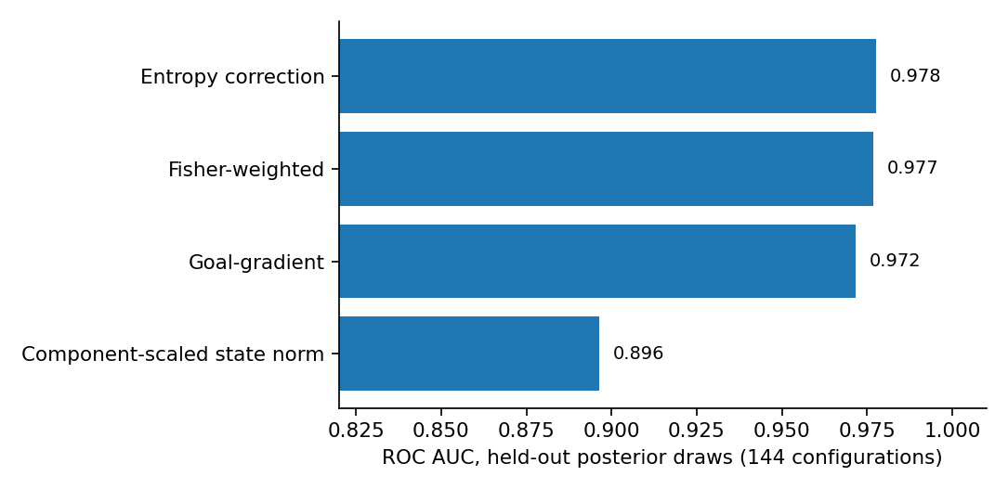
Held-out posterior-draw warning discrimination. The entropy–Fisher near-tie limits claims of entropy-specific diagnostic superiority.

Interpretation and external-validity limits
This comparison demonstrates a benchmark-design effect rather than a new mathematical identity: an apparently large benefit over an unweighted or component-scaled norm becomes negligible against a reference-informed Fisher-weighted diagnostic. A meaningful comparison must match access to reference trajectories, Taylor order, observable geometry, calibration examples and computational budgets. This is consistent with longstanding goal-oriented estimation and Bregman information geometry, rather than contradicting those approaches.
An exploratory chemostat-holdout forecasting analysis using separately refitted simplified mechanistic parameters did not beat a day-2 persistence forecast on observed algal and rotifer biomass (mean absolute natural-log errors approximately 0.895 versus 0.746 for the 23 matched valid vessels under one latent-nitrogen strategy). This negative result is supplementary: the original Stan model was not refitted under the exact same holdout setup, nutrient concentrations were unobserved and one model run failed. It should not be read as a refutation of the published ecological model.
Independent validated numerical certification of a continuous latent-state uncertainty set remains outside the results reported here. Preliminary residual-coordinate bound experiments need separate software verification and do not alter the matched warning result. No claim of certified ecological forecasts or universal optimality is made.

Conclusions
The reproducible evidence supports a specific limitation on claims of goal-specific diagnostic superiority: when the comparison baseline is given the same geometric information, relative-entropy corrections and Fisher-weighted state corrections can be nearly indistinguishable as warnings of a defined within-model error. This may inform future benchmarking designs, but the single-model example, exploratory threshold selection and shared posterior fitting restrict generalization. This is a neutral, scope-limited computational comparison and remains subject to the target venue’s scientific-significance and reproducibility review.

Reproducibility and data availability
The analysis source, draw tables, figures and verification assertions are included in this working repository. Running python build_release.py --full recomputes the 576 perturbation outcomes and 336 matched-comparator feature records from posterior draws and then generates the figures and checks. The archived posterior-curve reconstruction is checked separately; its original published data archive and R posterior-export process are an external upstream prerequisite. The original ecological data and posterior objects are distributed through Dryad under CC0 (Wojcik, Pfennig, Flamm, and others 2025); numeric posterior draw tables in this package were exported from those fitted objects. The published data should still be cited and the export procedure documented as an upstream prerequisite. The present package includes reproducible downstream Python analyses but not a rerun of the original Stan fitting. Clean-environment recreation, official Computo Quarto rendering, public CI, and permanent archiving remain incomplete.

References
Banerjee, Arindam, Srujana Merugu, Inderjit S. Dhillon, and Joydeep Ghosh. 2005. “Clustering with Bregman Divergences.” Journal of Machine Learning Research 6: 1705–49. https://www.jmlr.org/papers/v6/banerjee05b.html.
Becker, Roland, and Rolf Rannacher. 2001. “An Optimal Control Approach to a Posteriori Error Estimation in Finite Element Methods.” Acta Numerica 10: 1–102. https://doi.org/10.1017/S0962492901000010.
Bregman, Lev M. 1967. “The Relaxation Method of Finding the Common Point of Convex Sets and Its Application to the Solution of Problems in Convex Programming.” USSR Computational Mathematics and Mathematical Physics 7: 200–217. https://doi.org/10.1016/0041-5553(67)90040-7.
Cao, Yang, and Linda Petzold. 2004. “A Posteriori Error Estimation and Global Error Control for Ordinary Differential Equations by the Adjoint Method.” SIAM Journal on Scientific Computing 26: 359–74. https://doi.org/10.1137/S1064827503420969.
Giles, Michael B., and Endre Suli. 2002. “Adjoint Methods for PDEs: A Posteriori Error Analysis and Postprocessing by Duality.” Acta Numerica 11: 145–236. https://doi.org/10.1017/S096249290200003X.
Wojcik, Laurie Anne Myriam, Arne Pfennig, Steven Flamm, et al. 2025. “Data for: Top-down Control and Species Composition Non-Linearly Influence the Short-Term Response of Experimental Food Webs to a Nutrient Pulse Perturbation.” Dryad. https://doi.org/10.5061/dryad.51c59zwj5.
Wojcik, Laurie Anne Myriam, Arne Pfennig, Steven Flamm, Toni Klauschies, Benjamin Rosenbaum, Guntram Weithoff, and Ursula Gaedke. 2025. “Top-down Control and Species Composition Influence Nonlinearly the Short-Term Response of Experimental Food Webs to a Nutrient Pulse Perturbation.” Proceedings of the Royal Society B: Biological Sciences 292 (2060): 20251969. https://doi.org/10.1098/rspb.2025.1969.

