University of Central Punjab

OS Lab 02

Hussain Durrani
L1F24BSCS0937

Task 1:

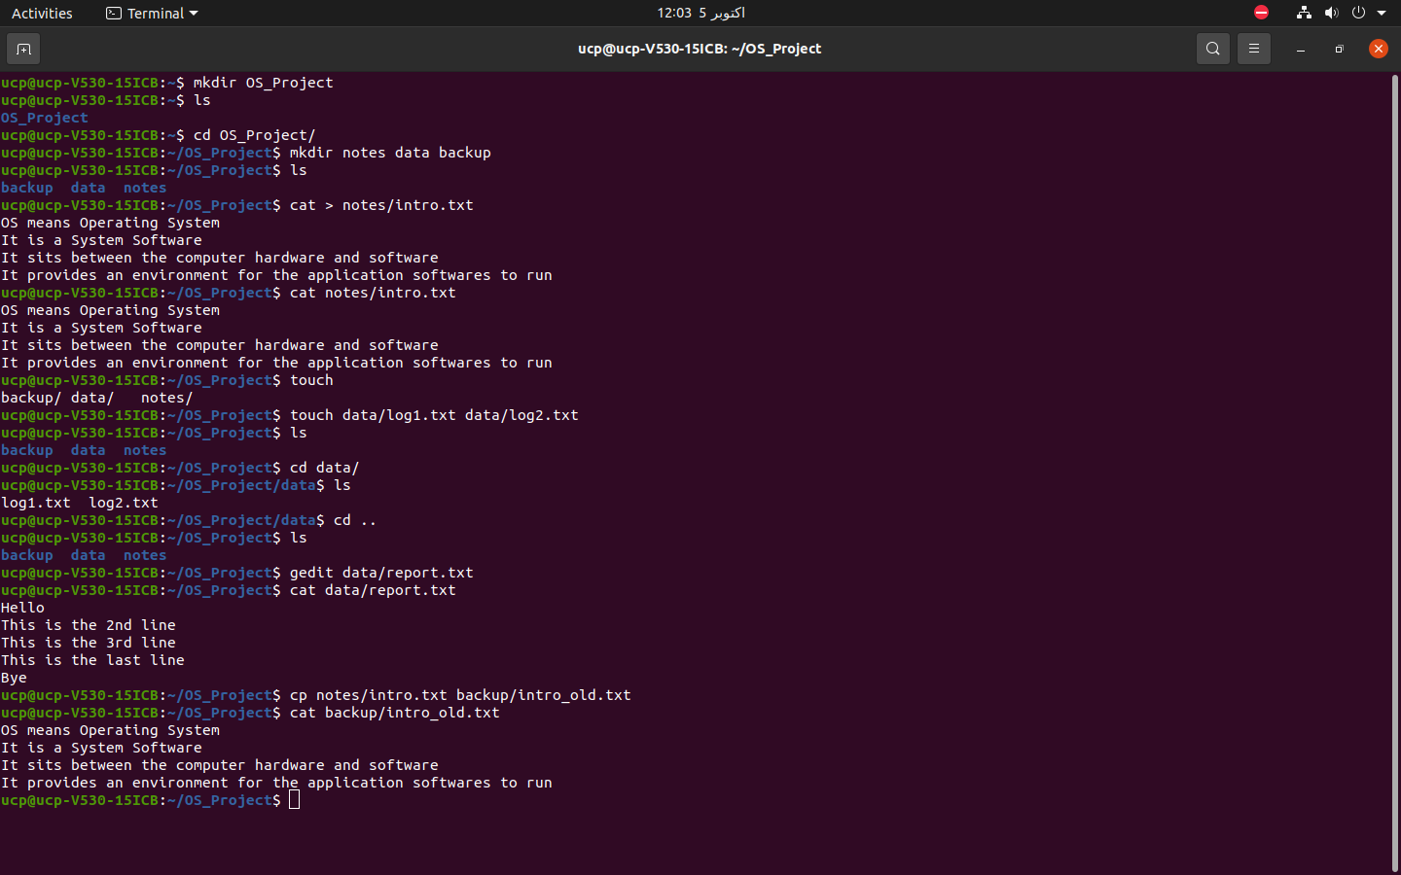

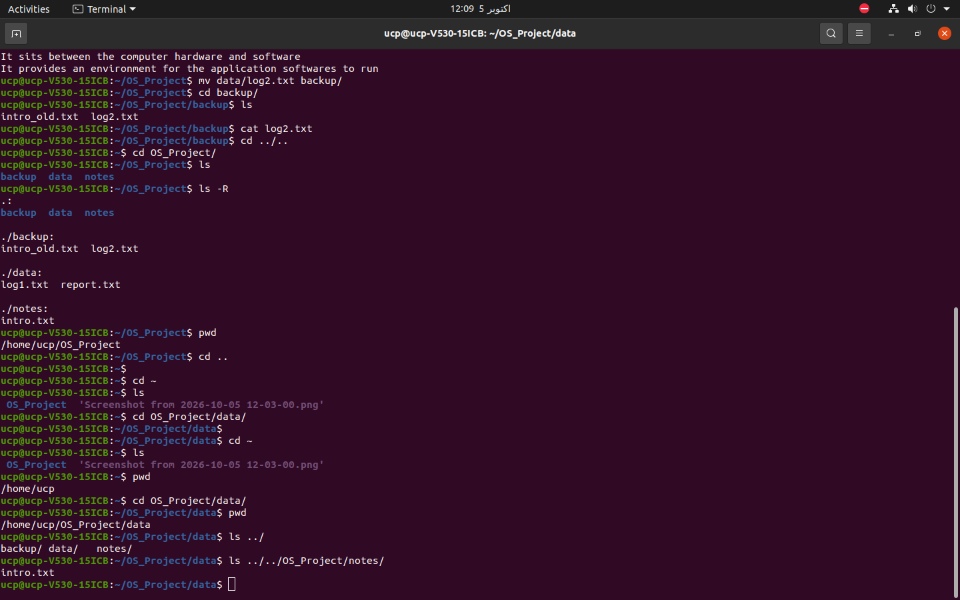

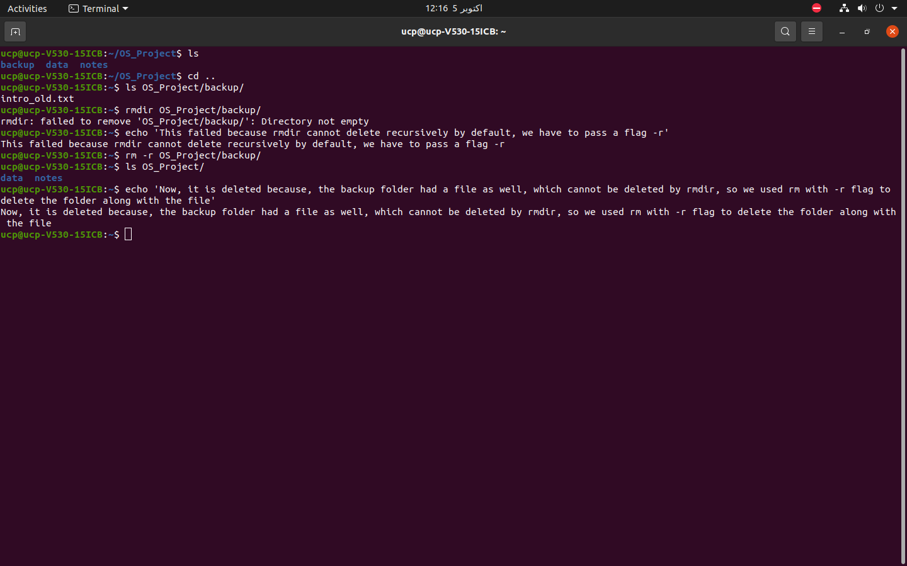

Task 2:

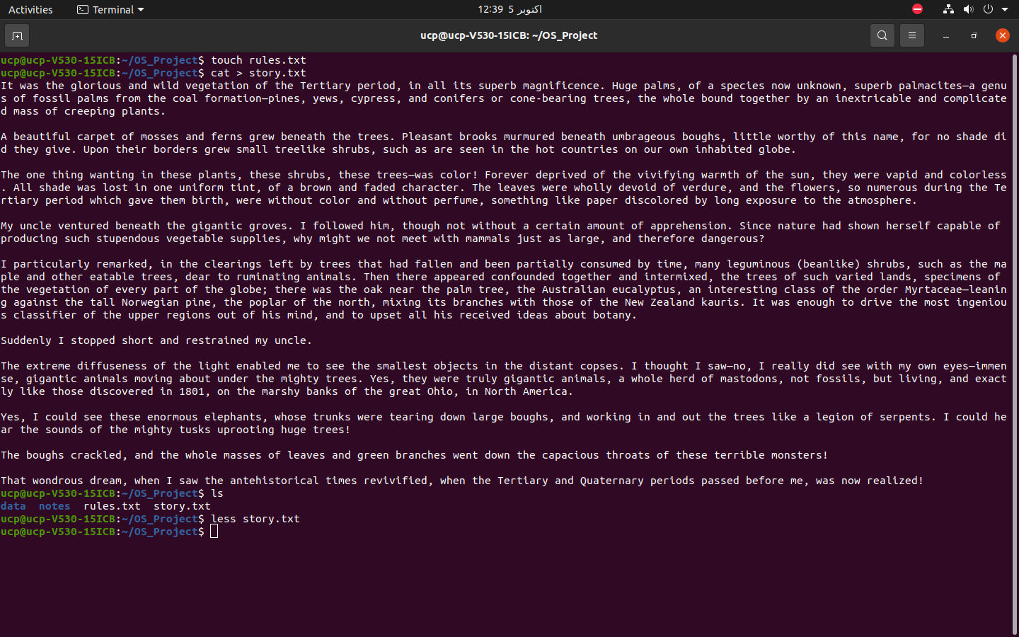
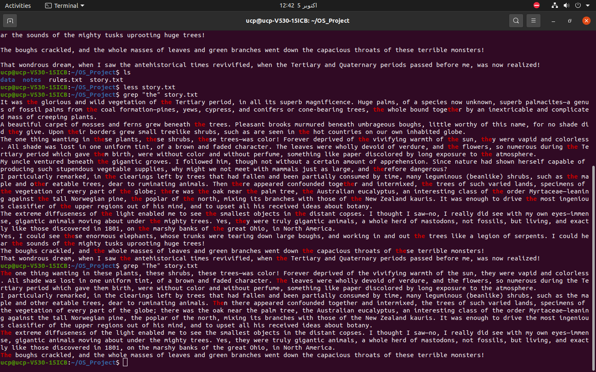
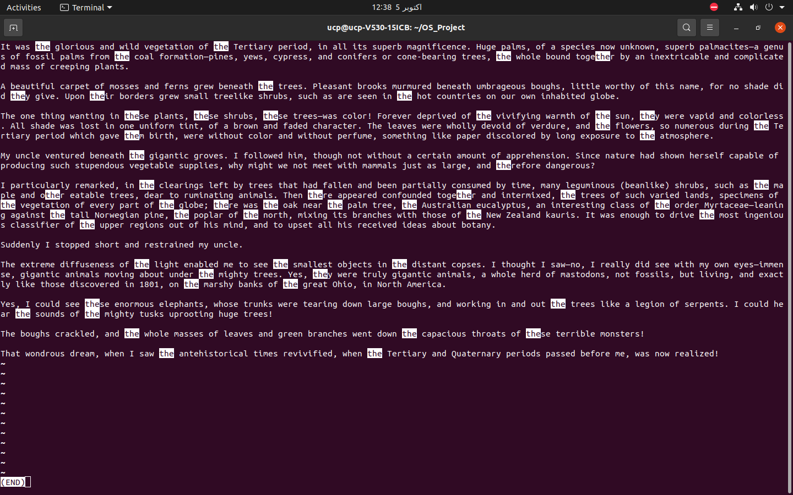

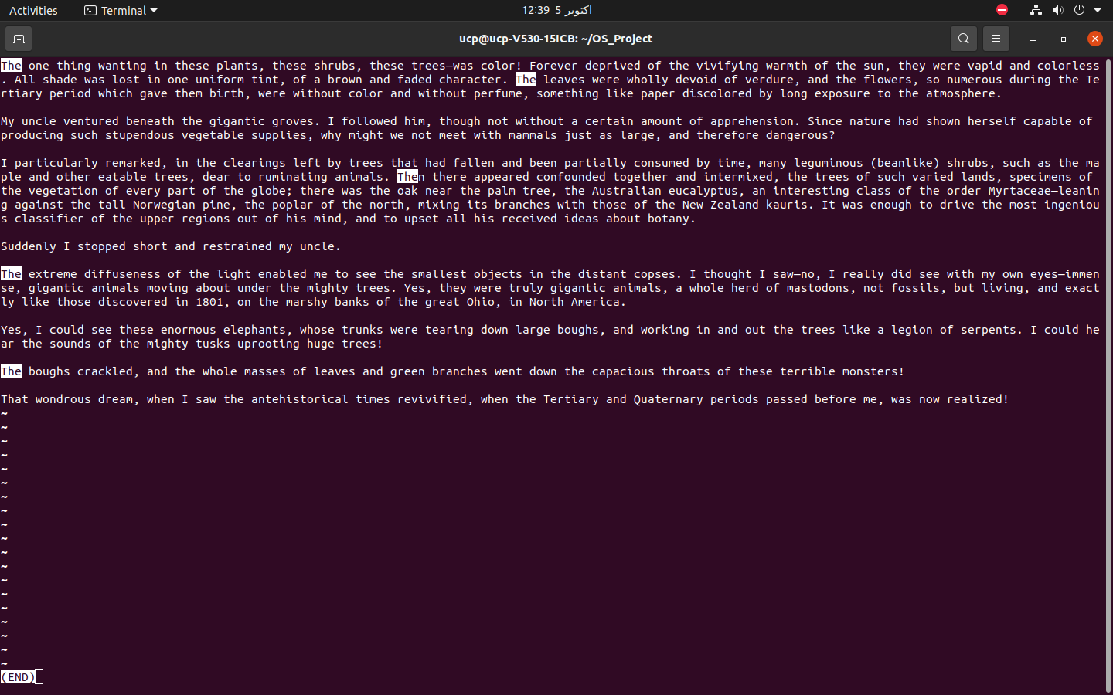
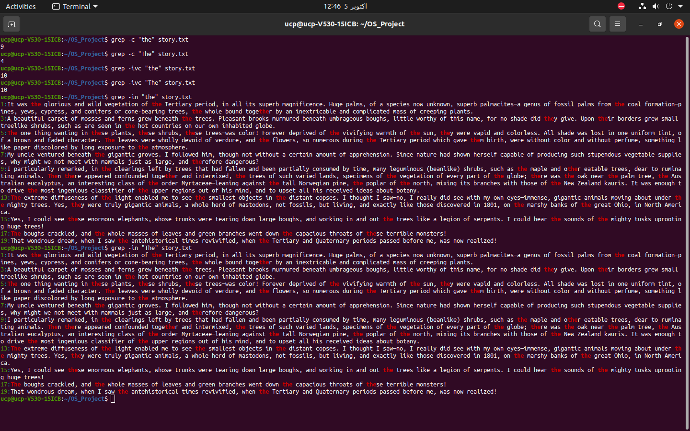
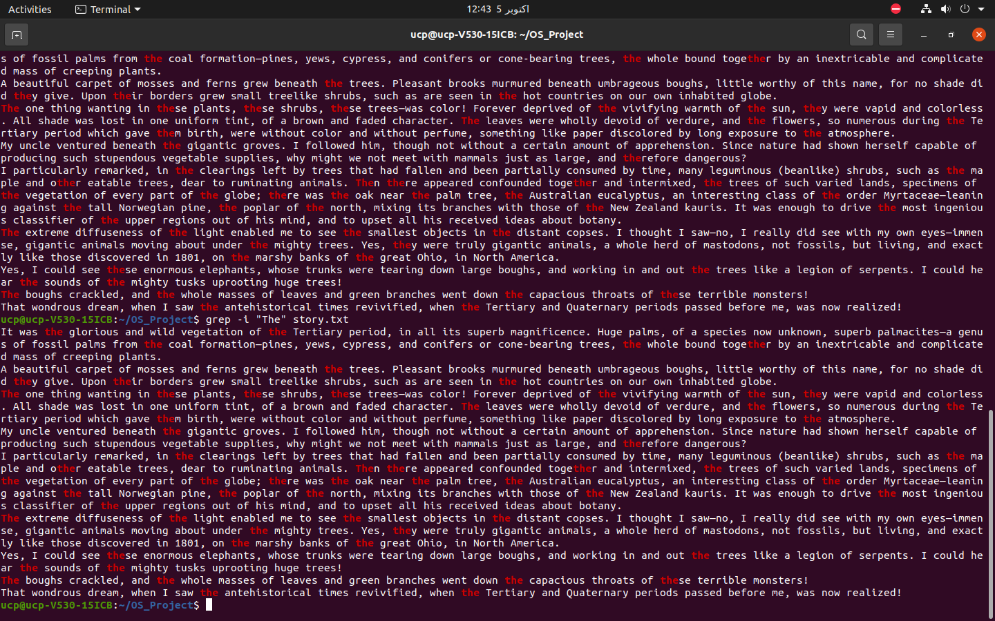

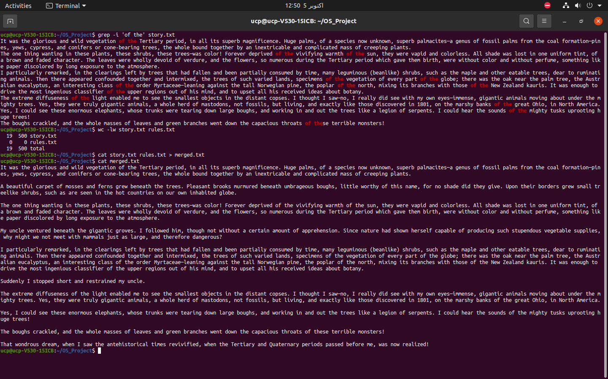
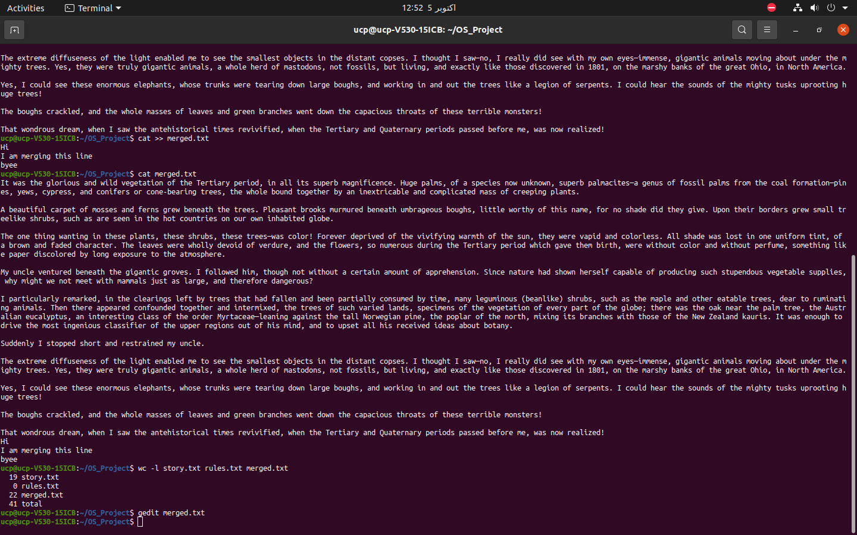
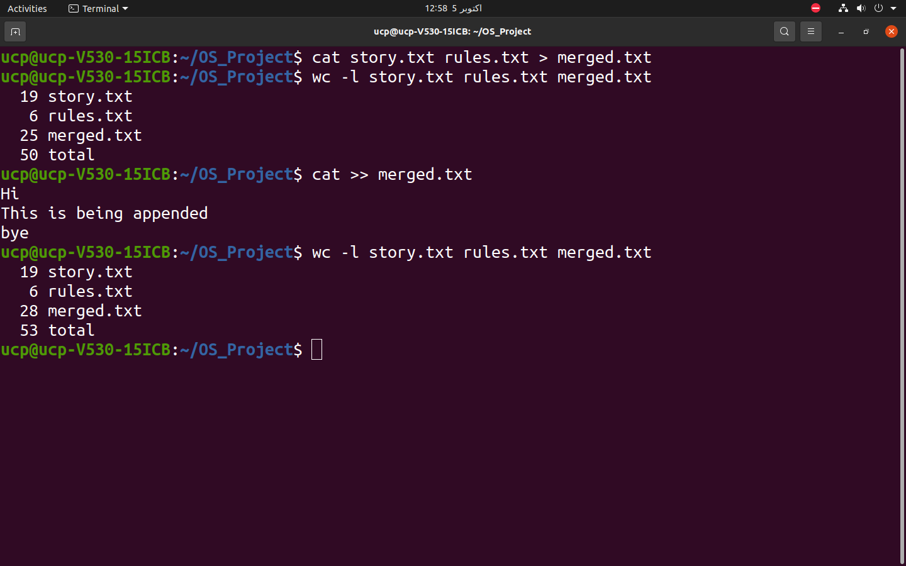

Task 3:

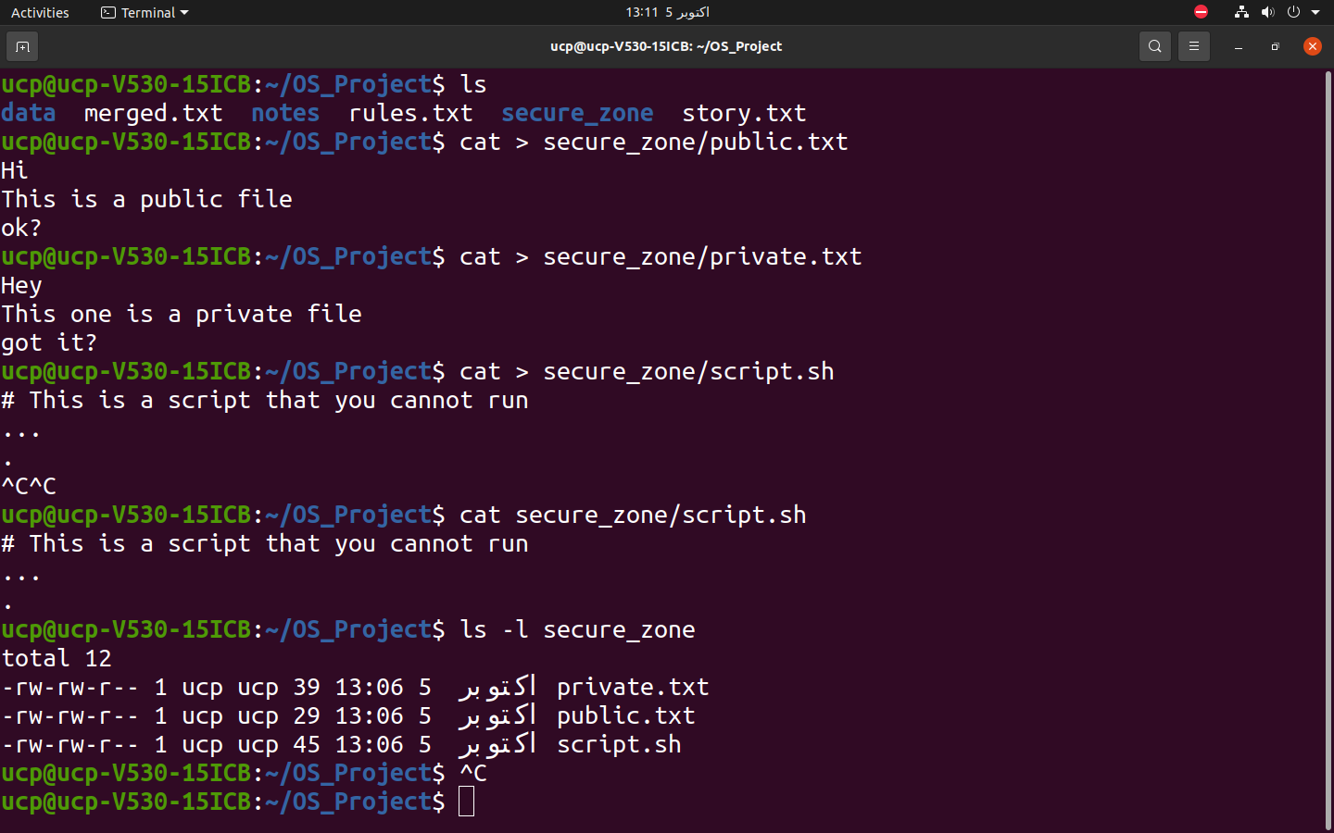

ucp@ucp-V530-15ICB:~/OS_Project$ ls -l secure_zone
total 12
-rw-rw-r-- 1 ucp ucp 39 اکتوبر 5 13:06 private.txt
-rw-rw-r-- 1 ucp ucp 29 اکتوبر 5 13:06 public.txt
-rw-rw-r-- 1 ucp ucp 45 اکتوبر 5 13:06 script.sh
ucp@ucp-V530-15ICB:~/OS_Project$

This tells that, for each file, Owner & Group has read and write permissions, while the Others only have read permissions

